**SOFTWARE DEVELOPMENT AND FUNDEMENTAL-1(LABS)**

**(15B11CI111)**

**MINI-PROJECT**

**CGPA Calculating Grading System**

**Project by:**

**ADITI JAIN**

ABOUT THE PROJECT

The main aim of our project was to analyse the semester details of each students in a batch and display Cumulative grade point aggregate

We assessed the use of data types to collectively input the information of students in a batch.

We entered batch in the beginning. As we assessed the number of students in the current batch we arranged them according to the enrolment number.

After this we handed over the access to separate faculty and with their assigned password details they can input the marks obtained by students in different subject and at last printed their CGPA.

During the making we came across the hands on knowledge of various tools and methods of project development, one of which was based on the use of data types as tools for problem solving and knowledge representation.

#INPUT:

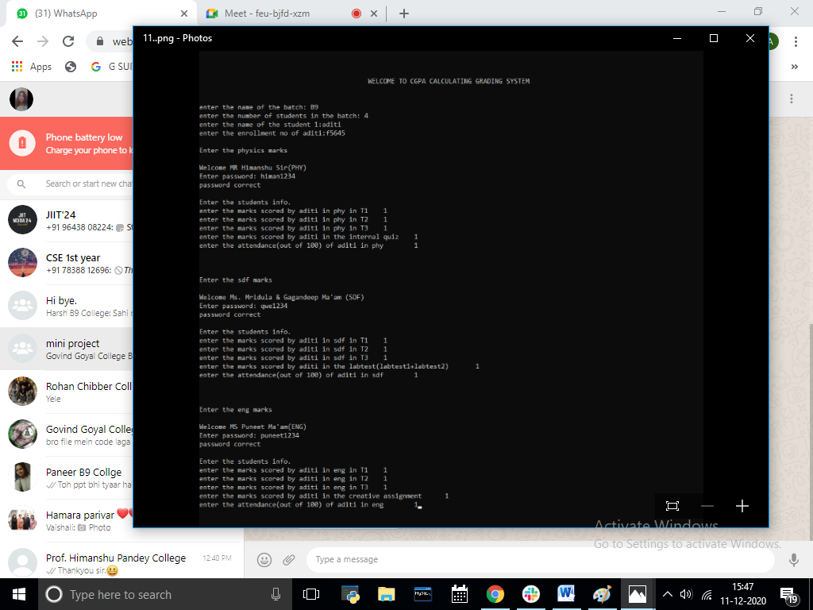

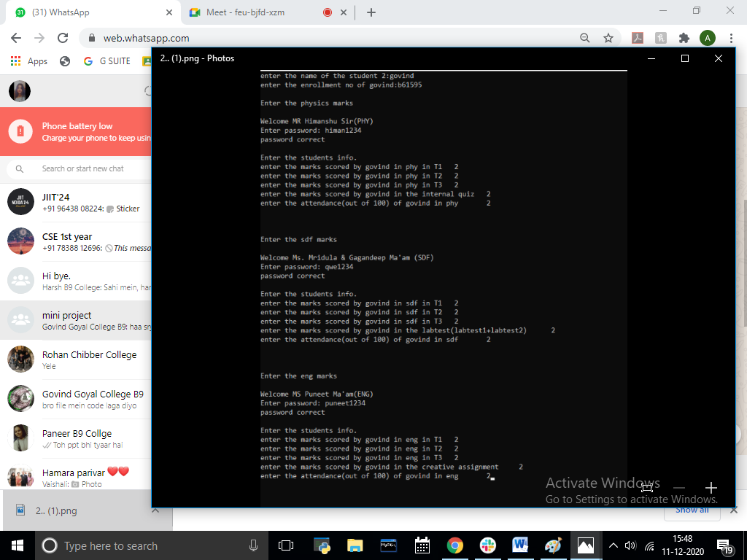

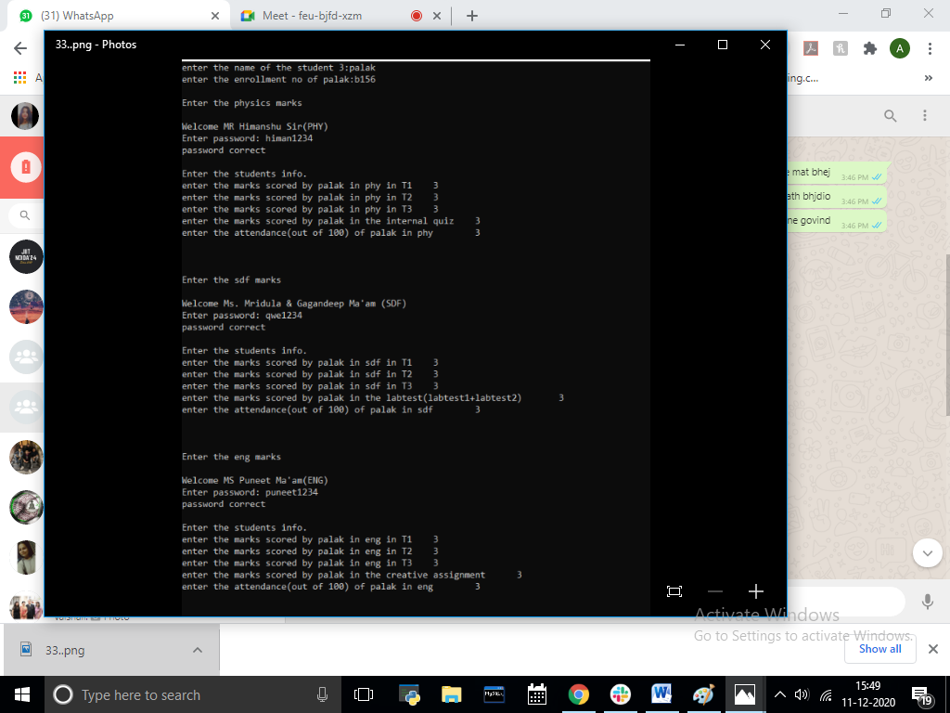

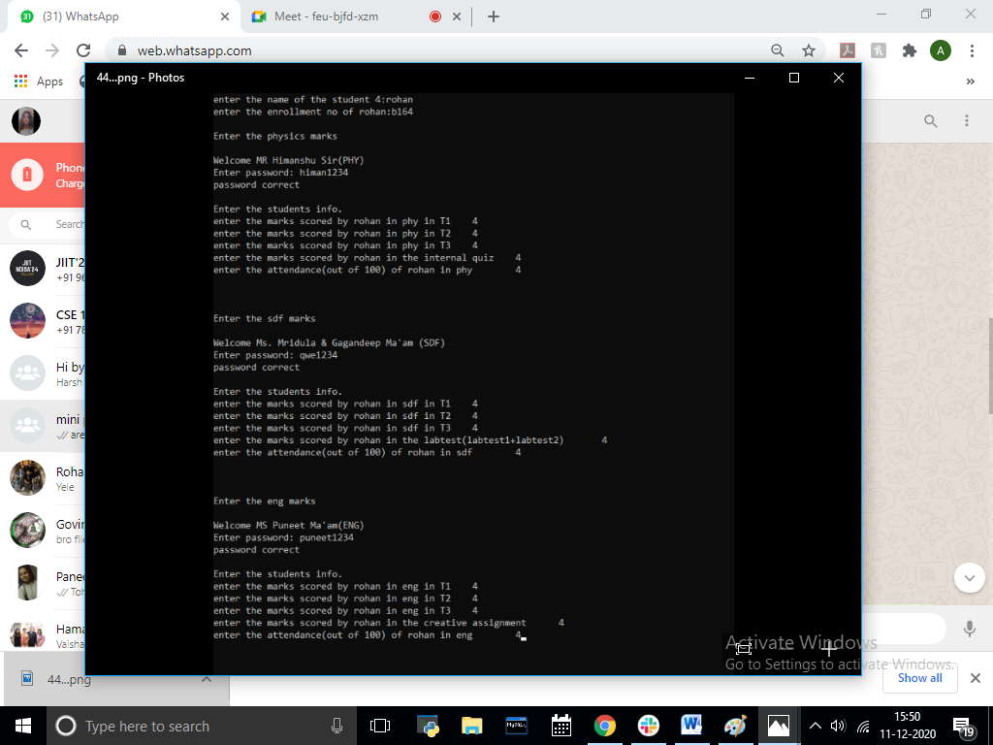

#OUTPUT

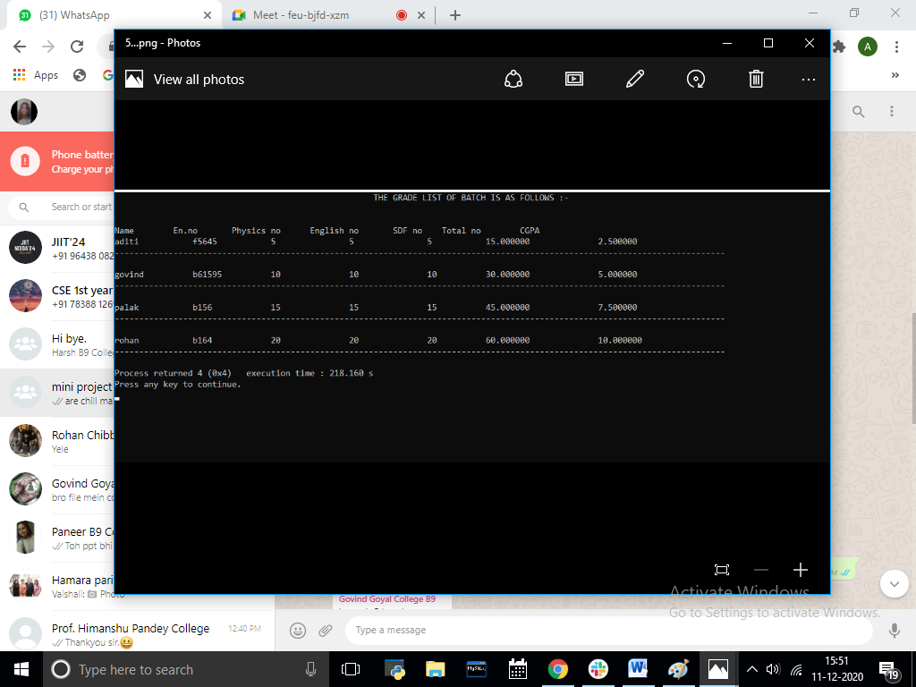

#SOURCE CODE:

#include <stdio.h>

#include <stdlib.h>

#include <string.h>

#include <math.h>

int pass(char *s1,char *s2)

{

int i,c=0;

if(strlen(s1)==strlen(s2))

{

for(i=0; s2[i]; i++)

{

if(s1[i]==s2[i])

c++;

}

if(c==i)

return 1;

}

}

void main()

{

printf("\n\n\n WELCOME TO CGPA CALCULATING GRADING SYSTEM \n\n\n");

int n,i;

char batch[3];

printf("enter the name of the batch: ");

gets(batch);

printf("enter the number of students in the batch: ");

scanf("%d",&n);

struct college

{

int tuteval,t1,t2,t3,att,quiz,labeval,ca;

};

struct info

{

char name[20],enrollment[50];

};

struct college phy[n];

struct college sdf[n];

struct college eng[n];

struct info stud[n];

int phymarks[n];

int sdfmarks[n];

int engmarks[n];

float max;

float cgpa[n];

for(i=1; i<=n; i++)

{

printf("enter the name of the student %d:",i);

scanf("%s",&stud[i].name);

printf("enter the enrollment no of %s:",stud[i].name);

scanf("%s",&stud[i].enrollment);

printf("\nEnter the physics marks\n");

printf("\nWelcome MR Himanshu Sir(PHY)\n");

char s3[9],c;

printf("Enter password: ");

scanf("%s",&s3);

c=pass(s3,"himan1234");

if(c==1)

{

printf("password correct\n\n");

printf("Enter the students info.\n");

{

printf("enter the marks scored by %s in phy in T1\t",stud[i].name);

scanf("%d",&phy[i].t1);

printf("enter the marks scored by %s in phy in T2\t",stud[i].name);

scanf("%d",&phy[i].t2);

printf("enter the marks scored by %s in phy in T3\t",stud[i].name);

scanf("%d",&phy[i].t3);

printf("enter the marks scored by %s in the internal quiz\t",stud[i].name);

scanf("%d",&phy[i].quiz);

printf("enter the attendance(out of 100) of %s in phy\t",stud[i].name);

scanf("%d",&phy[i].att);

phymarks[i]=phy[i].t1+phy[i].t2+phy[i].t3+phy[i].quiz+phy[i].att;

}

}

else

{

printf("incorrect password");

}

printf("\n\n");

printf("\nEnter the sdf marks\n");

printf("\nWelcome Ms. Mridula & Gagandeep Ma'am (SDF)\n");

char s5[10],c1;

printf("Enter password: ");

scanf("%s",&s5);

c1=pass(s5,"qwe1234");

if(c1==1)

{

printf("password correct\n\n");

printf("Enter the students info.\n");

{

printf("enter the marks scored by %s in sdf in T1\t",stud[i].name);

scanf("%d",&sdf[i].t1);

printf("enter the marks scored by %s in sdf in T2\t",stud[i].name);

scanf("%d",&sdf[i].t2);

printf("enter the marks scored by %s in sdf in T3\t",stud[i].name);

scanf("%d",&sdf[i].t3);

printf("enter the marks scored by %s in the labtest(labtest1+labtest2)\t",stud[i].name);

scanf("%d",&sdf[i].labeval);

printf("enter the attendance(out of 100) of %s in sdf\t",stud[i].name);

scanf("%d",&sdf[i].att);

sdfmarks[i]=sdf[i].t1+sdf[i].t2+sdf[i].t3+sdf[i].labeval+sdf[i].att;

}

}

else

{

printf("incorrect password");

}

printf("\n\n");

printf("\nEnter the eng marks\n");

printf("\nWelcome MS Puneet Ma'am(ENG)\n");

char s1[9],c2;

printf("Enter password: ");

scanf("%s",&s1);

c2=pass(s1,"puneet1234");

if(c2==1)

{

printf("password correct\n\n");

printf("Enter the students info.\n");

{

printf("enter the marks scored by %s in eng in T1\t",stud[i].name);

scanf("%d",&eng[i].t1);

printf("enter the marks scored by %s in eng in T2\t",stud[i].name);

scanf("%d",&eng[i].t2);

printf("enter the marks scored by %s in eng in T3\t",stud[i].name);

scanf("%d",&eng[i].t3);

printf("enter the marks scored by %s in the creative assignment\t",stud[i].name);

scanf("%d",&eng[i].ca);

printf("enter the attendance(out of 100) of %s in eng\t",stud[i].name);

scanf("%d",&eng[i].att);

engmarks[i]=eng[i].t1+eng[i].t2+eng[i].t3+eng[i].ca+eng[i].att;

}

}

else

{

printf("incorrect password");

}

system("cls");

}

float total[n];

for(i=1; i<=n; i++)

{

total[i]=phymarks[i]+sdfmarks[i]+engmarks[i];

}

max=total[1];

for(int i=1; i<=n; i++)

{

if(total[i]>max)

max=total[i];

}

printf(" THE GRADE LIST OF BATCH IS AS FOLLOWS :-");

printf("\n\n");

printf("\nName\t En.no \tPhysics no\tEnglish no\t SDF no\t Total no\t CGPA");

for(int i=1; i<=n; i++)

{

cgpa[i]=(total[i]/max)*10;

printf("\n%s\t \t%s \t%d\t\t%d\t \t% d\t %f\t\t %f",stud[i].name,stud[i].enrollment,phymarks[i],engmarks[i],sdfmarks[i],total[i],cgpa[i]);

printf("\n-----------------------------------------------------------------------------------------------------------------------------\n");

}

}