Home Test Solution for ModulrFinance Opportunity
- Bhagyashri Dhadage

Contents
Purpose 3
Home Assignments 3
1. Feature File (Login) 3
2. Step Definition/Implementation (Login) 5
3. Login API Calls and analysis 8
Login API 8
Additional API’s 9
Supporting Skills 9
Framework Developed 10
My Skillsets 10
References/ Recommendations: 10

Purpose
Document is created as a solution for 3 home assignments. It includes detailed analysis performed on different API’s available in the Modulr. Embedded with project feature file, step Definition, step implementation and API excel sheet.
Demo framework creation and implementation is in progress and can be demoed on request.
****GUI automation only. Can be created for API automation with difference in use of REST Assured Java library and validation again response than page objects.

Home Assignments

Feature File (Login)
- Framework used is java + selenium with cucumber (Gherkin) for feature file
- Maven is used as dependency management and build tool.

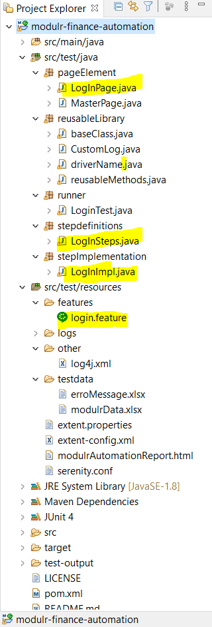
- Login scenarios are written using below combination of users
  - Sandbox user
  - Developer user
  - Direct Customers
  - Partners
  - Delegates
- Login Scenarios are
  - Valid Credentials
  - Incorrect UserName
  - Incorrect Password
  - Blank UserName & Password
  - Blank UserName
  - Blank Password
  - SignIn button Disable(Double Login)
  - Reset Password
  - Warning message to lock account for multiple incorrect passwords
- These test cases can be executed on different environment at same time by just changing value from Properties file (Customizable in framework).
  - Sandbox (URL : https://secure-sandbox.modulrfinance.com/)
  - dev1 (URL : https://secure-dev.modulrfinance.com/ )
  - test1 (URL : https://secure-test.modulrfinance.com/)
- Tags are added in runner file to execute number of test cases based on purpose of testing.
  - MF-01 tag is used to test login feature for all combination of users during story testing.
  - Smoke/Sanity : This tag will be used only to test major functionalities due to small change in code
  - Regression: This tag will be used to include scenarios which are must for regression testing of application.
Detailed code is available in separate file attached with solution [login.feature]
Sample Screens:
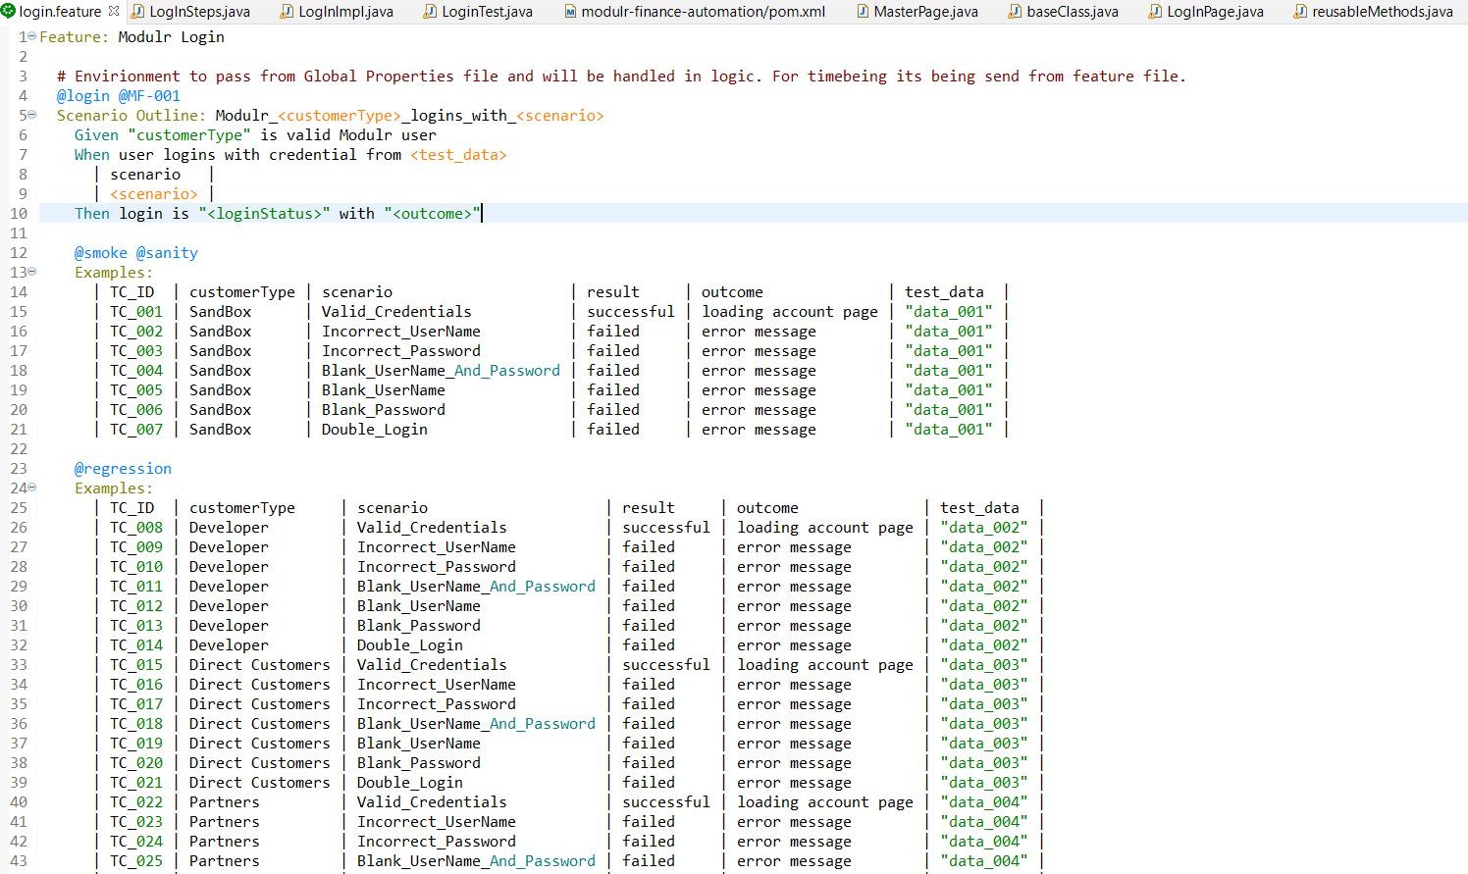

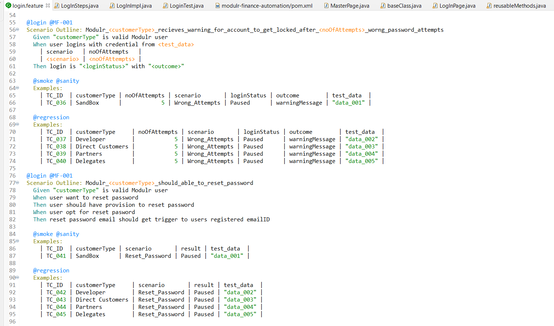

Step Definition/Implementation (Login)
- Step Definition
Feature file will be glue to step definition where we will have the implementation of user behaviour. These will have detailed implementation under respective implementation file.
Detailed code for login is available in separate file attached with solution [LogInSteps.java]
Sample Screenshot from Editor:
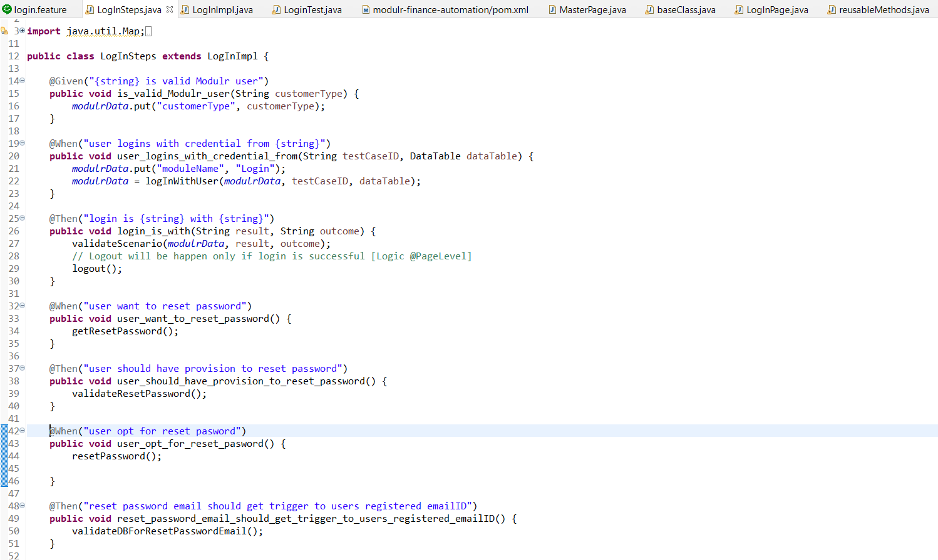
- Step Implementation:
Step Implementation consist of detailed logic with all validation check and database validations.
Detailed code for login is available in separate file attached with solution [LogInImpl.java]
Sample Screenshot from Editor:
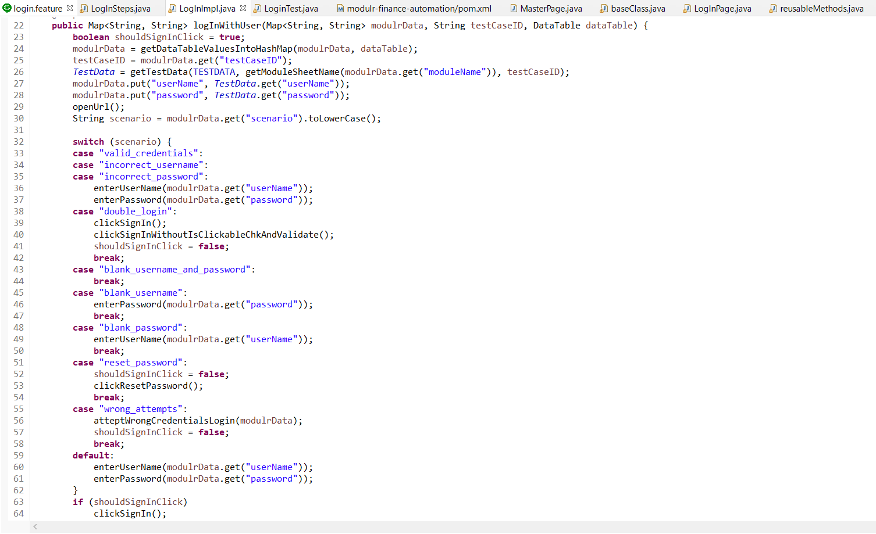

- Page Objects
This folder will have repository of all the page elements along with actions on these elements. We have used methods provided in serenity framework which is on top of selenium, to have additional in-built methods and features.
Detailed code for login is available in separate file attached with solution [LogInPage.java]
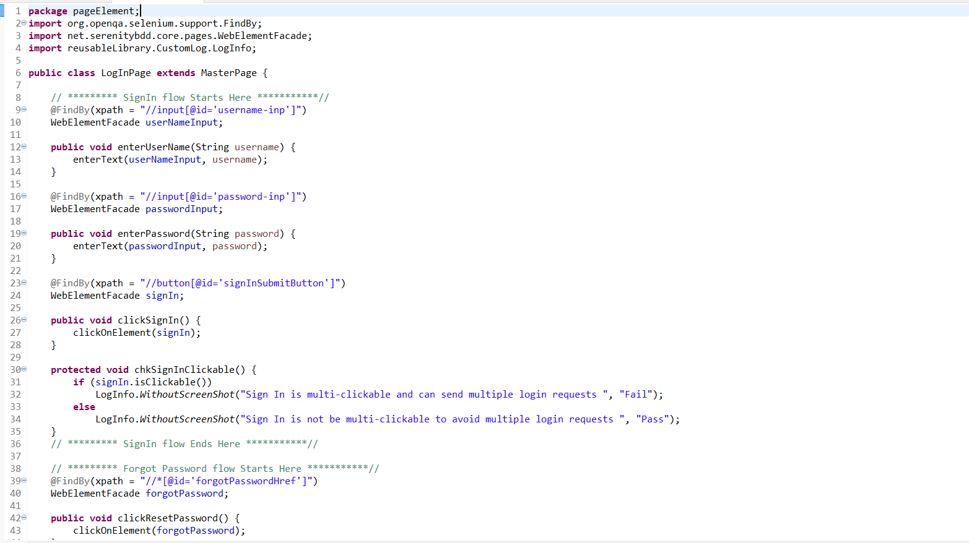

- Reusable Library
Reusable library will have methods that are used across framework and common everywhere.
E.g.
- Before performing any action on element check if it’s available on screen.
- Logger to add custom messages on automation reports.

Flow will be like
Runner Feature File Step Definition Step Implementation Page Object Reusable Library Base Class

- Customized Solution
This solution implemented has feature to rerun automation for any test environment just changing some config parameters from excel
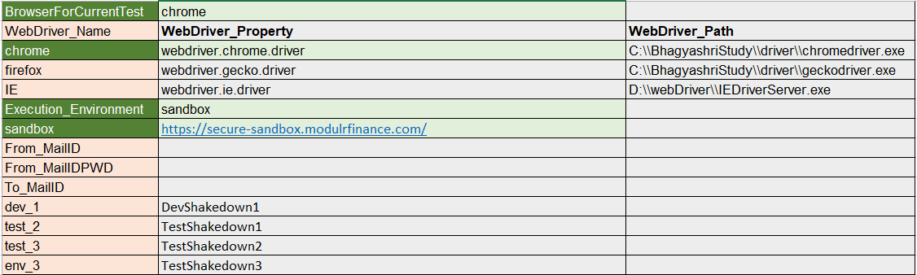

Login API Calls and analysis

Login API
Using sandbox account I am able to login into Modulr web and able to locate endpoints from Network tab of browser that got triggered one after the other.
Sr Num | API | URI
1 | Authenticate | https://api-sandbox.modulrfinance.com/api-sandbox/security-service/authenticate
2 | MFAStatus | https://api-sandbox.modulrfinance.com/api-sandbox/security-service/mfastatus/e71531a-84b44e853446-03e61a-99a72f0
3 | Customers | https://api-sandbox.modulrfinance.com/api-sandbox/customers?
4 | Direct Debit | https://api-sandbox.modulrfinance.com/api-sandbox/accounts?identifierType=DD
5 | Accounts | https://api-sandbox.modulrfinance.com/api-sandbox/accounts?page=0&size=15&sortField=id&sortOrder=asc&q=
6 | Revoke | https://api-sandbox.modulrfinance.com/api-sandbox/security-service/revoke
7 | Audit | https://api-sandbox.modulrfinance.com/api-sandbox/audits

Detailed analysis with below data point for authentiction are added in attached excel with this document–
  - URI
  - Request Header
  - Body Payload
  - Response
  - Logic of sharing token and algorithm used as public & private encryption.
API Details is available in separate file attached with solution [API_And_ScenarioSheet.xlsx]

Additional API’s
Along with sign In API, I went through below additional endpoints to get brief idea about Modulr API (URI/Header/Payload)

APIs | EndPoints
AccessGroup | 4
account-name-check | 1
Accounts | 8
Address Lookup | 1
Async | 1
Beneficiaries | 3
Cards | 14
Customers | 4
Direct Debit Outbound | 3
Direct Debits | 8
File Upload | 3
Inbound payments | 1
Notifications | 5
Payments | 4
PISP Service | 3
Rules | 5
Transactions | 1
Authentication | 4
Grand Total | 73

Supporting Skills
- Skills matching with Job description
  - Manual/Functional Testing
    - Writing test scenarios/test cases and executing them on different browsers/mobile devices.
    - Reporting findings in test management tool(Jira) and track till closure
  - Automation
    - Develop/Customize framework for API/GUI automation
    - Create/update/execute automation scripts in Java / Java Script using developed automation framework.
    - Git/GitHub as version control
    - Basic knowledge on Jenkins
  - Supporting skills
    - Good in Problem solving, proactive
    - Can work under pressure in strict timelines
    - Good team player
    - Worked in agile projects
    - Good at creating documentations

Framework Developed
- CodeElan/STA(Eleaos) BDD framework (Java + Selenium +Cucumber+Maven+Reporting)
[API + GUI]
- Demo JS BDD framework (Protractor + HTML reporting)
- Test Data driven framework using SoapUI (CountryInfo Service)
- Hybrid framework using SoapUI (CountryInfo Service)
- Used SpringBoot framework to customise Student API (Get/POST/PUT/Delete) for AT

It would be great opportunity for me if requested for demo. Happy to arrange demo and detailed walkthrough on this automation activity.

My Skillsets
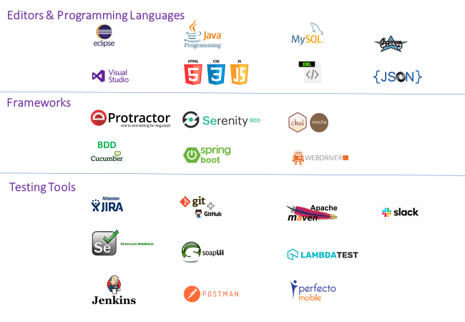

References/ Recommendations:
Based on request happy to share references.

