**Integration with Jenkins**

Following steps were followed to integrate the project with Jenkins:

**Step 1**: Run the command “java -jar jenkins.war --httpPort=8088” where .war file is located.

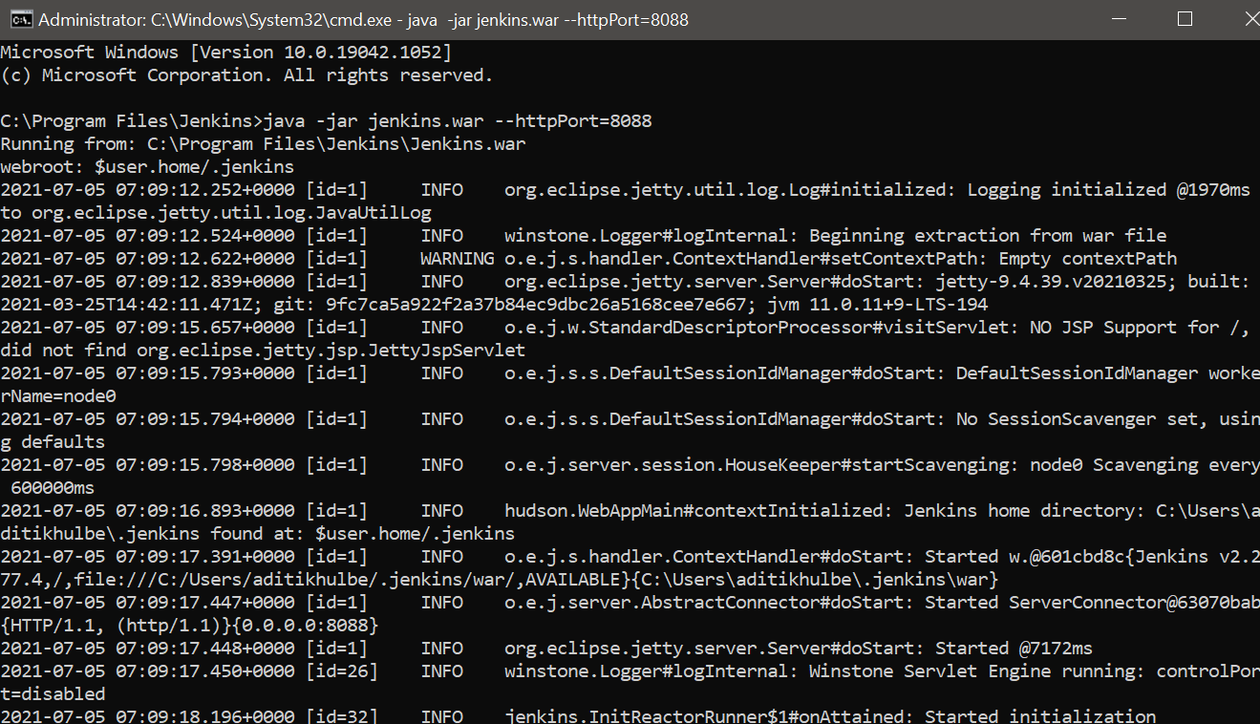

**Step 2*:*** Open localhost:8088 on browser and enter the username and password.

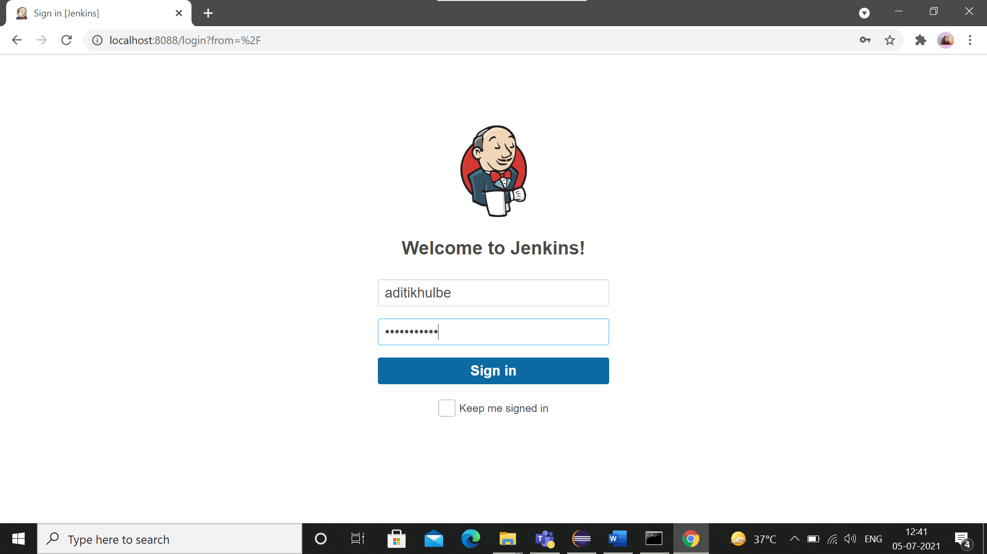

**Step 3:** Click on the project.

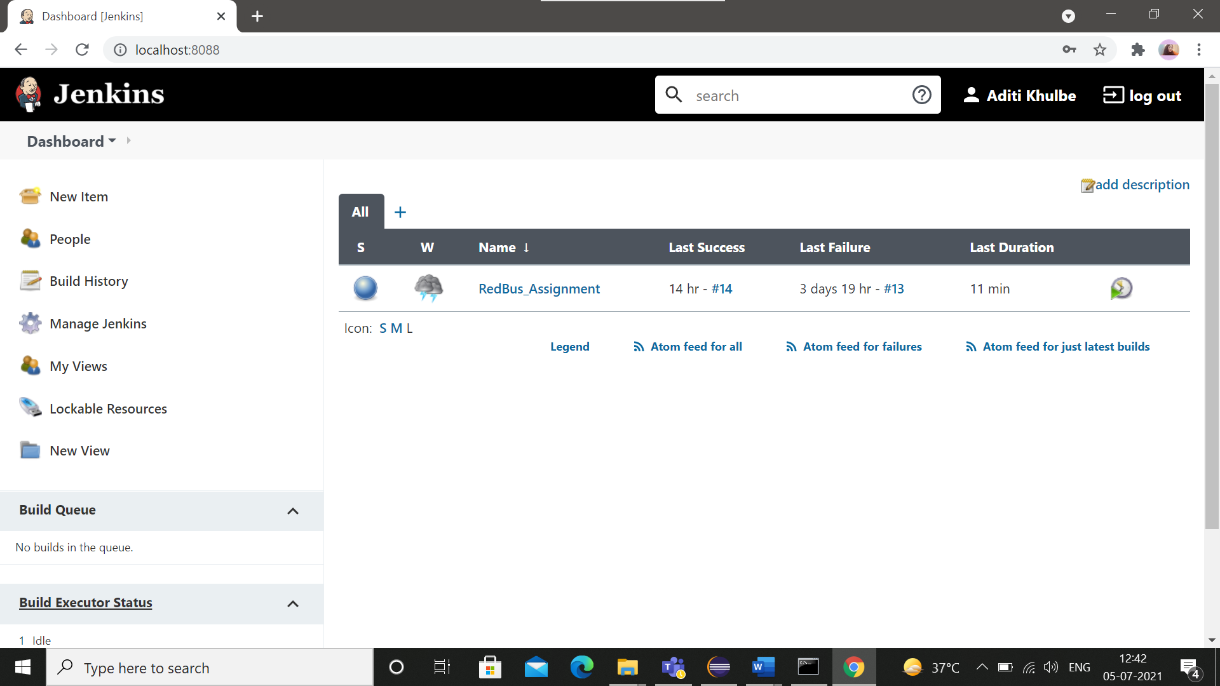

**Step 4:** Click on Build Now.

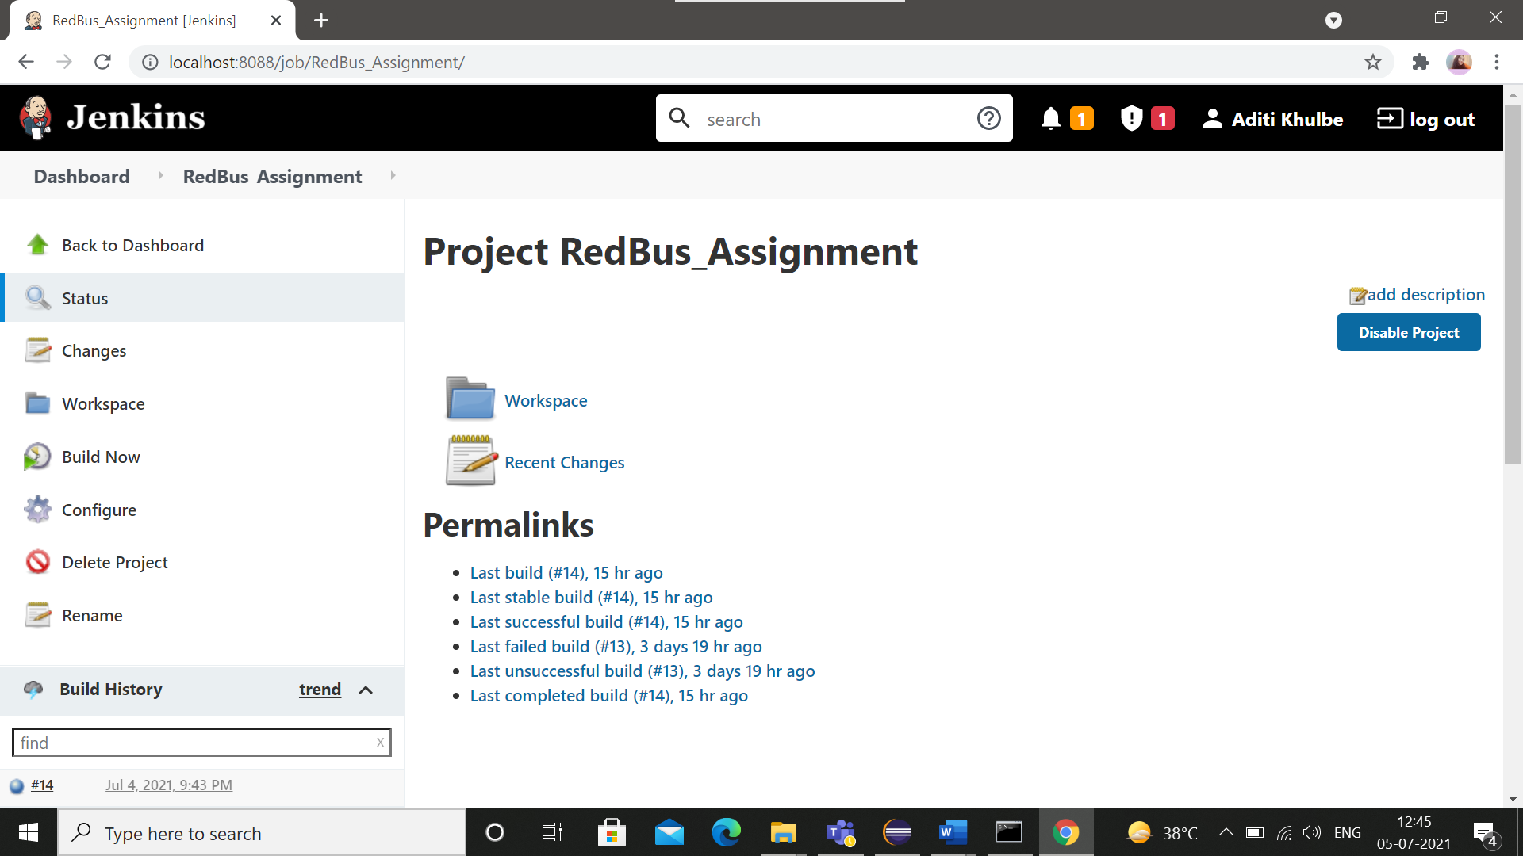

**Step 5:** After the Build is completed, the output can be seen in the console as follows:

