WEEK 2 TASK
SYSTEM ARCHITECTURE DESIGN
AND MODULE BREAKDOWN
Project: Student Task Management System
Prepared by: Aditi Mishra
Course: B.Tech – Computer Science and Engineering
Institution: Jaipur National University
Task: System Architecture Planning
Date: 22 October 2026

Executive Summary
This report proposes a high-level architecture for a hypothetical Student Task Management System. The system helps students organize academic tasks, set deadlines, track progress, and receive reminders. The design separates the user interface, application/API layer, business logic, data access, database, and external integrations. This separation reduces dependency between components and makes the application easier to develop, test, secure, and extend.
The proposed first version uses a modular monolithic architecture. It keeps deployment simple for a small team while preserving clear module boundaries so individual components can later be separated into services if scale or organizational needs justify it. The report describes the system context, architecture diagram, module responsibilities, data flow, technology stack, security, testing, scalability, maintainability, risks, and implementation phases.

1. Introduction

1.1 Project Overview
The Student Task Management System is a web application for managing coursework, assignments, project milestones, and personal study tasks. Users can register or sign in, create tasks, assign due dates and priorities, update task status, and view a dashboard of upcoming and completed work. A notification integration can send reminders before deadlines.

1.2 Problem Statement
Students may keep deadlines across notebooks, messages, calendars, and learning platforms. This makes it easy to overlook due dates or lose track of progress. A central application provides one organized view of tasks and supports better planning.

1.3 Objectives
- Provide a simple interface for creating, viewing, updating, and deleting tasks.
- Allow users to organize tasks by subject, project, priority, and due date.
- Protect each user's data through authentication and authorization.
- Send optional reminders for upcoming deadlines.
- Use modular components that can be tested and improved independently.
- Support future growth without requiring a complete redesign.

2. Scope and Assumptions

2.1 Included in the Initial Scope
- User registration, login, logout, and profile management.
- Task creation, editing, deletion, status updates, and filtering.
- Dashboard showing pending, overdue, and completed tasks.
- Deadline reminders through an external email or notification provider.
- Basic audit events for important actions and operational errors.

2.2 Excluded from the Initial Scope
- Full learning-management functionality such as video classes and online examinations.
- Payments, subscription billing, and advertising.
- Complex institutional administration and grading workflows.
- Native Android/iOS applications; the initial interface is responsive web.

2.3 Assumptions
The application is intended initially for individual student accounts and a modest user population. Users have internet access and a modern browser. Notification delivery depends on the availability and configuration of the chosen provider. The design is technology-neutral in principle, although a recommended stack is specified below.

3. High-Level Architecture
The system follows a layered architecture with modular business services. The browser sends HTTPS requests to the API layer. The API validates requests and checks identity and permissions. Business services apply task-management rules. The data-access layer reads and writes persistent records in the relational database. When a reminder is required, the integration layer communicates with an email or notification provider.
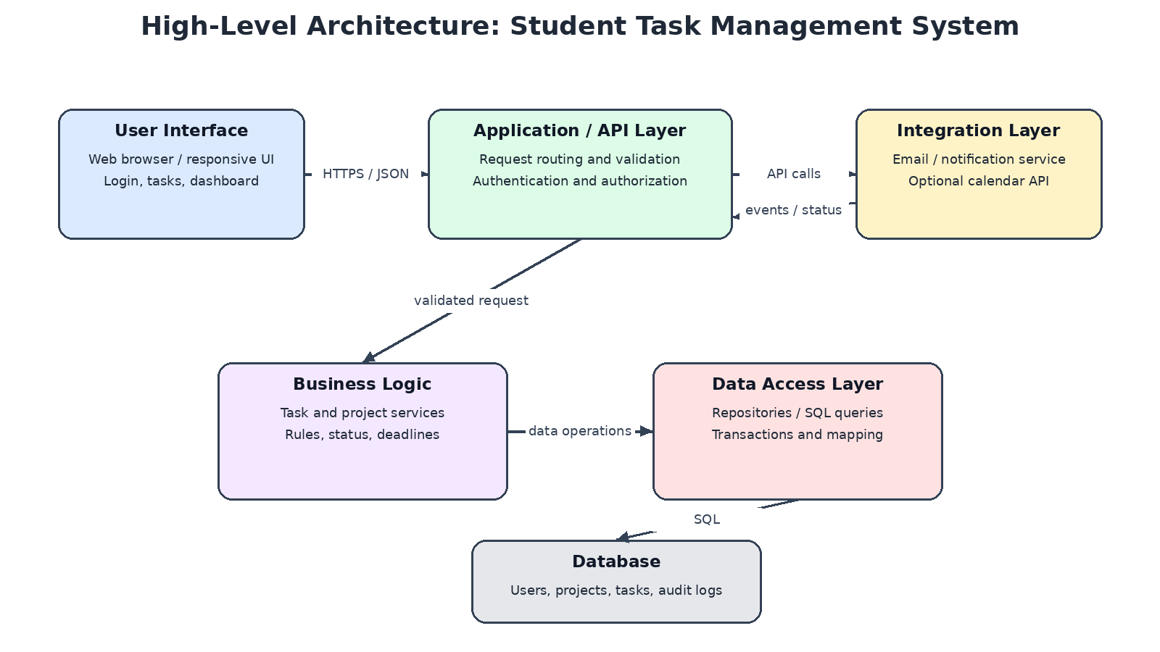
Figure 1. High-level architecture and primary communication paths.

3.1 Architectural Style
A modular monolith is recommended for the first release. All application modules are deployed as one application, but each module has a clear responsibility and a defined interface. This approach avoids the operational overhead of multiple microservices while preserving the option to extract high-demand modules later. The design uses separation of concerns, low coupling, high cohesion, and a layered flow of dependencies.

3.2 Main Components
- User Interface: pages, forms, task lists, dashboard, and client-side feedback.
- Application/API Layer: request routing, input validation, authentication checks, and response formatting.
- Business Logic Layer: task rules, deadline handling, permissions, and workflow decisions.
- Data Access Layer: database queries, repository methods, transactions, and record mapping.
- Database: durable storage for users, tasks, projects, preferences, and audit events.
- Integration Layer: communication with external email or notification services.

4. Module Breakdown

4.1 User Interface Module
Responsibilities: render responsive pages; collect user input; display task lists, filters, and status; show validation messages and loading/error states.
Inputs: user actions, API responses, filter values, form data.
Outputs: HTTPS API requests and visible screens or messages.
Communication: calls the API through a typed client; it does not connect directly to the database.
Suggested technology: HTML, CSS, JavaScript, and React. React supports reusable UI components, while standard web technologies provide browser compatibility.

4.2 Authentication and User Module
Responsibilities: registration, login, logout, password-reset workflow, session/token handling, and user-profile management.
Inputs: credentials, profile updates, authentication tokens or session cookies.
Outputs: authenticated identity, access decisions, profile data, and safe error responses.
Communication: API middleware verifies identity; business services receive a trusted user identifier and enforce ownership rules.
Suggested technology: a mature authentication library, secure cookie/session support or short-lived tokens, and a password-hashing library. Avoid storing plain-text passwords.

4.3 Task Management Module
Responsibilities: create, read, update, and delete tasks; manage priority, subject, status, and due date; filter and sort tasks.
Inputs: task form fields, task identifiers, current user identity, and requested changes.
Outputs: task records, validation errors, and updated task status.
Communication: receives validated API requests, applies task rules, and calls the data-access repositories.
Suggested technology: a server-side application framework such as Django or Express.js. The team should choose one framework and keep business rules out of the UI.

4.4 Dashboard and Reporting Module
Responsibilities: summarize pending, completed, and overdue tasks; provide useful filters and progress indicators.
Inputs: authenticated user ID, date range, filter settings, and task records.
Outputs: dashboard counts, grouped lists, and progress summaries.
Communication: calls task/query services and receives aggregated data; it does not bypass business services to query the database directly.
Suggested technology: reusable UI components and server-side aggregation queries. Keep calculations consistent and testable.

4.5 Reminder and Notification Module
Responsibilities: identify tasks approaching their deadlines, prepare reminder messages, and record delivery attempts.
Inputs: due dates, notification preferences, recipient address, and provider response.
Outputs: queued reminder jobs, delivery status, and retry/error records.
Communication: receives events or scheduled work from the application and calls the external provider through an adapter.
Suggested technology: a scheduled worker or task queue and an email provider API. Use retries with limits and avoid sending duplicate reminders.

4.6 Data Access Module
Responsibilities: encapsulate database queries, transactions, filtering, and mapping between database rows and application objects.
Inputs: repository method calls and validated parameters from business services.
Outputs: records, result sets, success/failure outcomes, and transaction results.
Communication: only this layer communicates directly with the database; it returns data to business services.
Suggested technology: an ORM such as Django ORM or Prisma, or parameterized SQL. Use migrations to track schema changes.

4.7 Integration Module
Responsibilities: isolate external provider APIs, translate internal requests into provider formats, handle timeouts, and normalize provider responses.
Inputs: notification payloads and configuration secrets.
Outputs: normalized success/failure results and provider message identifiers where available.
Communication: called by the reminder module through an interface so providers can be replaced without changing task rules.
Suggested technology: HTTPS REST APIs, environment-based configuration, timeouts, and retry policies.

4.8 Logging, Monitoring, and Error Handling Module
Responsibilities: capture structured application events, record unexpected errors, expose health checks, and help diagnose failures.
Inputs: request IDs, error details, performance measurements, and module events.
Outputs: logs, operational alerts, and health status.
Communication: used across layers through a shared logging interface; secrets and passwords must never be logged.
Suggested technology: structured logs and platform monitoring tools. In production, restrict access and define log retention.

5. Inter-Module Communication and Data Flow

5.1 Example: Creating a Task
- The student opens the task form and enters a title, subject, priority, and due date.
- The UI sends an HTTPS POST request to the API with the form data.
- The API checks the session or token, validates the request format, and confirms the user is authorized.
- The Task Management service checks business rules, such as required title and valid due date.
- The Data Access module saves the task in the database within a transaction.
- The API returns a success response and the UI updates the task list.
- If reminders are enabled, the system schedules reminder work for the due date.

5.2 Example: Sending a Reminder
- A scheduled worker finds tasks whose reminder time has arrived and that have not already been processed.
- The worker checks the user's notification preference and task status.
- The Reminder module creates a message and passes it to the Integration module.
- The Integration module calls the provider using a protected API credential and a timeout.
- The provider response is normalized and the attempt is recorded.
- Temporary failures may be retried using a bounded backoff policy; permanent failures are logged for review.

5.3 Communication Rules
- Use HTTPS for client-to-server communication.
- Use documented API request and response formats, with consistent error codes.
- Do not let the UI access database tables directly.
- Keep external provider-specific code inside the Integration module.
- Use transactions for operations that update multiple related records.
- Use asynchronous jobs for work that should not delay the user's request.

6. Data Design
A relational database is suitable because users, tasks, projects, and reminders have structured relationships and require reliable updates. A starter data model is shown below; exact columns can be refined during implementation.
Entity | Example fields | Purpose
User | user_id, name, email, password_hash, created_at | Account identity and preferences
Project / Subject | project_id, user_id, name, description | Groups tasks by subject or project
Task | task_id, user_id, project_id, title, due_at, priority, status | Stores task details and progress
Reminder | reminder_id, task_id, scheduled_at, status, attempt_count | Tracks scheduled notifications
Audit Event | event_id, user_id, event_type, created_at, request_id | Supports diagnosis and accountability
Primary keys uniquely identify records. Foreign keys connect tasks to their owner and optional project. Indexes should be considered for user_id, due_at, status, and common filter combinations. Passwords must be stored as strong password hashes, never as plain text. Database migrations should be version-controlled.

7. Recommended Technology Stack
The stack below is a practical recommendation rather than a mandatory requirement. One consistent backend framework should be selected for implementation; the alternatives listed are options, not technologies that must all be used.
Layer | Recommended choice | Rationale
Frontend | HTML, CSS, JavaScript, React | Responsive interfaces and reusable components.
Backend/API | Python with Django REST Framework OR Node.js with Express | Both can expose REST APIs; choose one based on team familiarity.
Database | PostgreSQL | Relational integrity, transactions, indexing, and mature tooling.
Data access | Django ORM or Prisma/parameterized SQL | Centralizes queries and supports schema migrations.
API format | REST over HTTPS with JSON | Simple, widely supported client-server communication.
Notifications | Email provider API plus scheduled worker | Keeps reminder delivery separate from interactive requests.
Testing | Unit tests, API integration tests, browser-based end-to-end tests | Covers rules, component interactions, and critical user journeys.
Version control / CI | Git and GitHub Actions | Change history and repeatable automated checks.
Deployment | Container or managed application platform | Consistent environments and a path to horizontal scaling.

8. Security and Privacy
- Authentication: use a trusted framework and secure session/token handling.
- Authorization: check task ownership on every read, update, and delete request.
- Password protection: hash passwords using a modern, dedicated password-hashing algorithm.
- Transport security: use HTTPS in deployed environments.
- Input validation: validate types, lengths, dates, identifiers, and allowed status values on the server.
- Database safety: use an ORM or parameterized queries to reduce SQL injection risk.
- Secrets management: keep API keys and database credentials out of source code; use environment or secret-management facilities.
- Privacy: collect only necessary personal data and restrict log access.
- Abuse prevention: add rate limits to login and sensitive endpoints where appropriate.
- Backups: schedule backups and periodically test restoration.

9. Scalability and Performance
The initial modular monolith can support early growth by optimizing database queries, adding indexes, caching frequently requested non-sensitive summaries where appropriate, and serving static assets through a suitable delivery layer. The API can be run on multiple application instances behind a load balancer if demand increases, provided session state and files are not tied to a single instance.
- Keep application instances stateless where practical.
- Use pagination for long task lists rather than returning every record.
- Move reminders and other slow work to background workers.
- Monitor request latency, error rate, database load, and job queue depth.
- Use database connection pooling and review slow queries.
- Scale the database and worker capacity based on measured bottlenecks.
- Extract a module into a separate service only when independent scaling, ownership, or reliability needs justify the added complexity.

10. Maintainability and Testability
Clear module boundaries allow a developer to change one component without unnecessarily affecting others. For example, the email provider can be changed behind the Integration interface, while task-management rules remain unchanged. A consistent code style, code review, API documentation, and version-controlled database migrations improve long-term maintainability.

10.1 Testing Strategy
- Unit tests: verify task validation, due-date rules, status transitions, and permission logic.
- Integration tests: verify API-to-service and service-to-database behavior.
- Contract tests: verify that external integration adapters handle expected provider responses.
- End-to-end tests: test registration/login, creating a task, editing it, and viewing it on the dashboard.
- Security tests: check unauthorized access, invalid input, and exposure of sensitive information.
- Regression tests: rerun critical tests after each change.

10.2 Development Practices
- Keep modules cohesive and avoid circular dependencies.
- Use descriptive names, small functions, and documented public interfaces.
- Maintain a README with setup instructions and environment variables.
- Use Git branches and pull requests for reviewed changes.
- Automate formatting, linting, and tests in continuous integration.

11. Reliability, Risks, and Mitigations
Risk | Potential impact | Mitigation
External notification provider unavailable | Reminders may be delayed | Queue jobs, bounded retries, failure logging, and provider adapter.
Incorrect authorization check | A user could access another user's task | Enforce ownership in business services and test negative cases.
Slow database queries | Dashboard and task lists become slow | Indexes, pagination, query analysis, and monitoring.
Unvalidated user input | Invalid data or security vulnerabilities | Server-side validation and parameterized queries.
Scope expansion | Schedule and quality may suffer | Prioritize MVP features and review change requests.
Lost or corrupted data | Tasks may become unavailable | Automated backups and tested restore procedures.

12. Implementation Roadmap
- Phase 1 – Requirements: confirm user stories, acceptance criteria, and non-functional requirements.
- Phase 2 – Foundation: create repository, configure environment, establish database schema, and implement authentication.
- Phase 3 – Core tasks: implement task CRUD operations, validation, filters, and dashboard summaries.
- Phase 4 – Notifications: add scheduled reminder processing and an integration adapter.
- Phase 5 – Quality: complete unit, integration, end-to-end, and security tests.
- Phase 6 – Deployment: configure production secrets, HTTPS, monitoring, backups, and deployment documentation.
- Phase 7 – Review: collect feedback, prioritize improvements, and plan future releases.

13. Conclusion
This report defines a practical, layered architecture for a Student Task Management System. Separating the interface, API, business logic, data access, database, and integrations creates a clear flow of responsibility. A modular monolith is a suitable starting point because it is easier to deploy and operate than a distributed microservice system while still supporting independent module development and testing. Security, data integrity, observability, and testing are built into the design rather than treated as last-minute additions. As usage grows, measured bottlenecks can guide caching, worker scaling, database optimization, and—if justified—service extraction. The proposed design therefore provides a maintainable foundation for future implementation.

14. Public References
- React documentation, “Quick Start”: https://react.dev/learn
- Django documentation: https://docs.djangoproject.com/
- PostgreSQL documentation: https://www.postgresql.org/docs/
- OWASP Cheat Sheet Series: https://cheatsheetseries.owasp.org/
- MDN Web Docs, HTTP overview: https://developer.mozilla.org/en-US/docs/Web/HTTP/Overview
- Git documentation: https://git-scm.com/doc
- GitHub Actions documentation: https://docs.github.com/en/actions
- The Twelve-Factor App: https://12factor.net/
Reference note: These public documentation sources provide implementation guidance for the technologies and practices discussed. The architecture and project-specific design in this report are a proposed design for a hypothetical application.

