Walchand College of Engineering, Sangli Department of Computer Science and Engineering

Batch T1
Assignment No. 1
Title: Sorting Algorithm
Student Name: Aditi Mittal
Student PRN: 23610067

Problem Statement #1:

You are given two sorted array, A and B, where A has a large enough buffer at the end to hold B. Write a method to merge B into A in sorted order.
- Technologies/libraries/algorithm used
2 pointer approach

- Related theory or any related information you want to add
The challenge is to merge the two sorted arrays in-place, without using extra space for another array. Our intuition might suggest starting from the beginning of both arrays and comparing the elements one by one. However, this approach would require shifting elements in A to make space for elements from B, which is not efficient.
To efficiently merge these arrays, we leverage the fact that we have empty space at the end of A where n zeros are placed. This allows us to fill A from the end (right to left), placing the largest elements first and avoiding the need for shifting.
Time Complexity – O(m+n)

- Algorithm / procedure
Use three pointers and fill from end to start to avoid overwriting and unnecessary shifting.
- Initialize pointers:
  - i = m - 1: points to the last valid element in A.
  - j = n - 1: points to the last element in B.
  - k = m + n - 1: points to the end of A, where the merged elements go.
- While both arrays have elements (i ≥ 0 and j ≥ 0):
  - Compare A[i] and B[j].
  - Place the greater of the two at A[k].
  - Decrement the pointer(s) accordingly.
- If B still has elements left, copy them:
  - While j ≥ 0: set A[k--] = B[j--].
- If A still has elements, no action needed—they're already in correct spots.
Code:
#include <iostream>
#include <vector>
using namespace std;
void merge_sorted_arrays(vector<int>& A, const vector<int>& B, int m, int n) {
int ptrA = m - 1;
int ptrB = n - 1;
int ptr_merged = m + n - 1;

while (ptrB >= 0) {
if (ptrA >= 0 && A[ptrA] > B[ptrB]) {
A[ptr_merged] = A[ptrA];
ptrA--;
} else {
A[ptr_merged] = B[ptrB];
ptrB--;
}
ptr_merged--;
}
}

int main() {
int m, n;
cout << "Enter number of elements in A (excluding buffer): ";
cin >> m;
cout << "Enter number of elements in B: ";
cin >> n;
vector<int> A(m + n);
vector<int> B(n);
cout << "Enter " << m << " elements of sorted array A:" << endl;
for (int i = 0; i < m; i++) {
cin >> A[i];
}
cout << "Enter " << n << " elements of sorted array B:" << endl;
for (int i = 0; i < n; i++) {
cin >> B[i];
}
merge_sorted_arrays(A, B, m, n);
cout << "Merged array A: ";
for (int val : A) {
cout << val << " ";
}
return 0;
}
- Screenshots of the output according to the problem statements

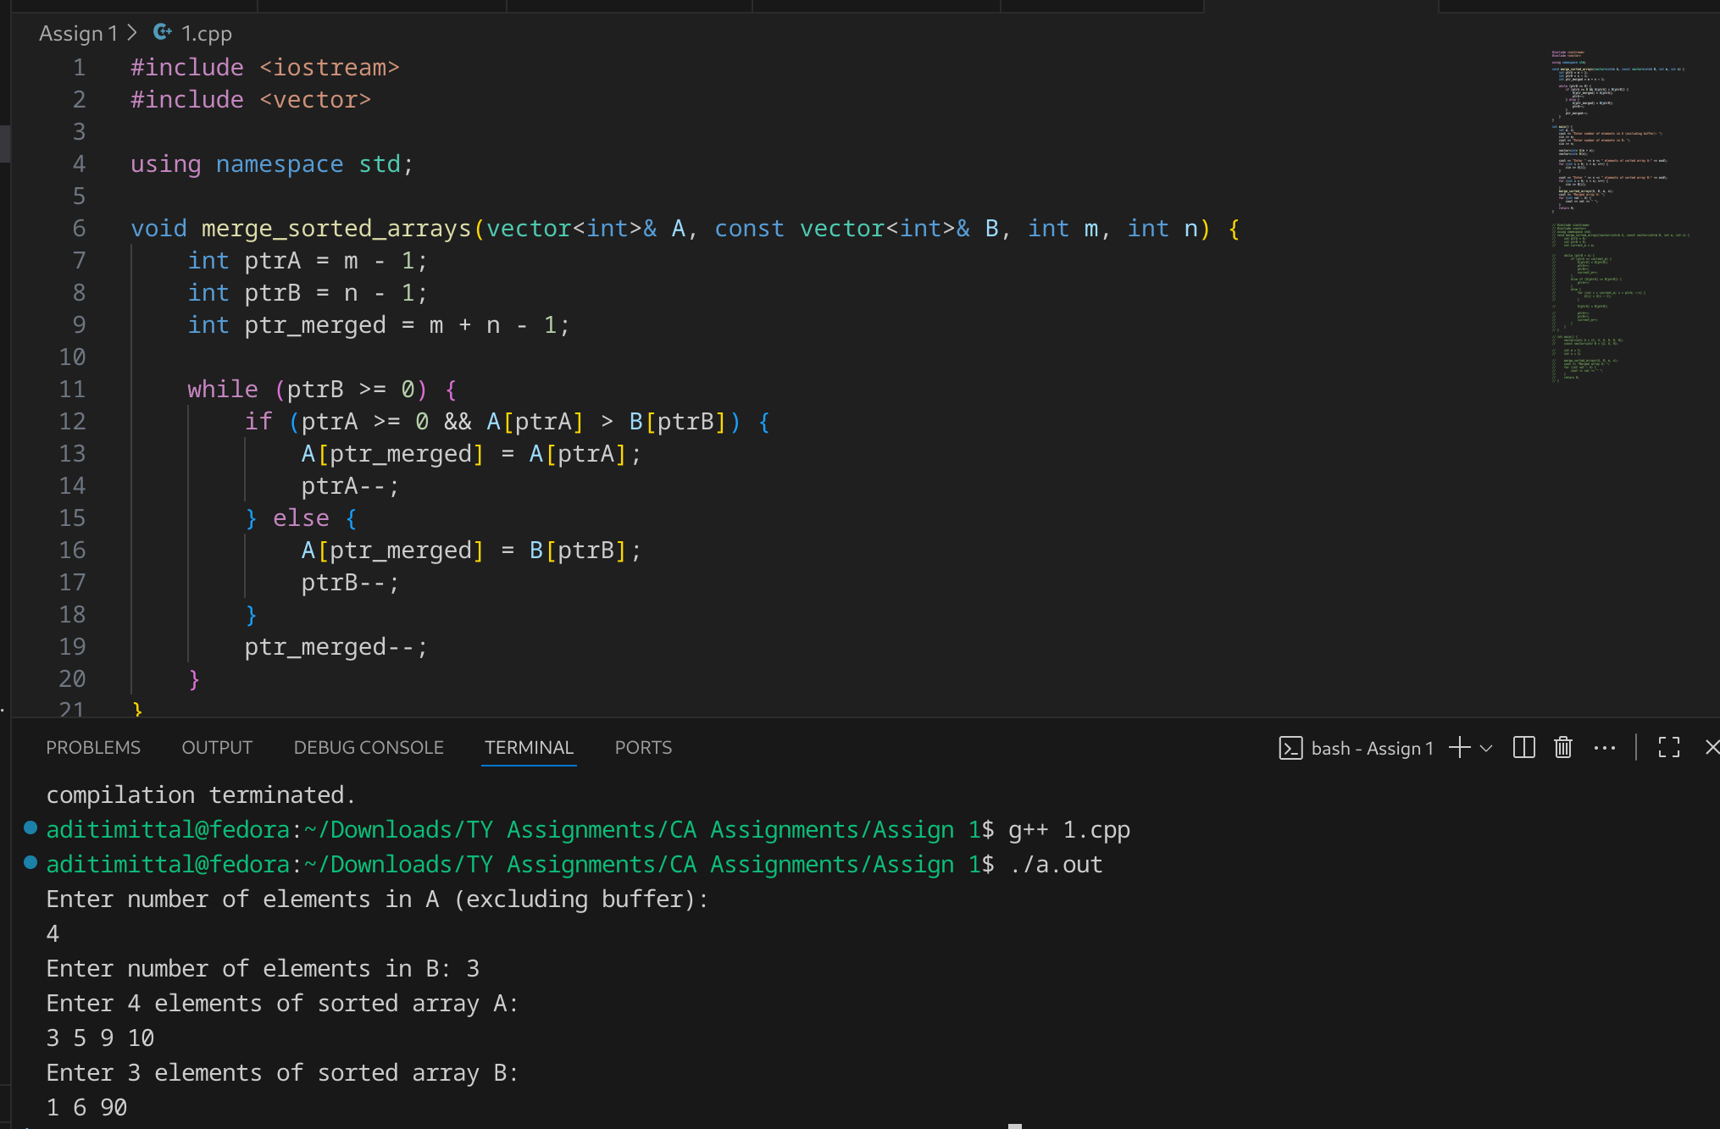
- Source: https://algo.monster/liteproblems/88

Problem Statement #2:

Write a method to sort an array of string so that all the anagrams are next to each other
- Technologies/libraries/algorithm used
Vectors, sort function (algorithm library), map
- Related theory or any related information you want to add
Anagrams are words which comprise of the same letters but in different order to generate different words.
eg. “silent”, “lentsi” , “ilents” etc.
- Algorithm / procedure
Here we create a function sort_anagrams where we first store the original string in a copy variable. We then sort the string so that all anagrams now have the same sorted string. We next store all the words that produce the same sorted string in a map of key: string of sorted word and value: a vector consisting of all anagrams that can be made from letters of this sorted word. We then iterate through the dictionary and pushback all the anagrams in a result vector this brings all anagrams together.
function sort_anagrams(arr):
anagram_groups = map<string, list of strings>

for each word in arr:
key = sort_characters(word)
append word to anagram_groups[key]

result = empty list of strings
for each group in anagram_groups:
for each word in group.value:
add word to result

return result

- Code:
#include <iostream>
#include <vector>
#include <string>
#include <map>
#include <algorithm>

using namespace std;

vector<string> sort_anagrams(vector<string>& arr) {
map<string, vector<string>> anagram_groups;

for (int i = 0; i < arr.size(); i++) {
string sorted_s = arr[i];
sort(sorted_s.begin(), sorted_s.end());
anagram_groups[sorted_s].push_back(arr[i]);
}

vector<string> result;
for (const auto& pair : anagram_groups) {
for (const string& s : pair.second) {
result.push_back(s);
}
}

return result;
}

int main() {
vector<string> words = {"listen", "silent", "hello", "world", "ehllo", "drwol", "apple", "pleap"};

vector<string> sorted_words = sort_anagrams(words);
cout << "Array after sorting anagrams:\n";
for (const string& word : sorted_words) {
cout << word << " ";
}
cout << endl;
}
- Screenshots of the output according to the problem statements
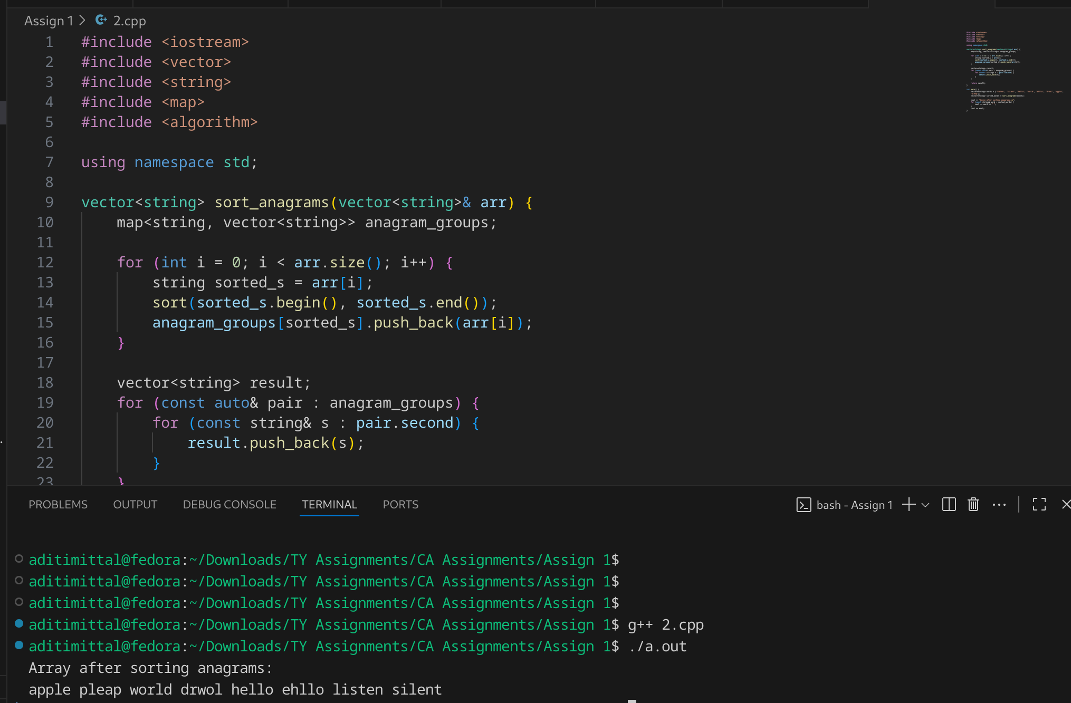

Problem Statement #3:

Given a sorted array of n integers that has been rotated an unknown number of times, write code to find an element in the array. You may assume that the array was originally sorted in increasing order.

EXAMPLE

Input: find 5 in {15, 16, 19, 20, 25, 1, 3, 4, 5, 7, 10, 14}

Output: 8 (the index of 5 in the array)
- Technologies/libraries/algorithm used
Binary Search with modification
- Related theory or any related information you want to add
In a rotated sorted array, at least one half (either left or right of the current middle) remains sorted.

Naive Approach Using Linear Search - O(n) Time and O(1) Space
A simple approach is to iterate through the array and check for each element, if it matches the target then return the index, otherwise return -1.

Using Binary Search Twice - O(log n) Time and O(1) Space
The main Idea is to first finds the index of the smallest element (pivot), which is also the number of rotations applied to the sorted array. Once the pivot is known, the array is split into two sorted subarrays.
- Algorithm / procedure
To find the target:
• First check the middle → if its the target, return it
• If not → figure out which half is sorted
• If the target lies inside that sorted half → search there
• Otherwise →go to the other side
Code:
#include <iostream>
using namespace std;

int find_in_rotated_array(int arr[], int n, int target) {
int low = 0, high = n - 1;

while (low <= high) {
int mid = low + (high - low) / 2;

if (arr[mid] == target) {
return mid;
}

// we assume here that the left half is sorted
if (arr[low] <= arr[mid]) {
if (target >= arr[low] && target < arr[mid]) {
high = mid - 1;
} else {
low = mid + 1;
}
}
// we assume here that the right half is sorted
else {
if (target > arr[mid] && target <= arr[high]) {
low = mid + 1;
} else {
high = mid - 1;
}
}
}

return -1;
}

int main() {
int n;
cout << "Enter number of elements: ";
cin >> n;

int arr[n];
cout << "Enter elements of the rotated sorted array:\n";
for (int i = 0; i < n; i++) {
cin >> arr[i];
}
// 15 18 2 3 6 12

int target;
cout << "Enter element to be searched: ";
cin >> target;

int index = find_in_rotated_array(arr, n, target);

if (index != -1) {
cout << target << " found at index " << index << endl;
} else {
cout << target << " not found in the array.\n";
}

return 0;
}
- Screenshots of the output according to the problem statements
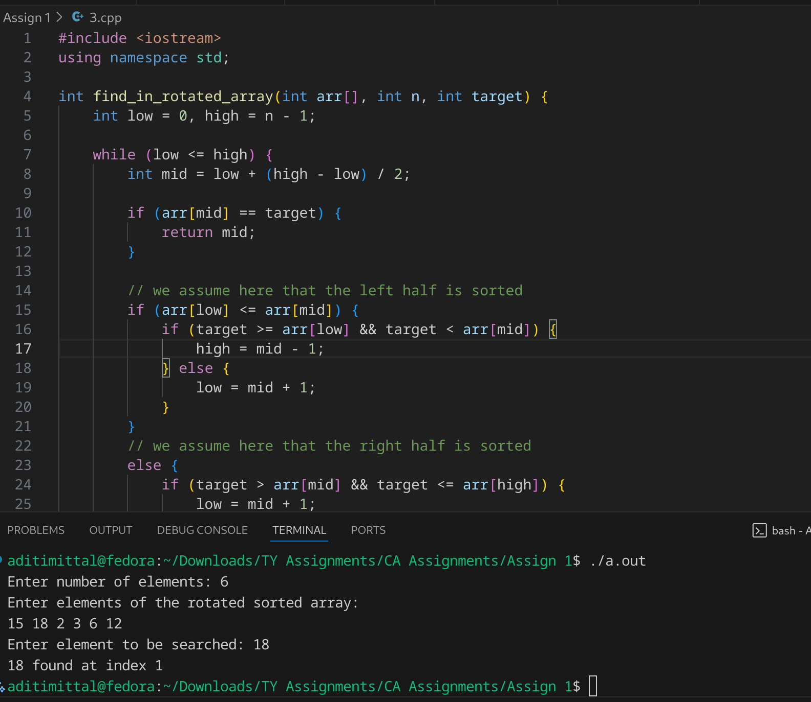
- Source https://leetcode.com/problems/search-in-rotated-sorted-array/description/
https://www.geeksforgeeks.org/dsa/search-an-element-in-a-sorted-and-pivoted-array/

Problem Statement #4:

Imagine you have a 20GB file with one string per line. Explain how you would sort the file.
- Technologies/libraries/algorithm used
External Merge Sort Algorithm
- Related theory or any related information you want to add
External sorting is a term for a class of sorting algorithms that can handle massive amounts of data. External sorting is required when the data being sorted does not fit into the main memory of a computing device (usually RAM) and instead, must reside in the slower external memory (usually a hard drive).
External sorting typically uses a hybrid sort-merge strategy. In the sorting phase, chunks of data small enough to fit in the main memory are read, sorted, and written out to a temporary file. In the merge phase, the sorted sub-files are combined into a single larger file.

When We do External Sorting?
- When the unsorted data is too large to perform sorting in computer internal memory then we use external sorting.
- In external sorting we use the secondary device
Time complexity will be O(N * log N).

Problem Statement #5:

Given a sorted array of string which is interspersed with empty string, write a method to find the location of a given string.

EXAMPLE

Input: find “ball” in {“at”, “”, “”, “ball”, “”, “”, “car”, “”, “”, “dad”, “”,””}

Output: 4
- Technologies/libraries/algorithm used
Binary search with modification to find mid such that it is a non empty string
- Related theory or any related information you want to add
We implement binary search here to find the index in Time Complexity of O(logn). We find the mid element and check if its greater than or less than the target element and accordingly check further in correct sorted half of the array. However to adjust for empty string elements as mid, we iterate left of and right of the mid element till we find a non empty string and name that as our new mid.
- Algorithm / procedure
function find_string(arr, target):

low ← 0
high ← length(arr) − 1

while low ≤ high:
mid ← low + (high − low) ÷ 2

if arr[mid] is empty:
left ← mid − 1
right ← mid + 1

// Find nearest non-empty string
while true:
if left < low AND right > high:
return -1 // no non-empty strings available

if left ≥ low AND arr[left] is not empty:
mid ← left
break

if right ≤ high AND arr[right] is not empty:
mid ← right
break

left ← left − 1
right ← right + 1

// normal binary search
if arr[mid] == target:
return mid
else if arr[mid] < target:
low ← mid + 1
else:
high ← mid − 1

return -1
Code
#include <iostream>
#include <vector>
#include <string>

using namespace std;

int find_string(const vector<string>& arr, const string& target) {
if (arr.empty()) {
return -1;
}

int low = 0;
int high = arr.size() - 1;

while (low <= high) {
int mid = low + (high - low) / 2;

if (arr[mid].empty()) {
int left = mid - 1;
int right = mid + 1;

while (true) {
if (left < low && right > high) {
return -1;
}
if (left >= low && !arr[left].empty()) {
mid = left;
break;
}
if (right <= high && !arr[right].empty()) {
mid = right;
break;
}
left--;
right++;
}
}

if (arr[mid] == target) {
return mid;
} else if (arr[mid] < target) {
low = mid + 1;
} else {
high = mid - 1;
}
}

return -1;
}

int main() {
vector<string> arr = {"at", "", "", "ball", "", "", "car", "", "", "dad", "", ""};
string target;

cout<< "The input array is: ";
for(int i=0 ; i<arr.size(); i++){
cout << arr[i]<< " ";
}
cout << endl;
cout << "Enter target string: " << target << endl;
cin>>target;

int index = find_string(arr, target);

if (index != -1) {
cout << "Index: " << index+1 << " \n";
} else {
cout << target << " not found in the array.\n";
}

return 0;
}
- Screenshots of the output according to the problem statements

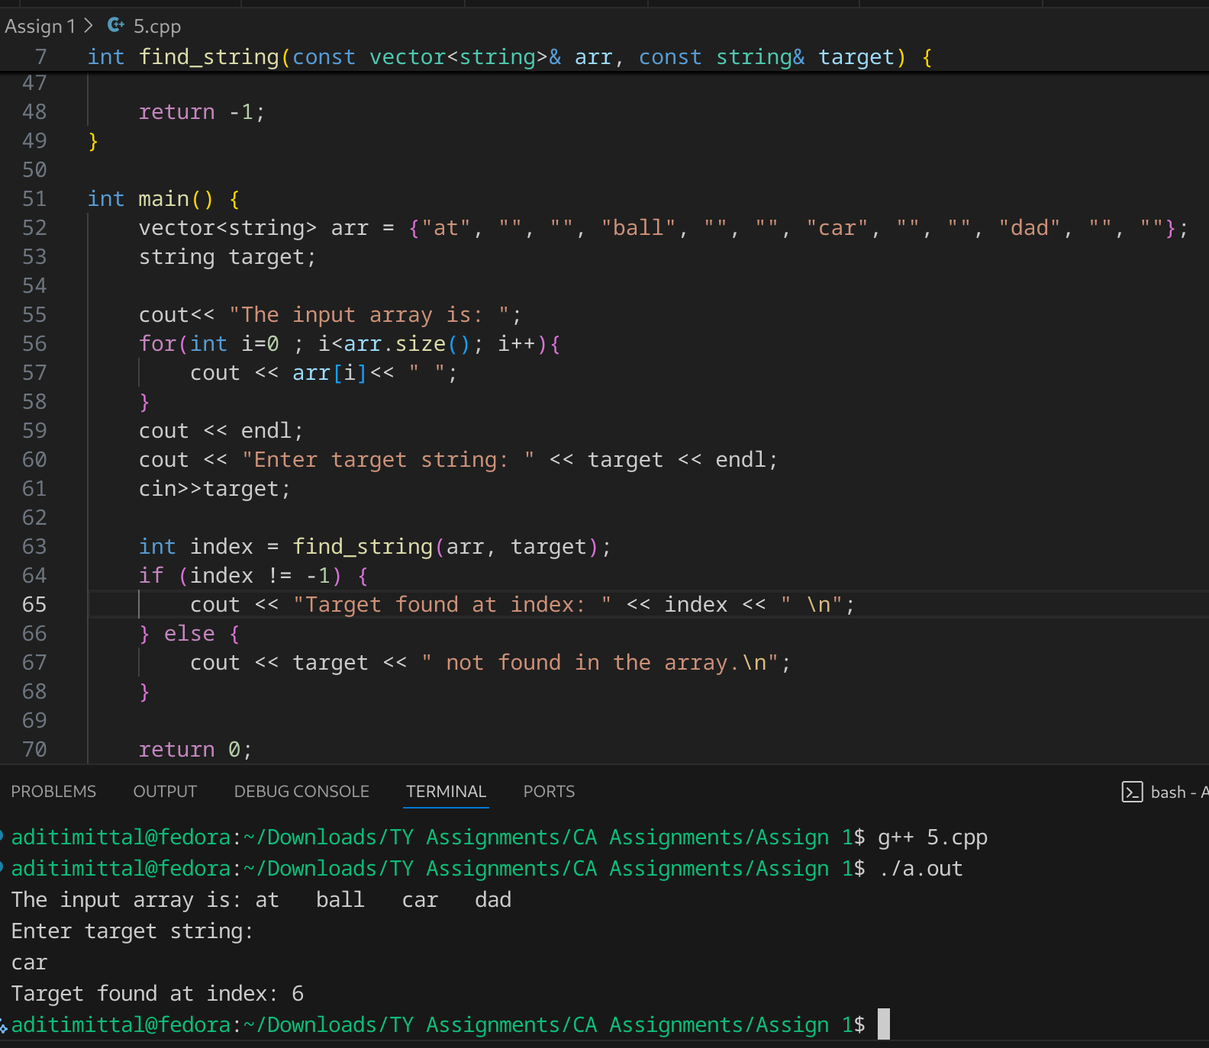

Problem Statement #6:
Given an M*N matrix in which each row and each column is sorted in ascending order, write a method to find an element.
- Technologies/libraries/algorithm used
Staircase algorithm
- Related theory or any related information you want to add

[Naive Approach] Comparing with all elements - O(n*m) Time and O(1) Space
The simple idea is to traverse the complete matrix and search for the target element. If the target element is found, return true. Otherwise, return false.

[Better Approach] Binary Search - O(n*logm) Time and O(1) Space:
To optimize the above approach we are going to use the Binary Search algorithm.
The problem specifies that each row in the given matrix is sorted in ascending order. Instead of searching each column sequentially, we can efficiently apply Binary Search on each row to determine if the target is present.

[Expected Approach] Eliminating rows or columns - O(n + m) Time and O(1) Space:
The idea is to remove a row or column in each comparison until an element is found. Start searching from the top-right corner of the matrix. There are 3 possible cases:
- x is greater than the current element: This ensures that all the elements in the current row are smaller than the given number as the pointer is already at the right-most element and the row is sorted. Thus, the entire row gets eliminated and continues the search from the next row.
- x is smaller than the current element: This ensures that all the elements in the current column are greater than the given number. Thus, the entire column gets eliminated and continues the search from the previous column, i.e. the column on the immediate left.
- The given number is equal to the current number: This will end the search.
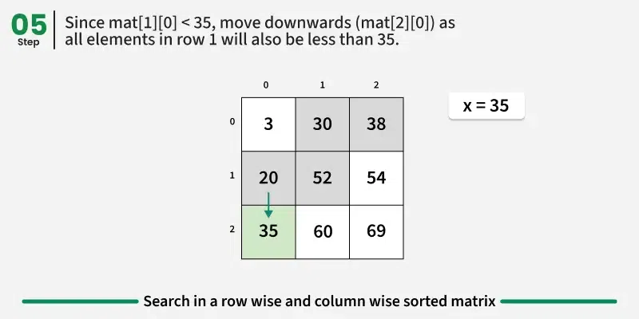
- Algorithm / procedure

function searchMatrix(matrix, rows, cols, target)
row = 0
col = cols - 1 // start from top right corner

while row < rows and col >= 0
if matrix[row][col] == target
print "element found at row =", row, ", col =", col
return
else if matrix[row][col] > target
col = col - 1 // move left
else
row = row + 1 // move down

print "element not found in the matrix"
end function

Code:
#include <iostream>
using namespace std;

void searchMatrix(int matrix[][100], int M, int N, int target) {
int row = 0, col = N - 1;
while (row < M && col >= 0) {
if (matrix[row][col] == target) {
cout << "Element " << target << " found at row=" << row << ", col=" << col << "\n";
return;
}
else if (matrix[row][col] > target) {
col--;
}
else {
row++;
}
}

cout << "Element " << target << " not found in the matrix.\n";
}

int main() {
int M, N;
cout << "Enter number of rows M: ";
cin >> M;
cout << "Enter number of columns N: ";
cin >> N;

int matrix[M][100];
// 1 4 7
// 2 5 9
// 3 6 10

cout << "Enter the matrix row by row:\n";
for (int i = 0; i < M; i++) {
for (int j = 0; j < N; j++) {
cin >> matrix[i][j];
}
}

int target;
cout << "Enter the element to search: ";
cin >> target;

searchMatrix(matrix, M, N, target);

return 0;
}
- Source: https://www.geeksforgeeks.org/dsa/search-in-row-wise-and-column-wise-sorted-matrix/
- Screenshots of the output according to the problem statements
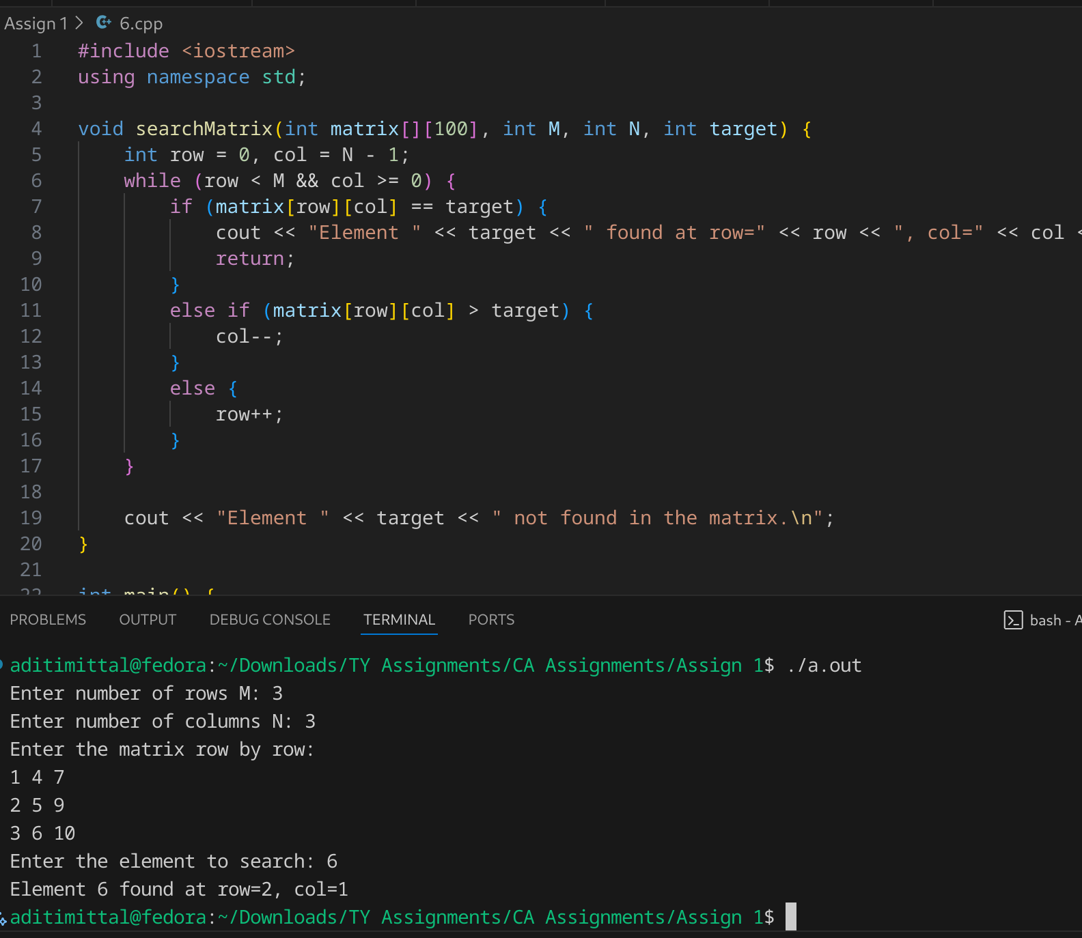

Problem Statement #7:

A circus is designing a tower routine consisting of people standing atop one another’s shoulders. For practical and aesthetic reasons, each person must be both shorter and lighter than the person below him or her. Given the heights and weight of each circus, write a method to compute the largest possible number of people in such tower.

EXAMPLE:

Input(ht,wt): (65, 100) (70, 150) (56, 90) (75,190) (60, 95) (68, 110).

Output: The longest tower is length 6 and includes from top to bottom: (56, 90) (60, 95) (65, 100) (68, 110) (70, 150) (75, 190)
- Technologies/libraries/algorithm used

Russian Doll Envelopes Problem
- Related theory or any related information you want to add
This Q is similar to the Russian Doll Envelope Problem. Here, we first sort the people by their height and if 2 people have the same height we sort then by their weight. We then create a dynamic array dp array initialised to 1 to store the longest tower each person can make. For this we traverse through the array and keep count of the number ofn people with weights less than the current person thus they can form a tower and the value of dp[i] is updated. We then find the maximum value of this dp array to get the maximum height of the tower. We then try to reconstruct the tower using the person heights and weights.

- Algorithm / procedure
function circusTower(people[], n):
// Step 1: Sort people by height, then by weight if heights are equal
sort people by (height ascending, weight ascending)

// Step 2: Initialize DP array
for i = 0 to n-1:
dp[i] = 1 // each person alone forms a tower

// Step 3: Fill DP array
for i = 1 to n-1:
for j = 0 to i-1:
if people[j].weight < people[i].weight:
dp[i] = max(dp[i], dp[j] + 1)

// Step 4: Find maximum tower length
maxTower = 0
for i = 0 to n-1:
maxTower = max(maxTower, dp[i])

// Step 5: Reconstruct the tower sequence
tower[maxTower]
idx = maxTower - 1
lastWeight = infinity

for i = n-1 downto 0 and idx >= 0:
if dp[i] == idx + 1 and people[i].weight < lastWeight:
tower[idx] = i
idx = idx - 1
lastWeight = people[i].weight

// Step 6: Print results
print "Length of the longest tower: ", maxTower
print "Tower sequence from top to bottom:"
for i = 0 to maxTower-1:
print people[tower[i]].height, people[tower[i]].weight

Code:
#include <iostream>
#include <algorithm>
using namespace std;

struct Person {
int height;
int weight;
};

bool compare(Person a, Person b) {
if(a.height == b.height)
return a.weight < b.weight;
return a.height < b.height;
}

int main() {
int n;
cout << "Enter number of people: ";
cin >> n;

Person people[n];
cout << "Enter height and weight for each person:\n";
for(int i = 0; i < n; i++) {
cin >> people[i].height >> people[i].weight;
}

sort(people, people + n, compare);

int dp[n];
for(int i = 0; i < n; i++) {
dp[i] = 1;
}
for(int i = 1; i < n; i++) {
for(int j = 0; j < i; j++) {
if(people[j].weight < people[i].weight) {
dp[i] = max(dp[i], dp[j] + 1);
}
}
}

int maxTower = 0;
for(int i = 0; i < n; i++) {
if(dp[i] > maxTower) maxTower = dp[i];
}

cout << "Length of the longest tower: " << maxTower << endl;

cout << "Tower sequence from top to bottom:" << endl;
int tower[maxTower];
int idx = maxTower - 1;
int lastWeight = 1e9;
for(int i = n-1; i >= 0 && idx >= 0; i--) {
if(dp[i] == idx + 1 && people[i].weight < lastWeight) {
tower[idx--] = i;
lastWeight = people[i].weight;
}
}

for(int i = 0; i < maxTower; i++) {
cout << "(" << people[tower[i]].height << ", " << people[tower[i]].weight << ") ";
}
cout << endl;

return 0;
}
- Screenshots of the output according to the problem statements

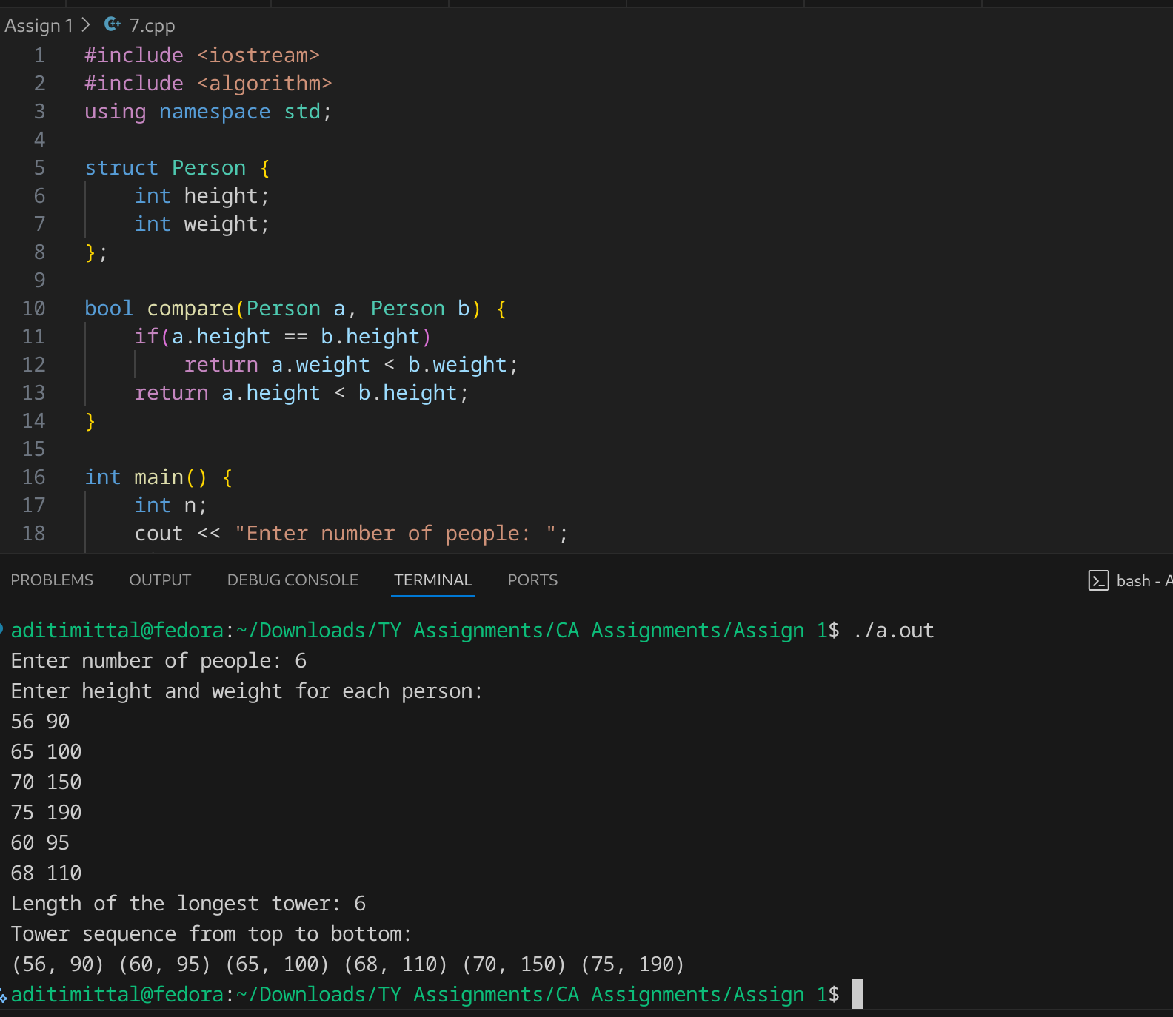
- Source: https://algo.monster/liteproblems/354
https://www.youtube.com/watch?v=mTORRFK2t_M

Problem Statement #8:

Imagine you are reading in stream of integers. Periodically, you wish to be able to look up the rank of number x (the number of values less than or equal to x). Implement the data structures and algorithms to support these operations. That is, Implement the method track (int x), which is called when each number is generated, and the method getRankOfNumber (int x), which return the number of values less than or equal to x (not including x itself).

EXAMPLE

Stream (in order of appearance) : 5, 1, 4, 4, 5, 9, 7, 13, 3

getRankOfNumber(1) = 0

getRankOfNumber(3) = 1

getRankOfNumber(4) =3
- Technologies/libraries/algorithm used
Hashmap
- Related theory or any related information you want to add
The rank of a number x in a stream is defined as the number of values in the stream less than x.
Brute-force linear traversal has time complexity O(n) per query, where n is the number of elements in the stream.
- For large streams or frequent queries, more efficient methods like BST with left subtree counts can reduce query time to O(log n).
Initialize an array arr to store numbers from the stream.
- Read the number of elements n and the stream elements into arr.
- For each query number x:
a. create a hashmap to store the frequency of the numbers.
b. everytime a new number si inout increment its frequency in the hash map.
- Output the rank for the queried number.

- Algorithm / procedure
read n
create array arr[n]
for i = 0 to n-1
read arr[i]
increment freq of x in hashmap

read q // number of queries
for each query
read x
read from hashmap in constant time

print rank

Code:
#include <iostream>
#include <unordered_map>
#include <vector>
using namespace std;

unordered_map<int,int> freq;

void track(int x) {
freq[x]++;
}

int getRankOfNumber(int x) {
int rank = 0;
for (auto &p : freq) {
if (p.first <= x) rank += p.second;
}
return rank - 1;
}

int main() {
int n;
cout << "Enter number of elements: ";
cin >> n;

vector<int> arr(n);
cout << "Enter elements:\n";
for (int i = 0; i < n; i++) {
cin >> arr[i];
track(arr[i]);
}

int q;
cout << "Enter number to find rank of: ";
cin >> q;
cout << "Rank of " << q << " is: " << getRankOfNumber(q) << endl;

return 0;
}
- Screenshots of the output according to the problem statements
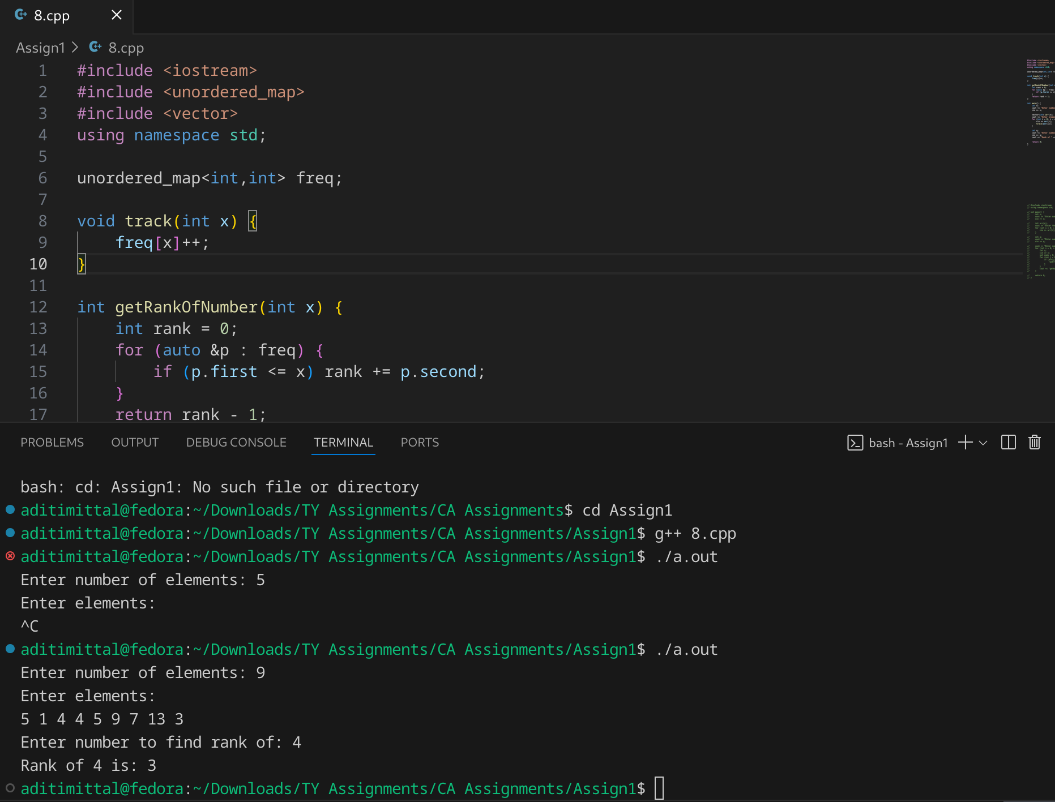

1 | P a g e
Third Year Computer Algorithm Laboratory (2025-26)

