Batch T1
Assignment No. 2
Title of Assignment: Searching Algorithm
Student Name: Aditi Mittal
Student PRN: 23610067

Problem Statement #1:
You are an IT company's manager. Based on their performance over the last N working days, you must rate your employee. You are given an array of N integers called workload, where workload[i] represents the number of hours an employee worked on an ith day. The employee must be evaluated using the following criteria: ∙
Rating = the maximum number of consecutive working days when the employee has worked more than 6 hours.
You are given an integer N where N represents the number of working days. You are given an integer array workload where workload[i] represents the number of hours an employee worked on an ith day.
Task:
Determine the employee rating.

1. Technologies/libraries/algorithm used
Linear array traversal

2. Related theory or any related information you want to add
For this program, we traverse the array in a linear manner and track the number of times the employee has worked for more than 6 hours in a row. When we encounter working hours less than 6, we check if the current max consecutive working hours are greater than previous max consecutive hours. If it is more, we save rating = current max working hours and so on..

Time Complexity: O(N)

3. Algorithm / procedure

N<-number of working days
workload[N] <- array of working hours
maxConsecutiveDays <- 0
rating <- 0
loop(N times)
if workload[i] is not more than 6 hours
rating <- max (rating, maxConsecutiveDays)
maxConsecutiveDays <- 0
else
increment maxConsecutiveDays
rating <- max (rating, maxConsecutiveDays)

4. Code:
#include <iostream>
using namespace std;

int main(){
int N;
cout<<"Enter number of days: ";
cin>> N;
int workload[N];
cout<<"Enter workload of employee for "<< N <<" days: ";
for(int i = 0; i<N; i++){
cin>> workload[i];
}
int maxConsecutiveDays = 0;
int rating = 0;
for (int i = 0; i<N; i++){
if(workload[i]<=6){
rating = max(rating, maxConsecutiveDays);
maxConsecutiveDays = 0;
}
else{
maxConsecutiveDays++;
}
rating = max(rating, maxConsecutiveDays);

}
cout<<"Rating of employee = "<< rating<<endl;

}

5. Screenshots of the output according to the problem statements
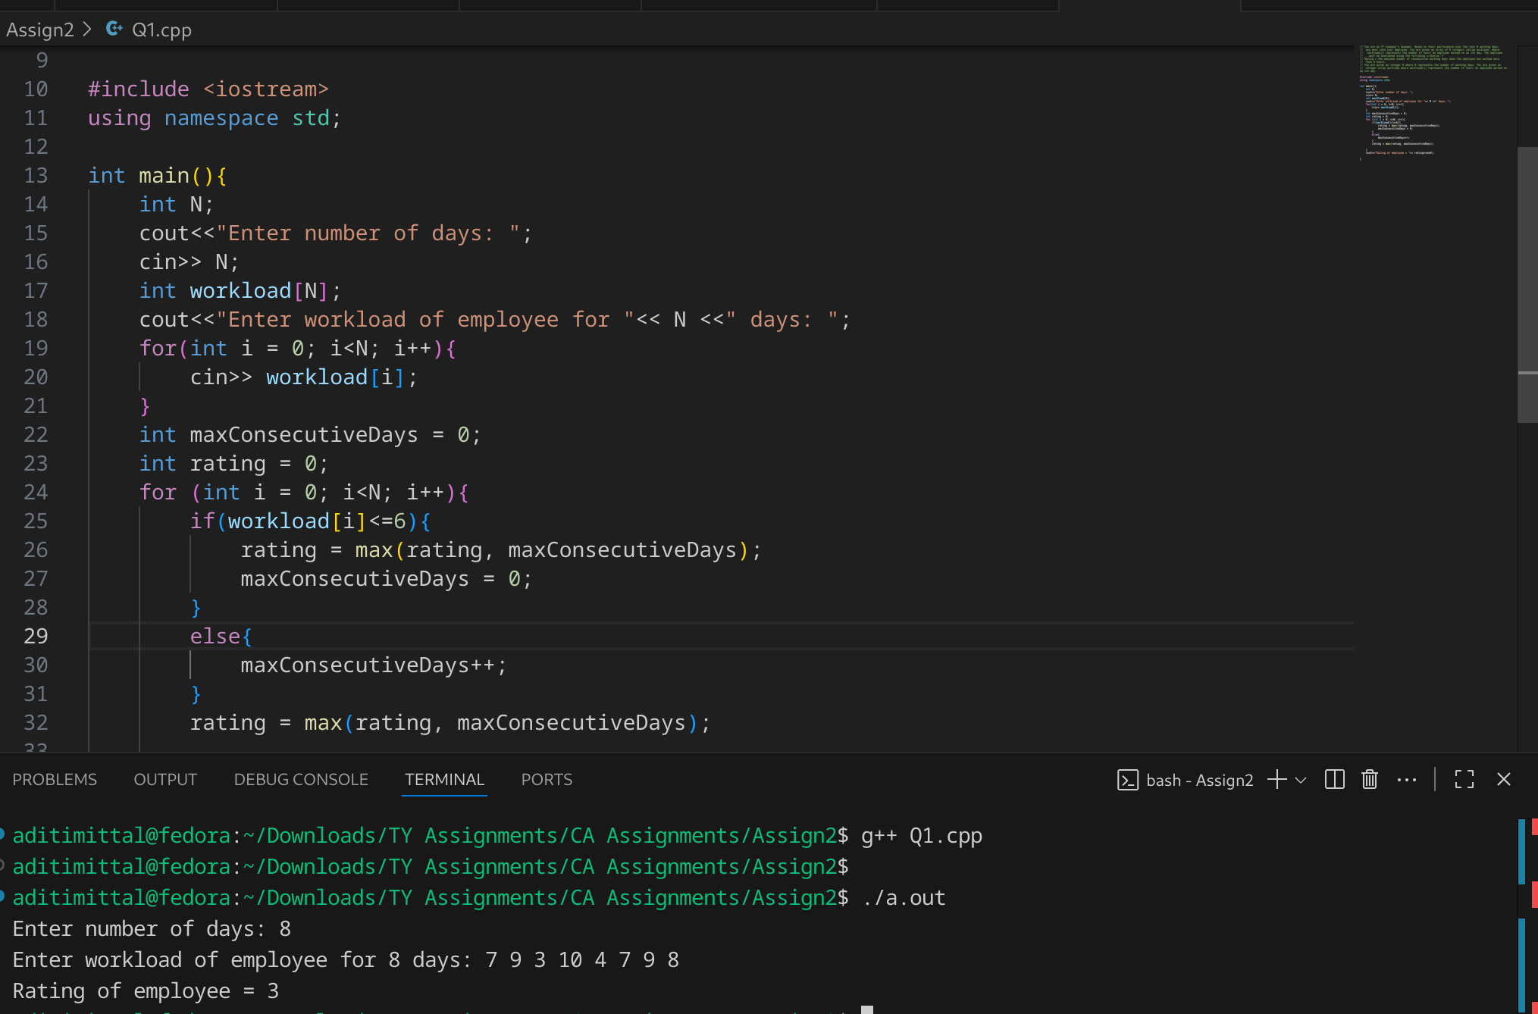

Problem Statement #2:
You have N boxes numbered 1 through N and K candies numbered 1 through K. You put the candies in the boxes in the following order:
- first candy in the first box,
- second candy in the second box,
- .......
- ........
- so up to N-th candy in the Nth box,
- the next candy in (N - 1)-th box,
- the next candy in (N - 2)-th box
- ........
- .......
- and so on up to the first box,
- then the next candy in the second box
- ...... and so on until there is no candy left.
So you put the candies in the boxes in the following order:
Find the index of the box where you put the K-th candy.

1. Technologies/libraries/algorithm used
Linear array traversal with forward and backward passes
2. Related theory or any related information you want to add
In this problem, the first candy goes to the first box and the second candy to the second box and so on till the nth candy goes to the nth box i.e. in the first parse we have no boxes. If the number of candies k are less than n, the kth candy lands in the kth box itself. However if k>n, after the traversal of 1st forward pass, we have k-n candies left and n-1 boxes to put the cnadies into. So we again check if k<n-1 then the kth candy falls into the k-(n-1)th box. Else, the backward pass gets completed and we have further k-(n-1) candies remaining. We again check if the candies k <=n-1 we go for the forward pass and kth candy goes to the k+1th box since the 1st box got a candy in the last backward pass. Else, the forward pass gets completed and if we still have candies remaining, we continue parsing back n forth with n-1 candy boxes like this till the kth candy gets assigned to a box.
Time Complexity = O(k)
3. Algorithm / procedure
function kthCandyBox(n, k):
if k <= n then
return k

k = k - n // remove the initial forward pass

while true:
// backward pass: boxes from n-1 down to 1
if k <= n - 1 then
return n - k
end if
k = k - (n - 1)

// forward pass: boxes from 2 up to n
if k <= n - 1 then
return k + 1
end if
k = k - (n - 1)
end while
end function
4. Screenshots of the output according to the problem statements
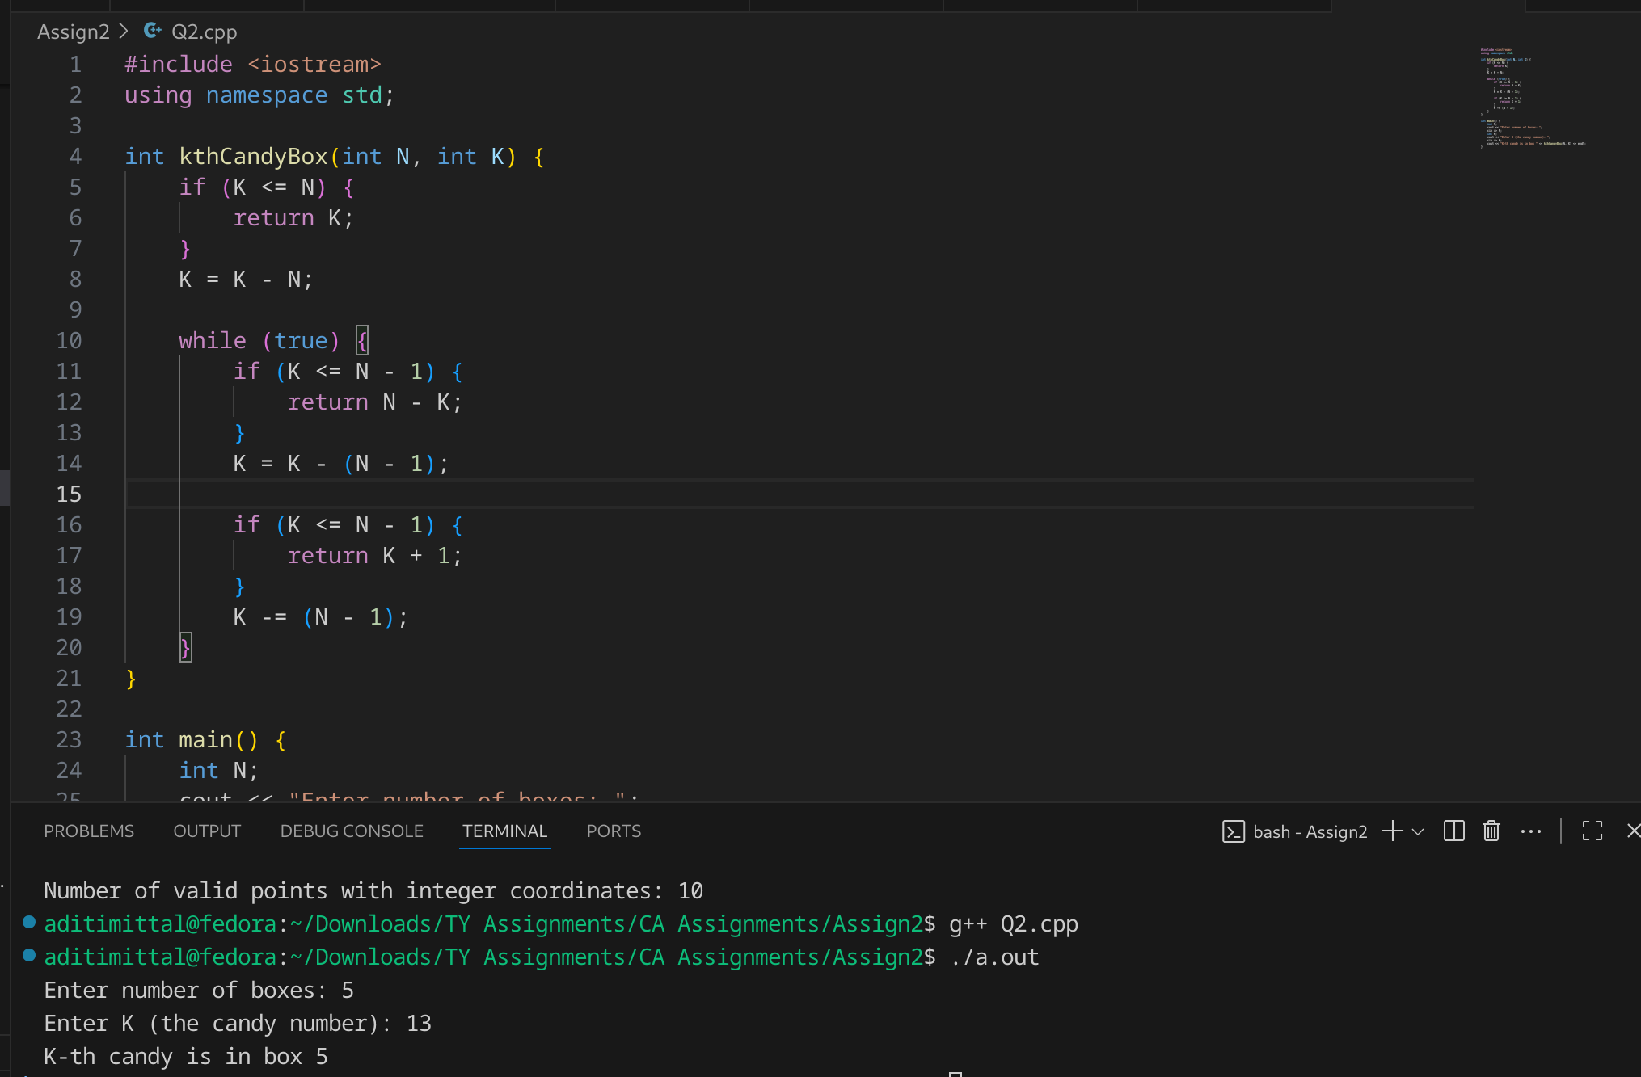

Problem Statement #3:
Implement and Explain Tower of Hanoi algorithm.
1. Technologies/libraries/algorithm used
Recursion, Stack
2. Related theory or any related information you want to add
Tower of Hanoi, is a mathematical puzzle which consists of three towers (pegs) and more than one rings is as depicted
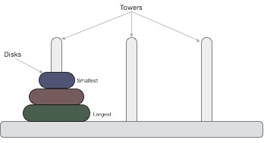
These rings are of different sizes and stacked upon in an ascending order, i.e. the smaller one sits over the larger one. There are other variations of the puzzle where the number of disks increase, but the tower count remains the same.
The mission is to move all the disks to some another tower without violating the sequence of arrangement. A few rules to be followed for Tower of Hanoi are −
- Only one disk can be moved among the towers at any given time.
- Only the "top" disk can be removed.
- No large disk can sit over a small disk.
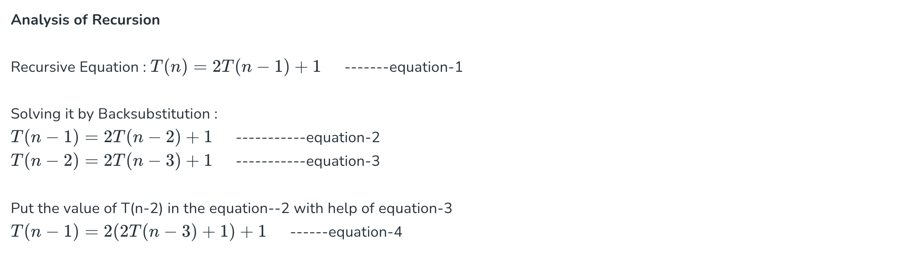
.
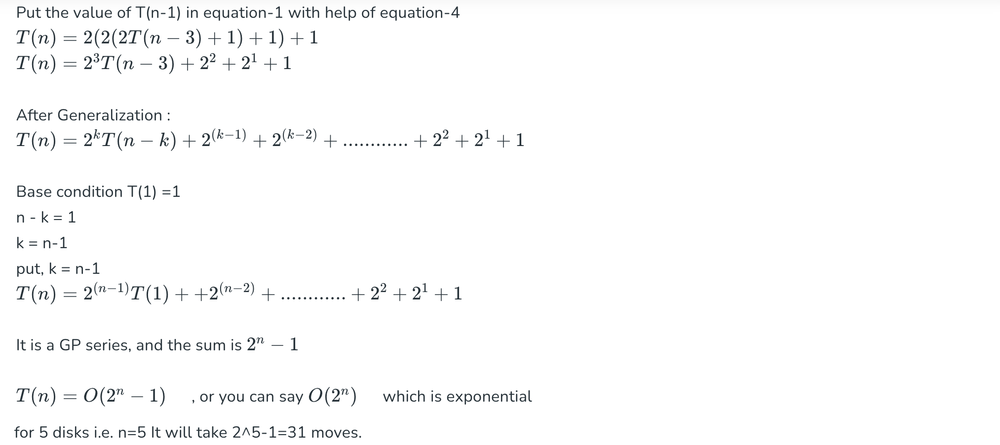
3. Algorithm / procedure

We first move n-1 disks from source to auxillary
We the move the last disk from source to destination
We move the n-1 disks from source to auxillary
Movement of n-1 disks is done recursively

void towerOfHanoi( char source, char destination, char auxillary, int numOfDisks):
if numOfDisks = 1:
Move last disk from source to destination
else:
towerOfHanoi (source, auxillary, destination, numOfDisks-1)
Move last disk from source to destination
towerOfHanoi(auxillary, destination, source, numOfDisks-1)

Code:
#include <iostream>
using namespace std;

void towerOfHanoi(char source, char destination, char auxillary, int numOfDisks){
if (numOfDisks == 1){
cout<< "Move Disk "<< numOfDisks << " from "<< source << " to " <<destination<< endl;
return;
}
else{
towerOfHanoi(source, auxillary, destination, numOfDisks-1);
cout<< "Move Disk "<< numOfDisks << " from "<< source << " to " <<destination<< endl;
towerOfHanoi(auxillary, destination, source, numOfDisks-1);
}
}

int main(){
// we use recursion
// move n-1 disks from source to auxillary
// move nth disk to destination
// move n-1 disks from auxillary to destination
int n;
cout << "Enter number of disks: ";
cin >> n;
char source = 'A';
char auxillary = 'B';
char destination = 'C';
towerOfHanoi(source, destination, auxillary, n);

}
4. Screenshots of the output according to the problem statements

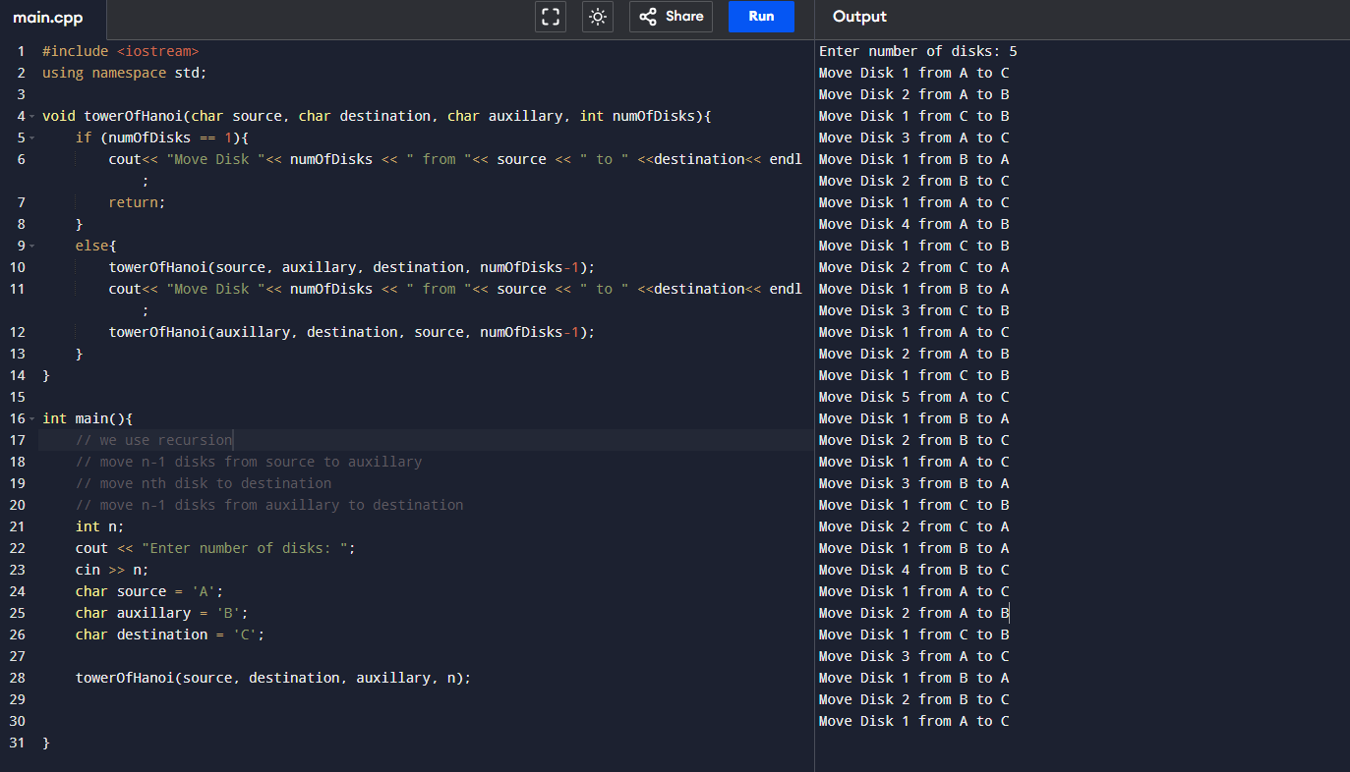
Source:
https://www.geeksforgeeks.org/dsa/time-complexity-analysis-tower-hanoi-recursion/

Problem Statement #4:
There is a frog initially placed at the origin of the coordinate plane. In exactly 1 second, the frog can either move up 1 unit, move right 1 unit, or stay still. In other words, from position (x,y), the frog can spend 1 second to move to:
- (x+1,y)
- (x,y+1)
- (x,y)
After T seconds, a villager who sees the frog reports that the frog lies on or inside a square of side-length s with coordinates (X,Y),(X+s,Y),(X,Y+s),(X+s,Y+s).
Calculate how many points with integer coordinates on or inside this square could be the frog's position after exactly T seconds.

Input Format:
The first and only line of input contains four space-separated integers:
X,Y,s,T

Output Format:
Print the number of points with integer coordinates that could be the frog's position after T seconds.

1. Technologies/libraries/algorithm used
Double nested loop traversal

2. Related theory or any related information you want to add
If the frog is on or inside the square, the minimum distance covered by it are X steps along x coordinate and Y steps along y coordinate i.e. it has already covered X+Y steps in 1 second each that is X+Y seconds have already elapsed. Thus now the frog can have coordinates on or inside the square only if T>=X+Y. After reaching the square boundary, the frog can either stay stationary or move 1 step per second. So we traverse every possible combination of X+Y <=T to get all possible coordinates of the frog.

This uses 2 loops hence the Time Complexity is O(N^2)

3. Algorithm / procedure
// Read inputs: square defined by bottom-left (X,Y), side-length s, and time T
count = 0

for x from X to X + s:
for y from Y to Y + s:
if (x + y) <= T:
count = count + 1
Output count

Code:
#include <iostream>
using namespace std;
int main(){
int X, Y, s, T;
cout << "Enter X, Y, s and T: ";
cin >> X >> Y >> s >> T;

int count = 0;
for(int x = X; x <= X + s; x++){
for(int y = Y; y <= Y + s; y++){
if((x + y) <= T){
count++;
}
}
}
cout << "Number of valid points with integer coordinates: " << count << endl;
return 0;
}

4. Screenshots of the output according to the problem statements
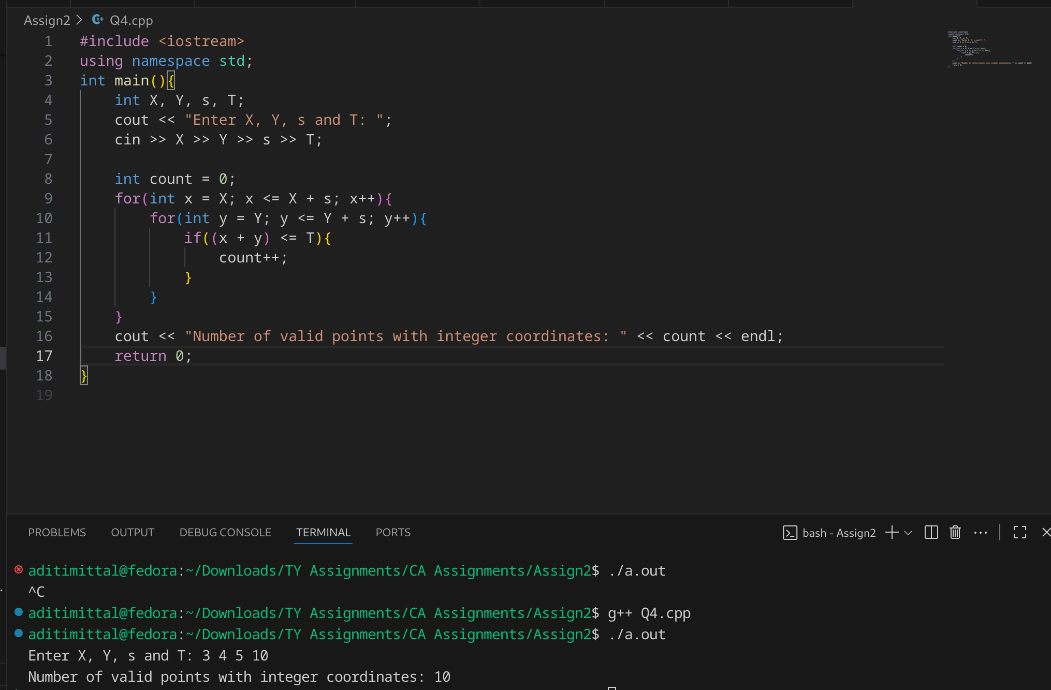

Problem Statement #5:
Lost Package Tracker
A logistics company stores the scanned timestamps (in hours) of packages entering a warehouse in an array timestamps[]. Sometimes, a timestamp is repeated due to re-scanning. A package is considered "lost" if its ID (timestamp) is missing between two valid timestamps.
Task: Given a sorted but incomplete list of timestamps from start to end, find the first missing timestamp in the range.
Input: timestamps = [1001, 1002, 1004, 1005]
Output: 1003

1. Technologies/libraries/algorithm used
Linear array traversal
2. Related theory or any related information you want to add
Here we try to find the missing integer in a consecutive sequence of integer timestamps. We check if the next element is either equal to or greater than the current element by one. If that’s not the case, we declare it as a misisng timestamp.

Time Complexity: O(N)

3. Algorithm / procedure
Code:

#include <iostream>
using namespace std;

void findMissingTimestamp(int* timestamp, int n){
if (n == 1){
cout<< "No missing Values"<< endl;
return;
}
for (int i = 0; i<n-1 ; i++){
if (!(timestamp[i+1] == timestamp[i] || timestamp[i+1] == timestamp[i] + 1)){
cout << "Missing timestamp is: "<< timestamp[i]+1;
return;
}
}
cout<< "No missing Values"<< endl;
}

int main() {
int n = 5;
// cin >> n;
int timestamps[n] = { 1,2,3,5,6};
// for(int i =0; i<n ;i ++){
// cin>> timestamps[i];
// }

findMissingTimestamp(timestamps, n);

return 0;
}
4. Screenshots of the output according to the problem statements
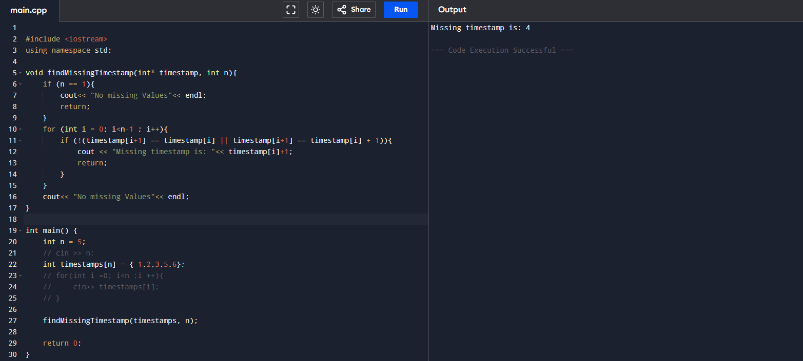

Problem Statement #6: Implement linear search algorithm.
1. Technologies/libraries/algorithm used
Linear Search Algorithm
2. Related theory or any related information you want to add
In Linear Search, we iterate over all the elements of the array and check if it the current element is equal to the target element. If we find any element to be equal to the target element, then return the index of the current element. Otherwise, if no element is equal to the target element, then return -1 as the element is not found. Linear search is also known as sequential search.
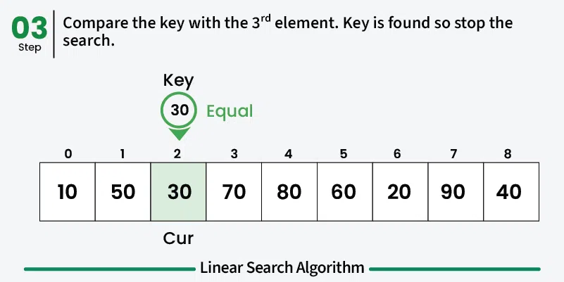

Time and Space Complexity of Linear Search Algorithm:
Time Complexity:
- Best Case: In the best case, the key might be present at the first index. So the best case complexity is O(1)
- Worst Case: In the worst case, the key might be present at the last index i.e., opposite to the end from which the search has started in the list. So the worst-case complexity is O(N) where N is the size of the list.
- Average Case: O(N)
Auxiliary Space: O(1) as except for the variable to iterate through the list, no other variable is used.

Advantages of Linear Search Algorithm:
- Linear search can be used irrespective of whether the array is sorted or not. It can be used on arrays of any data type.
- Does not require any additional memory.
- It is a well-suited algorithm for small datasets.

Disadvantages of Linear Search Algorithm:
- Linear search has a time complexity of O(N), which in turn makes it slow for large datasets.
- Not suitable for large arrays.

When to use Linear Search Algorithm?
- When we are dealing with a small dataset.
- When you are searching for a dataset stored in contiguous memory.

3. Algorithm / procedure
void linear_search(int array, int array_size, int search_key):
loop(counter = 0 → n-1)
if array[i] = search_key
print(“Element is found at”, I)
else
print(“Element not found”)
Code:
#include <iostream>
using namespace std;

void linear_search(int arr[], int n, int key){
for(int i = 0; i < n; i++){
if(arr[i] == key){
cout << "Element found at index: " << i << endl;
return;
}
}
cout << "Element not found" << endl;
}

int main(){
int n;
cout << "Enter the size of the array: ";
cin >> n;
int arr[n];
cout << "Enter the elements of the array: ";
for(int i = 0; i < n; i++){
cin >> arr[i];
}
int key;
cout << "Enter the element to be searched: ";
cin >> key;
linear_search(arr, n, key);

}

4. Screenshots of the output according to the problem statements
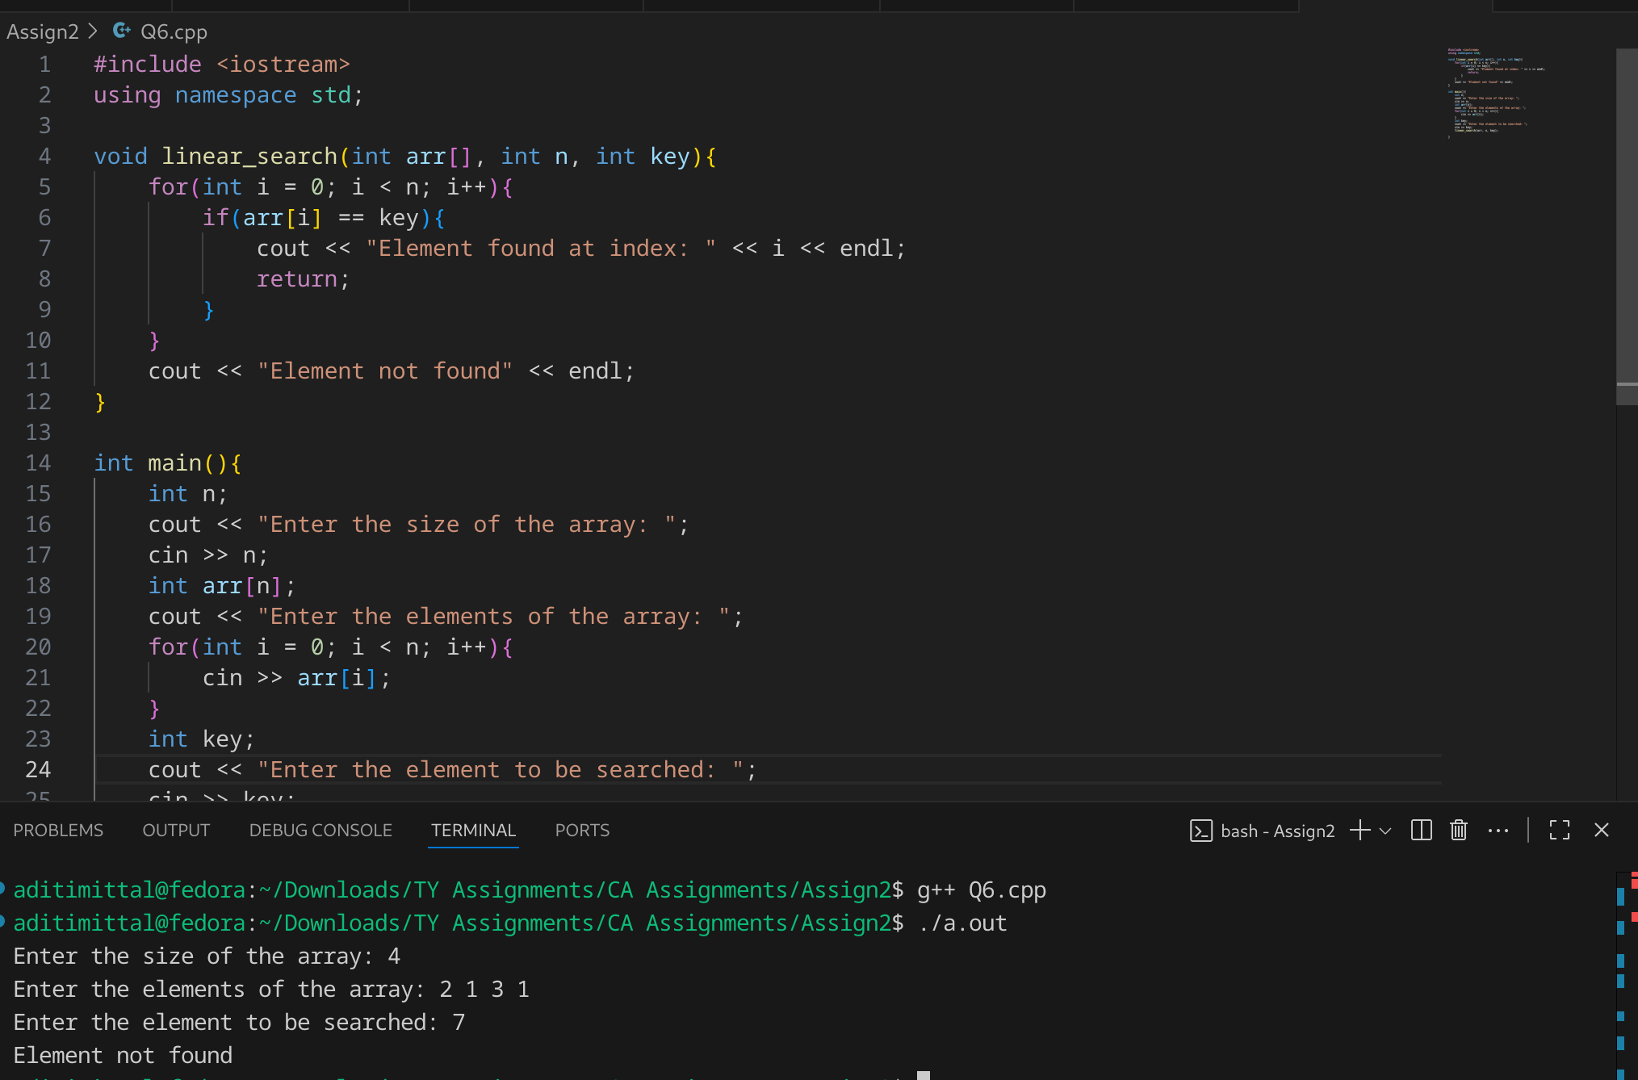
Source: https://www.geeksforgeeks.org/dsa/linear-search/

Problem Statement #7: Implement Binary Search algorithm
1. Technologies/libraries/algorithm used
Binary Search Algorithm
2. Related theory or any related information you want to add
Binary Search is an searching algorithm that operates on a sorted or monotonic search space, repeatedly dividing it into halves to find a target value or optimal answer in logarithmic time O(log N).

Conditions to apply Binary Search Algorithm in a Data Structure
To apply Binary Search algorithm:
- The data structure must be sorted.
- Access to any element of the data structure should take constant time.
Complexity Analysis of Binary Search Algorithm
- Time Complexity:
-> Best Case: O(1)
-> Average Case: O(log N)
-> Worst Case: O(log N)
- Auxiliary Space: O(1), If the recursive call stack is considered then the auxiliary space will be O(log N).
3. Algorithm / procedure
Divide the search space into two halves by finding the middle index "mid".
- Compare the middle element of the search space with the key.
- If the key is found at middle element, the process is terminated.
- If the key is not found at middle element, choose which half will be used as the next search space.
-> If the key is smaller than the middle element, then the left side is used for next search.
-> If the key is larger than the middle element, then the right side is used for next search.
- This process is continued until the key is found or the total search space is exhausted.
int binary_search_recursive(int arr[], int low, int high, int key):
int mid = low + (high - low) / 2
if(arr[mid] = key)
return mid

else if(arr[mid] < key)
return binary_search(arr, mid+1, high, key)

else:
return binary_search(arr, low, mid-1, key)
return -1

int binary_search_iterative(int arr[], int n, int key)
int left = 0;
int right = n - 1
loop(left <= right)
int mid = left + (right - left) / 2
if(arr[mid] == key):
return mid
else if(arr[mid] < key):
left = mid + 1
else:
right = mid - 1
return -1

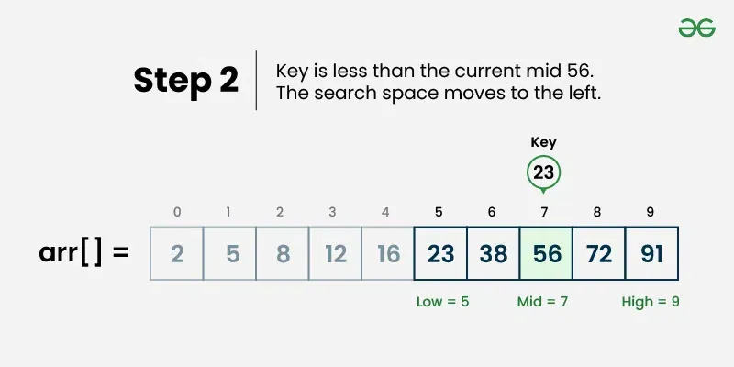
The Binary Search Algorithm can be implemented in the following two ways
- Iterative Binary Search Algorithm
- Recursive Binary Search Algorithm

Iterative Binary Search Algorithm: O(log n) Time and O(1) Space
Here we use a while loop to continue the process of comparing the key and splitting the search space in two halves.

Recursive Binary Search Algorithm:
Create a recursive function and compare the mid of the search space with the key. And based on the result either return the index where the key is found or call the recursive function for the next search space.

Code: Iterative
#include <iostream>
using namespace std;

int binary_search(int arr[], int n, int key){
int left = 0;
int right = n - 1;
while(left <= right){
int mid = left + (right - left) / 2;
if(arr[mid] == key){
return mid;
}
else if(arr[mid] < key){
left = mid + 1;
}
else{
right = mid - 1;
}
}
return -1;
}

int main(){
int n;
cout << "Enter number of elements: ";
cin >> n;
int arr[n];
cout << "Enter elements: ";
for(int i = 0; i < n; i++){
cin >> arr[i];
}
int key;
cout << "Enter element to be searched: ";
cin >> key;
int index = binary_search(arr, n, key);
if(index != -1){
cout << "Element found at index: " << index << endl;
}
else{
cout << "Element not found" << endl;
}
}
Code: Recursive
#include <iostream>
using namespace std;

int binary_search(int arr[],int low, int high, int key){
int mid = low + (high - low) / 2;
if(arr[mid] == key){
return mid;
}
else if(arr[mid] < key){
return binary_search(arr, mid+1, high, key);
}
else{
return binary_search(arr, low, mid-1, key);
}
return -1;
}

int main(){
int n;
cout << "Enter number of elements: ";
cin >> n;
int arr[n];
cout << "Enter elements: ";
for(int i = 0; i < n; i++){
cin >> arr[i];
}
int key;
cout << "Enter element to be searched: ";
cin >> key;
int index = binary_search(arr, 0, n-1, key);
if(index != -1){
cout << "Element found at index: " << index << endl;
}
else{
cout << "Element not found" << endl;
}
}

4. Screenshots of the output according to the problem statements
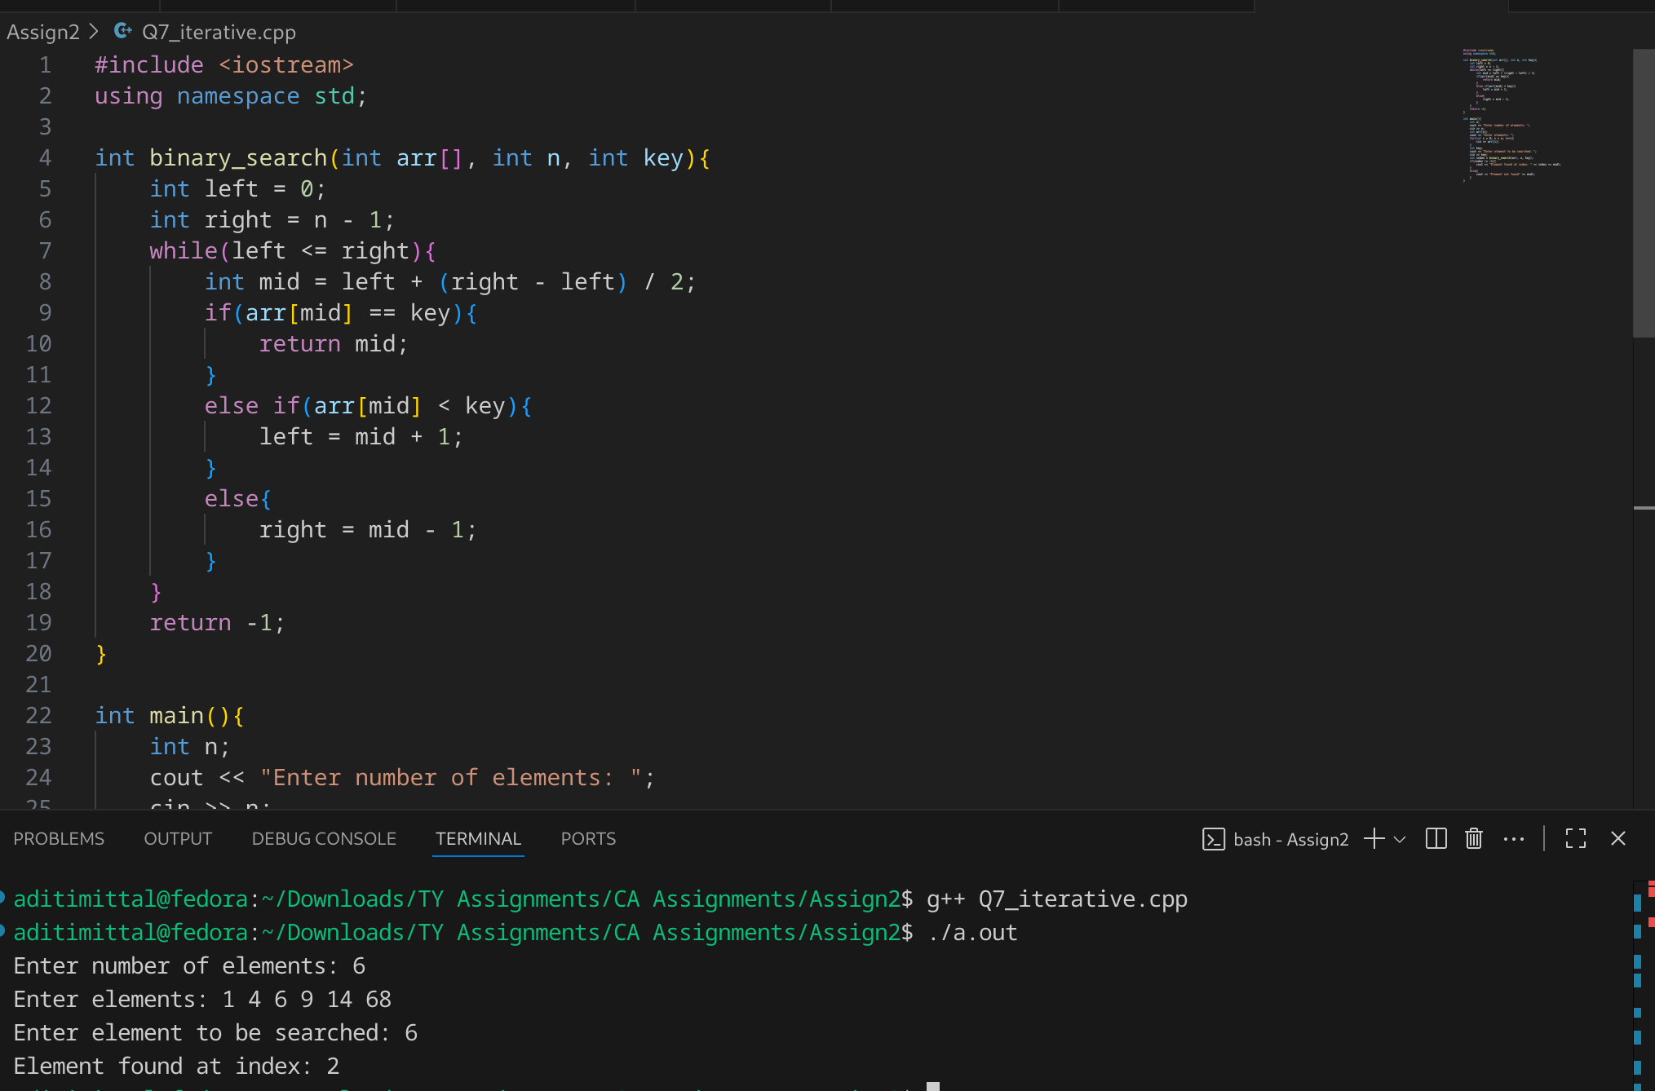
.
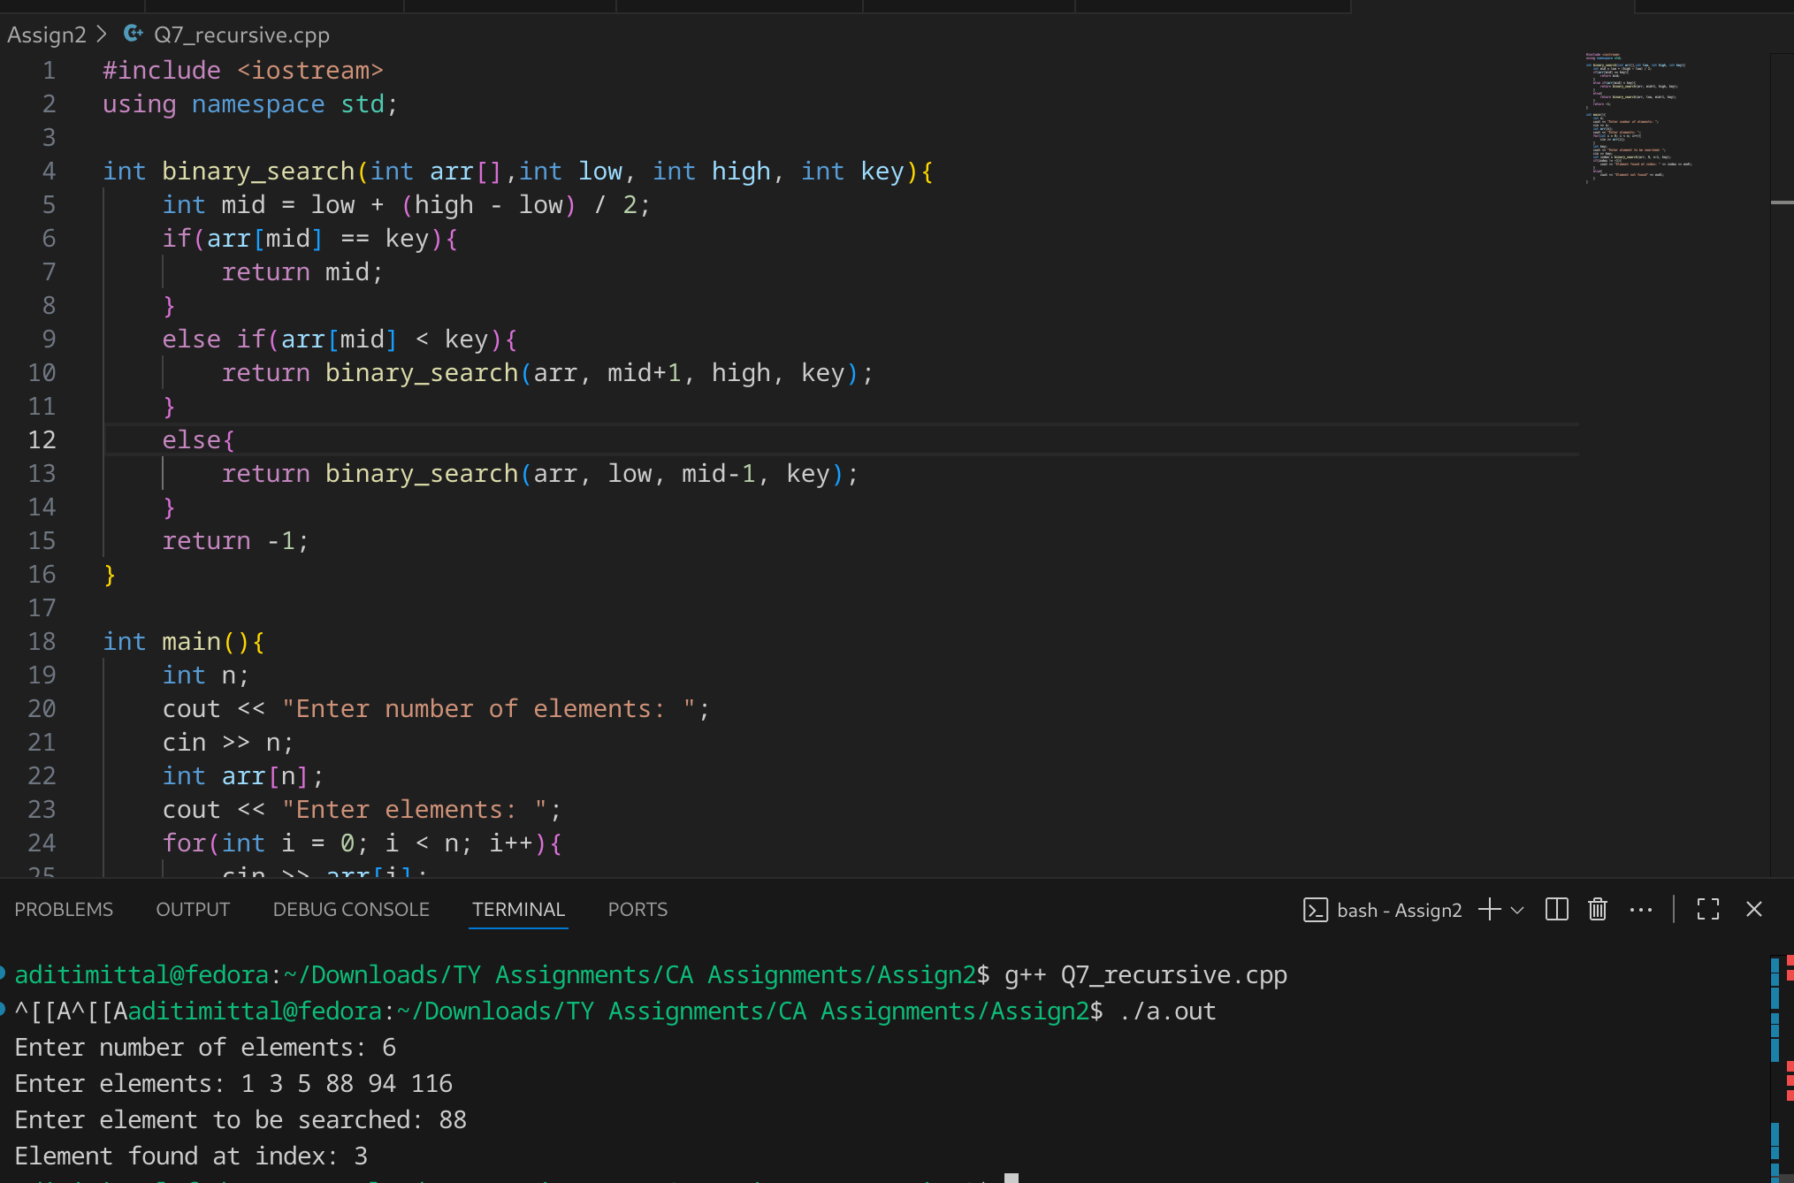
5. Source https://www.geeksforgeeks.org/dsa/binary-search/

Problem Statement #8: Signal Drop Detector Problem Statement:
You're monitoring signal strengths over time using an array signal[]. A drop is defined as a strictly decreasing subsequence for at least 3 consecutive readings.
Task: Find the number of such "signal drops" in the array.
Input: signal = [5, 4, 3, 6, 7, 4, 3, 2]
Output: 2 (drops: 5→4→3 and 7→4→3→2)
1. Technologies/libraries/algorithm used
Linear array traversal
2. Related theory or any related information you want to add
In this problem, we find out the number of signal drops by keeping a track of whether the every element is smaller than the previous element or not for atleast 3 consecutive elements. This is called a signal drop. If an element is greater than its previous element it implies that the signal has increased and thus we reset the counter of consecutive elements to 0.

Time Complexity: O(N)
3. Algorithm / procedure
input n
read arr[0...n-1]

consecutive = 0
count = 0

for i = 0 to n - 2:
if arr[i] > arr[i+1]:
consecutive += 1
else:
if consecutive >= 2:
count += 1
consecutive = 0

if consecutive >= 2:
count += 1

print count
4. Screenshots of the output according to the problem statements
