Walchand College of Engineering, Sangli Department of Computer Science and Engineering

Batch T1
Assignment No. 3
Divide and Conquer Strategy
Student Name: Aditi Mittal
Student PRN: 23610067

Problem Statement #1:

Implement algorithm to Find the maximum element in an array which is first increasing and then decreasing, with Time Complexity O(Logn).
- Technologies/libraries/algorithm used
Biotonic Point
Given an array arr[] of integers which is initially strictly increasing and then strictly decreasing, the task is to find the bitonic point, that is the maximum value in the array.
Bitonic Point is a point in bitonic sequence before which elements are strictly increasing and after which elements are strictly decreasing.
- Related theory or any related information you want to add
Examples:
Input: arr[] = [1, 2, 4, 5, 7, 8, 3]
Output: 8
Explanation: 8 is the maximum element in the array.
Input: arr[] = [10, 20, 30, 40, 50]
Output: 50
Explanation: 50 is the maximum element in the array.
Input: arr[] = [120, 100, 80, 20, 0]
Output: 120
Explanation: 120 is the maximum element in the array.

- Algorithm / procedure
Brute Force: Linear Search
// C++ program to find bitonic point in an array
// using linear search
#include <iostream>
#include <vector>
using namespace std;

// function to find the maximum element
int findMaximum(vector<int>& arr) {
int mx = arr[0];
for (int i = 1; i < arr.size(); i++) {

// update max when found greater value
if (arr[i] > mx)
mx = arr[i];

// break when once an element is smaller than
// the max then it will go on decreasing
// and no need to check after that
else
break;
}
return mx;
}

int main() {
vector<int> arr = {1, 2, 4, 5, 7, 8, 3};
cout << findMaximum(arr);
return 0;
}

Optimised: Binary Search
We can optimize the maximum element searching by using Binary Search where we find the mid element and then decide whether to stop or to go to left half or right half. How do we decide in this case.
- If the mid element is greater than both of its adjacent elements, then mid is the maximum.
- If the mid element is smaller than its next element then we should try to search on the right half of the array. So, update low = mid + 1.
- If the mid element is greater than the next element, then we should try to search on the left half. So, update high = mid - 1.

- Screenshots of the output according to the problem statements
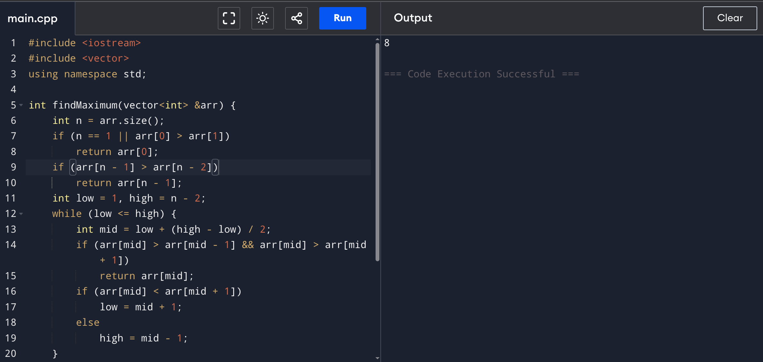
- Code
#include <iostream>
#include <vector>
using namespace std;

int findMaximum(vector<int> &arr) {
int n = arr.size();
if (n == 1 || arr[0] > arr[1])
return arr[0];
if (arr[n - 1] > arr[n - 2])
return arr[n - 1];
int low = 1, high = n - 2;
while (low <= high) {
int mid = low + (high - low) / 2;
if (arr[mid] > arr[mid - 1] && arr[mid] > arr[mid + 1])
return arr[mid];
if (arr[mid] < arr[mid + 1])
low = mid + 1;
else
high = mid - 1;
}

return arr[high];
}

int main() {
vector<int> arr = {1, 2, 4, 5, 7, 8, 3};
cout << findMaximum(arr);
return 0;
}
- Dry Run
Input array:
arr = {1, 2, 4, 5, 7, 8, 3}
So, n = 7.

Step 1: Edge cases check
- if (n == 1 || arr[0] > arr[1])
→ arr[0] = 1, arr[1] = 2, so 1 > 2 → false
- if (arr[n - 1] > arr[n - 2])
→ arr[6] = 3, arr[5] = 8, so 3 > 8 → false
Continue.

Step 2: Initialize binary search
- low = 1, high = 5

Step 3: Iteration 1
- mid = low + (high - low)/2 = 1 + (5-1)/2 = 3
- arr[mid] = arr[3] = 5
Check conditions:
- arr[3] > arr[2] && arr[3] > arr[4] → 5 > 4 (true) and 5 > 7 (false) → not peak
- arr[3] < arr[4] ? → 5 < 7 → true → update low = mid + 1 = 4

Step 4: Iteration 2
- low = 4, high = 5
- mid = 4 + (5-4)/2 = 4
- arr[mid] = arr[4] = 7
Check:
- arr[4] > arr[3] && arr[4] > arr[5] → 7 > 5 (true) and 7 > 8 (false) → not peak
- arr[4] < arr[5] ? → 7 < 8 → true → update low = mid + 1 = 5

Step 5: Iteration 3
- low = 5, high = 5
- mid = 5
- arr[mid] = arr[5] = 8
Check:
- arr[5] > arr[4] && arr[5] > arr[6] → 8 > 7 (true) and 8 > 3 (true) → condition true
- Return arr[mid] = 8

Final Output:
8

- Source:
https://www.geeksforgeeks.org/dsa/find-the-maximum-element-in-an-array-which-is-first-increasing-and-then-decreasing/

Problem Statement #2:

Implement algorithm for Tiling problem: Given an n×n board where n is of form 2k where k >= 1 (Basically n is a power of 2 with minimum value as 2). The board has one missing cell (of size 1 x 1). Fill the board using L shaped tiles. An L shaped tile is a 2 x 2 square with one cell of size 1×1 missing
- Technologies/libraries/algorithm used

Tiling Problem - L Shaped
- Related theory or any related information you want to add
Given an n×n board (where n = 2k and k≥1), with one missing cell, the task is to fill the remaining cells using L-shaped tiles. An L-shaped tile covers 3 cells in a 2x2 grid, with one cell missing.
Examples:
Input: n = 2, missing_cell = (0,0)
Output: [[-1,1], [1, 1]]
Explanation: Coordinate (0, 0) is marked. So, no tile is there. In the remaining three positions, a tile is placed with its number as 1.
Input : n = 4, missing_cell = (0,1)
Output: [[3, -1, 2, 2], [3, 3, 1, 2], [4, 1, 1, 5], [4, 4, 5, 5]]
Explanation: In this 4×4 grid, the cell at position (0,1) is missing, and the rest using L-shaped tromino tiles, each marked with a unique number, ensuring all other cells are covered without overlapping.

- Algorithm / procedure

Using Divide and Conquer algorithm
- If the board size is 2x2, fill the missing cell with a tile number and return.
- Divide the board into four quadrants by halving the dimensions of the board (top-left, top-right, bottom-left, bottom-right).
- Place an L-shaped tile in the three quadrants that do not contain the missing cell, and number the tiles sequentially. Now all four quadrants have a cell not to be filled. So our problem reduces from (n x n) to (n/2) x (n/2)
- Recursively apply the same process to each of the four smaller sub-boards until the base case (2x2 board) is reached.
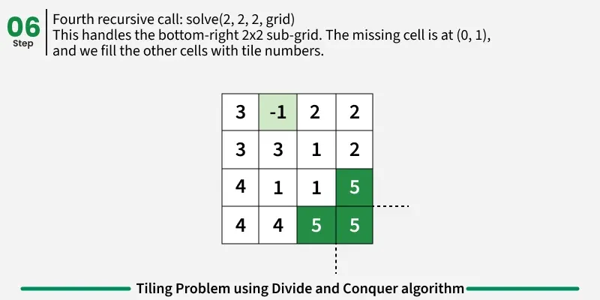
- Screenshots of the output according to the problem statements
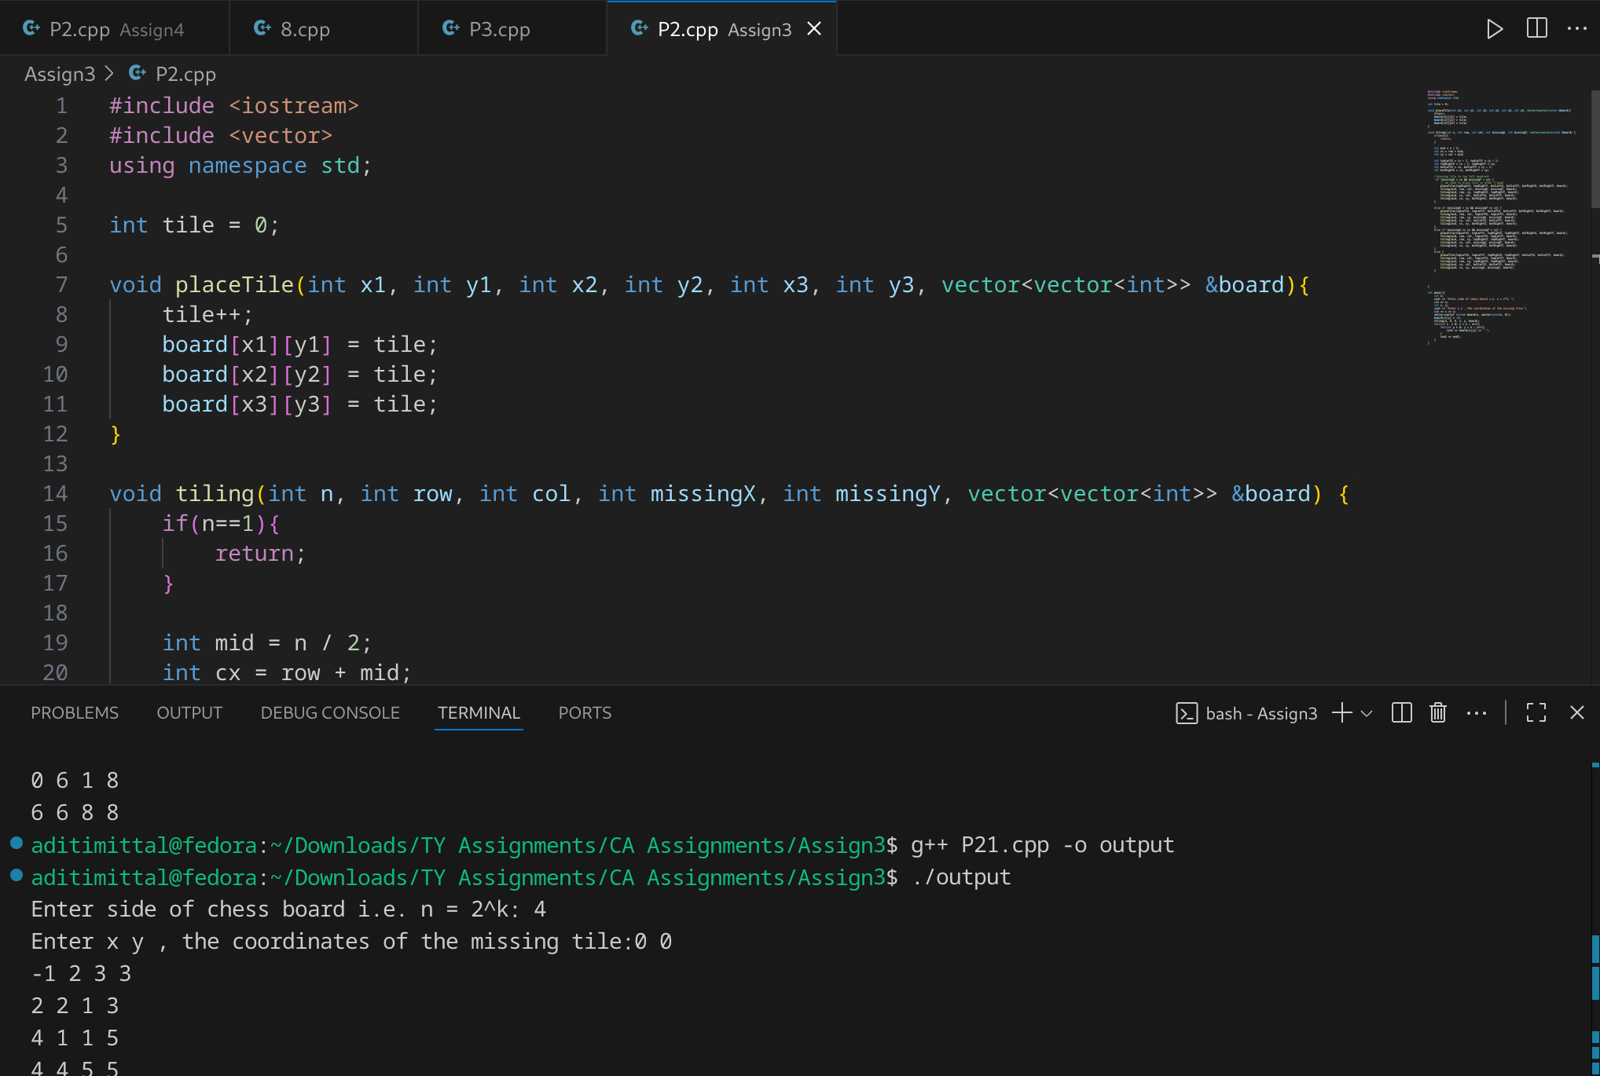
- Code
#include <iostream>
#include <vector>
using namespace std;

int tile = 0;

void placeTile(int x1, int y1, int x2, int y2, int x3, int y3, vector<vector<int>> &board){
tile++;
board[x1][y1] = tile;
board[x2][y2] = tile;
board[x3][y3] = tile;
}

void tiling(int n, int row, int col, int missingX, int missingY, vector<vector<int>> &board) {
if(n==1){
return;
}

int mid = n / 2;
int cx = row + mid;
int cy = col + mid;

int topLeftX = cx - 1, topLeftY = cy - 1;
int topRightX = cx - 1, topRightY = cy;
int botLeftX = cx, botLeftY = cy - 1;
int botRightX = cx, botRightY = cy;

//missing tile in top left quadrant
if (missingX < cx && missingY < cy) {
// we need to place tile in other 3 quad
placeTile(topRightX, topRightY, botLeftX, botLeftY, botRightX, botRightY, board);
tiling(mid, row, col, missingX, missingY, board);
tiling(mid, row, cy, topRightX, topRightY, board);
tiling(mid, cx, col, botLeftX, botLeftY, board);
tiling(mid, cx, cy, botRightX, botRightY, board);
}

else if (missingX < cx && missingY >= cy) {
placeTile(topLeftX, topLeftY, botLeftX, botLeftY, botRightX, botRightY, board);
tiling(mid, row, col, topLeftX, topLeftY, board);
tiling(mid, row, cy, missingX, missingY, board);
tiling(mid, cx, col, botLeftX, botLeftY, board);
tiling(mid, cx, cy, botRightX, botRightY, board);
}
else if (missingX >= cx && missingY < cy) {
placeTile(topLeftX, topLeftY, topRightX, topRightY, botRightX, botRightY, board);
tiling(mid, row, col, topLeftX, topLeftY, board);
tiling(mid, row, cy, topRightX, topRightY, board);
tiling(mid, cx, col, missingX, missingY, board);
tiling(mid, cx, cy, botRightX, botRightY, board);
}
else {
placeTile(topLeftX, topLeftY, topRightX, topRightY, botLeftX, botLeftY, board);
tiling(mid, row, col, topLeftX, topLeftY, board);
tiling(mid, row, cy, topRightX, topRightY, board);
tiling(mid, cx, col, botLeftX, botLeftY, board);
tiling(mid, cx, cy, missingX, missingY, board);
}

}

int main(){
int n;
cout << "Enter side of chess board i.e. n = 2^k: ";
cin >> n;
int x, y;
cout << "Enter x y , the coordinates of the missing tile:";
cin >> x >> y;
vector<vector <int>> board(n, vector<int>(n, 0));
board[x][y] = -1;
tiling(n, 0, 0, x, y, board);
for(int x = 0; x < n ; x++){
for(int y = 0; y < n ; y++){
cout << board[x][y] << " ";
}
cout << endl;
}
}
- Source:
https://www.geeksforgeeks.org/dsa/tiling-problem-using-divide-and-conquer-algorithm/
https://www.youtube.com/watch?v=lQhNiv3w45w 11

Problem Statement #3:

Implement algorithm for The Skyline Problem:

Given n rectangular buildings in a 2- dimensional city, computes the skyline of these buildings, eliminating hidden lines. The main task is to view buildings from a side and remove all sections that are not visible.

All buildings share common bottom and every building is represented by triplet (left, ht, right) ‘left’: is x coordinated of left side (or wall). ‘right': is x coordinate of right side ‘ht': is height of building.

For example, the building on right side is represented as (1, 11, 5) A skyline is a collection of rectangular strips. A rectangular strip is represented as a pair (left, ht) where left is x coordinate of left side of strip and ht is height of strip. With Time Complexity O(nLogn)
- Technologies/libraries/algorithm used
Sky Line Problem
- Related theory or any related information you want to add
Given n rectangular buildings in a 2-dimensional city, compute the skyline of these buildings, eliminating hidden lines. The main task is to view buildings from a side and remove all sections that are not visible. All buildings share a common bottom and every building is represented by a triplet (left, ht, right)
- 'left': is the x coordinate of the left side (or wall).
- 'right': is x coordinate of right side
- 'ht': is the height of the building.
A skyline is a collection of rectangular strips. A rectangular strip is represented as a pair (left, ht) where left is x coordinate of the left side of the strip and ht is the height of the strip.
Example:
Input: build[][] = [[1, 5, 11 ], [2, 7, 6 ], [3, 9, 13 ], [ 12, 16, 7 ], [ 14, 25, 3 ], [ 19, 22, 18 ], [ 23, 29, 13 ], [ 24, 28, 4 ]]
Output: [[1, 11 ], [ 3, 13 ], [ 9, 0 ], [ 12, 7 ], [ 16, 3 ], [ 19, 18 ], [ 22, 3 ], [ 23, 13 ], [ 29, 0 ]]
Explanation: The skyline is formed based on the key-points (representing by “green” dots)
eliminating hidden walls of the buildings. Note that no end point of the second building (2, 7, 6) is considered because it completely overlaps. Also, the points where the y coordinate changes are considered (Note that the top right of the third building (3, 9, 13) is not considered because it has same y coordinate.

Input: build[ ][ ] = [[1, 5, 11]]
Output: [[ 1, 11 ], [ 5, 0 ]]
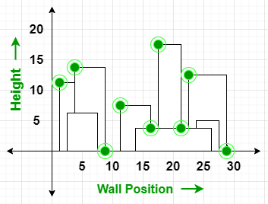
One thing is obvious, we build the skyline from left to right. Now we know the point [1, 11] is going to be in the output as it is the leftmost point.
If we take a look at the right point of the first building which is [5, 11], we find that this point cannot be considered because there is a higher height building (third building in our input array [3, 9, 13[). So we ignore the right point.
Now we see the second building, its both left and right are covered. Left is covered by first building and right is covered by third building because its height is smaller than both of its neighbors. So we ignore the second building completely.
We process all the remaining building same way.

- Algorithm / procedure
Naive Sweep Line Algorithm - O(n^2) Time and O(n) Space
- Get all corner x coordinates of all buildings in an array say points[]. We are mainly going to have 2n points in this array as we have left and right for every building.
- Sort the points[] to simulate the sweep line from left to right.
- Now traverse through the sorted point[] and for every x point check which building has the maximum height at this point and add the maximum height to the skyline if the maximum height is different from the previously added height to the skyline.
Divide and Conquer Algorithm:
Divide step: Split buildings into two halves recursively.
- Conquer step: Compute skyline for each half.
- Combine step: Merge two skylines using the maximum height at each x-coordinate.
function computeSkyline(buildings, start, end)
if start == end:
create a new skyline result
add point (buildings[start].left, buildings[start].height)
add point (buildings[start].right, 0)
return result

mid = (start + end) / 2
leftSkyline = computeSkyline(buildings, start, mid)
rightSkyline = computeSkyline(buildings, mid + 1, end)
return mergeSkylines(leftSkyline, rightSkyline)
Function mergeSkylines(leftSkyline, rightSkyline)
initialize mergedSkyline as empty list
initialize leftHeight = 0, rightHeight = 0
i = 0, j = 0

while i < size(leftSkyline) and j < size(rightSkyline):
if leftSkyline[i].x < rightSkyline[j].x:
x = leftSkyline[i].x
leftHeight = leftSkyline[i].height
i = i + 1
else if leftSkyline[i].x > rightSkyline[j].x:
x = rightSkyline[j].x
rightHeight = rightSkyline[j].height
j = j + 1
else:
x = leftSkyline[i].x
leftHeight = leftSkyline[i].height
rightHeight = rightSkyline[j].height
i = i + 1
j = j + 1

maxHeight = max(leftHeight, rightHeight)
if mergedSkyline is empty or last height != maxHeight:
append (x, maxHeight) to mergedSkyline

append remaining points of leftSkyline to mergedSkyline
append remaining points of rightSkyline to mergedSkyline

return mergedSkyline

Code:
#include <iostream>
#include <vector>
#include <algorithm>
using namespace std;

vector<vector<int>> mergeSkylines(vector<vector<int>> &leftSkyline, vector<vector<int>> &rightSkyline) {
vector<vector<int>> result;
int i = 0, j = 0;
int leftHeight = 0, rightHeight = 0, currHeight = 0;

while (i < leftSkyline.size() && j < rightSkyline.size()) {
int x;
if (leftSkyline[i][0] < rightSkyline[j][0]) {
x = leftSkyline[i][0];
leftHeight = leftSkyline[i][1];
i++;
} else if (rightSkyline[j][0] < leftSkyline[i][0]) {
x = rightSkyline[j][0];
rightHeight = rightSkyline[j][1];
j++;
} else {
x = leftSkyline[i][0];
leftHeight = leftSkyline[i][1];
rightHeight = rightSkyline[j][1];
i++; j++;
}
int maxHeight = max(leftHeight, rightHeight);
if (currHeight != maxHeight) {
result.push_back({x, maxHeight});
currHeight = maxHeight;
}
}

while (i < leftSkyline.size()) {
if (currHeight != leftSkyline[i][1]) {
result.push_back(leftSkyline[i]);
currHeight = leftSkyline[i][1];
}
i++;
}
while (j < rightSkyline.size()) {
if (currHeight != rightSkyline[j][1]) {
result.push_back(rightSkyline[j]);
currHeight = rightSkyline[j][1];
}
j++;
}

return result;
}

vector<vector<int>> findSkyLine(vector<vector<int>> &buildings, int start, int end) {
if (start > end) return {};
if (start == end) {
// (left, height), (right, 0)
return {{buildings[start][0], buildings[start][2]},
{buildings[start][1], 0}};
}

int mid = (start + end) / 2;
vector<vector<int>> leftSkyline = findSkyLine(buildings, start, mid);
vector<vector<int>> rightSkyline = findSkyLine(buildings, mid + 1, end);
return mergeSkylines(leftSkyline, rightSkyline);
}

int main() {
int n;
cout << "Enter number of buildings: ";
cin >> n;

vector<vector<int>> buildings(n, vector<int>(3));
cout << "Enter buildings as: left right height\n";
for (int i = 0; i < n; i++) {
cin >> buildings[i][0] >> buildings[i][1] >> buildings[i][2];
}

// 1 5 11
// 2 7 6
// 3 9 13
// 12 16 7
// 14 25 3
// 19 22 18
// 23 29 13
// 24 28 4

sort(buildings.begin(), buildings.end());
vector<vector<int>> result = findSkyLine(buildings, 0, n - 1);

cout << "\nSkyline: \n";
for (auto &point : result) {
cout << point[0] << " " << point[1] << "\n";
}
}
Source:
https://www.youtube.com/watch?v=Cv0ft2dFz80

- Screenshots of the output according to the problem statements
1 | P a g e
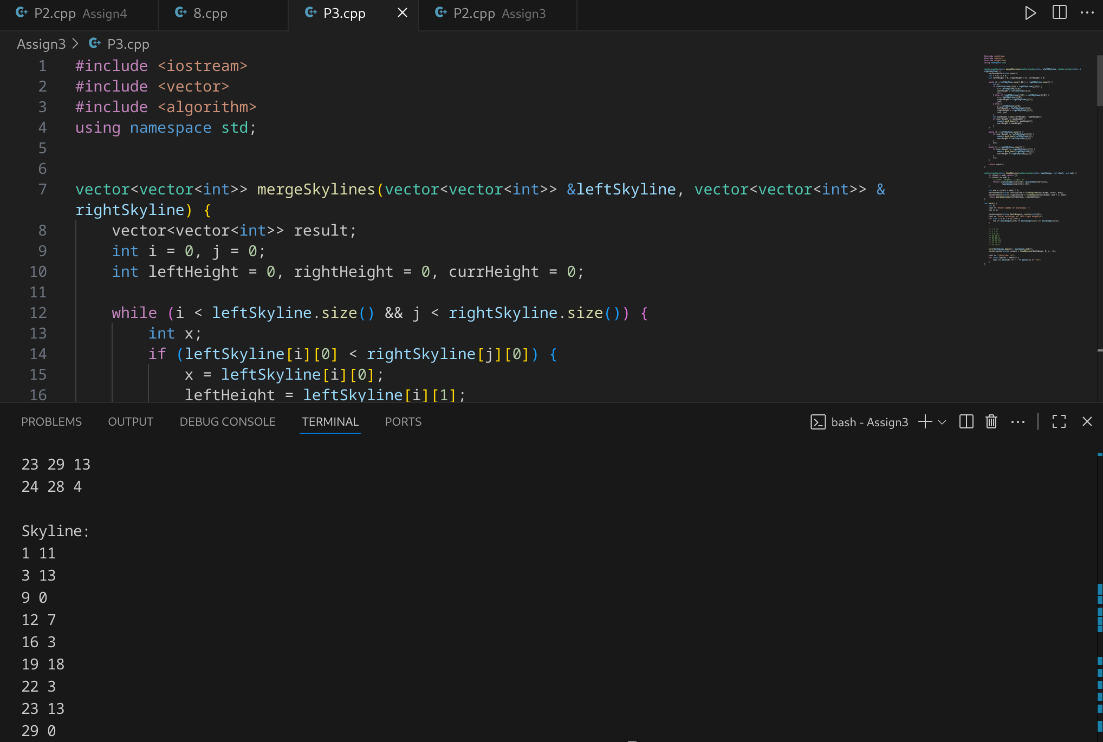
Third Year Computer Algorithm Laboratory (2025-26)

