Walchand College of Engineering, Sangli Department of Computer Science and Engineering
Batch T1
Assignment No. 4
Divide and conquer strategy
Aditi Mittal
Student PRN: 23610067

Problem Statement #1: Implement Naive method multiply two matrices and Justify complexity is o(n3)
- Technologies/libraries/algorithm used
- Naive Algorithm
- Related theory or any related information you want to add
We’re taking two matrices and of order and .
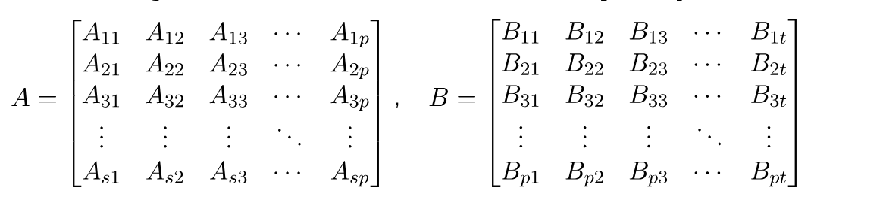
Now when we multiply the matrix by the matrix , we get another matrix – let’s name it . The order of the matrix would be .

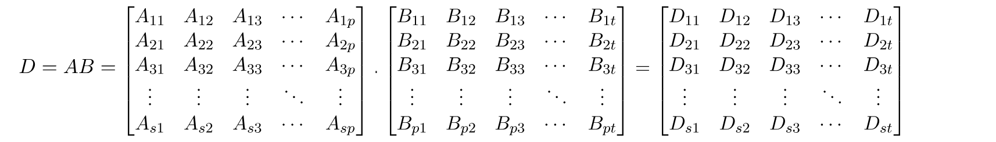
- Algorithm / procedure
algorithm NaiveMatrixMultiplication(A, B, A, B, G, H):
// INPUT
// A = Matrix of size s x p
// B = Matrix of size o x t
// OUTPUT
// D = The matrix product of S and P

if p = o:
for m <- 0 to s - 1:
for r <- 0 to t - 1:
D[m, r] <- 0 make a new matrix of size s x t
for k <- 0 to p - 1:
D[m, r] = D[m, r] + A[m, k] * B[k, r]
return D
else:
return "Incompatible dimensions"

4. Code
#include <iostream>
using namespace std;

int main() {
int s, p, o, t;

cout << "Enter rows and columns for matrix A: ";
cin >> s >> p;
cout << "Enter rows and columns for matrix B: ";
cin >> o >> t;

if (p != o) {
cout << "Incompatible dimensions" << endl;
return 0;
}

int A[s][p], B[o][t], D[s][t];

cout << "Enter elements of matrix A:" << endl;
for (int i = 0; i < s; i++) {
for (int j = 0; j < p; j++) {
cin >> A[i][j];
}
}

cout << "Enter elements of matrix B:" << endl;
for (int i = 0; i < o; i++) {
for (int j = 0; j < t; j++) {
cin >> B[i][j];
}
}

for (int i = 0; i < s; i++) {
for (int j = 0; j < t; j++) {
D[i][j] = 0;
for (int k = 0; k < p; k++) {
D[i][j] += A[i][k] * B[k][j];
}
}
}

cout << "Resultant matrix D:" << endl;
for (int i = 0; i < s; i++) {
for (int j = 0; j < t; j++) {
cout << D[i][j] << " ";
}
cout << endl;
}

return 0;
}
5. Screenshots of the output according to the problem statements
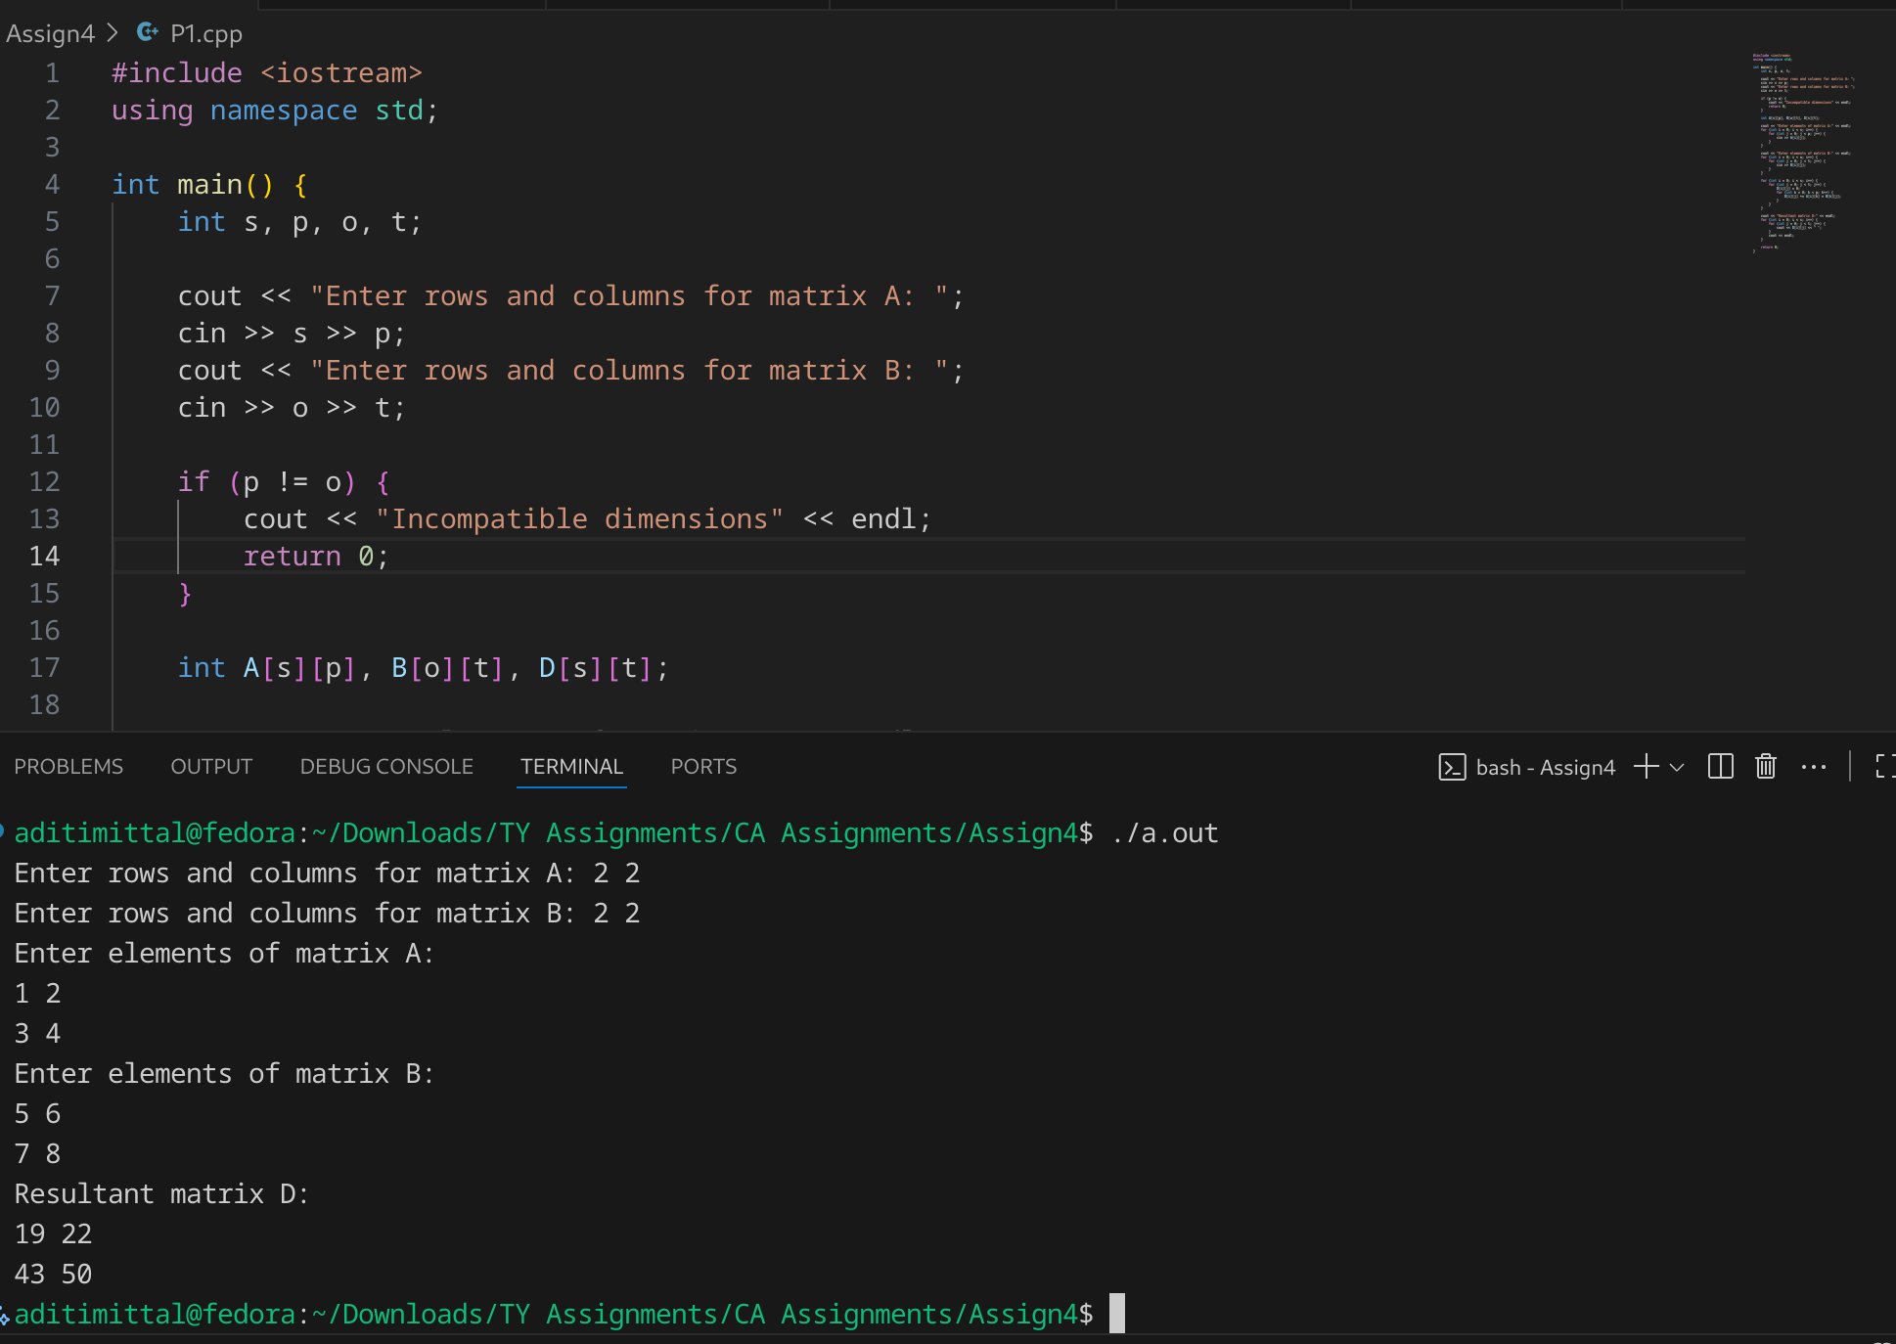

6. Dry Run:
Input:
A=[[1, 2,],[3,4]],B=[[5, 6], [7, 8]]
(s=2, p=2, o=2, t=2)

Step 1: Check
Since p=o (2 = 2), proceed.

Step 2: Initialize D
D = [[0, 0],
[0, 0]]

Step 3: Loops
- m = 0, r = 0
  - D[0][0] = 0
  - k=0 → D[0][0] = 0 + (1*5) = 5
  - k=1 → D[0][0] = 5 + (2*7) = 19
- m = 0, r = 1
  - D[0][1] = 0
  - k=0 → D[0][1] = 0 + (1*6) = 6
  - k=1 → D[0][1] = 6 + (2*8) = 22
- m = 1, r = 0
  - D[1][0] = 0
  - k=0 → D[1][0] = 0 + (3*5) = 15
  - k=1 → D[1][0] = 15 + (4*7) = 43
- m = 1, r = 1
  - D[1][1] = 0
  - k=0 → D[1][1] = 0 + (3*6) = 18
  - k=1 → D[1][1] = 18 + (4*8) = 50
7. Step-by-Step Complexity
- Outer loop (m from 0 → s-1):
Runs s times.
- Second loop (r from 0 → t-1):
Runs t times for each m.
So far → s × t iterations.
- Innermost loop (k from 0 → p-1):
Runs p times for each (m, r).
So far → s × t × p iterations.
- Inside innermost loop (constant work):
A[m][k] * B[k][r] → multiplication
D[m][r] + ... → addition
→ Constant time = O(1).
T(s,p,t)=O(s⋅p⋅t)
- If all matrices are square (n × n):
T(n)=O(n^3)

Space Complexity
- Storing result matrix D of size s × t → O(s × t)
- Input matrices A and B are given (not extra).
- Extra variables are constant → O(1).
So:
ComplexitySpace Complexity=O(s⋅t)

Source: https://www.baeldung.com/cs/matrix-multiplication-algorithms

Problem Statement #2: Implement Strassen’s matrix multiplication for 3*3 matrix.
- Technologies/libraries/algorithm used

Strassen’s Algorithm
- Related theory or any related information you want to add
In the year 1969, Volker Strassen made remarkable progress, proving the complexity was not optimal by releasing a new algorithm, named after him.
Where the naive method takes an exhaustive approach, the Stassen algorithm uses a divide-and-conquer strategy along with a nice math trick to solve the matrix multiplication problem with low computation.
Let matrices:
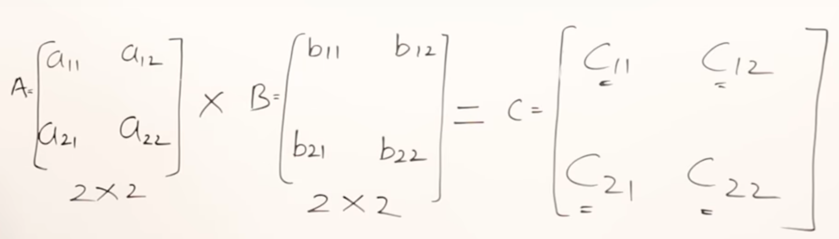
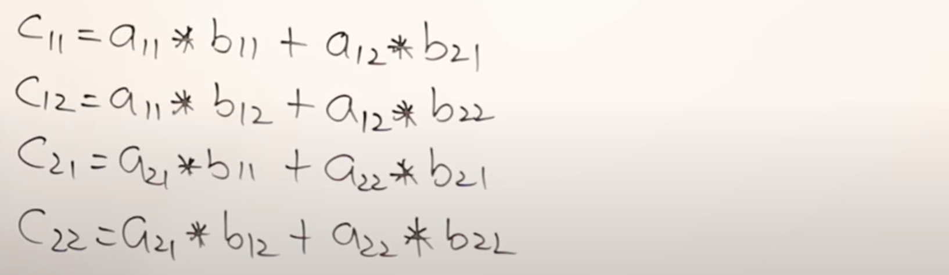
.
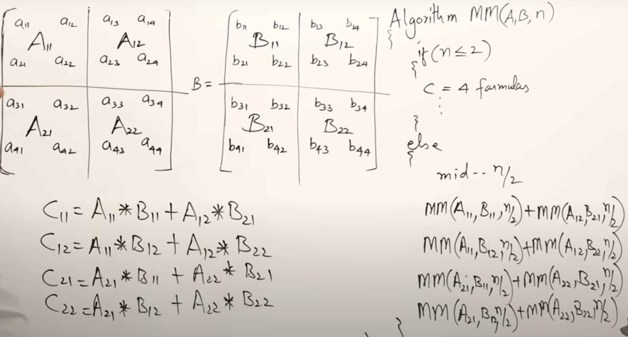
.
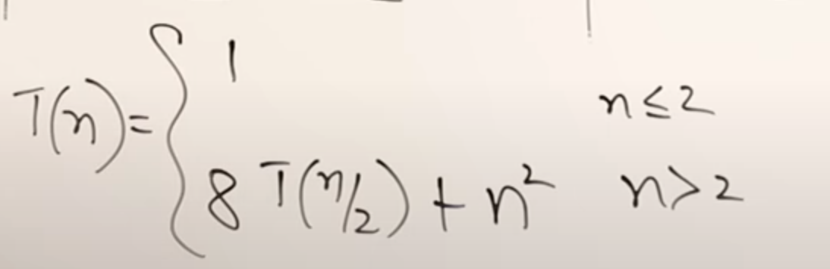
.
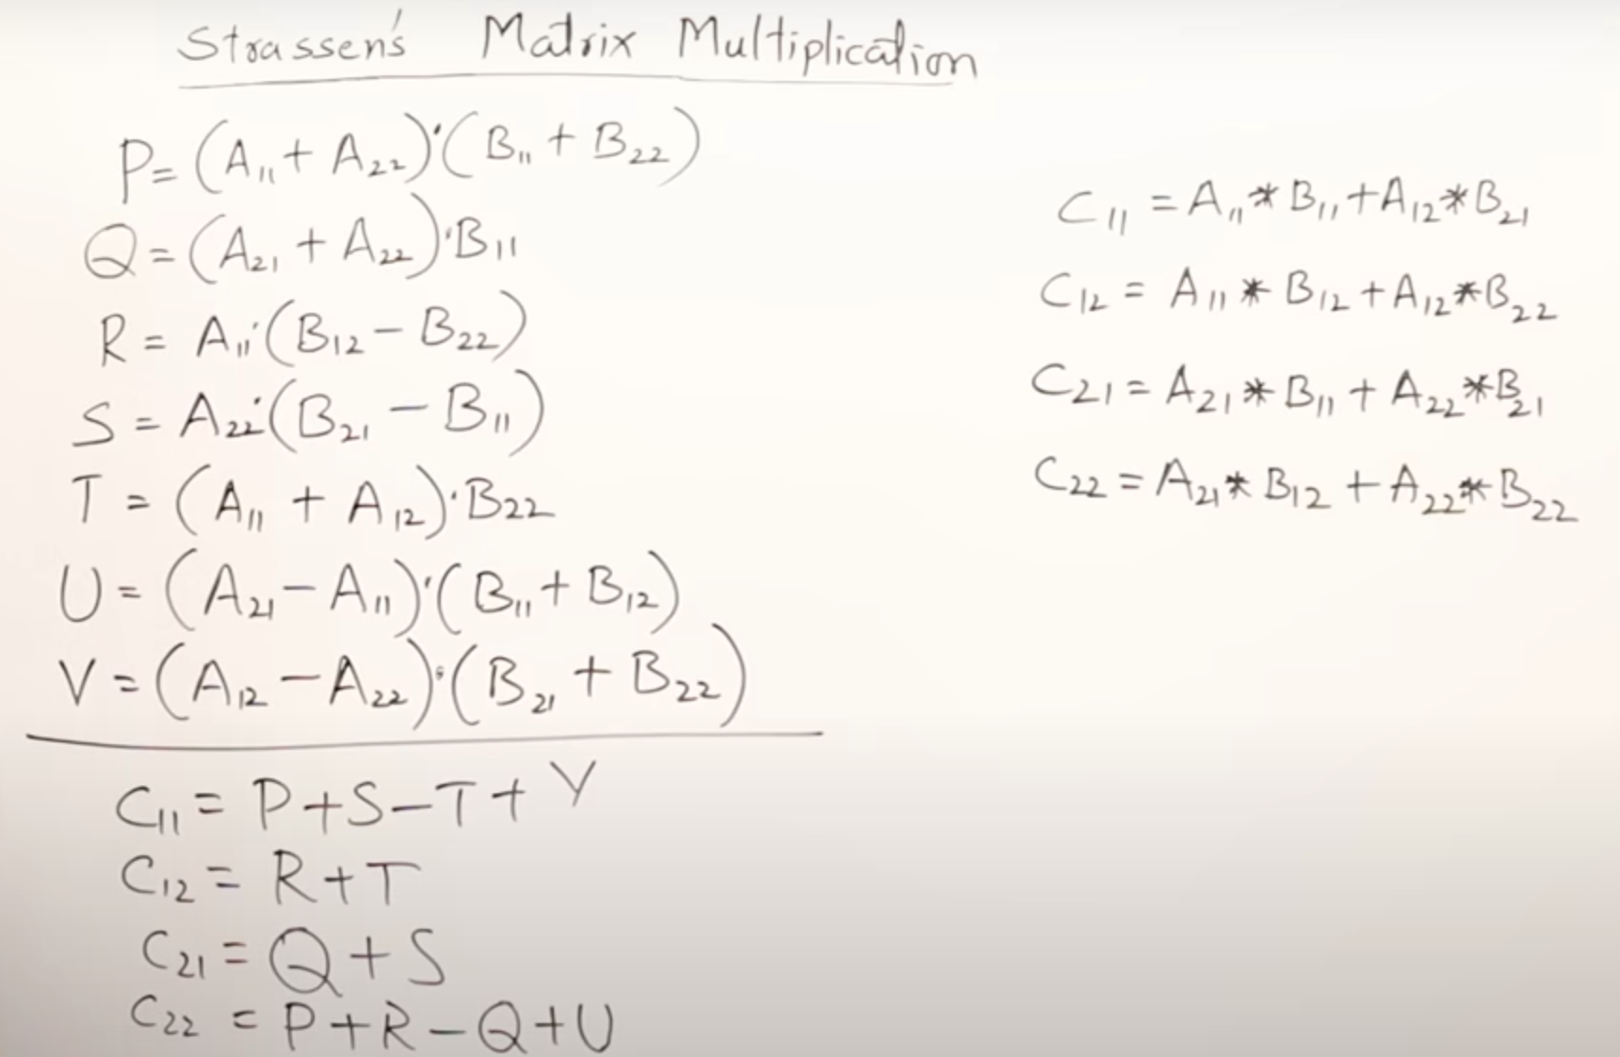
.

- Algorithm / procedure

Algorithm: StrassenMatrixMultiplication(A, B, n)
Input:
- A: Matrix of size n × n
- B: Matrix of size n × n
Output:
- C: Product matrix of size n × n

- If n is not a power of 2, pad both matrices with zeros to size m × m where m = next power of 2 ≥ n.
- If n = 1:
  - Return a matrix with single element A[0][0] * B[0][0].
- Partition A and B into four submatrices of size (n/2 × n/2) each:
A11, A12, A21, A22
B11, B12, B21, B22
- Compute the seven products using recursive calls:
P = multiply_matrices( A11 + A22 , B11 + B22 )
Q = multiply_matrices( A21 + A22 , B11 )
R = multiply_matrices( A11 , B12 - B22 )
S = multiply_matrices( A22 , B21 - B11 )
T = multiply_matrices( A11 + A12 , B22 )
U = multiply_matrices( A21 - A11 , B11 + B12 )
V = multiply_matrices( A12 - A22 , B21 + B22 )
- Compute resulting submatrices:
C11 = P + S - T + V
C12 = R + T
C21 = Q + S
C22 = P + R - Q + U
- Combine C11, C12, C21, C22 into final matrix C.
- If padding was applied, remove extra rows and columns to return the original n × n result.

- Code
#include <iostream>
#include <vector>
#include <cmath>
using namespace std;

using Matrix = vector<vector<int>>;

Matrix make_matrix(int n) {
return Matrix(n, vector<int>(n, 0));
}

void add_matrices(int n, const Matrix &A, const Matrix &B, Matrix &C) {
for(int i=0;i<n;i++)
for(int j=0;j<n;j++)
C[i][j] = A[i][j] + B[i][j];
}

void sub_matrices(int n, const Matrix &A, const Matrix &B, Matrix &C) {
for(int i=0;i<n;i++)
for(int j=0;j<n;j++)
C[i][j] = A[i][j] - B[i][j];
}

void multiply_matrices(int n, const Matrix &A, const Matrix &B, Matrix &C) {
if(n == 1){
C[0][0] = A[0][0] * B[0][0];
return;
}

int k = n/2;
Matrix A11 = make_matrix(k), A12 = make_matrix(k), A21 = make_matrix(k), A22 = make_matrix(k);
Matrix B11 = make_matrix(k), B12 = make_matrix(k), B21 = make_matrix(k), B22 = make_matrix(k);
Matrix P = make_matrix(k), Q = make_matrix(k), R = make_matrix(k), S = make_matrix(k),
T = make_matrix(k), U = make_matrix(k), V = make_matrix(k);
Matrix C11 = make_matrix(k), C12 = make_matrix(k), C21 = make_matrix(k), C22 = make_matrix(k);
Matrix temp1 = make_matrix(k), temp2 = make_matrix(k);

// Split matrices
for(int i=0;i<k;i++)
for(int j=0;j<k;j++){
A11[i][j]=A[i][j];
A12[i][j]=A[i][j+k];
A21[i][j]=A[i+k][j];
A22[i][j]=A[i+k][j+k];
B11[i][j]=B[i][j];
B12[i][j]=B[i][j+k];
B21[i][j]=B[i+k][j];
B22[i][j]=B[i+k][j+k];
}

// Strassen’s algorithm
add_matrices(k,A11,A22,temp1);
add_matrices(k,B11,B22,temp2);
multiply_matrices(k,temp1,temp2,P);

add_matrices(k,A21,A22,temp1);
multiply_matrices(k,temp1,B11,Q);

sub_matrices(k,B12,B22,temp1);
multiply_matrices(k,A11,temp1,R);

sub_matrices(k,B21,B11,temp1);
multiply_matrices(k,A22,temp1,S);

add_matrices(k,A11,A12,temp1);
multiply_matrices(k,temp1,B22,T);

sub_matrices(k,A21,A11,temp1);
add_matrices(k,B11,B12,temp2);
multiply_matrices(k,temp1,temp2,U);

sub_matrices(k,A12,A22,temp1);
add_matrices(k,B21,B22,temp2);
multiply_matrices(k,temp1,temp2,V);

add_matrices(k,P,S,temp1);
sub_matrices(k,temp1,T,temp2);
add_matrices(k,temp2,V,C11);

add_matrices(k,R,T,C12);
add_matrices(k,Q,S,C21);
add_matrices(k,P,R,temp1);
sub_matrices(k,temp1,Q,temp2);
add_matrices(k,temp2,U,C22);

// Combine results
for(int i=0;i<k;i++)
for(int j=0;j<k;j++){
C[i][j]=C11[i][j];
C[i][j+k]=C12[i][j];
C[i+k][j]=C21[i][j];
C[i+k][j+k]=C22[i][j];
}
}

int main(){
int n;
cout << "Enter size of square matrix: ";
cin >> n;

int size = 1;
while(size < n) size *= 2; // round up to next power of 2

Matrix A = make_matrix(size);
Matrix B = make_matrix(size);
Matrix C = make_matrix(size);

cout << "Enter elements of matrix A:\n";
for(int i=0;i<n;i++)
for(int j=0;j<n;j++)
cin >> A[i][j];

cout << "Enter elements of matrix B:\n";
for(int i=0;i<n;i++)
for(int j=0;j<n;j++)
cin >> B[i][j];

multiply_matrices(size,A,B,C);

cout << "Resultant matrix:\n";
for(int i=0;i<n;i++){
for(int j=0;j<n;j++)
cout << C[i][j] << " ";
cout << endl;
}
return 0;
}
- Screenshots of the output according to the problem statements
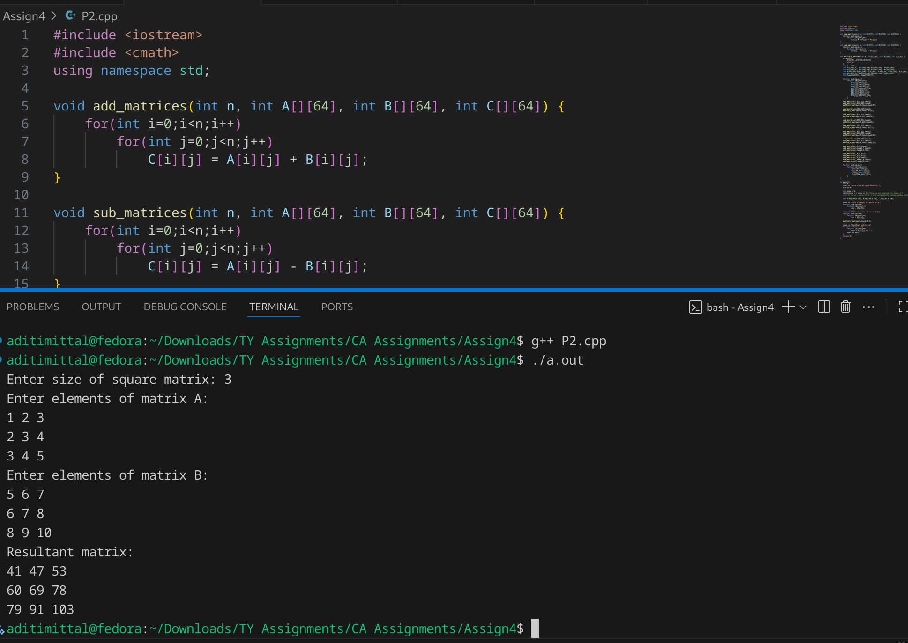
- Source:
https://www.youtube.com/watch?v=vStua4YTkQY
https://www.youtube.com/watch?v=0oJyNmEbS4w
https://www.baeldung.com/cs/matrix-multiplication-algorithms
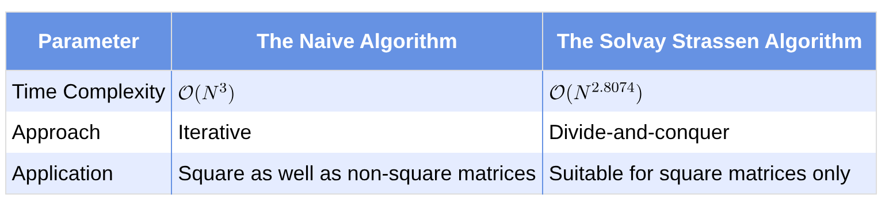

1 | P a g e
Third Year Computer Algorithm Laboratory (2025-26)

