Walchand College of Engineering, Sangli
Computer Science & Engineering Third Year
Course: Computer Algorithm Lab

Week 5 Assignment

Divide and conquer strategy
- You are working on the city construction project. You have A houses in the city. You have to divide these houses into B localities such that every locality has at least one house. Also, every house in a locality should have a telephone connection wire with each of the other houses in the locality.You are given integers A and B.

Task

Print the minimum and the maximum number of telephone connections possible if you design the city accordingly.

Algorithm:
- Total houses = A
- Total Localities = B
- Every house is connected to every other house in a locality, i.e., a complete graph of n houses(nodes) will have n(n-1)/2 network connections.
- Goal is to:
  - Maximise number of total connections:
- It is observed that x(x-1)/2 + y(y-1)/2 < (x+y)(x+y-1)/2
Eg. let A = 5, B = 2: x = 2, y = 3,
2(2-1)/2 + 3(3-1)/2 = 4, (2+3)(2+3-1)/2 = 10.
Thus, the maximum number of connections can be achieved by creating 1 locality with the maximum number of houses to maximise connections and rest B-1 localities with 1 house each i.e. 0 connections each.
  - Minimise number of total connections:
- Minimum number of connections can be achieved if the houses are almost evenly distributed among all localities. So, we can place floor(A/B) houses in each locality and remaining A mod B houses can be distributed as 1 among each locality.
Pseudocode:
- Input A, B;
- maxConnections = (B-1) localities * 0 connections each + 1 locality * (A-(B-1))* (A-(B-1)-1) / 2 connections
- minConnections = (A mod B)localities * ((A/B) + 1)((A/B) + 1 - 1)/2 connections + (B - (A mod B))localities * (A/B)(A/B -1)/2 connections

Time complexity: O(1) (constant time)

Code:

#include <iostream>
using namespace std;
int main(){
int A; // number of houses
int B; // number of localities
cout << "Enter number of houses: ";
cin >> A;
cout << "Enter number of localities: ";
cin >> B;
int maxConnections = 0;
int minConnections = 0;
//max
//max connections can be made using:
// 1 locality with max number of houses and
// B-1 localities with 1 house each
// thus total number of connections:
// B-1 localities: 1 house each: 0 connections
// 1 locality with A-(B-1) houses: nC2 connections between them

maxConnections = (B-1)*0 + (A-(B-1))* (A-(B-1) - 1) / 2;

//min
//min connections can be made using:
// all houses with roughly equal houses i.e. A/B houses
int quotient = A/B; // by default will return floor int value for the division
int remainder = A%B; // will return the remaining houses;
// now we have "remainder" number of LOCALITIES with "quotient+1" houses
// and "B-remainder" number of localities with "quotient" houses
minConnections = remainder * ((quotient + 1) * (quotient + 1 - 1)/2) + (B-remainder)* (quotient * (quotient - 1) / 2);
cout<<"Maximum number of connections: " << maxConnections<< endl;
cout<<"Minimum number of connections: " << minConnections << endl;

return 0;
}

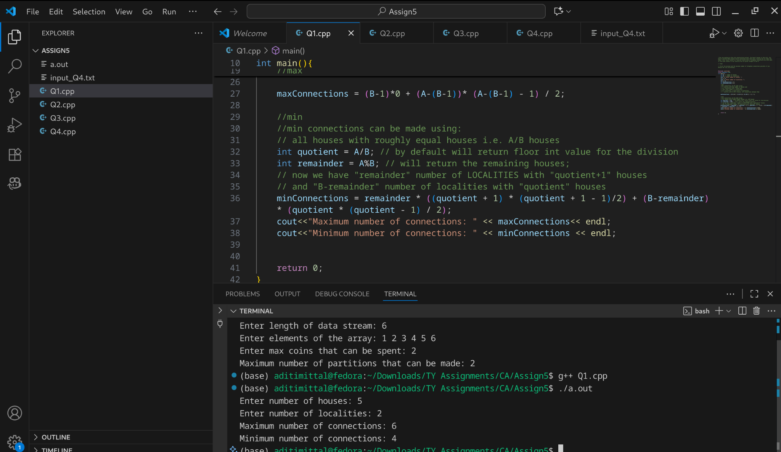

- You are working in the Data Consistency team of your company. You are allocated a task as follows:

  - You have a data stream consisting of an equal number of odd and even numbers. You can make separations in the data stream but the number of odd elements should be equal to the number of even elements in both partitions after separation. Also, if you make a separation between a number x and number y, then the cost of this operation will be |x-y| coins.

You are given the following:

  - An integer N
  - An array arr
  - An integer K

Task

Determine the maximum number of separations that can be made in the array by spending no more than K coins.

Concept:
- We have an array of n integers with both odd and even numbers. The number of elements = number of even elements. (implying pre-requisite that n can only be a power of 2).
- We have to find in how many ways we can partition the array such that the number of even partitions = number of odd elements in each of the partitions.
- For every partition at ith index, cost of partition is abs(arr[i] + arr[i+1]).
- We have to maximise the number of partitions by minimising cost. We can only spend k coins.

Algorithm:
- Take input n, array of integers arr, max cost k.
- DEclare variables odd =0, even = 0, vector to store partition costs.
- Traverse through the array:
  - If arr[i] is even: even ++
  - Else odd++
  - If odd = even
A partition can be created here.
Push_back cost of partition abs(arr[i] + arr[i+1]) to vector.
- Sort the vector in ascending order.
- Create a maxSEparations Counter = 0
- While k>0, traverse through the vector:
  - If k>=vector[i]:
    - Add a partition here
    - Decrement k by vector[i]
    - Increment maxSeparations counter.
- REport maxSEparations Counter.

Time Complexity
Step | Complexity
Counting odd/even & finding potential cuts | O(n)
Sorting partition costs | O(n log n)
Selecting partitions under budget K | O(n)
Total | O(n log n)

\Code:
// You are working in the Data Consistency team of your company. You are allocated a task as follows:

// You have a data stream consisting of an equal number of odd and even numbers. You can make separations in the data stream but the number of odd elements should be equal to the number of even elements in both partitions after separation. Also, if you make a separation between a number x and number y, then the cost of this operation will be |x-y| coins.

// You are given the following:

// An integer N
// An array arr
// An integer K

// Task

// Determine the maximum number of separations that can be made in the array by spending no more than K coins.

/*
Question Explanation:
n-> array length
arr -> of integers where total number of odd numbers = total number of even numbers
if i make a cut between arr[i] and arr[i+1], cost = |arr[i]-arr[i+1]|
after each cut, number of odd and even numbers in both partitions should be equal
k-> max coins that can be spent
GOAL: To maximise number of cuts
*/

#include <iostream>
#include <vector>
#include <algorithm>
using namespace std;

int main(){
// You have a data stream consisting of an equal number of odd and even numbers.
// implies n is a multiple of 2
int n;
cout << "Enter length of data stream: ";
cin >> n;
int arr[n];
cout << "Enter elements of the array: ";
for(int i = 0; i<n; i++){
cin >> arr[i];
}
int k; // max coins that can be spent
cout << "Enter max coins that can be spent: ";
cin >> k;
int odd = 0;
int even = 0;
vector <int> partitions;
for (int i=0; i<n; i++){
if(arr[i] % 2 == 0){
even++;
}
else{
odd++;
}
if (odd == even){
int partition_cost = abs(arr[i] - arr[i+1]);
partitions.push_back(partition_cost);
}

}
// now we have all the possible partitions and their costs
// to maximise partitions, sort partition costs in ascending order
sort(partitions.begin(), partitions.end());
int ptr = 0;
while(k > 0 && ptr<partitions.size()){
if(k - partitions[ptr] >= 0){
k -= partitions[ptr];
ptr++;
}
else{
break;
}
}
cout << "Maximum number of partitions that can be made: " << ptr << endl;
return 0;
}

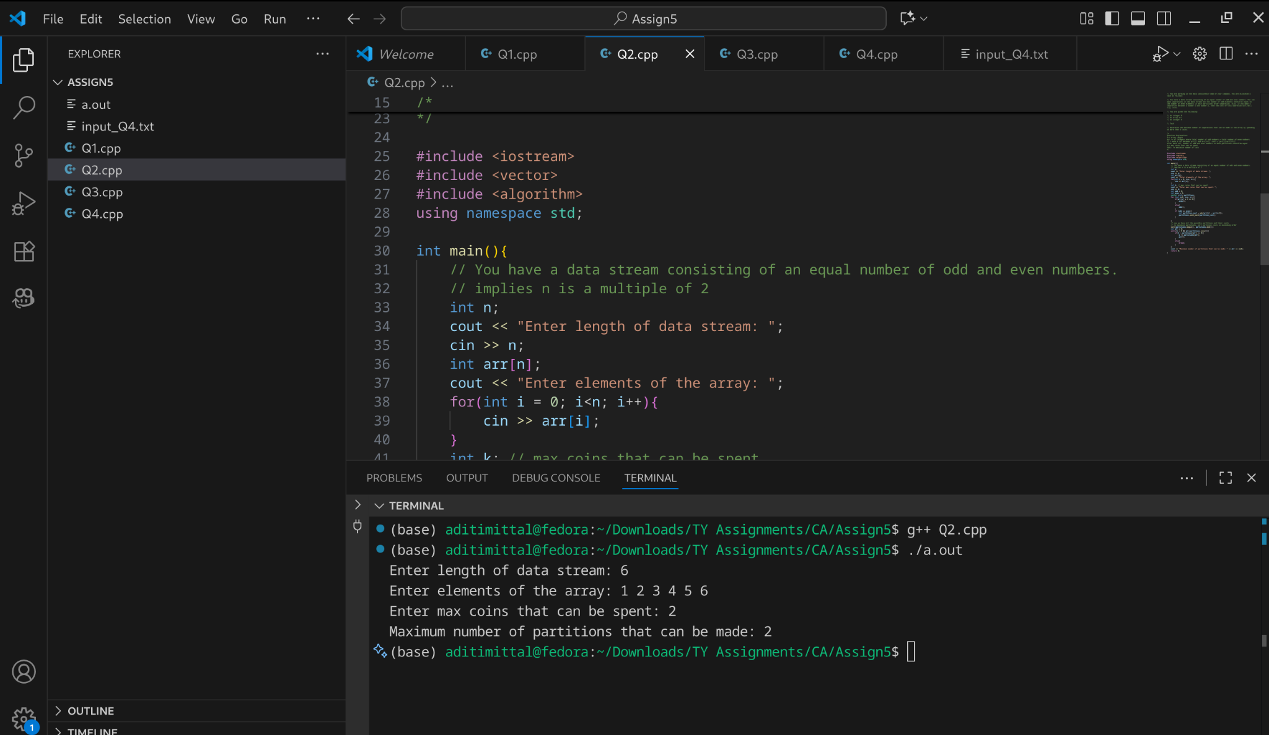
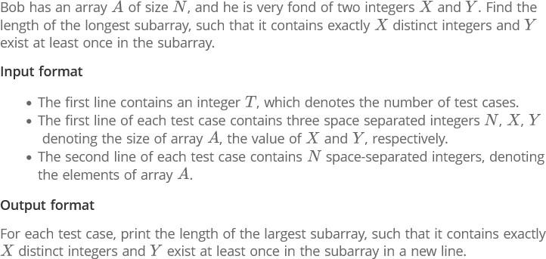

Concept:
Sliding Window: 2 pointer approach

Algorithm:
- For every test case:
  - Initialise leftptr =0, freq map, maxLength = -1, distinctCount = 0
  - While rightptr =0, rightptr<n, rightptr ++;
  - Check if arr[rightptr] has a freq 0 in the freq map. If yes, its a distinct integer, increment distinctCount else, its a repeated digit dint increment distinctCount.
  - If distinctCount > x
    - Shrink the window from left side
      - If freq of arr[leftptr] = 0
        - Decrement the freq of arr[leftptr]
        - Increment Leftptr
  - If distincount = x and freq of y >0
    - Maxlength = max(maxlength, rightptr-leftptr+1)
  - Print maxlength for the particular testcase.
Time Complexity:
Unordered_map operations = O(1)
While loop: O(n)
For each test case: O(T)
Overall time complexity:
Per testcase: O(n)
For all testcases: O(T*n)

Code:
/*
Bob has an array A of size N, and he is very fond of two integers X and Y.
Find the length of the longest subarray such that

it contains exactly X distinct integers, and

Y exists at least once in the subarray.

Input format

The first line contains an integer T, denoting the number of test cases.

The first line of each test case contains three space-separated integers N, X, Y,
denoting the size of array A, the value of X, and the value of Y respectively.

The second line of each test case contains N space-separated integers, the elements of array A.

Output format
For each test case, print the length of the largest subarray such that it contains exactly X distinct integers and Y exists at least once in the subarray, each answer on a new line.
*/

#include <iostream>
#include <vector>
#include <unordered_map>
using namespace std;

int main(){
int t;
cin >> t;
int n, x, y;
for (int j = 0; j<t; j++){
cin >> n >> x >> y;
vector<int> arr(n);
for(int i =0; i<n; i++){
cin >> arr[i];
}
int leftptr = 0;
int maxLength = -1;
int distinctCount = 0;
unordered_map<int, int> freqMap;
for (int rightptr = 0; rightptr < n; rightptr++){
// frequency map to store frequency of elements in current window
if (++freqMap[arr[rightptr]] == 1){
distinctCount++;
}
while (distinctCount > x){
//shrink window from left until distinctCount becomes x
if(--freqMap[arr[leftptr]] == 0){
distinctCount--;
}
leftptr++;
}

if(distinctCount == x && freqMap[y] > 0){
maxLength = max(maxLength, rightptr - leftptr + 1);
}

}
cout << maxLength << endl;

}

return 0;
}

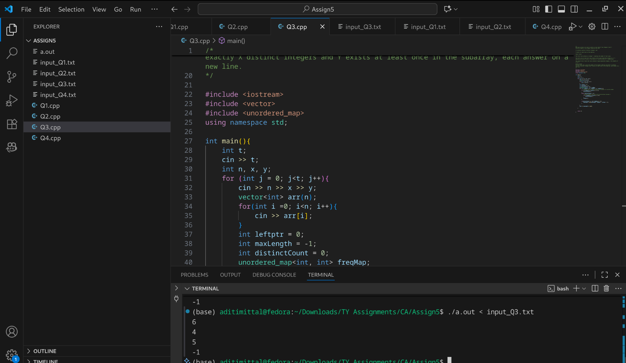

- The country of Byteland consists of n cities. Between any 2 cities it is possible to have a railway track and a road. Railway tracks are bidirectional, meaning if there exists a railway track between u and v then you can take a train from u to v as well as from v to u. Similarly, roads are bidirectional, meaning if there exists a route between u and v then you can drive from u to v as well as from v to u.

2 cities, u and v are called railway-connected if it is possible to travel between u and v using railway tracks.

2 cities, u and v are called road-connected if it is possible to travel between u and v using roads.The transportation network is called balanced if for all pairs of cities u, v:
u,v are railway-connected if and only if u,v are road-connected.

Initially, there are n cities and no roads or railways in Byteland. You will be given q instructions asking you to build either a railway track or a road between some 2 cities. After each instruction, you must report whether the transportation network is balanced.

Input format

The first line of input will contain 2 integers, n and q. q lines will follow. Each line will contain 3 space-separated integers in one of the following formats:

1 u v : build a railway track between u and v

2 u v : build a road between u and v

Output format

You must print q lines. The ith line contains an answer to the question whether the transport network is balanced after the ith instruction. If it is balanced print "YES" (without quotes) otherwise print "NO" (without quotes)

Intuition:
Two separate graphs on n nodes:
- Railway graph
- Road graph
Balanced network:
u and v are railway-connected ⇔ u and v are road-connected
i.e., connected components of railway and road graphs are identical.
We process q instructions adding edges. After each addition, report "YES" if balanced, else "NO".

Pseudocode:
Start with n cities. No roads or railways exist.
For each instruction:
a. Read the instruction (type, u, v):
- type = 1 → build a railway between city u and city v
- type = 2 → build a road between city u and city v
b. Add the connection to the corresponding network (railway or road).
c. Find connected groups in both networks:
- For the railway network:
  - Go through all cities.
  - If a city is not yet assigned to a group, start a DFS from it.
  - Mark all cities reachable from it as belonging to the same group.
  - Give each group a unique number (like a “flag”).
- Do the same for the road network.
d. Compare groups:
- For each city, check if its railway group number is equal to its road group number.
- If all cities match, the network is balanced → print "YES".
- If any city doesn’t match, the network is not balanced → print "NO".
Code:
/*
The country of Byteland consists of n cities. Between any 2 cities it is possible to have a railway track and a road. Railway tracks are bidirectional, meaning if there exists a railway track between u and v then you can take a train from u to v as well as from v to u. Similarly, roads are bidirectional, meaning if there exists a route between u and v then you can drive from u to v as well as from v to u.

2 cities, u and v are called railway-connected if it is possible to travel between u and v using railway tracks.

2 cities, u and v are called road-connected if it is possible to travel between u and v using roads.The transportation network is called balanced if for all pairs of cities u, v:
u,v are railway-connected if and only if u,v are road-connected.

Initially, there are n cities and no roads or railways in Byteland. You will be given q instructions asking you to build either a railway track or a road between some 2 cities. After each instruction, you must report whether the transportation network is balanced.

Input format

The first line of input will contain 2 integers, n and q. q lines will follow. Each line will contain 3 space-separated integers in one of the following formats:

1 u v : build a railway track between u and v

2 u v : build a road between u and v

Output format

You must print q lines. The ith line contains an answer to the question whether the transport network is balanced after the ith instruction. If it is balanced print "YES" (without quotes) otherwise print "NO" (without quotes)
*/

#include <iostream>
#include <vector>
using namespace std;

void dfs(int node, int flag, vector<int>& comp, vector<vector<int>>& adj) {
comp[node] = flag;
for (int neighbour : adj[node]) {
if (comp[neighbour] == -1)
dfs(neighbour, flag, comp, adj);
}
}

int main() {
int n, q;
cin >> n >> q;

vector<vector<int>> railway(n+1), road(n+1);

for (int i = 0; i < q; i++) {
int type, u, v;
cin >> type >> u >> v;

if (type == 1) {
railway[u].push_back(v);
railway[v].push_back(u);
} else {
road[u].push_back(v);
road[v].push_back(u);
}
// For railway: connected components
vector<int> comp_rail(n+1, -1);
int flag = 0;
for (int j = 1; j <= n; j++) {
if (comp_rail[j] == -1) {
dfs(j, flag, comp_rail, railway);
flag++;
}
}

// For road: connected components
vector<int> comp_road(n+1, -1);
flag = 0;
for (int j = 1; j <= n; j++) {
if (comp_road[j] == -1) {
dfs(j, flag, comp_road, road);
flag++;
}
}

// Check if network is balanced
bool balanced = true;
for (int j = 1; j <= n; j++) {
if (comp_rail[j] != comp_road[j]) {
balanced = false;
break;
}
}

cout << (balanced ? "YES" : "NO") << endl;
}

return 0;
}

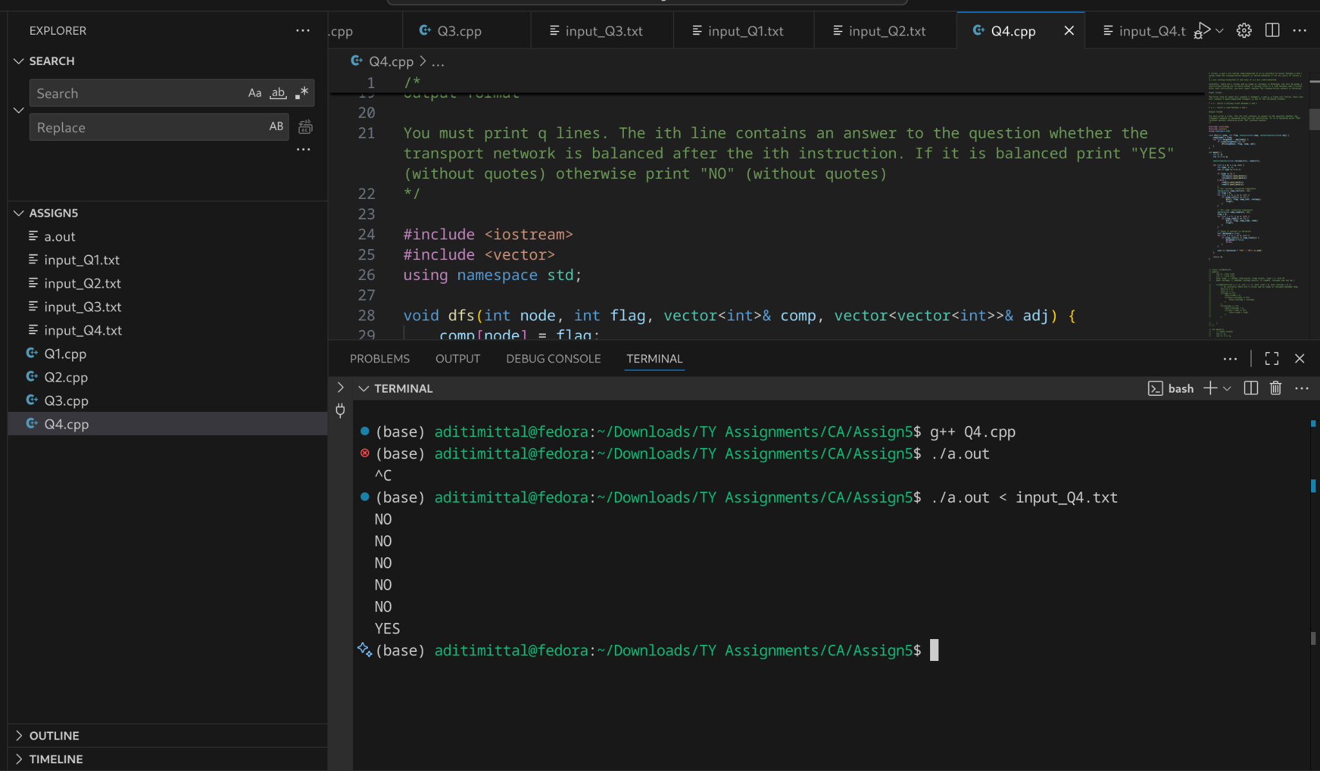

Time Complexity: O(q^2)
- For loop: O(q)
- Per query: O(n+q)

