Walchand College of Engineering, Sangli
Computer Science & Engineering Third Year
Course: Computer Algorithm Lab

Assignment No. 6 Greedy Method
Implement Kruskal’s algorithm & Prim's algorithm to find Minimum Spanning Tree (MST) of the given an undirected, connected and weighted graph.
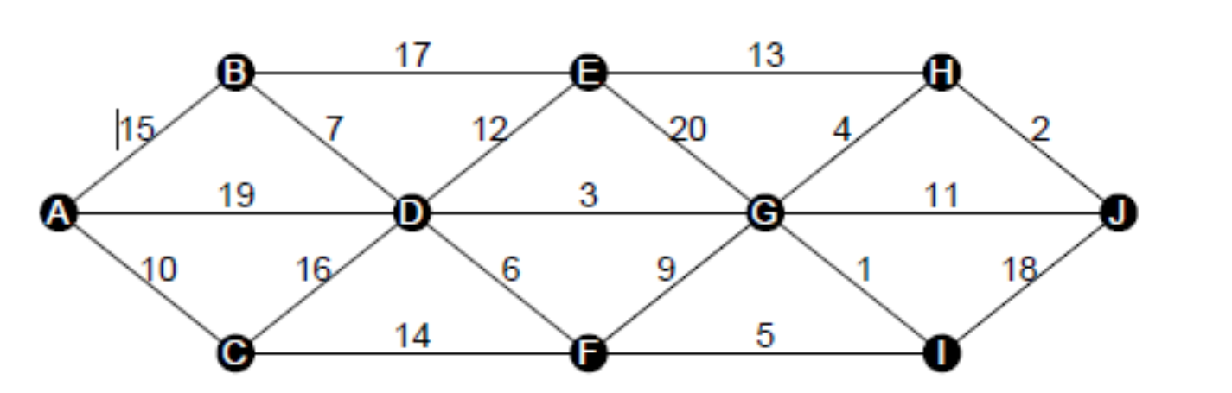

Q) How many edges does a minimum spanning tree for above example?
Answer: For a connected graph with n nodes, an MST always has n − 1 edges, i.e. 9 here
Q) In a graph G. let the edge u v have the least weight. is it true that u v is always part of any minimum spanning tree of G?.Justify your answers.
Answer: Not necessarily. While the minimum-weight edge is always in some MST, it is not guaranteed to appear in all MSTs if there are multiple edges with the same weight or multiple MSTs exist.
Q) Let G be a graph and T be a minimum spanning tree of G. Suppose that the weight of an edge e is decreased. How can you find the minimum spanning tree of the modified graph? What is the runtime of your solution?
Answer: Only edges with decreased weight could become part of MST if they weren’t included before. Check if e is in the current MST:
- If yes -> MST weight decreases by difference -> MST still valid.
- If no -> Add e to MST temporarily -> a cycle forms -> remove the maximum weight edge in that cycle -> MST is updated.
Q) Find order of edges for Kruskal's and Prim's?
Kruskal:
- Sort all edges by weight ascending -> process edges from smallest to largest.
- Add edge if it does not form a cycle.
Prim:
- Start from any node -> maintain priority queue of edges to unexplored nodes.
- Always pick the smallest weight edge connecting MST so far to a new node.
- Order depends on starting node and graph structure.

Concept:
- Prim’s Algorithm
Starting at a particular node, we traverse through the graph and find its adjacent nodes, we pick an edge between the current node and adjacent node with the least weight. Then we move on to that adjacent node and repeat the process. If a node is already visited, we skip it and do not form closed loops.
Minimum spanning tree of n nodes and n-1 edges.
Algorithm:
- We create a vector initialised to 0 that stores whether a certain node has been visited or not where the node number is denoted by the array index.
For n nodes, we initialise a vector of size n+1 with values all 0.
- Next we create a priority queue (can also use a min heap) to store the adjacent nodes and their weights as: {edge_weight, adjacent_node, current_node}.
- As we visit the various nodes, we push its adjacent nodes along with their weights to the priority queue. We then fetch the node with the least weight (i.e. top of the priority queue) and if the adjacent node is not already visited, we add an edge between the current node and that adjacent node.
- This process continues inside a loop till the priority queue is empty, i.e. all edges have been processed.
- At each iteration, we store the pair {current_node, adjacent_node} in a vector<pair<int,int>> to store the edges of the minimum spanning tree whenever a new edge is added.
- A sum variable initially initialised to 0, stores the sum of all the weights of the edges chosen in the MST.
2. Kruskal’s ALgorithm
Start by sorting the edges:
- Take all edges of the graph and sort them in ascending order of their weights.
- This way, we always consider the smallest edges first.
Prepare a “parent” array for nodes:
- Create a vector of size n (number of nodes), where each node initially points to itself.
- This keeps track of which component (or set) each node belongs to.
Go through the edges one by one:
- For each edge (u, v, weight) in sorted order:
  - Check if u and v belong to different sets (using the find_set function).
  - If they are in different sets, adding this edge will not create a cycle.
    - So, we add this edge to the MST.
    - Update the total MST weight by adding this edge’s weight.
    - Merge the two sets by updating the parent array (parent[u] = v).
  - If they are in the same set, skip the edge (it would create a cycle).
Repeat until you have n−1 edges in MST:
- Once we have n−1 edges (for n nodes), the MST is complete.
Store MST edges and sum of weights:
- Maintain a vector of pairs {u, v} to store the edges added to the MST.
- Keep a sum variable to track the total weight of the MST.

Code:
#include <bits/stdc++.h>
using namespace std;

struct Edge {
int u, v, weight;
};

bool custom_comparator(Edge a, Edge b) {
return a.weight < b.weight;
}

bool hasCycle(int u, int parent, vector<vector<int>>& adj, vector<bool>& visited) {
visited[u] = true;
for (int v : adj[u]) {
if (!visited[v]) {
if (hasCycle(v, u, adj, visited)) return true;
} else if (v != parent) {
return true;
}
}
return false;
}

void kruskal_algo(int n, vector<Edge>& edges) {
sort(edges.begin(), edges.end(), custom_comparator);

vector<vector<int>> adj(n);
vector<pair<int,int>> mst_edges;
int mst_weight = 0;

for (auto e : edges) {
// Add edge temporarily
adj[e.u].push_back(e.v);
adj[e.v].push_back(e.u);

// Check for cycle
vector<bool> visited(n, false);
if (hasCycle(0, -1, adj, visited)) {
// Cycle detected, remove edge
adj[e.u].pop_back();
adj[e.v].pop_back();
} else {
// No cycle, include edge in MST
mst_edges.push_back({e.u, e.v});
mst_weight += e.weight;
}
}

cout << "Kruskal MST weight: " << mst_weight << endl;
cout << "Edges in MST: ";
for (auto p : mst_edges) {
cout << "(" << p.first << "," << p.second << ") ";
}
cout << endl;
}

void prims_algo(int n, vector<vector<pair<int,int>>>& adj) {
vector<int> key(n, INT_MAX);
vector<int> parent(n, -1);
vector<bool> visited(n, false);

key[0] = 0;
priority_queue<pair<int,int>, vector<pair<int,int>>, greater<pair<int,int>>> pq;
pq.push({0, 0});
while (!pq.empty()) {
int u = pq.top().second;
pq.pop();

if (visited[u] == true) {
continue;
} else {
visited[u] = true;
}
for (auto e : adj[u]) {
int v = e.first;
int w = e.second;
if (visited[v] == false && w < key[v]) {
key[v] = w;
parent[v] = u;
pq.push({key[v], v});
}
}
}

int mst_weight = 0;
vector<pair<int,int>> mst_edges;
for (int i = 1; i < n; i++) {
mst_weight += key[i];
mst_edges.push_back({parent[i], i});
}

cout << "Prim MST weight: " << mst_weight << endl;
cout << "Edges in MST: ";
for (auto p : mst_edges) {
cout << "(" << p.first << "," << p.second << ") ";
}
cout << endl;
}

int main() {
int n, m;
cout << "Enter number of nodes: ";
cin >> n;
cout << "Enter number of edges: ";
cin >> m;

vector<Edge> edges(m);
vector<vector<pair<int,int>>> adj(n);

cout << "Enter edges (u v weight)" << endl;
for (int i = 0; i < m; i++) {
cin >> edges[i].u >> edges[i].v >> edges[i].weight;
adj[edges[i].u].push_back({edges[i].v, edges[i].weight});
adj[edges[i].v].push_back({edges[i].u, edges[i].weight});
}

kruskal_algo(n, edges);
prims_algo(n, adj);

return 0;
}

Screenshots:
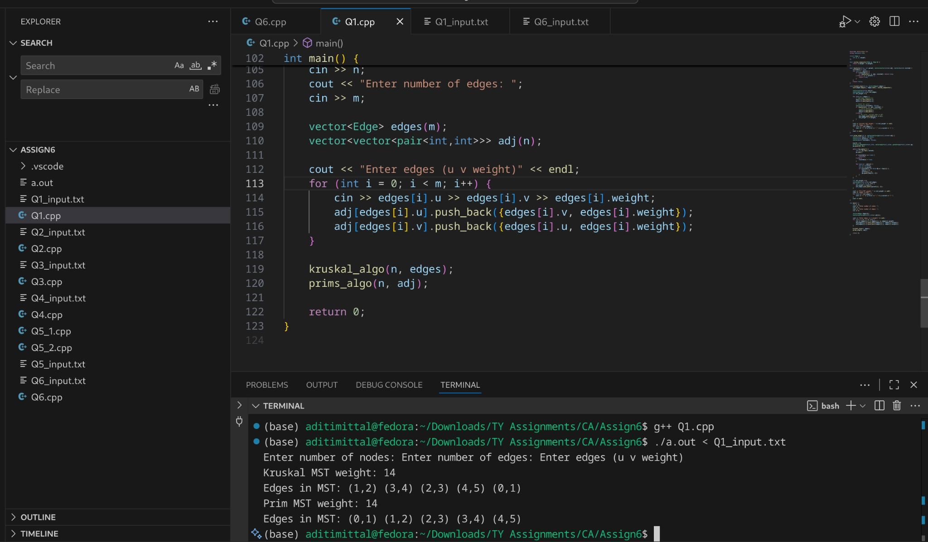

Prim’s Algorithm (using min-heap / priority queue)
- Initialization: O(V)
- Priority queue operations:
  - Each edge might be pushed/popped -> O(E log V)
- Total complexity: O(E log V + V log V) ≈ O(E log V)

Kruskal (using adjacency list + DFS for cycle detection)
- Sorting edges:
  - You sort all E edges -> O(E log E)
- Cycle detection per edge:
  - For each edge, you add it and run DFS to check for cycles.
  - DFS takes O(V + E) per edge in the worst case.
- Total complexity: O(E log E + E⋅(V + E)) ≈ O (E⋅(V + E))

Emergency Evacuation – Container Loading
Evacuating 200 families with varying luggage weights onto a bus with a capacity of 5000 kg. Input sample:
Bus Capacity = 5000
Families’ luggage = [45, 120, 300, 150, 90, 600, 75, 430, 250, 500,
60, 100, 700, 85, 95, 200, 320, 180, 150, 275, ...]
Implement container loading problem.

Concept:

Container Loading Problem

We arrange the weights of the luggages in ascending order.

The goal is to maximize the number of luggages.

Algorithm:

We first take input of all the luggage weights in a vector of type int.

Next we sort them in the ascending order.

Loop through the vector and while capacity of bus is still >0, check if the weight of luggage[i] <= capacity, increment the number of luggages and decrease the bus capacity left. If luggage[i]>capacity all successive weights in the sorted array will also weight more than the capacity, thus break from the loop.

Print the number of luggages that can be loaded.

Code:

/*

Emergency Evacuation – Container Loading

Evacuating 200 families with varying luggage weights onto a bus with a capacity of 5000 kg. Input sample:

Bus Capacity = 5000

Families’ luggage = [45, 120, 300, 150, 90, 600, 75, 430, 250, 500,

60, 100, 700, 85, 95, 200, 320, 180, 150, 275, ...]

Implement container loading problem.

*/

#include <iostream>

#include <vector>

#include <algorithm>

using namespace std;

int main(){

// number of families (luggages)

int number_of_luggages;

cout << "Enter number of luggages: ";

cin >> number_of_luggages;

//capacity of bus

int capacity;

cout << "Enter bus capacity: ";

cin >> capacity;

// number of lugages loaded

int num_loaded = 0;

vector<int> luggages(number_of_luggages);

for(int i = 0; i<number_of_luggages; i++){

cin >> luggages[i];

}

sort(luggages.begin(), luggages.end());

int i = 0;

cout << endl << "Luggages loaded: "<< endl;

while(i<number_of_luggages && capacity>0){

if(luggages[i]<=capacity){

capacity -= luggages[i];

cout << luggages[i] << " ";

num_loaded += 1;

i++;

}

else{

break;

}

}

cout << endl;

cout << "Number of luggages loaded: " << num_loaded << endl;

return 0;

}

Time Complexity:

Input: O(n)

Sorting: O(n log n)

Greedy Algorithm O(n)

Total Time Complexity: O(n) + O(n log n) + O(n) = O(n log n)

3. Startup Pitch Scheduling – Job Sequencing

50 startups pitching to an investor, with deadlines (1–10 slots) and profits (10–500).

Input sample:
Startups =
S1(deadline=2, profit=300), S2(1, 200), S3(3, 180), S4(2, 400),
S5(1, 250), S6(3, 100), S7(4, 500), S8(2, 150), S9(3, 220), S10(4, 330), ...
Slots Available = 10
Concept:
Greedy Algorithm
- Delay the job to the last days
- Maximise profits
Algorithm:
- Create a class jobs with data members and constructor with parameters initialised to 0 to work both as a parameterised and non parameterised constructor (needed when initialising vector jobs of job without initial values).
- Create a vector jobs of type job and take input from user and call the constructor.
- Sort the vector in decreasing order of profits using a custom comparator.
- Initialise total_profit = 0 and a vector slots of length number_of_slots initialised to -1.
- Traverse through the jobs vector and if the slot with index job deadline -1 (0 based indexing) is -1, replace it with the job id of current job and increase the profit. If slot is not equal to -1, decrement counter till slot[counter] = -1 is found or the counter<0.
- Print the slots holding respective job ids and print the total profit.
Code:
/*
3. Startup Pitch Scheduling – Job Sequencing
50 startups pitching to an investor, with deadlines (1–10 slots) and profits (10–500).
Input sample:
Startups =
S1(deadline=2, profit=300), S2(1, 200), S3(3, 180), S4(2, 400),
S5(1, 250), S6(3, 100), S7(4, 500), S8(2, 150), S9(3, 220), S10(4, 330), ...
Slots Available = 10
*/
#include <iostream>
#include <vector>
#include <algorithm>
using namespace std;
class job{
public:
int id;
int deadline;
int profit;
job(int id = -1, int deadline = -1, int profit = -1){
this->id = id;
this->deadline = deadline;
this->profit = profit;
}
};

bool customComparator(const job &j1, const job &j2){
return j1.profit > j2.profit;
}

int main(){
// 10 deadline slots
int num_of_slots = 10;
// 50 startup jobs
int n;
cout<< "Enter number of jobs:";
cin >> n;
// vector to store the jobs
vector<job> jobs(n);
int id, deadline, profit;
for(int i = 0; i<n; i++){
cin >> id >> profit >> deadline;
jobs[i] = job(id, deadline, profit);
}
// vector of slots initilaised to -1
vector <int> slots(num_of_slots,-1);
// now we sort the jobs in decreasing order of profits
sort(jobs.begin(), jobs.end(), customComparator);
//variable to store profits
int total_profit = 0;
// now we traverse through the sorted vector of jobs
int slot_number;
for(int i = 0; i<n ; i++){
// slot_number = jobs[i].deadline - 1;
slot_number = min(jobs[i].deadline, num_of_slots) - 1;
// this is to ensure in case the deadline given is more than the number of slots.
while(slot_number >=0 && slots[slot_number] != -1){
slot_number--;
}
if(slot_number < 0){
continue;
}
slots[slot_number] = jobs[i].id;
total_profit += jobs[i].profit;

}
//printing
cout <<endl;
for(int i=0; i<num_of_slots; i++){
cout << "Slot " << i + 1 << " -> " << "Job " << slots[i] << " -> " << jobs[slots[i]-1].profit<< endl;
}
cout << "Total profit = " << total_profit <<endl;

return 0;
}
Time Complexity:
- Input: O(n)
- Sort: O( n log n)
- Job scheduling: nested for and while loop: O(n*m):
  - If number of slots(m) << number of jobs(n):
  - O(n*m) approximates to O(n)
- Printing the result: O(n)
Total Time Complexity: O(n) + O(n log n) + O(n) + O(n) = O(n log n)

4. Disaster Relief Supply Drop – Fractional Knapsack
Helicopter capacity = 1000 kg, 100 supply items (divisible & indivisible).

Input sample:
Capacity = 1000 Supplies =
Rice(100, value=500), Medicine(50, value=400, indivisible), Water(200, value=600), Blankets(150, value=450, indivisible), Tents(300, value=800, indivisible), Wheat(120, value=300), Sugar(80, value=250), Oxygen(60, value=700, indivisible), Milk(90, value=350), FirstAid(40, value=500, indivisible), ...

Concept:

Greedy Algorithm:

Divisible: Fractional Knapsack Problem

Indivisible: 0/1 Knapsack Problem

Algorithm:

We first create a class article to store the weight, prices and boolean value of whether the article is divisible or not. The class has data members and constructor (with parameters but with default values to function as a non parameterised constructor as well)

We create a vector supplies of such articles and take input of the supplies.

Next we use a custom comparator to sort the vector by the decreasing order of price/weight ratio.

Next we traverse through the sorted vector, and if the capacity of helicopter is greater than or equal to the weight of the article, we send all of the supplies by the helicopter and reduce the capacity by the weight left and add the profit to the total profit.

Else, if the capacity is less than weight of the remaining supplies, we check if the article is divisible or not. If its divisible we take the fraction of article weight that can be sent in the remaining capacity adn set capacity to 0 and profit to the ratio of the weight of article sent. Else if the article is indivisible we can skip it.

Finally we print the maximum profit and the articles along with their weight used and profit respectively.

Code:

/*

4. Disaster Relief Supply Drop – Fractional Knapsack

Helicopter capacity = 1000 kg, 100 supply items (divisible & indivisible).

Input sample:

Capacity = 1000

Supplies =

Rice(100, value=500),

Medicine(50, value=400, indivisible),

Water(200, value=600),

Blankets(150, value=450, indivisible),

Tents(300, value=800, indivisible),

Wheat(120, value=300),

Sugar(80, value=250),

Oxygen(60, value=700, indivisible),

Milk(90, value=350),

FirstAid(40, value=500, indivisible), ...

*/

#include <iostream>

#include <vector>

#include <algorithm>

#include <string>

#include <iomanip>

using namespace std;

class article{

public:

string article_name;

int weight;

int value;

bool divisible;

double weight_used;

double profit;

int cap_remaining;

article(string article_name = "", int weight = 0, int value = 0, bool divisible = 1){

this->article_name = article_name;

this->weight = weight;

this->value = value;

this->divisible = divisible;

this->weight_used = 0;

this->profit = 0;

this->cap_remaining = 0;

}

};

//custom comparator

bool customSort(const article &A1, const article &A2){

double r1 = (double)A1.value / A1.weight;

double r2 = (double)A2.value / A2.weight;

return r1 > r2;

}

int main(){

double capacity = 1000;

double profit = 0;

cout << " Enter number of supplies: ";

int n;

cin >> n;

string article_name;

int weight, value, divisible;

vector<article> supplies(n);

for(int i = 0; i < n; i++){

cin >> article_name >> weight >> value >> divisible;

supplies[i] = article(article_name, weight, value, divisible);

// divisible = 1 (true) for divisble,

// divisible = 0 (false) for indivisible

}

//sorting artciles by highest profit/weight ratio to maximise profit

sort(supplies.begin(), supplies.end(), customSort);

// greedy method

for (int i = 0; i < n && capacity > 0; i++) {

if(capacity >= supplies[i].weight){

capacity -= supplies[i].weight;

supplies[i].profit = supplies[i].value;

profit += supplies[i].profit;

supplies[i].weight_used = supplies[i].weight;

}

else {

// for divisible (fractional knapsack)

if (supplies[i].divisible == 1){

supplies[i].profit = (capacity / supplies[i].weight) * supplies[i].value;

profit += supplies[i].profit;

supplies[i].weight_used = capacity;

capacity = 0;

}

//for indivisible 0/1 knapsack: skip

//go to the next article

}

supplies[i].cap_remaining = capacity;

}

//printing

cout << fixed << setprecision(0);

cout << endl;

cout << left

<< setw(12) << "Article"

<< setw(10) << "Divisible"

<< setw(8) << "Weight"

<< setw(12) << "Used"

<< setw(8) << "Value"

<< setw(8) << "Profit"

<< setw(12) << "Cap_Rem"

<< endl;

for (int i = 0; i < n; i++) {

if (supplies[i].weight_used > 0) { // only print selected items

cout << left

<< setw(12) << supplies[i].article_name

<< setw(10) << (supplies[i].divisible ? "Yes" : "No")

<< setw(8) << supplies[i].weight

<< setw(12) << supplies[i].weight_used

<< setw(8) << supplies[i].value

<< setw(8) << supplies[i].profit

<< setw(12) << supplies[i].cap_remaining

<< endl;

}

}

cout << "Thus the maximum profit is: " << profit << endl;

return 0;

}

Time Complexity:

Input -> O(n)

Sorting -> O(n logn)

Greedy Algorithm -> O(n)

Printing results -> O(n)

Total: O(n) + O(n logn) + O(n) + O(n) = O(n logn)

5. Multi-Server Log Merging – Optimal Merge
A company has 20 log files with sizes from 5MB to 500MB. Logs arrive in rounds.

Input:
Round 1: [40, 120, 200, 10]
Round 2: [30, 15, 250, 90, 60]
Round 3: [100, 75, 35, 55, 85, 45]
Round 4: [500, 300, 150, 25, 70]

Concept:

Optimal File Merge

We merge the 2 least size files first and continue it till all files are merged to minimise number of record movements.

Algorithm:

We create a priority queue that sorts according to the minimum file size.

We use loops to input all the file sizes in rounds.

Next we use another loop and pick the top 2 files ( 2 least size files), pop them and find their sum. We need to add this to the total record movements and push the result back to the min heap.

We continue this process till the queue contains only 1 element which is the final merged file size.

We report to total number of record movements.

Code:

/*

5. Multi-Server Log Merging – Optimal Merge

A company has 20 log files with sizes from 5MB to 500MB. Logs arrive in rounds.

Input:

Round 1: [40, 120, 200, 10]

Round 2: [30, 15, 250, 90, 60]

Round 3: [100, 75, 35, 55, 85, 45]

Round 4: [500, 300, 150, 25, 70]

*/

//roundwise optimal merge

#include <iostream>

#include <queue>

using namespace std;

int main(){

// number of records = 20

int num_of_records;

cout << "Enter number of records: ";

cin >> num_of_records;

//number of rounds here = 4

int num_of_rounds;

cout << "Enter number of rounds:";

cin >> num_of_rounds;

// we create a priority queue to store the records by minimum file size

// min heap

// priority queue is max heap by default

priority_queue<int, vector<int>, greater<int>> records;

int record;

int r1, r2, sum, total_movements = 0;

cout <<endl;

for(int i = 0; i< num_of_rounds; i++){

// we add new records to the priority queue

cout << "Round " << i+1 << " input records: " << endl;

for(int j = 0; j < num_of_records/num_of_rounds; j++){

// we take input of records for current round

cin >> record;

records.push(record);

}

// we sort and merge records of the particular round

while(records.size()>1){

r1 = records.top(); records.pop();

r2 = records.top(); records.pop();

sum = r1 + r2;

records.push(sum);

total_movements+=sum;

}

// now we proceed for teh next round

}

cout << "Total record movements = " << total_movements << endl;

return 0;

}

Time Complexity:

Input: Total n records are taken O(n) and pushed into a priority queue O(log n). Total: O(n log n)
- Merging: 2 pop, 1 push operation (O(log n) each) and for n files: n-1 merges. Total O(n log n)

Total Time Complexity: O(n log n) + O(n log n) = O(n log n)

6. Huffman Coding for IoT Sensor Data
IoT network with 20 sensors, each with frequency (occurrence per hour) and importance factor (1–5).

Input:

Sensors with (Frequency × Importance):
Temp(400), Humidity(300), Pressure(600), Light(150), Gas(120), Motion(200), Smoke(100), Vibration(250), Sound(350), CO2(450), pH(80), Toxic(60), Voltage(220), Current(180), Wind(140), Rain(200), GPS(90), UV(70),
Dust(160), Salinity(110)

Expected Output:
Shortest Codes -> Pressure=‘0’, CO2=‘10’, Temp=‘110’, … Longest Codes -> Toxic=‘1111110’, pH=‘1111111’ Average Code Length ≈ 5.3 bits
Algorithm:
Use a min-heap (priority queue) to always pick two smallest weights.
Combine them into a new node with weight = sum of the two.
Repeat until one node remains.
Traverse the tree:
- Left edge -> append '0'
- Right edge -> append '1'
Shorter codes -> sensors with higher weights
Longer codes -> sensors with lower weights
Compute Average Code Length
Code:
/*
6. Huffman Coding for IoT Sensor Data
IoT network with 20 sensors, each with weightsuency (occurrence per hour) and importance factor (1–5).
Input:
Sensors with (weightsuency × Importance):
Temp(400), Humidity(300), Pressure(600), Light(150), Gas(120), Motion(200), Smoke(100), Vibration(250), Sound(350), CO2(450), pH(80), Toxic(60), Voltage(220), Current(180), Wind(140), Rain(200), GPS(90), UV(70),
Dust(160), Salinity(110)
Expected Output:
Shortest Codes -> Pressure=‘0’, CO2=‘10’, Temp=‘110’, … Longest Codes -> Toxic=‘1111110’, pH=‘1111111’ Average Code Length ≈ 5.3 bits
*/

#include <iostream>
#include <vector>
#include <string.h>
#include <queue>
#include <map>
using namespace std;

struct SensorNode {
string sensor;
int weight;
SensorNode* left;
SensorNode* right;
SensorNode(string s, int w) : sensor(s), weight(w), left(nullptr), right(nullptr) {}
};

struct Compare {
bool operator()(SensorNode* a, SensorNode* b) {
return a->weight > b->weight; // min-heap
}
};

void getCodes(SensorNode* root, string code, map<string,string>& codes) {
if (!root) return;
if (!root->left && !root->right) {
codes[root->sensor] = code;
}
getCodes(root->left, code + "0", codes);
getCodes(root->right, code + "1", codes);
}

int main() {
int n;
cout << "Enter number of sensors: ";
cin >> n;

vector<pair<string,int>> sensors(n);
cout << "Enter sensor name and weight for each sensor:\n";
for (int i = 0; i < n; i++) {
cin >> sensors[i].first >> sensors[i].second;
}

priority_queue<SensorNode*, vector<SensorNode*>, Compare> pq;

for (auto s : sensors) {
pq.push(new SensorNode(s.first, s.second));
}

while (pq.size() > 1) {
SensorNode* a = pq.top(); pq.pop();
SensorNode* b = pq.top(); pq.pop();
SensorNode* parent = new SensorNode("", a->weight + b->weight);
parent->left = a;
parent->right = b;
pq.push(parent);
}

SensorNode* root = pq.top();

map<string,string> codes;
getCodes(root, "", codes);

cout << "\nHuffman Codes for sensors:\n";
for (auto s : sensors) {
cout << s.first << " : " << codes[s.first] << endl;
}

int totalWeight = 0;
double avg = 0;
for (auto s : sensors) {
int len = codes[s.first].size();
avg += len * s.second;
totalWeight += s.second;
}
avg /= totalWeight;
cout << "\nAverage code length ≈ " << avg << " bits\n";

return 0;
}

Screenshots:
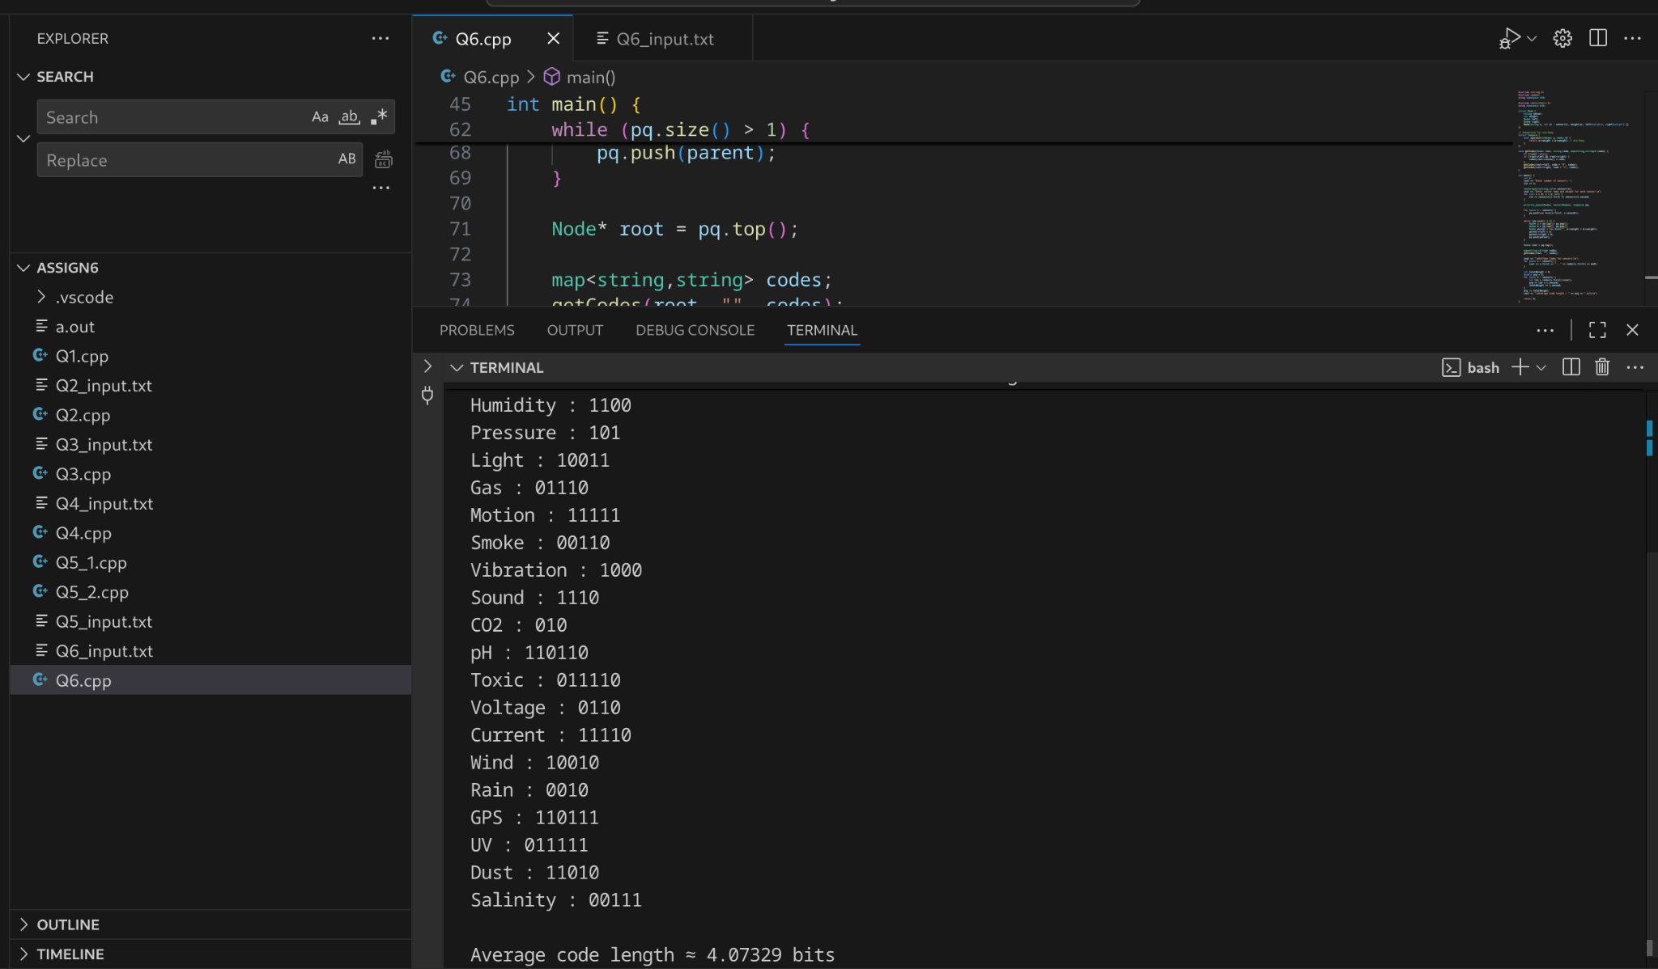
Time Complexity:
- Each pop and push in the priority queue takes O(log n).
- Building the min-heap: For n sensors: O(n log n)
- Constructing the Huffman tree: O(n log n)
- Traversing the Huffman tree recursively: O(n)

Calculating average code length: O(n)

Overall Time Complexity
O(n log n)O(nlogn)+O(nlogn)+O(n)+O(n)=O(nlogn)

