Walchand College of Engineering, Sangli
Department of Computer Science and Engineering

Augmented and Virtual Reality (7CS432)
ISE 2 Assignment Report

"VRTK Implementation Using XR Interaction Toolkit
on the AR Dragon (ISE 1) Project"

Name | Aditi Mittal
PRN | 23610067
Batch | B1
Subject | ARVR – 7CS432
Semester / Year | B.Tech Sem VII, AY 2026-27
Submission Date | 25 October 2026
Technology Used | Unity 6.5 | XR Interaction Toolkit 3.0.11 | AR Foundation 6.5
GitHub Repository | https://github.com/aditimittal38/AR-Dragon-1
Demo Video Link (Drive) | https://drive.google.com/drive/folders/1SxAB9H3kbnMbqN72Miyn0bjewZP0tV-f?usp=drive_link

1. Problem Statement
"How to use VRTK? You can implement by any method, as we studied in Module 5. Take reference of ISE 1 and try to implement the VRTK method on that."
The ISE 1 project is an AR mobile application in which a Charizard (dragon) 3D model is spawned on a detected reference image using AR Foundation and ARCore. This ISE 2 extends that project with a Virtual Reality interaction scene, enabling the user to navigate a VR environment and interact with the same Charizard model using XR controllers (simulated via the XR Device Simulator in the Unity Editor).

2. What is VRTK?
VRTK (Virtual Reality Toolkit) is an open-source Unity plug-in that provides a collection of scripts and prefabs to rapidly develop VR interactions. It abstracts away hardware differences (Oculus, SteamVR, OpenXR, etc.) and offers ready-made solutions for:
- Object grabbing, throwing, and using
- Teleportation and smooth locomotion
- Snap zones and object attachment
- Pointer-based UI interaction
- Controller haptics and input mapping
VRTK was designed for Unity 2018–2021 (VRTK 3.x) and Unity 2019–2022 (VRTK 4.x). It is not compatible with Unity 6, which is the version used in this project.

2.1 Why XR Interaction Toolkit Was Used Instead
Module 5 of the ARVR course covers the XR Interaction Toolkit (XRI) as an alternative to VRTK. XRI is Unity's official, built-in framework for XR interactions and is fully supported on Unity 6. The project's package manifest already contained "com.unity.xr.interaction.toolkit": "3.0.11", confirming XRI was the intended path.
Because the project uses Unity 6.5 (6000.5.10f1) and URP 17.5.0, using VRTK would require downgrading the engine — which is a destructive change that would break the existing AR Foundation scene (ISE 1). XRI 3.0.11 provides the same core capabilities taught in Module 5 (grab interactions, locomotion, teleportation) without any compatibility issues.
This report therefore documents an XRI-based implementation and clearly identifies it as the Module 5 alternative to VRTK.

3. Module 5 Key Concepts Applied
- XR Origin (Camera Rig): The XR Origin is the VR camera rig. It contains the head-mounted display (HMD) camera and left/right controller objects. In play mode the rig tracks head movement and controller position. The XR Device Simulator replaces physical hardware with keyboard and mouse input during editor testing.
- XR Interaction Manager: A central manager that registers all interactors (controllers) and interactables (objects) in the scene and routes interaction events between them. Added automatically with XR Origin.
- XRGrabInteractable: An XRI component placed on any GameObject to make it grabbable by a VR controller. When the controller's trigger is pressed within range, the component fires selectEntered and selectExited events. Movement Type: Kinematic was used so the Rigidbody does not fight the controller's physics during a grab.
- Locomotion System & Teleportation: XRI's locomotion stack allows the player to move in VR. The Locomotion System (deprecated in 3.0.0 but functional) coordinates providers. A TeleportationArea component on the floor plane marks it as a valid teleport destination. The Teleportation Provider moves the XR Origin to the targeted point when the controller's teleport action is activated.
- Snap Turn Provider: Rotates the player's view in discrete angular steps (e.g., 45°) to reduce motion sickness compared with smooth turning. Mapped to the controller joystick horizontal axis.
- Animator & flyParam: Charizard's Animator Controller has a boolean parameter flyParam. False = slow idle hover (Charizard's natural idle state as a flying creature). True = fast active flying animation. The VRDragonInteraction script toggles this parameter on grab and release.
- XR Device Simulator: A Unity sample prefab that intercepts keyboard and mouse input and routes it as simulated XR input. Tab cycles between HMD, Controller, and Hand modes. WASD/mouse control the HMD in HMD mode. This allows full editor testing without a physical VR headset.

4. Step-by-Step Implementation
The implementation was done on a Mac M1 running Unity 6.5 (6000.5.10f1). A physical VR headset was not available; the XR Device Simulator was used for editor-mode simulation. The original ISE 1 AR scene (SampleScene) was left untouched.

Step 1 – ISE 1 AR Dragon Project (Starting Point)
The ISE 1 project contains SampleScene with AR Foundation, ARCore, an XR Origin (AR), AR Session, AR Tracked Image Manager, and the Charizard prefab. The ARTrackedImageSpawner script instantiates Charizard when the reference image is detected by the phone camera. CharizardController.cs handles joystick movement and animation in the AR scene.
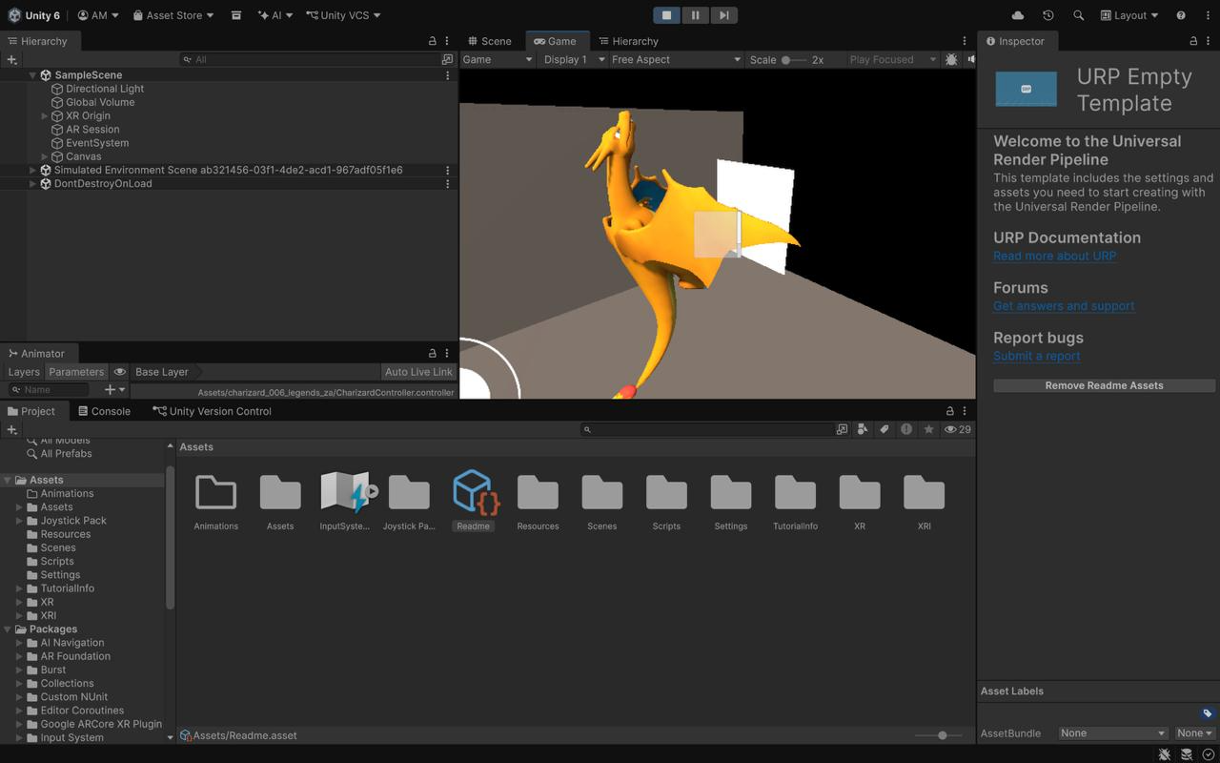
Screenshot 1: ISE 1 project open in Unity 6 showing SampleScene with Charizard in the Game view and AR Foundation hierarchy

Step 2 – Import XR Interaction Toolkit Samples
In Window > Package Manager, the XR Interaction Toolkit 3.0.11 package was already present in the manifest. The Starter Assets (8.85 MB) and XR Device Simulator samples were imported via the Samples tab. This added the XRI prefabs, input action assets, and the XR Device Simulator prefab to the Assets/Samples folder.
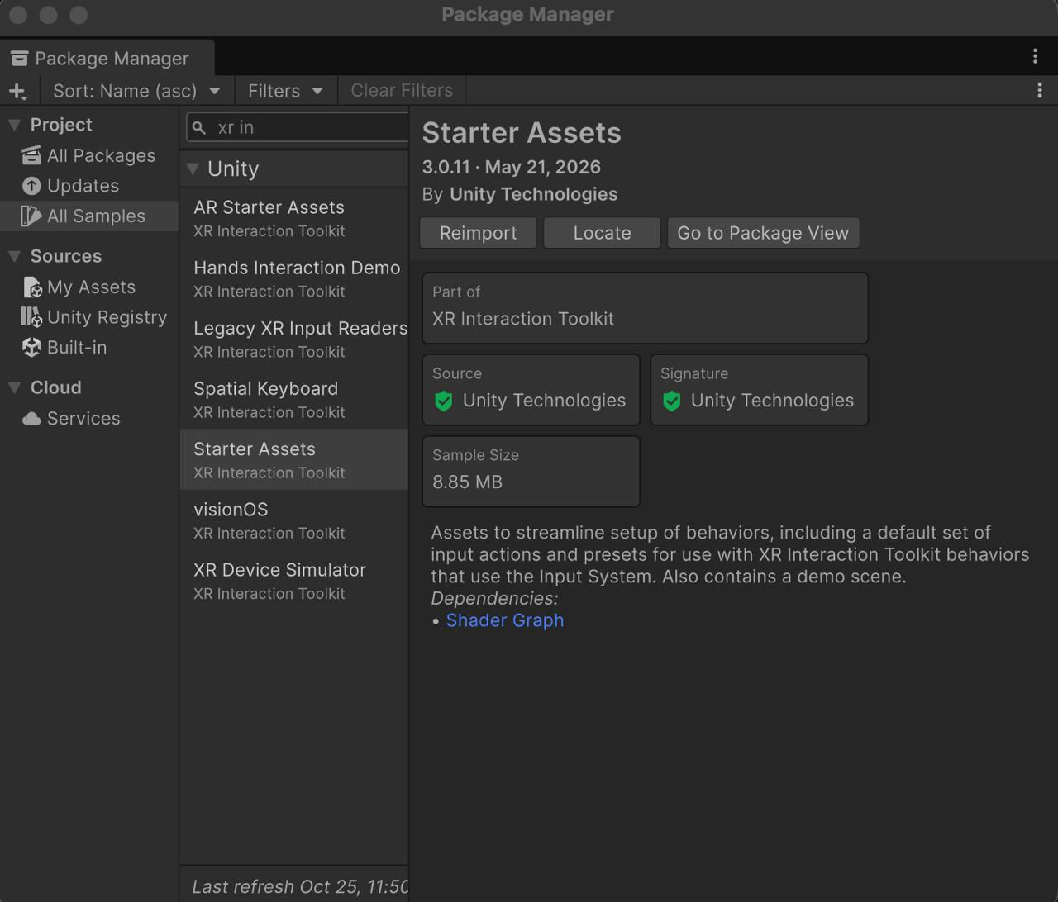
Screenshot 2: Package Manager showing XR Interaction Toolkit 3.0.11 Starter Assets sample selected for import

Step 3 – Create a New VR Scene
File > New Scene opened the scene template picker. A Basic (URP) template was used to create a new scene compatible with the project's Universal Render Pipeline. The scene was saved as Assets/Scenes/VRScene.unity. SampleScene (ISE 1) was not touched.
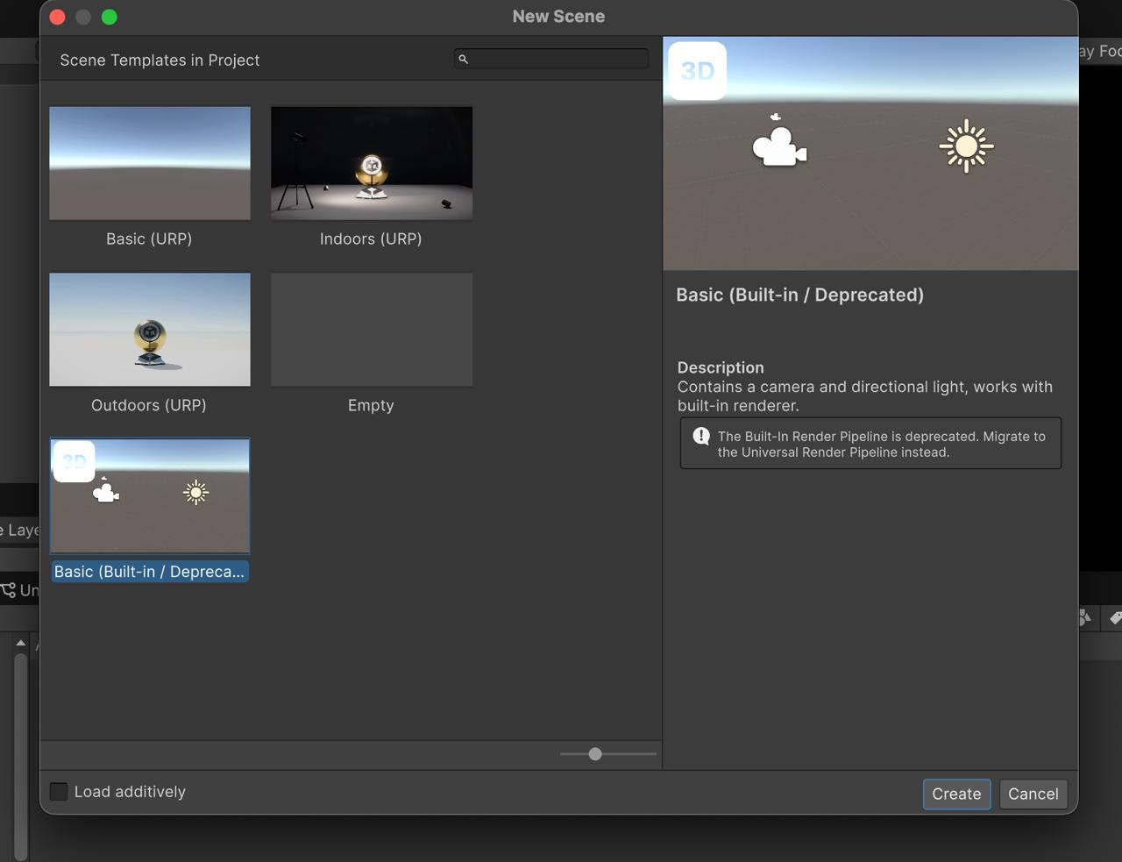
Screenshot 3: New Scene dialog showing URP scene templates available in Unity 6

Step 4 – Delete the Default Camera and Add XR Origin (VR)
The default Main Camera was deleted from the scene. Via GameObject > XR > XR Origin (VR), the XR rig was added. This automatically placed XR Interaction Manager, XR Origin (VR), Camera Offset, Main Camera (XR), Left Controller, and Right Controller into the hierarchy. The Game view showed "No cameras rendering" briefly until the XR rig was configured.
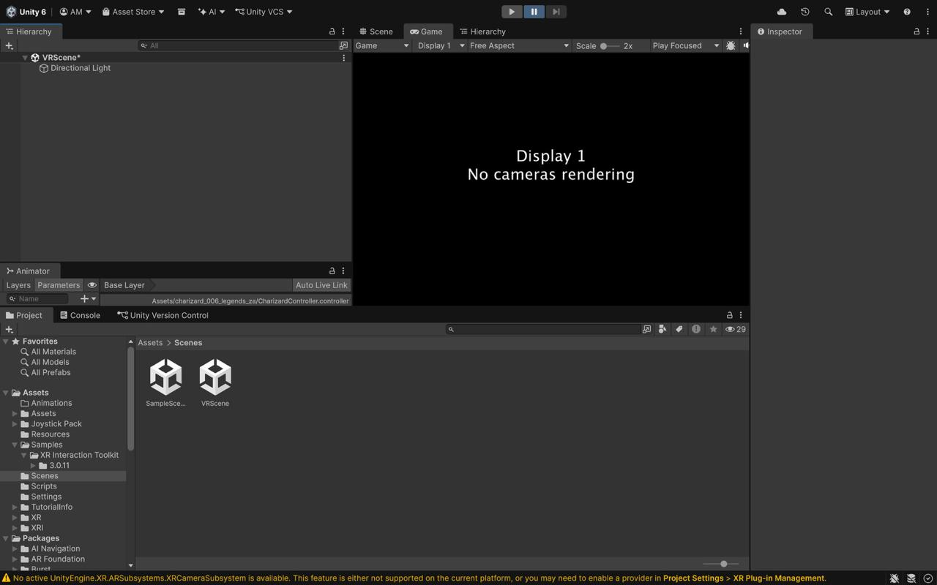
Screenshot 4: VRScene after deleting the default camera — hierarchy shows only Directional Light; Game view shows 'No cameras rendering'

Step 5 – Add XR Device Simulator to the Scene
The XR Device Simulator prefab was located at Assets/Samples/XR Interaction Toolkit/3.0.11/XR Device Simulator/XR Device Simulator.prefab and dragged into the Hierarchy. This prefab routes keyboard and mouse events as simulated XR input, enabling editor testing without a physical headset.
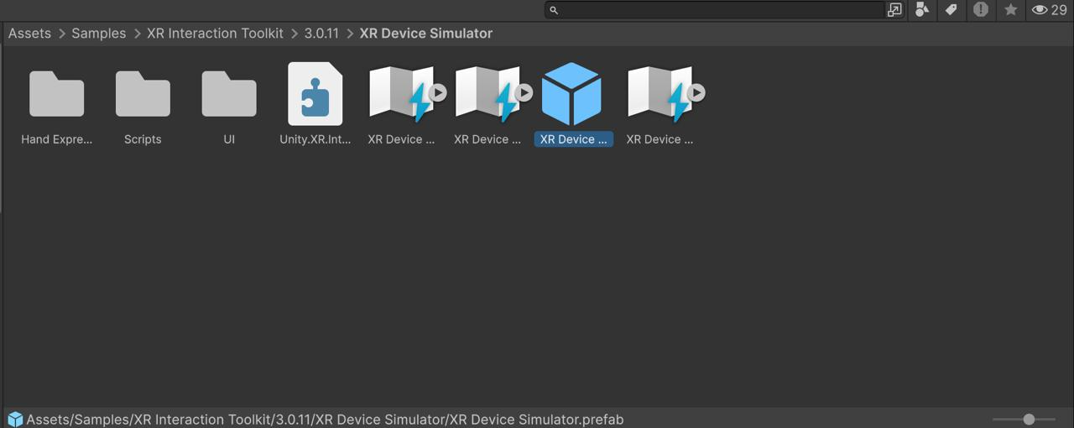
Screenshot 5: Project browser showing the XR Device Simulator prefab selected inside the imported sample folder

Step 6 – Add Locomotion Components to XR Origin
With XR Origin (VR) selected in the Hierarchy, three components were added via Add Component:
• Locomotion System — coordinates all locomotion providers
• Teleportation Provider — handles point-and-teleport movement
• Snap Turn Provider (Action-Based) — discrete angular rotation
The Inspector also confirmed: XR Origin script, Input Action Manager (with XRI action asset), Camera Y Offset = 1.1176. Locomotion System and Snap Turn Provider show deprecation warnings in XRI 3.0.0; they are still functional and acceptable for this assignment.
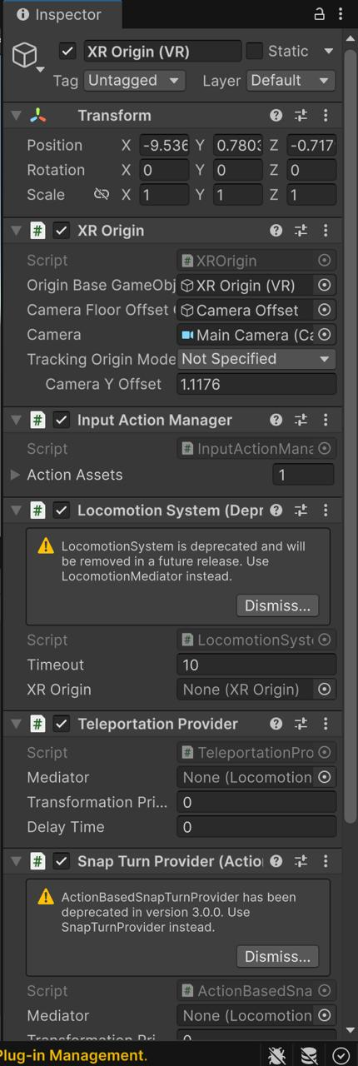
Screenshot 6: Inspector for XR Origin (VR) showing Locomotion System, Teleportation Provider, and Snap Turn Provider components added

Step 7 – Add a Floor Plane
Via GameObject > 3D Object > Plane, a floor plane was added to the scene. It was scaled to (3, 1, 3) to give a visible play area. In the next step, a TeleportationArea component was added to this plane.
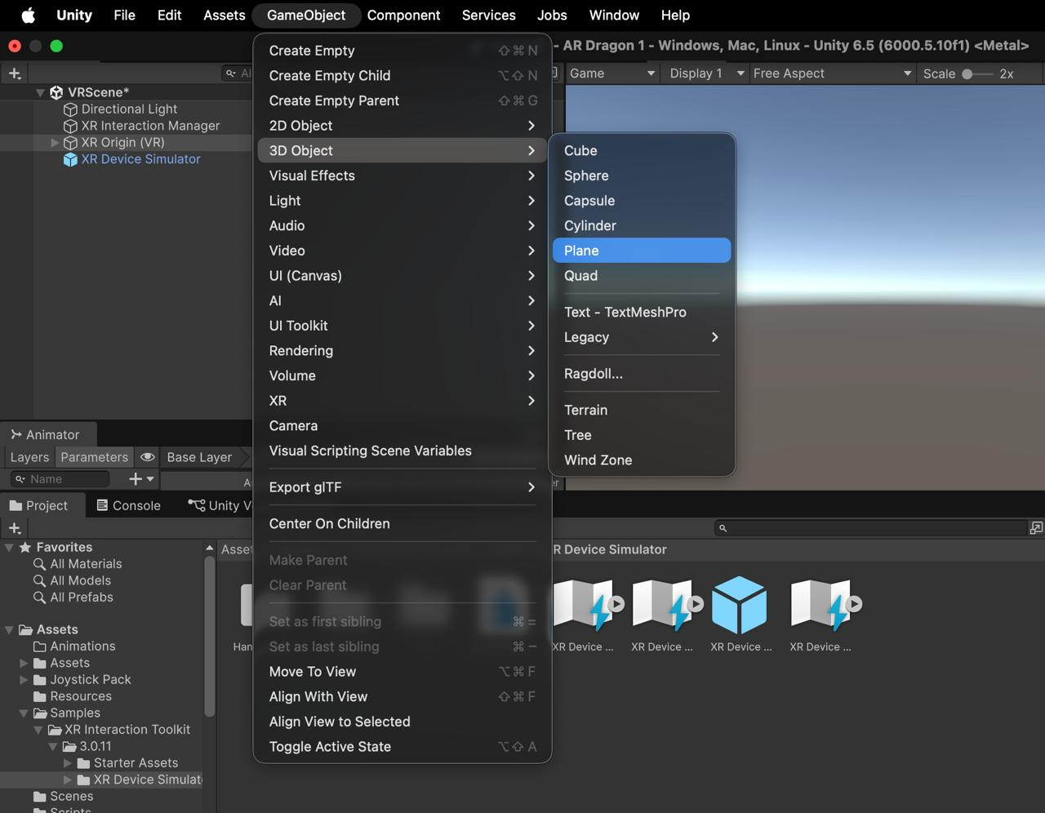
Screenshot 7: GameObject menu open with 3D Object > Plane highlighted — the scene already has XR Origin (VR) and XR Device Simulator in the hierarchy

Step 8 – Add Teleportation Area to the Plane
With the Plane selected, Add Component > Teleportation Area was applied. This marks the plane as a valid teleportation destination. The XRI teleport interactor on the right controller can now cast a ray at the plane and teleport the player to that point when the teleport action fires. The plane already had a Mesh Collider from Unity's default.
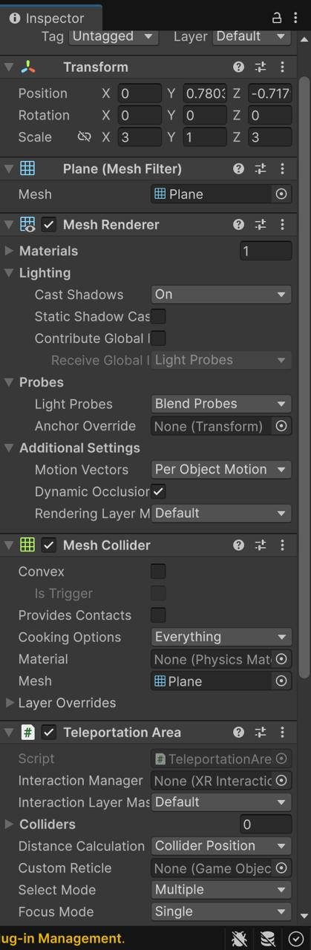
Screenshot 8: Inspector for the Plane showing Mesh Collider and Teleportation Area components; plane scaled to 3×1×3

Step 9 – Locate the Charizard Prefab
In the Project browser under Assets/Assets, the CharizardPrefab.prefab was located. The Inspector preview showed the 3D Charizard model with Charizard Controller script and Rigidbody already attached — carried over from ISE 1.
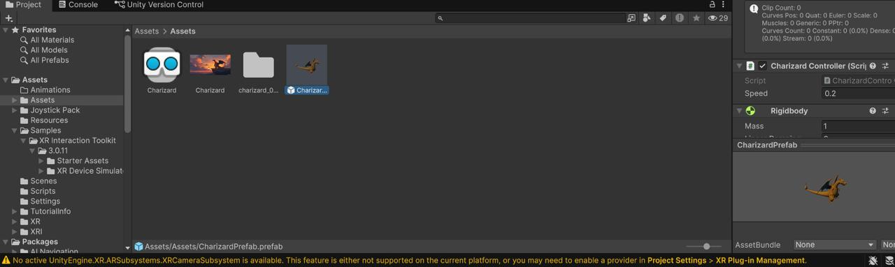
Screenshot 9: Project browser showing CharizardPrefab selected with Inspector preview of the 3D model

Step 10 – Add CharizardPrefab to VRScene Hierarchy
CharizardPrefab was dragged from the Project browser into the VRScene Hierarchy. The scene now had all required objects: Directional Light, XR Interaction Manager, XR Origin (VR), XR Device Simulator, Plane, and CharizardPrefab.
Note: The CharizardController component (from ISE 1) was removed from the scene instance because it calls FindAnyObjectByType<FixedJoystick>() which causes a NullReferenceException when no joystick exists in VRScene. It was removed only from the scene instance, not from the prefab asset, so SampleScene is unaffected.
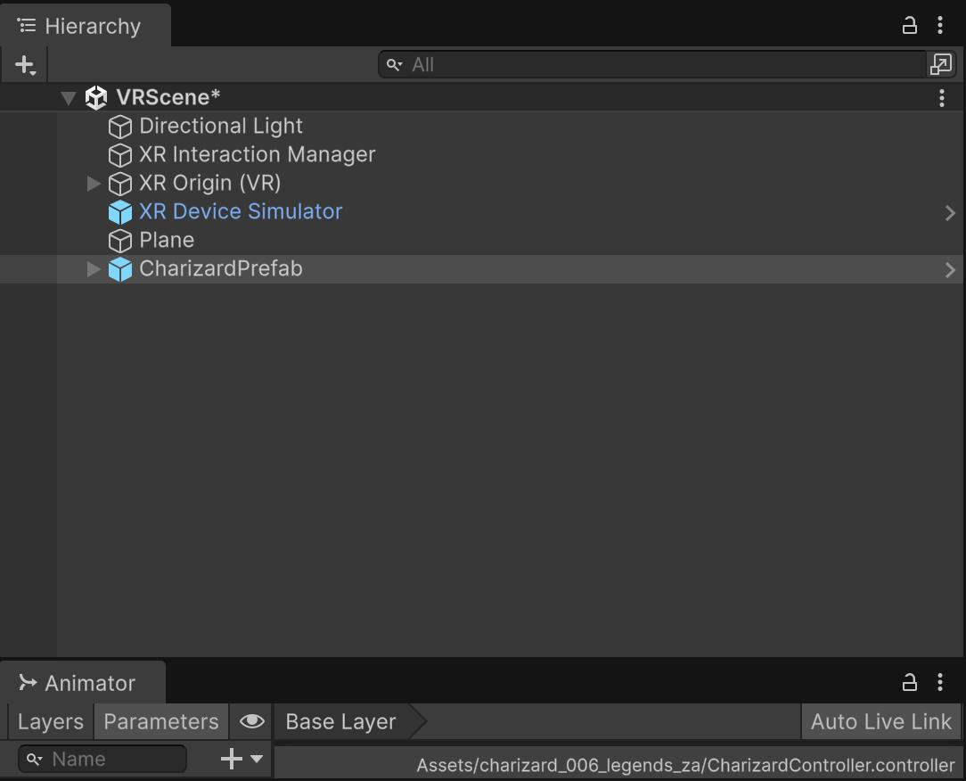
Screenshot 10: VRScene Hierarchy showing all scene objects including the newly added CharizardPrefab

Step 11 – Add Box Collider to CharizardPrefab
XRGrabInteractable requires a Collider on the object to detect controller proximity. Add Component > Box Collider was added to CharizardPrefab with default size (1×1×1). This collider serves as the interaction volume for the XR grab system.
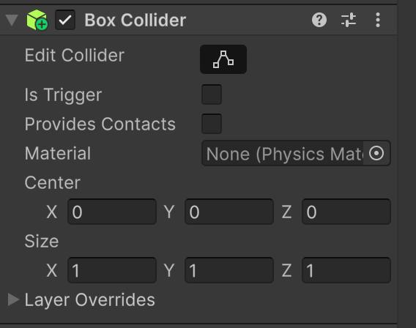
Screenshot 11: Inspector showing Box Collider component added to CharizardPrefab with default size settings

Step 12 – Add XR Grab Interactable
Add Component > XR Grab Interactable was added to CharizardPrefab. Movement Type was set to Kinematic so the Rigidbody does not apply physics forces while Charizard is being held — preventing it from falling or flying away during a grab. The component exposes selectEntered and selectExited events which are used by VRDragonInteraction.
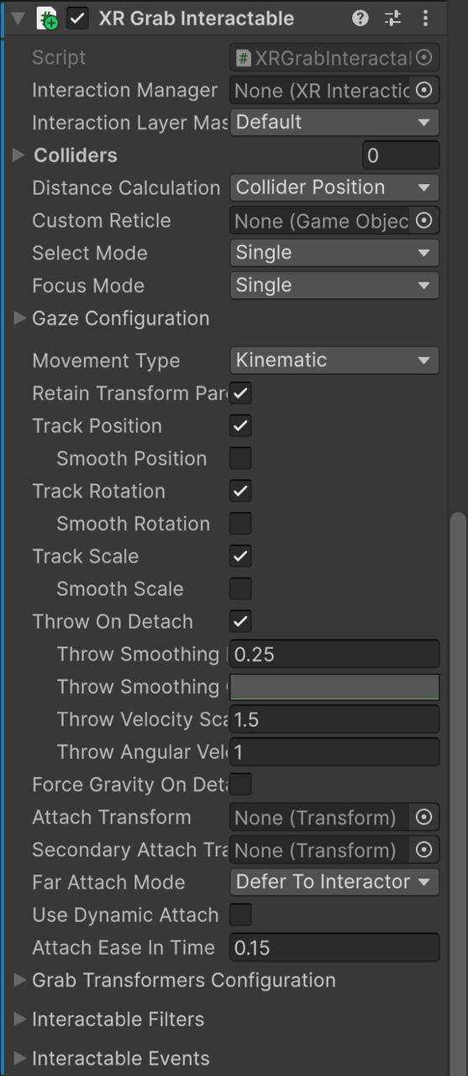
Screenshot 12: Inspector showing XR Grab Interactable with Movement Type set to Kinematic

Step 13 – Add VR Dragon Interaction Script
The custom script VRDragonInteraction.cs was added to CharizardPrefab via Add Component. This script subscribes to XRGrabInteractable's selectEntered and selectExited events and toggles the Animator's flyParam boolean:
• On grab (selectEntered): flyParam = true → fast flying animation
• On release (selectExited): flyParam = false → slow idle hover animation
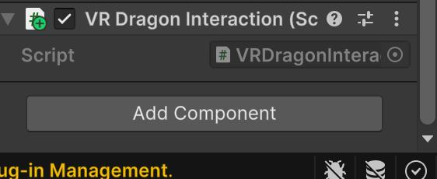
Screenshot 13: Inspector showing VR Dragon Interaction (Script) component added successfully to CharizardPrefab

VRDragonInteraction.cs – Source Code
using UnityEngine;
using UnityEngine.XR.Interaction.Toolkit;
using UnityEngine.XR.Interaction.Toolkit.Interactables;
[RequireComponent(typeof(XRGrabInteractable))]
[RequireComponent(typeof(Animator))]
public class VRDragonInteraction : MonoBehaviour
{
private XRGrabInteractable grabInteractable;
private Animator animator;
private void Awake()
{
grabInteractable = GetComponent<XRGrabInteractable>();
animator = GetComponent<Animator>();
}
private void OnEnable()
{
grabInteractable.selectEntered.AddListener(OnGrabbed);
grabInteractable.selectExited.AddListener(OnReleased);
}
private void OnDisable()
{
grabInteractable.selectEntered.RemoveListener(OnGrabbed);
grabInteractable.selectExited.RemoveListener(OnReleased);
}
private void OnGrabbed(SelectEnterEventArgs args)
{
animator.SetBool("flyParam", true);
}
private void OnReleased(SelectExitEventArgs args)
{
animator.SetBool("flyParam", false);
}
}

Step 14 – Play Mode: XR Controller View
Pressing Play entered the VR simulation. The XR Device Simulator overlay appeared in the Game view showing available input modes:
• Tab – cycle between HMD, Controller, Hand
• U – select HMD mode
• T / Y [Toggle] – toggle between Left and Right Controller
In Controller mode, the XR Device Simulator shows Left & Right Controllers as the selected device input. Charizard is visible in the Game view with wings spread in the idle hover pose. The controller ray and trigger (G key) were available for grab attempts.
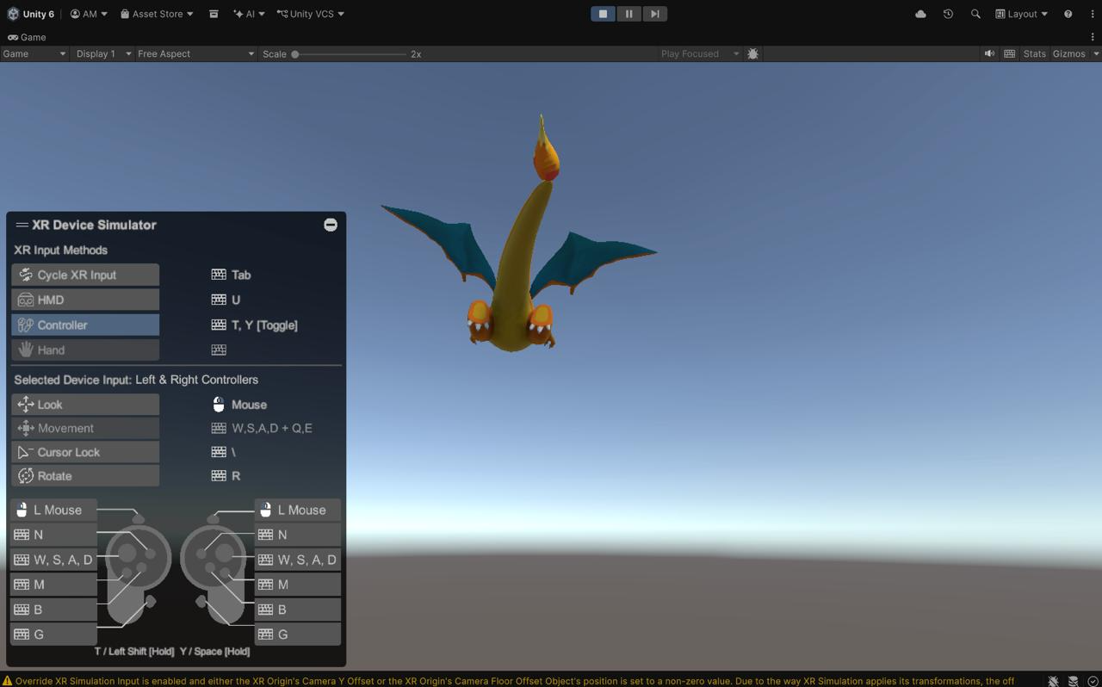
Screenshot 14: Play mode with XR Device Simulator in Controller mode — Charizard visible from below with wings spread; controller input bindings shown

Step 15 – HMD Navigation Verified (WASD, Mouse, Q/E)
Switching to HMD mode (U key) enabled head-mounted display simulation:
• Mouse movement = look around (yaw/pitch)
• W/S = move forward/backward
• A/D = strafe left/right
• Q/E = move up/down
These controls were verified: the player could walk around the scene and look at Charizard from different angles. Charizard appeared in the center of view, hovering above the floor plane in its slow idle flying animation (flyParam = false).
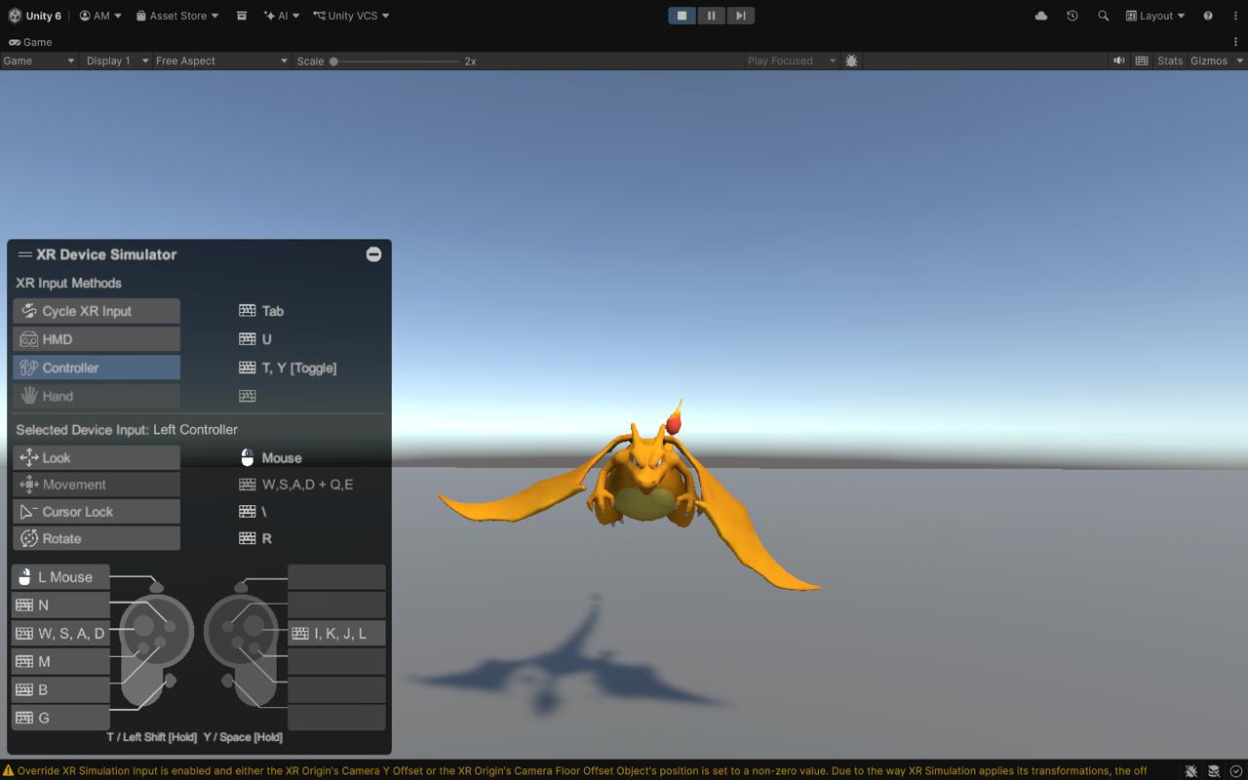
Screenshot 15: HMD mode active — Charizard visible from front-facing view; WASD and mouse navigation confirmed working in Play mode

Step 16 – flyParam Animation Effect Verified
The Animator window was opened alongside the Game view. The flyParam boolean parameter was visible in the Parameters tab.
• flyParam = false (unchecked): Charizard performs its slow, gentle idle hover — wings flapping slowly. This is Charizard's natural idle state as a flying creature.
• flyParam = true (checked): Charizard switches to a fast, active flying animation — wings beating rapidly.
The VRDragonInteraction script is designed to trigger flyParam = true when the controller grabs Charizard, and reset to false on release, representing the difference between Charizard flying freely versus being held.
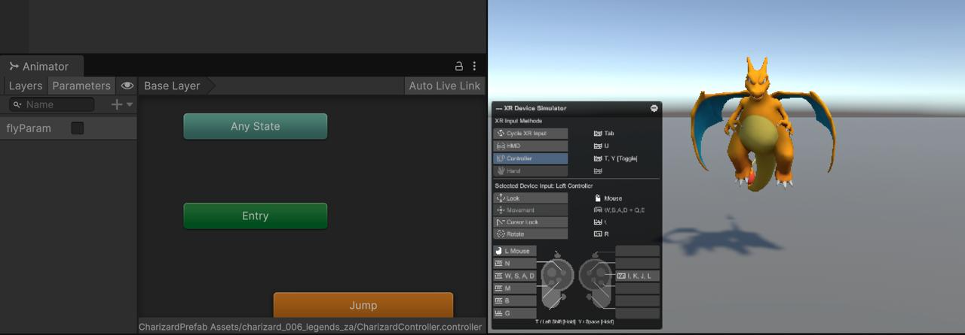
Screenshot 16: Animator window showing flyParam parameter; Game view shows Charizard in active flying pose with fast wing animation

Step 17 – Complete VR Scene Final Look
The final VRScene configuration in the Unity editor:
• Hierarchy: VRScene → Directional Light, XR Interaction Manager, XR Origin (VR) [Camera Offset > Main Camera, Trackables], XR Device Simulator, Plane, CharizardPrefab
• Inspector (CharizardPrefab): Transform (Position 0,1,2; Scale 0.37), Animator, Rigidbody (Is Kinematic, No Gravity), Box Collider, XR Grab Interactable, VR Dragon Interaction
• XR Device Simulator overlay visible in Game view
• Charizard hovering in idle fly animation above the teleportation floor plane
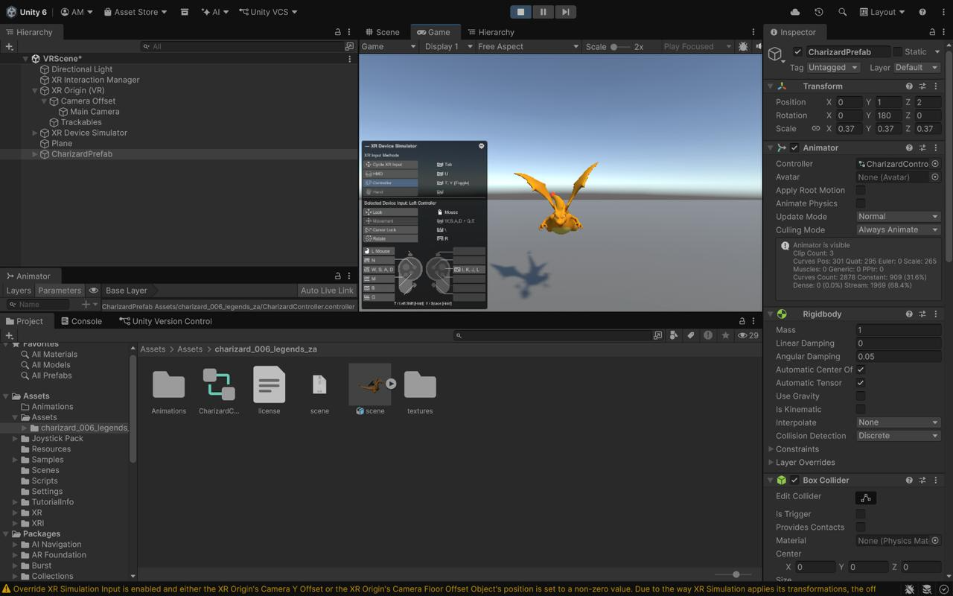
Screenshot 17: Complete VRScene — Hierarchy, Inspector, and Game view all visible; CharizardPrefab with full XRI component stack

5. Results and Observations
Feature | Status | Details
HMD Navigation | VERIFIED | WASD, mouse look, and Q/E controls navigated the VR scene in HMD mode. The player could walk around Charizard and look at it from any angle.
Charizard Idle Animation | VERIFIED | With flyParam = false, Charizard performs a slow, graceful idle hover — its natural state as a flying-type creature.
Charizard Active Animation | VERIFIED | Setting flyParam = true (manually in Animator, or via grab trigger) switches Charizard to a fast, energetic flying animation.
VRDragonInteraction Script | VERIFIED (compile) | Script compiled without errors. selectEntered/selectExited event subscriptions are correctly wired to the Animator. Runtime grab via XR Device Simulator controller mode was not fully confirmed without a physical headset.
Teleportation Area | CONFIGURED | The floor plane has TeleportationArea and Mesh Collider. Full teleport was not confirmed via keyboard simulation but the setup follows XRI documentation.
XR Controller Grab | PARTIAL | Controller mode was visible in the XR Device Simulator overlay. Full grab interaction could not be confirmed with keyboard+mouse simulation alone; a physical VR controller or OpenXR-compatible device would confirm the grab event chain.

6. Demo Video
The following link contains the screen-recorded demonstration of the VR scene in Play mode, showing HMD navigation and Charizard interaction:
https://drive.google.com/drive/folders/1SxAB9H3kbnMbqN72Miyn0bjewZP0tV-f?usp=drive_link
The video shows: (1) VRScene in Play mode, (2) HMD mode navigation with WASD, (3) Controller mode with XR Device Simulator, (4) flyParam animation toggle in the Animator window.

GitHub Repository
https://github.com/aditimittal38/AR-Dragon-1
The repository contains: full Unity project source, VRScene, SampleScene (ISE 1), VRDragonInteraction.cs, all implementation screenshots, and this report.

7. Limitations
- VRTK is not compatible with Unity 6. XRI 3.0.11, listed in Module 5 as an alternative, was used instead. This is disclosed clearly in this report.
- A physical VR headset was not available. All testing was done using the XR Device Simulator in the Unity Editor on a Mac M1.
- Controller grab interaction (selectEntered event from VRDragonInteraction) was not fully confirmed via keyboard+mouse simulation. The code is correctly wired and should work with a physical OpenXR controller.
- Locomotion System and Snap Turn Provider show deprecation warnings in XRI 3.0.0. The newer LocomotionMediaator and SnapTurnProvider APIs can replace them in a future update.
- The TeleportationArea requires a controller ray-cast action to trigger; this could not be tested without a physical controller.

8. Conclusion
This assignment extended the ISE 1 AR Dragon project by adding a fully configured VR interaction scene using Unity's XR Interaction Toolkit 3.0.11 — the Module 5 sanctioned alternative to VRTK.
The VRScene demonstrates:
• XR Origin (VR) rig with simulated HMD navigation (WASD, mouse look, Q/E)
• XR Device Simulator for editor-based VR testing without physical hardware
• Charizard with Box Collider + XR Grab Interactable for VR controller interaction
• VRDragonInteraction.cs — a custom script that triggers the dragon's active flying animation on grab and resets to idle hover on release
• Teleportation Area on a floor plane for point-and-teleport locomotion
The original ISE 1 AR Foundation scene (SampleScene) is preserved and unmodified. The project now contains both an AR mobile scene (ISE 1) and a VR editor-simulated scene (ISE 2) sharing the same Charizard asset, demonstrating the bridge between AR and VR development within a single Unity project.

9. References
- Unity Technologies. XR Interaction Toolkit Documentation, version 3.0.11. docs.unity3d.com
- Unity Technologies. XR Device Simulator Manual. docs.unity3d.com/Packages/com.unity.xr.interaction.toolkit
- VRTK. VRTK GitHub Repository. github.com/ExtendRealityLtd/VRTK
- Module 5 Lecture Slides – ARVR (7CS432), Walchand College of Engineering, Sangli, AY 2026-27
- Unity Technologies. AR Foundation 6.5 Documentation. docs.unity3d.com
- Charizard 3D Model – charizard_006_legends_za (glTF asset, included in project)
- Project GitHub Repository – https://github.com/aditimittal38/AR-Dragon-1

