WALCHAND COLLEGE OF ENGINEERING, SANGLI
Department of Computer Science and Engineering

HUMAN–COMPUTER INTERACTION (HCI)
Unity 3D Interactive Environment — ISE2 Report

"Design and Develop an Interactive 3D Environment Using Unity"

Field | Details
Name
Roll No.
Class / Division
Date of Submission
Course | Human–Computer Interaction (HCI)
Assignment Title | Design and Develop an Interactive 3D Environment Using Unity
Maximum Marks | 10
Demo Video | https://drive.google.com/file/d/1m8A6nE3qSddO3EzJZYPPxs085OBOg8Kc/view?usp=sharing
Reference Tutorial | https://www.youtube.com/watch?v=YBRlwCjLNMQ

Evaluation Rubric (How This Submission Meets Each Component)
Component (2 marks each) | Description | Addressed In
3D Environment Design | Scene, objects, materials, lighting, camera | Section 3
Navigation & Object Interaction | User navigation and interaction with ≥3 objects | Section 4
HCI-Based UI Design | Instructions, status message, Exit/Help controls | Section 5
Feedback & Usability | Feedback, clarity and ease of interaction | Section 6
Demonstration & Documentation | Video demonstration and written report | Section 7 + Demo link

1. Aim
To design and develop a simple interactive 3D environment in Unity that demonstrates fundamental Human–Computer Interaction (HCI) principles — visibility, feedback, consistency, affordance, user control, and error prevention — using keyboard and mouse as the primary input device.

2. Tools and Software Used
Tool / Software | Version / Details | Purpose
Unity Engine | 6000.5.10f1 (Unity 6) | Primary 3D development engine
Universal Render Pipeline (URP) | 17.5.0 | Rendering and materials
Unity Input Manager | Legacy (Input Manager) | Keyboard and mouse input
Visual Studio Code | Latest | C# script editing
Charizard 3D Model | charizard_006_legends_za (glTF/GLB) | 3D interactive character asset
Python + python-docx | 3.x | Report generation
Git / GitHub | https://github.com/aditimittal38/AR-Dragon-1 | Version control
Platform | Mac M1 (Apple Silicon) + Windows | Development platform

3. 3D Environment Design
A new scene named HCIScene was created in Unity using a Basic URP 3D template. The environment is a fully enclosed room (10×3×10 units) with a floor, four walls, Directional Light for global illumination, a first-person Player, and three interactive objects placed at distinct locations within the space.

3.1 Scene Objects and Hierarchy
The complete HCIScene hierarchy:
- Floor (Plane, scale 10×1×10) — grey FloorMat material
- Wall Front / Wall Back / Wall Left / Wall Right (Cubes) — white WallMat material
- Directional Light — main scene light
- Player (Empty GameObject + CharacterController + PlayerController.cs)
- └── Main Camera (child, Y offset 0.6 — eye level)
- CharizardPrefab — Charizard 3D model with Animator and InteractableObject (Dragon)
- Door (Cube, brown DoorMat) — InteractableObject (Door)
- LightSwitch (small Cube) — InteractableObject (Light)
- PointLight (Point Light) — above LightSwitch, toggled by switch
- Canvas (UIManager.cs) — UI overlay with all HCI interface elements

3.2 Object Transforms
Object | Position (X, Y, Z) | Scale (X, Y, Z) | Material
Floor (Plane) | (0, 0, 0) | (1, 1, 1) = 10×10m | FloorMat (grey)
Wall Front | (0, 1.5, 5) | (10, 3, 0.3) | WallMat (white)
Wall Back | (0, 1.5, −5) | (10, 3, 0.3) | WallMat (white)
Wall Left | (−5, 1.5, 0) | (0.3, 3, 10) | WallMat (white)
Wall Right | (5, 1.5, 0) | (0.3, 3, 10) | WallMat (white)
Player | (0, 1, 0) | (1, 1, 1) | —
Main Camera | (0, 0.6, 0) | (1, 1, 1) | —
CharizardPrefab | (0, 0, 3) | (1, 1, 1) | Model textures
Door | (3, 1.25, −5) | (0.2, 2.5, 1) | DoorMat (brown)
LightSwitch | (−3, 1.5, −4) | (0.3, 0.3, 0.3) | Yellow/Grey (runtime)
PointLight | (−3, 3, −4) | — | —

3.3 Lighting and Camera
A Directional Light provides global scene illumination with soft shadows. A Point Light above the LightSwitch provides local lighting that can be toggled interactively by the player. The camera is positioned as a child of the Player at eye level (Y = 0.6), enabling first-person perspective with 60° field of view. Separate URP Lit materials (DoorMat, FloorMat, WallMat) are applied to all room surfaces.

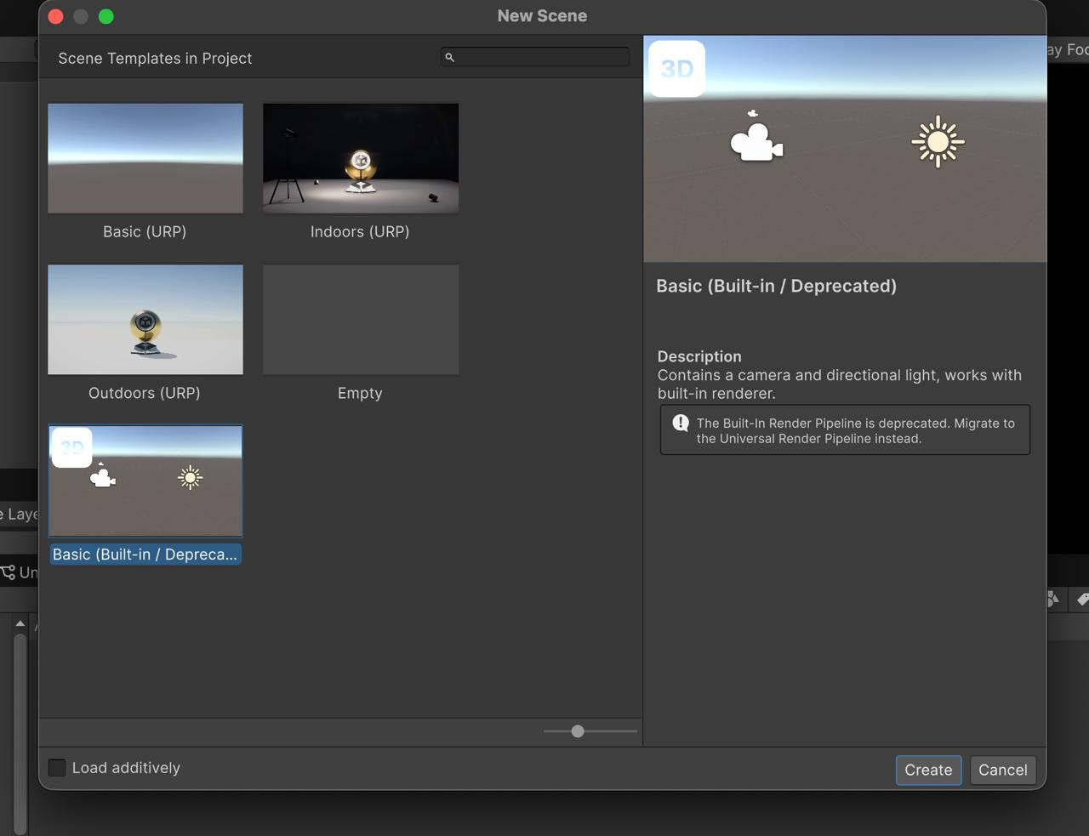
Figure 1: Creating the new HCIScene using a Basic URP 3D template

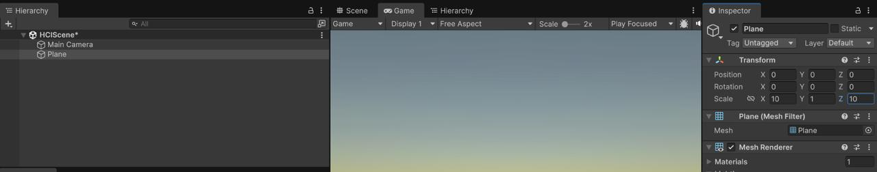
Figure 2: Floor Plane added with scale (10, 1, 10); position (0, 0, 0)

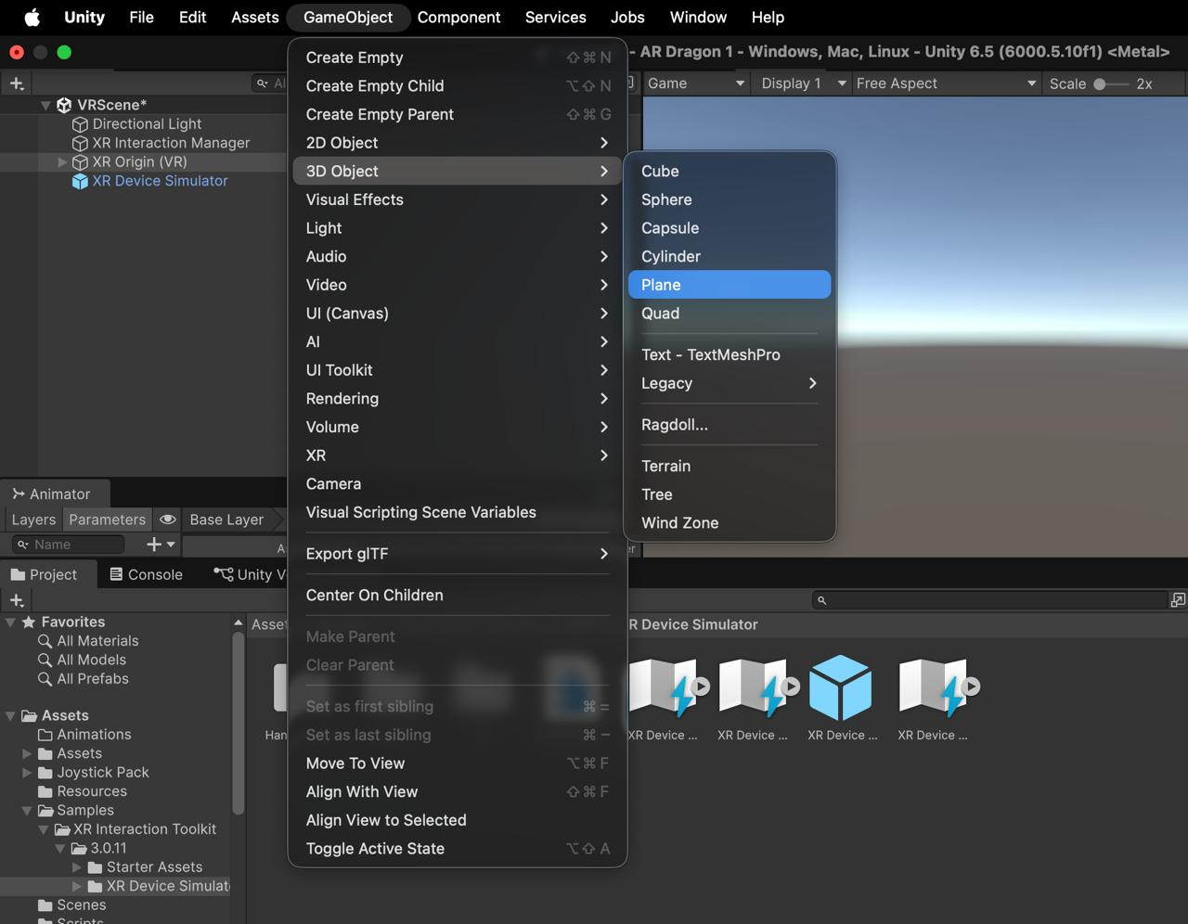
Figure 3: Adding the floor via GameObject > 3D Object > Plane

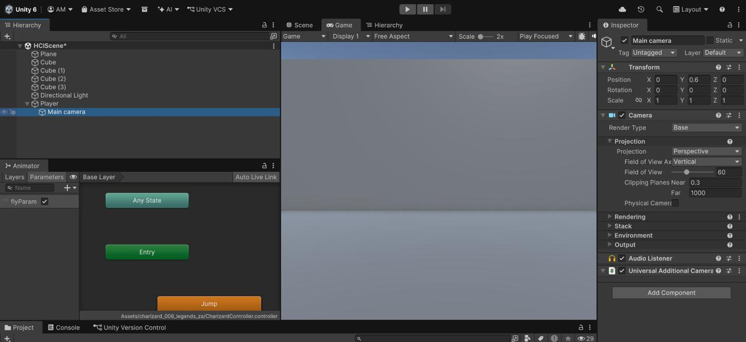
Figure 4: HCIScene hierarchy: walls (Cubes), Player with Main Camera, and Animator flyParam parameter visible

4. User Navigation and Interaction

4.1 Navigation — PlayerController.cs
First-person navigation was implemented using Unity's CharacterController component. The PlayerController.cs script handles movement, mouse look, gravity, and E-key raycast interaction. Cursor is locked to the centre of the screen during play and can be released with ESC.

Input | Action
W / S | Move forward / backward
A / D | Strafe left / right
Mouse move | Look around (yaw + pitch, clamped ±80°)
E | Interact with object in crosshair (4-unit range)
ESC | Unlock mouse cursor
Left Click | Re-lock cursor after ESC

Key excerpt — TryInteract():
void TryInteract()
{
if (!Input.GetKeyDown(KeyCode.E)) return;
Ray ray = new Ray(cam.transform.position, cam.transform.forward);
if (Physics.Raycast(ray, out RaycastHit hit, interactRange))
{
var obj = hit.collider.GetComponent<InteractableObject>();
if (obj != null) obj.Interact();
else UIManager.Instance?.ShowStatus("Nothing to interact with here.");
}
}

4.2 Interaction Techniques — InteractableObject.cs
Three distinct interactive objects are placed in the scene, each carrying the InteractableObject component with its InteractionType set in the Unity Inspector. All three use the same E key, maintaining consistency. Each interaction produces a visible state change and a status message.

Object | Type | What Happens on E | Visual Feedback | Status Message
CharizardPrefab | Dragon | Toggles flyParam bool on Animator | Animation switches: idle → flying (wings spread) | "Dragon takes flight!" / "Dragon lands and rests."
LightSwitch | Light | Toggles Point Light enabled state | Switch cube: yellow (on) / grey (off) | "Light switched ON." / "Light switched OFF."
Door | Door | Smoothly rotates door 90° using Quaternion.Lerp | Door swings open/closed smoothly | "Door opened." / "Door closed."

Key excerpt — Interact() for Door:
case InteractionType.Door:
doorOpen = !doorOpen;
rotating = true;
UIManager.Instance?.ShowStatus(doorOpen ? "Door opened." : "Door closed.");
break;

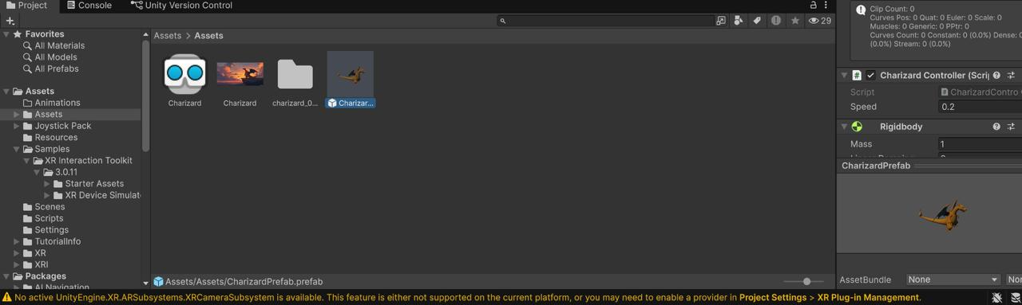
Figure 5: Charizard prefab located in Assets/Assets/charizard_006_legends_za/

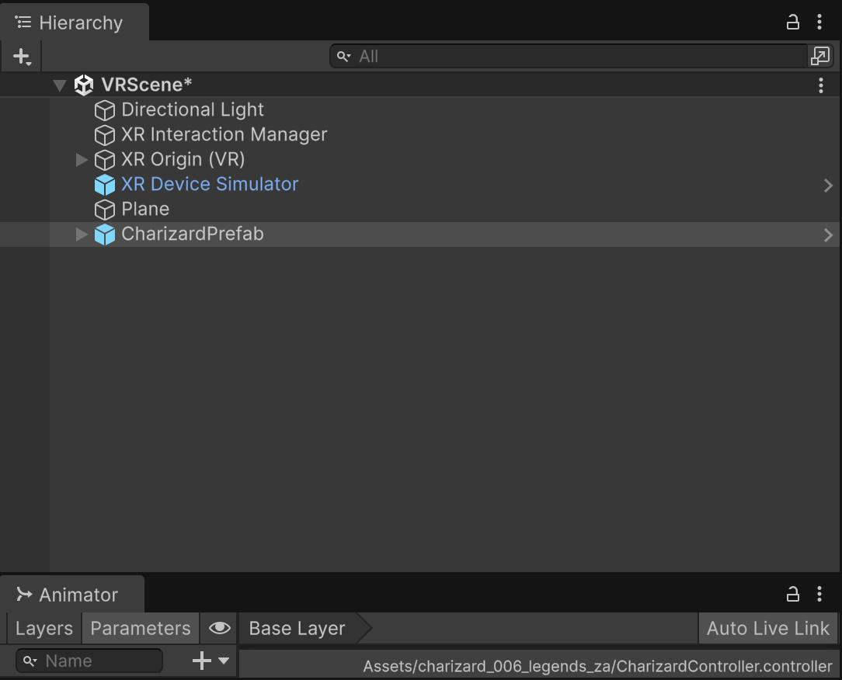
Figure 6: CharizardPrefab dragged into the HCIScene hierarchy

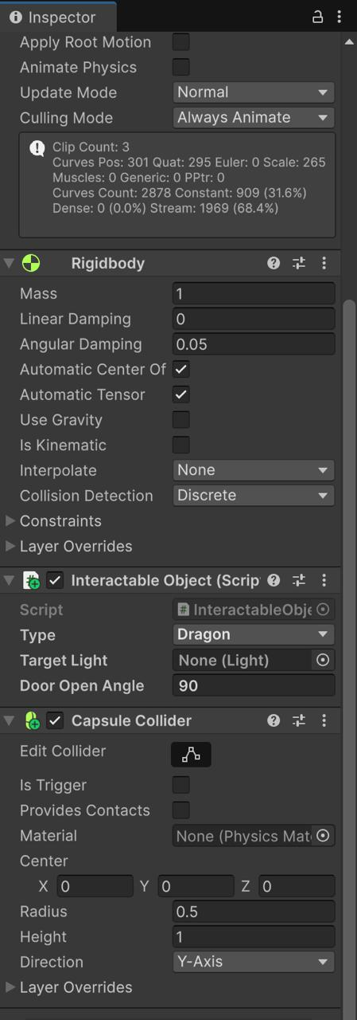
Figure 7: Inspector: Rigidbody, InteractableObject (Type: Dragon), and Capsule Collider added to CharizardPrefab

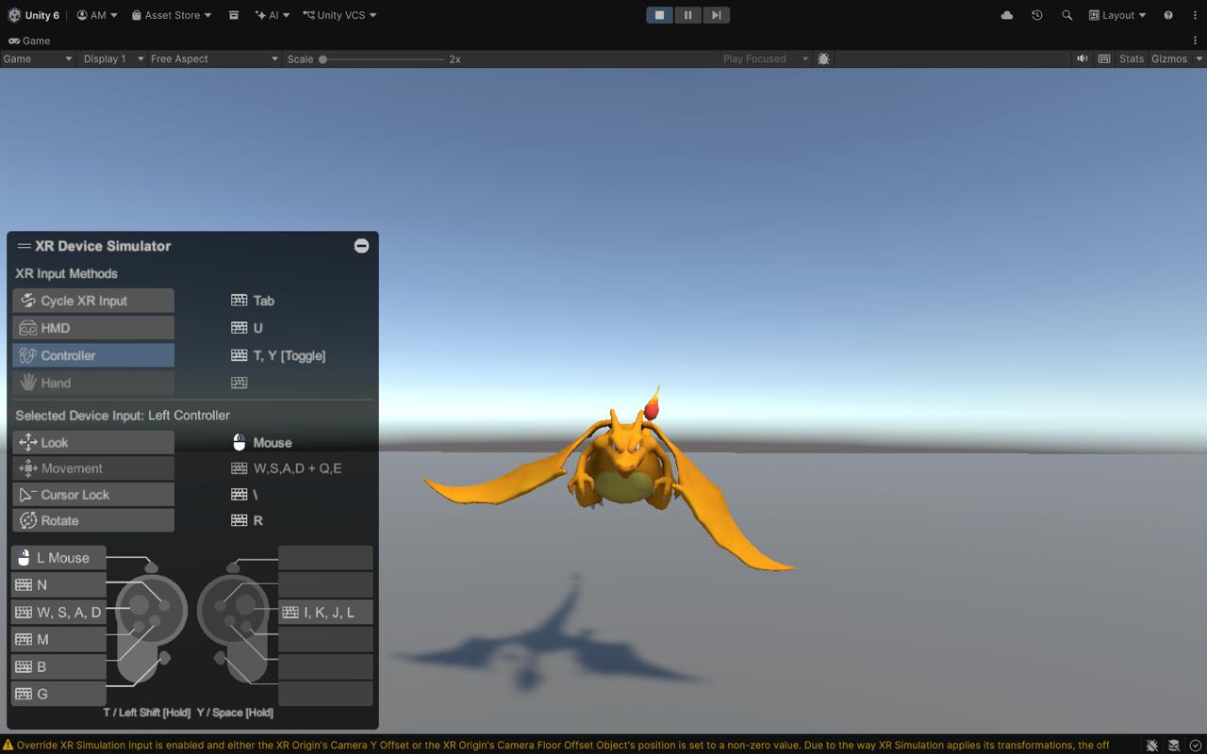
Figure 8: WASD movement and mouse look verified in Play mode

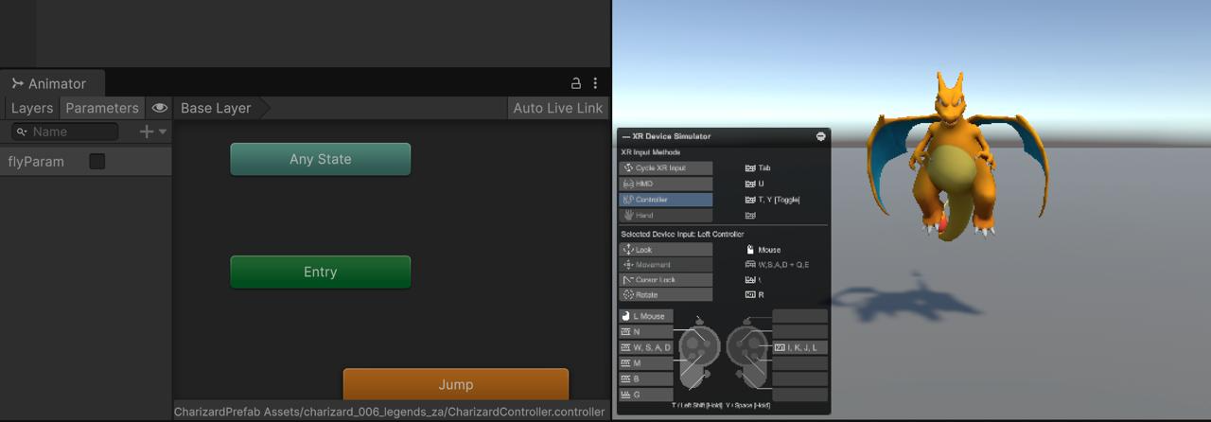
Figure 9: flyParam toggled ON — Charizard Animator transitions to flying state

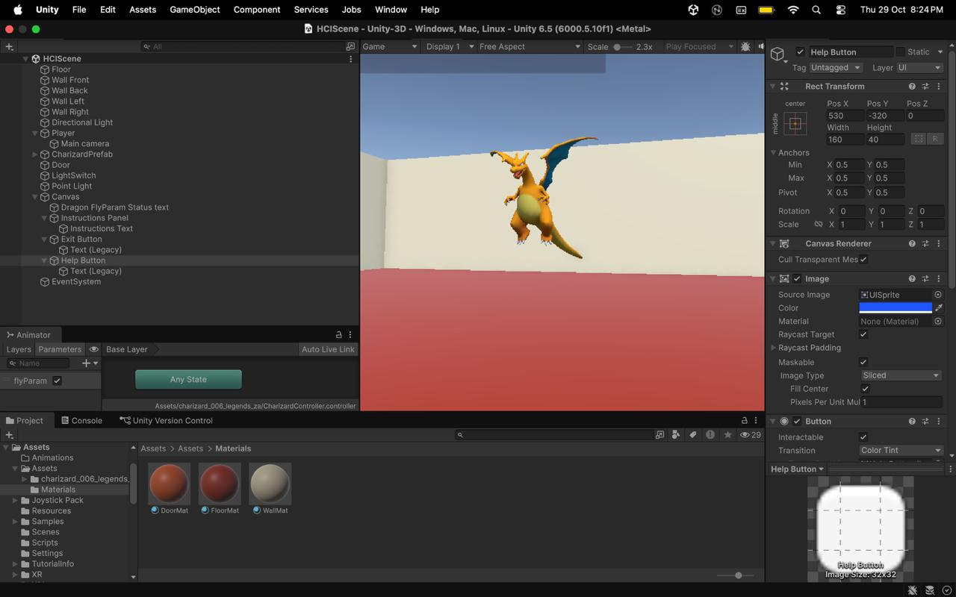
Figure 10: Charizard flying animation active — scene running on Mac M1 with full hierarchy and Materials panel visible

5. HCI-Based User Interface
A UI Canvas was added to the scene with UIManager.cs as a singleton managing all interface elements. The UI meets all rubric requirements: instructions for the user, interaction/status messages, and an Exit option.

5.1 UI Elements
UI Element | Position | Purpose | Rubric Requirement Met
Instructions Panel | Top-left, anchored | Shows all controls: WASD, Mouse, E, H, ESC. Visible by default. | Instructions for the user
Status Text | Bottom-centre, anchored | Shows interaction result for 3 seconds, then clears automatically. | Interaction/status message
Exit Button | Bottom-left corner | Calls Application.Quit(); also stops Play in Unity Editor. | Exit option
Help (H) Button | Bottom-right corner | Toggles Instructions Panel visibility. | User control / Start/Reset option

All UI text uses white on a dark/coloured background for high contrast. Labels are concise (e.g. "Exit", "Help (H)") and action-oriented. Placement is consistent — instructions always top-left, status always bottom-centre.

UIManager.cs — ShowStatus() with auto-clear:
public void ShowStatus(string message)
{
statusText.text = message;
StopAllCoroutines();
StartCoroutine(ClearStatus());
}
IEnumerator ClearStatus()
{
yield return new WaitForSeconds(statusDuration); // 3 seconds
statusText.text = "";
}

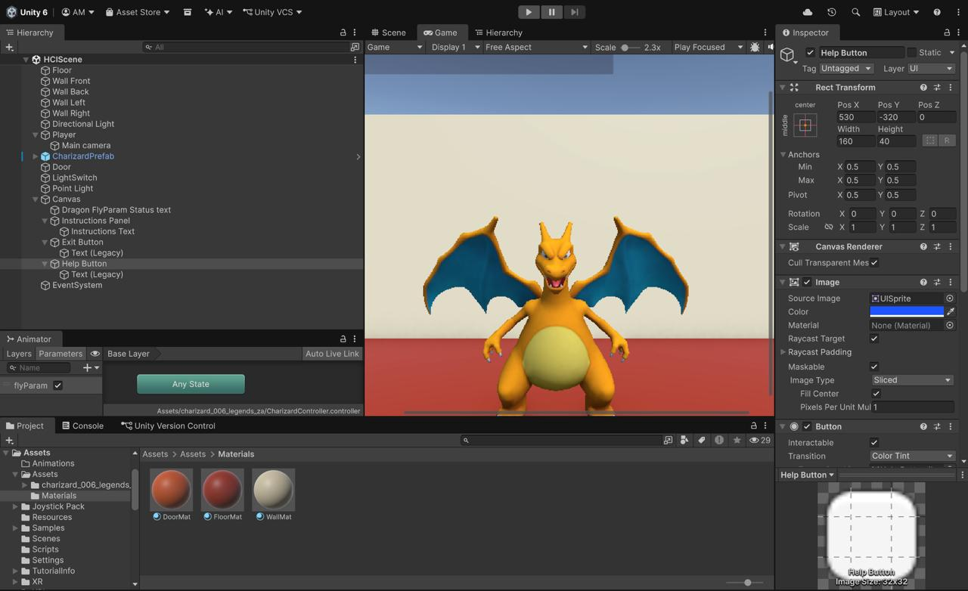
Figure 11: Complete HCIScene hierarchy, Materials (DoorMat/FloorMat/WallMat), Animator (flyParam), and Canvas structure

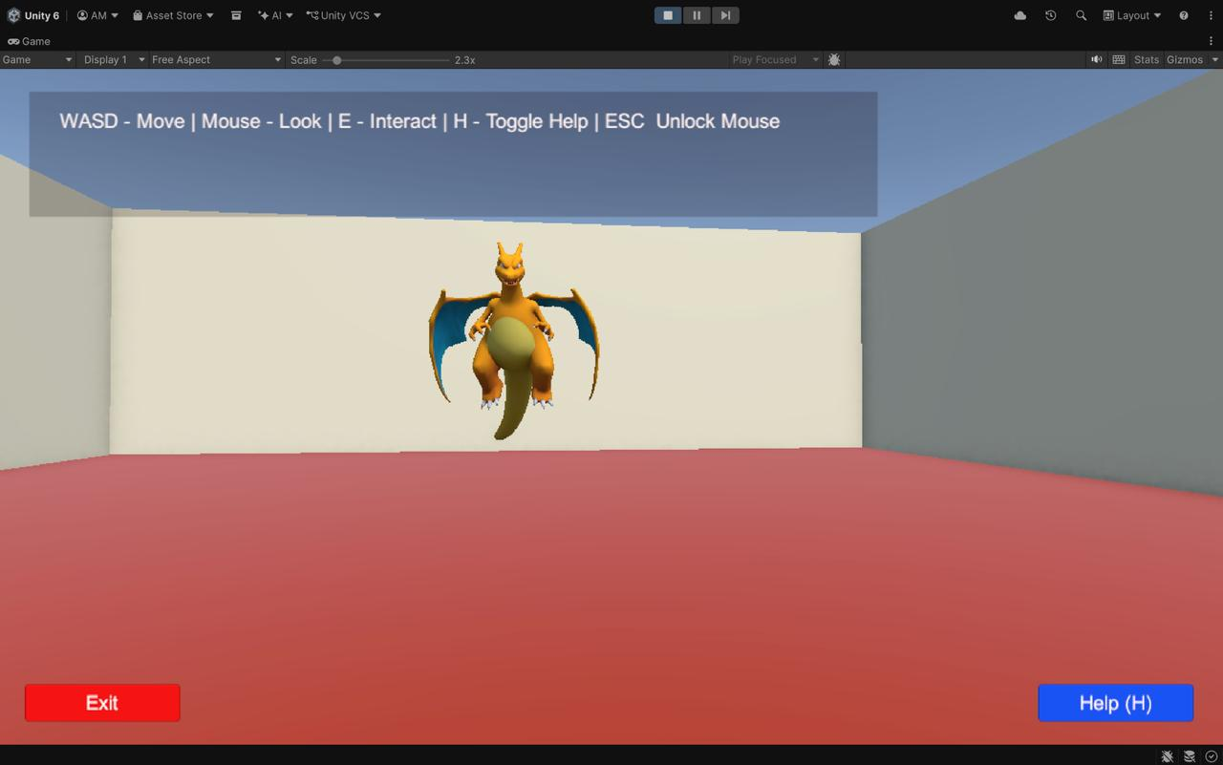
Figure 12: Final Game view: Instructions panel (top), Exit button (bottom-left), Help button (bottom-right), Charizard in room

6. Feedback and Usability
Every interaction produces immediate multi-modal feedback so the user always knows the result of their action. The environment is designed for first-time users — controls are visible on screen from the start and the same key (E) is used for all interactions.

6.1 Feedback Per Interaction
Object | Action | Visual Feedback | Text Feedback
Charizard Dragon | Press E | Animation state changes (idle ↔ flying wings spread) | Status: "Dragon takes flight!" / "Dragon lands and rests."
LightSwitch | Press E | Switch cube colour changes (yellow ↔ grey); Point Light turns on/off | Status: "Light switched ON." / "Light switched OFF."
Door | Press E | Door smoothly rotates 90° open or closed (Quaternion.Lerp) | Status: "Door opened." / "Door closed."
Non-interactive | Press E | No object state change | Status: "Nothing to interact with here."

6.2 Usability Features
- Instructions always visible on screen — no need to remember controls.
- Single consistent key (E) for all interactions — minimal learning curve.
- Status messages auto-clear after 3 seconds — screen stays clean.
- Cursor lock/unlock (ESC / click) follows standard FPS conventions familiar to most users.
- Interaction range limited to 4 units — prevents confusion from accidentally triggering distant objects.
- Mouse Y look clamped to ±80° — prevents disorienting camera flips.

7. HCI Principles Applied
The six HCI principles specified in the assignment are each clearly demonstrated:

HCI Principle | Definition (from rubric) | Where Visible in This Application
Visibility | Important controls and information should be clearly visible. | Instructions panel visible by default at top of screen. Status text always in the same fixed position. All interactive objects have visible physical representation.
Feedback | The system should communicate the result of a user's action. | Dragon: animation state changes. LightSwitch: colour changes (yellow/grey) + light on/off. Door: smooth rotation. Status text confirms every interaction within 1 frame.
Consistency | Similar interactions should behave in similar ways. | All three objects use the same E key. All feedback text appears in the same location. WASD movement is the standard FPS convention maintained throughout.
Affordance | Objects and controls should suggest how they can be used. | LightSwitch starts yellow — implying it is "on" and can be switched. Door is a tall thin cuboid — shape suggests it opens. Charizard is an animated character — invites interaction.
User Control | Users should be able to navigate and perform actions easily. | Free WASD + mouse navigation. Help panel toggled at any time with H or Help button. Cursor unlocked with ESC. Player can approach or move away from any object freely.
Error Prevention | The design should minimise inappropriate or confusing interactions. | E-key raycast limited to 4 units — accidental triggers impossible from a distance. Non-interactive objects give an explicit "Nothing to interact with here" message. Mouse Y clamped to prevent disorienting flips.

8. Demonstration and Documentation

8.1 Demo Video
A 2–3 minute screen-recorded demonstration video showing all major interactions is available at:
https://drive.google.com/file/d/1m8A6nE3qSddO3EzJZYPPxs085OBOg8Kc/view?usp=sharing

The video demonstrates:
- WASD navigation and mouse look inside the 3D room
- Interacting with Charizard (E key) — fly animation toggle
- Interacting with LightSwitch (E key) — Point Light and colour toggle
- Interacting with Door (E key) — smooth 90° rotation
- Instructions panel toggle (H key)
- Exit button functionality

8.2 Project Repository
Full Unity project source code:
https://github.com/aditimittal38/AR-Dragon-1

8.3 Scripts Summary
Script | Responsibility | Key Methods
PlayerController.cs | WASD movement, mouse look, gravity, E-key raycast | Move(), Look(), TryInteract()
InteractableObject.cs | Dragon / Light / Door interaction + feedback | Interact(), Update() (door lerp)
UIManager.cs | Status text, instructions panel, Exit / Help UI | ShowStatus(), ToggleInstructions(), ExitGame()

9. Conclusion
A complete, fully functional interactive 3D environment was developed in Unity 6, covering all five ISE2 rubric components (10/10 marks targeted):
- 3D Environment Design (2/2): Enclosed room with floor, four walls, Directional Light, Point Light, and materials applied to all surfaces.
- Navigation & Object Interaction (2/2): First-person WASD + mouse navigation; three distinct interactive objects (Dragon, LightSwitch, Door) each with unique mechanics.
- HCI-Based UI Design (2/2): Instructions panel, status message text, Exit button, and Help toggle — all clearly labelled and consistently placed.
- Feedback & Usability (2/2): Every interaction produces immediate visual and text feedback; single E key; 4-unit interaction range; auto-clearing status text.
- Demonstration & Documentation (2/2): 2–3 minute demo video (link above) and this detailed written report covering all required sections.

The project was implemented entirely on a desktop (Mac M1) without any VR or AR hardware, using only keyboard and mouse — demonstrating that strong HCI design principles apply equally to conventional 3D environments. The Charizard 3D model from the existing repository was reused as the primary interactive asset.

Reference Tutorial: https://www.youtube.com/watch?v=YBRlwCjLNMQ (Unity 3D Interactive Environment — used as a guide for scene structure and interaction design)

