Tutorial upgrade CPU & Memory Worker K8’s
- Drain node worker (setiap worker node)
kubectl drain k8-worker03 --ignore-daemonsets --delete-local-data
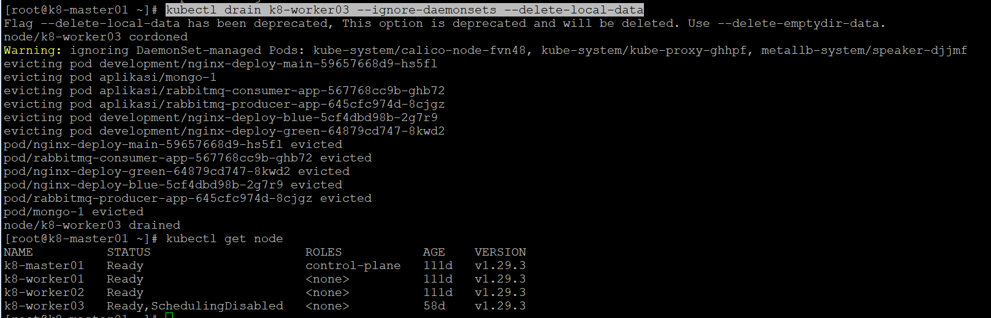
- Shutdown node
- Upgrade spesifikasi yang dibutuhkan kemudian jika sudah lakukan start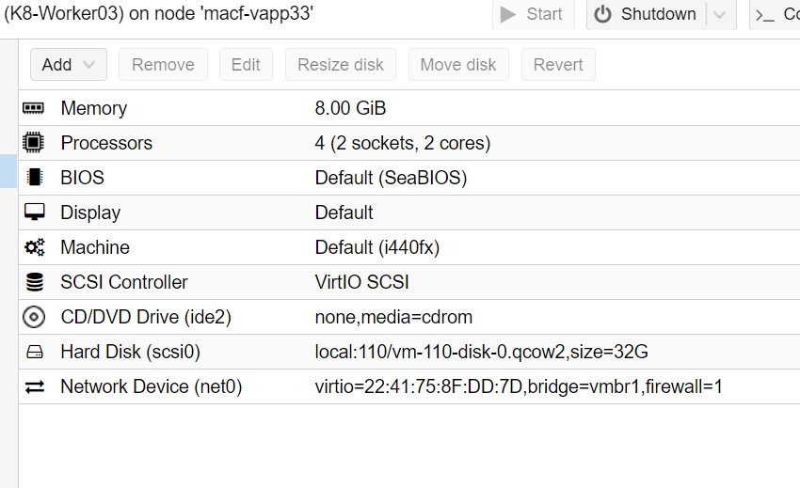
- Check node setelah upgrade
kubectl describe node k8-worker03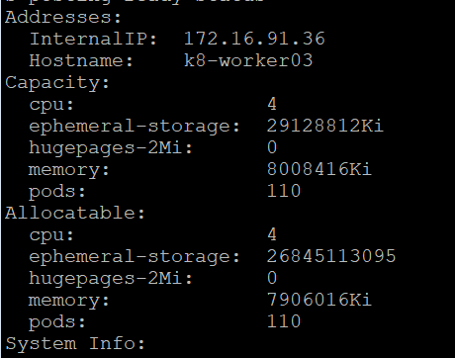
- Uncordon node, supaya bisa di schedule kembali setiap pod nya ke node available
kubectl uncordon k8-worker03
- Check kembali node setelah step nomor 5
kubectl get node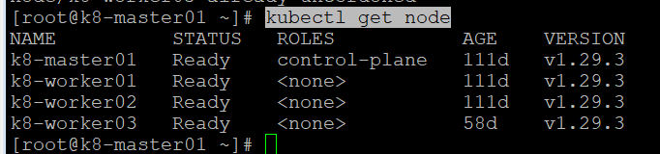
- Ulangi step 1-6 di node yg lain

