Findings from prod-mcf
- High Memory Usage >85% (acq-services)
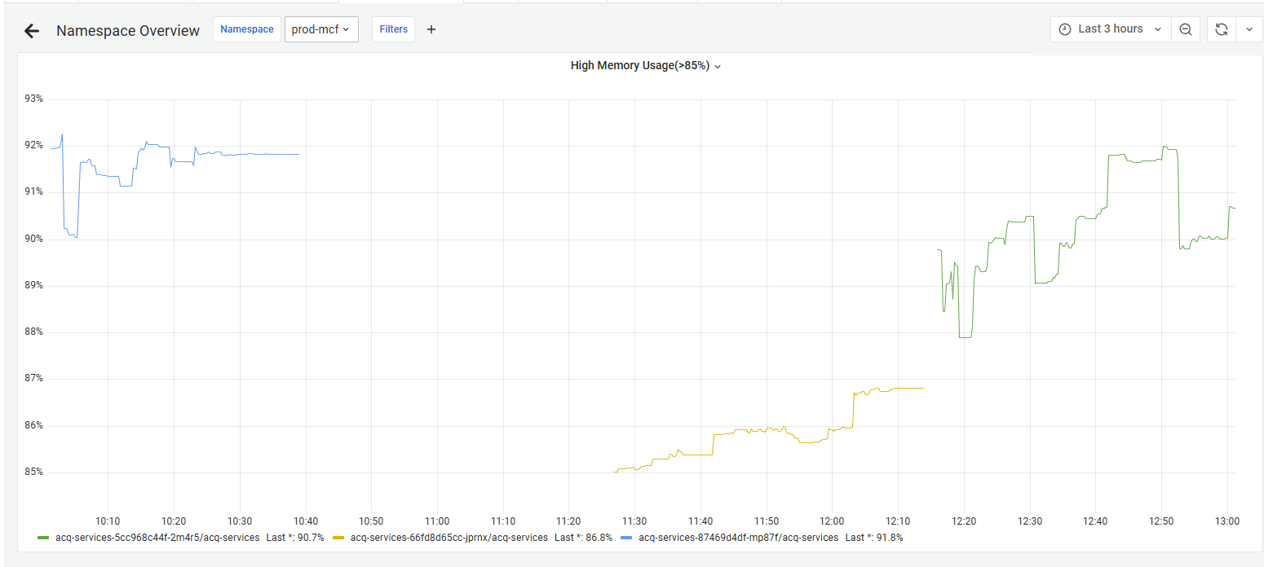
- Container utilization (acq-services)
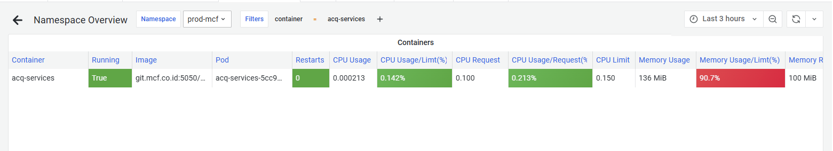
Recommendations:
- Upgrade memory limit from 100Mi to 250Mi
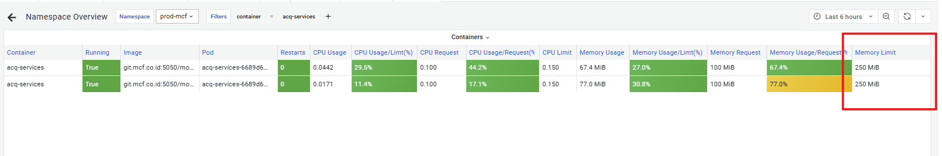
Findings from prod-maf
- High Memory Usage >85% (acq-services)
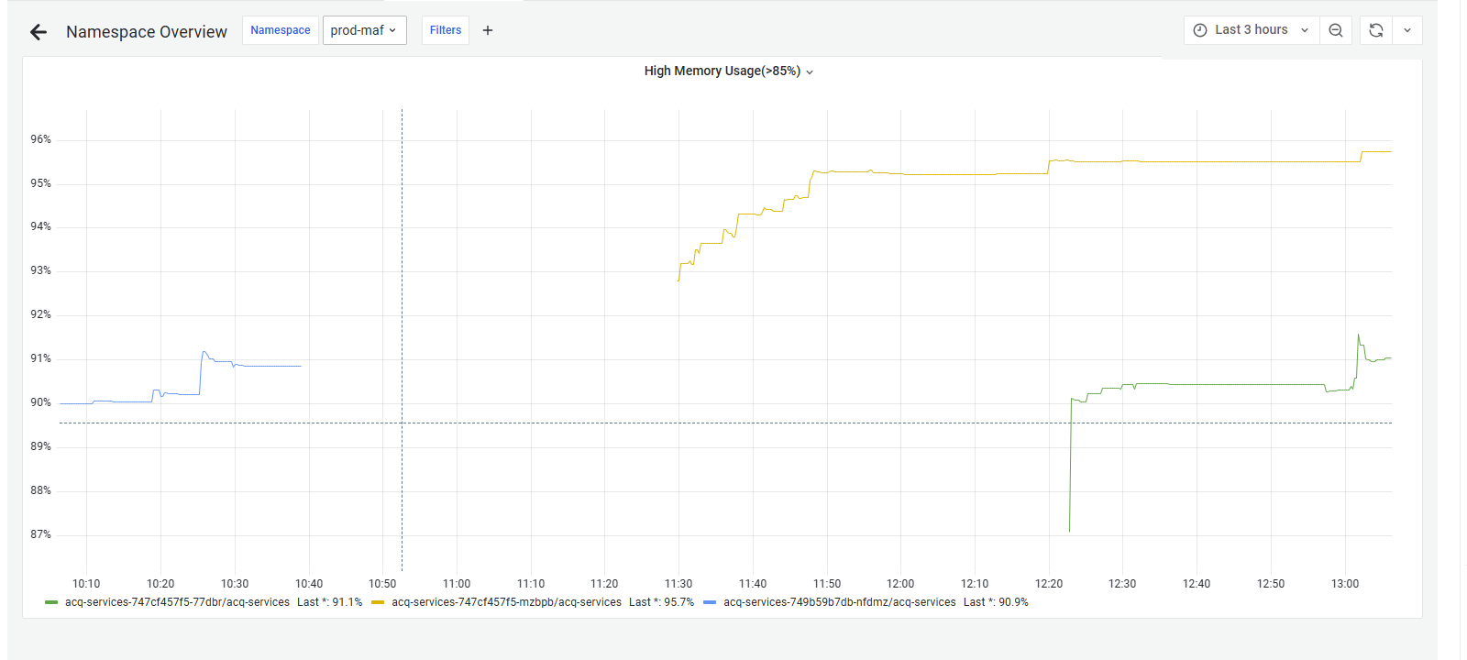
- Container utilization (acq-services)
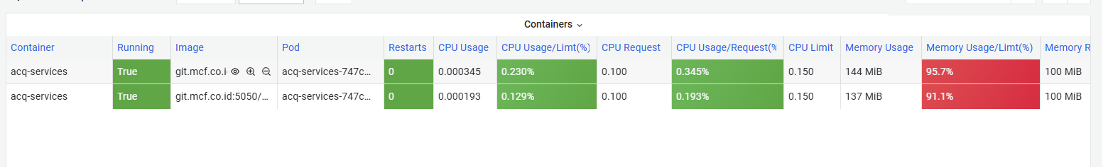
Recommendations:
- Upgrade memory limit from 100Mi to 250Mi

Top 3 Busiest service from prod-maf & prod-mcf
- Istio-proxy (Api Gateway)
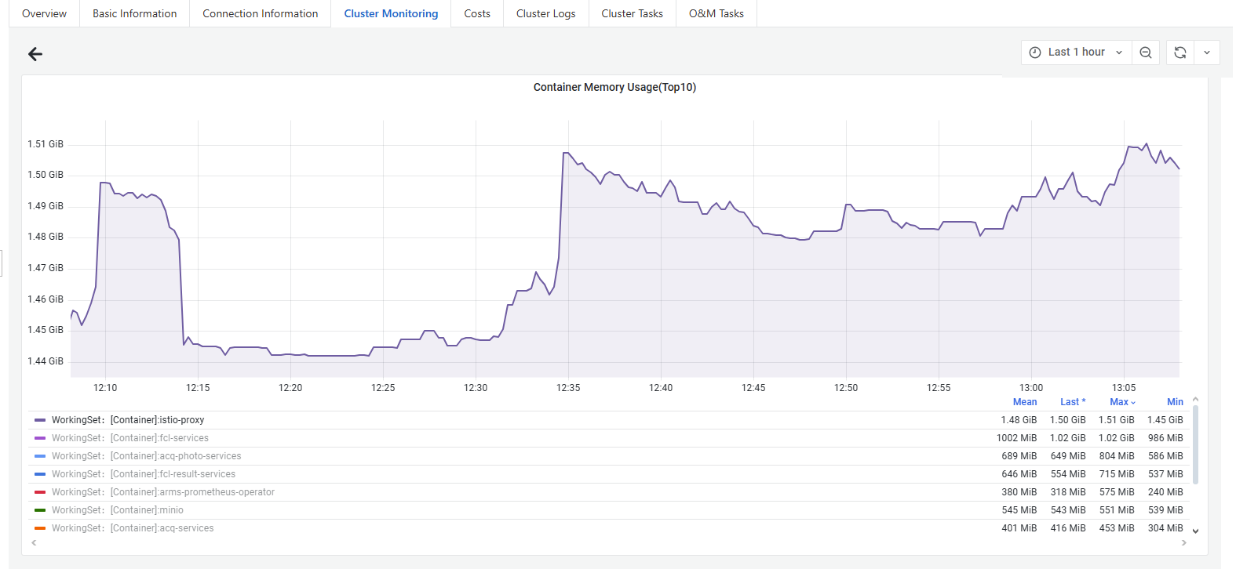
- Fcl-services
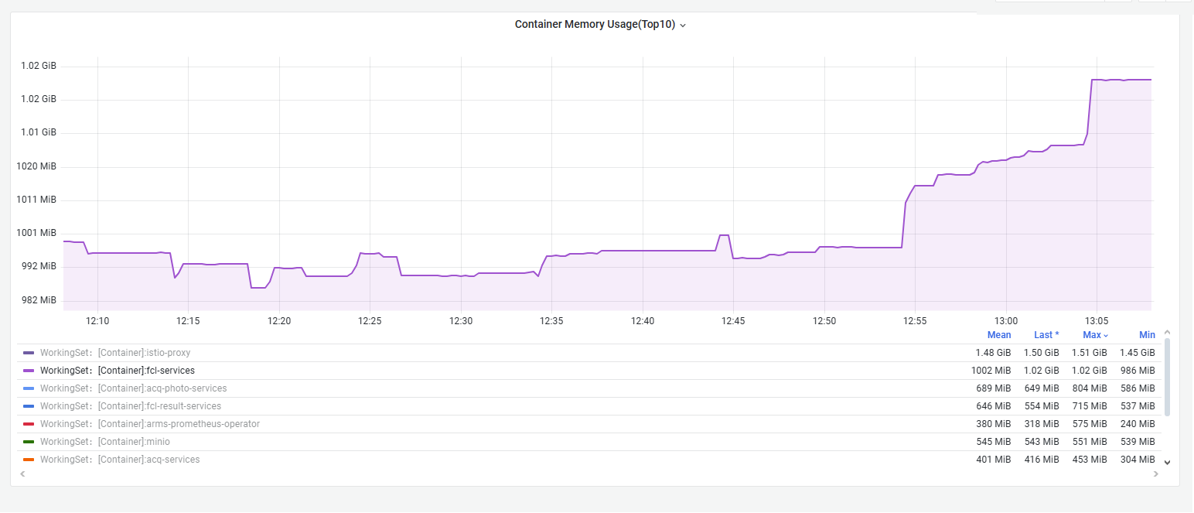
- Acq-photo-services
