Install Rook Ceph using Storage Node(Worker)
CRD existing
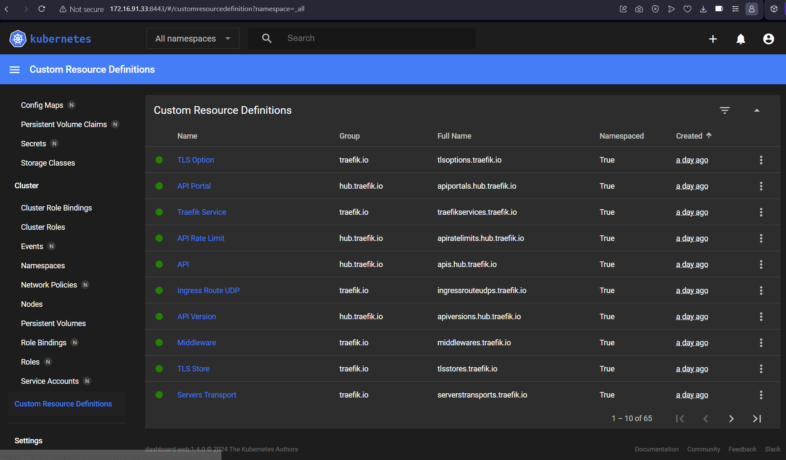
Clone Project Rook-Ceph
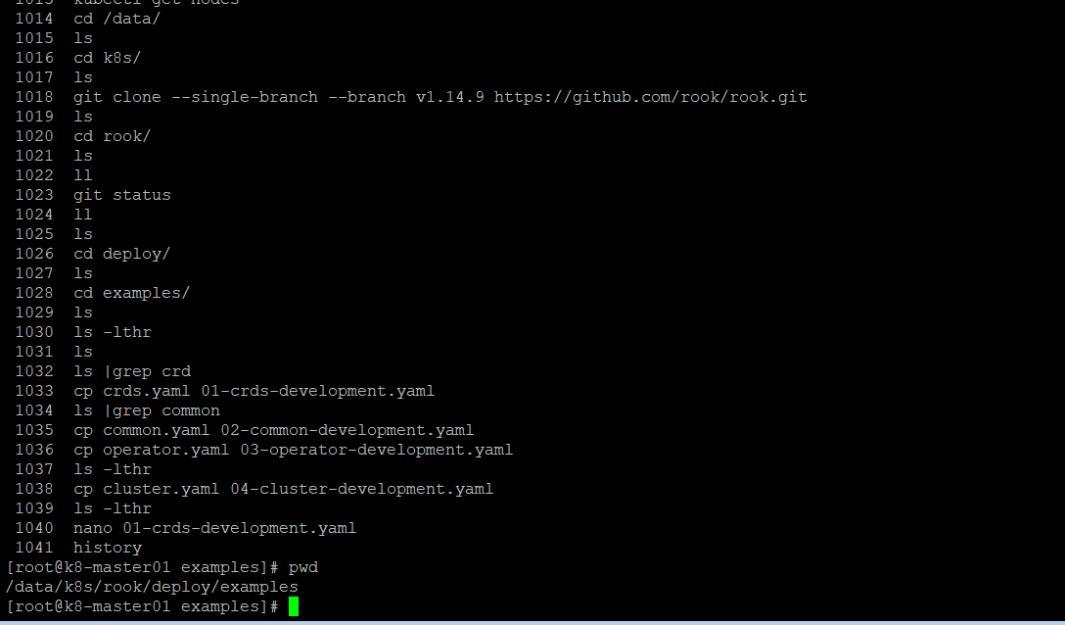
Edit ROOK_CSI_ENABLE_NFS: "true" from 03-operator-development.yaml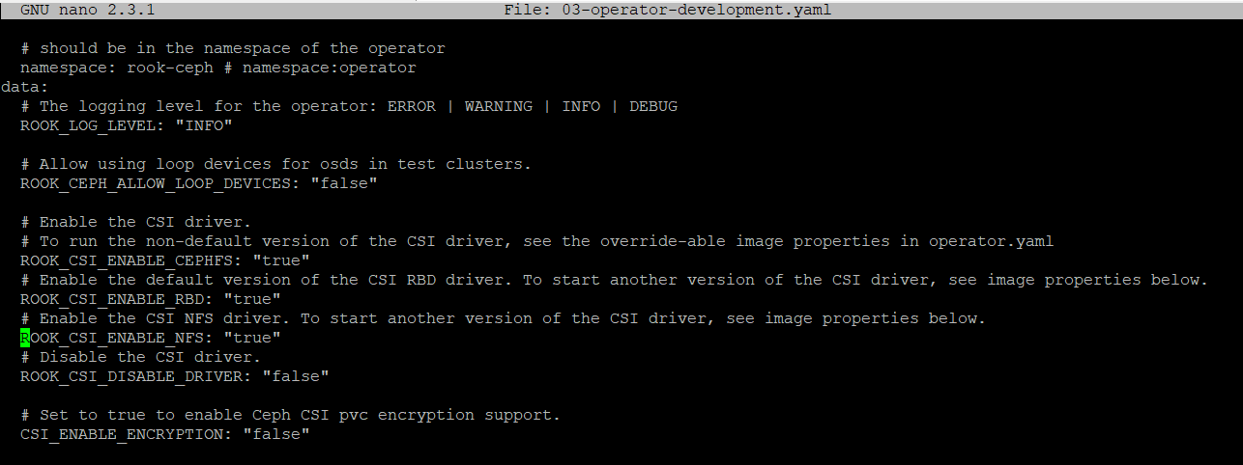
Deploy 01-crds-development.yaml -f 02-common-development.yaml -f 03-operator-development.yaml
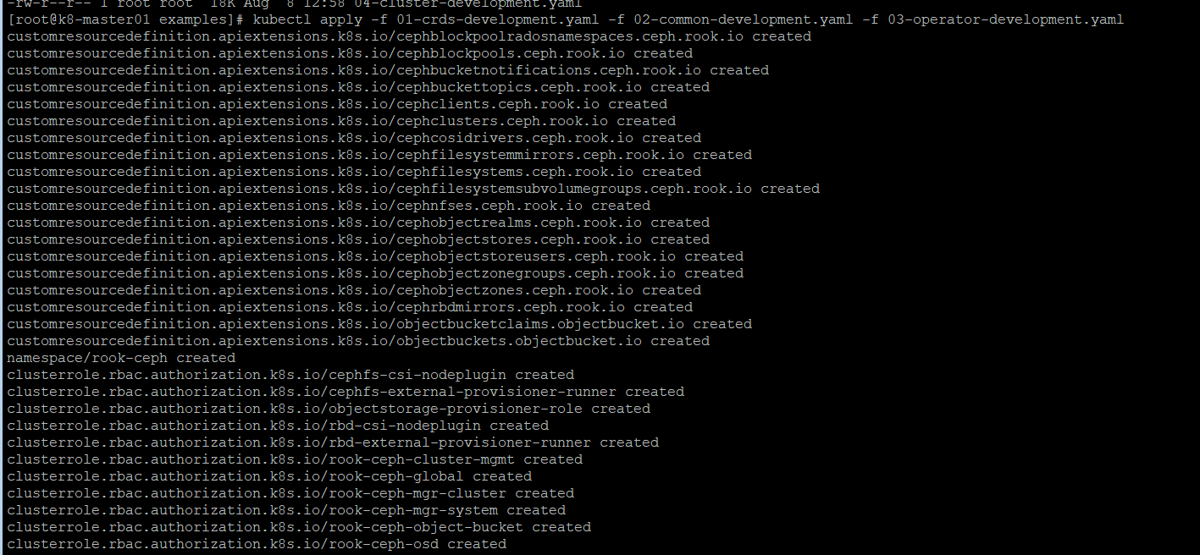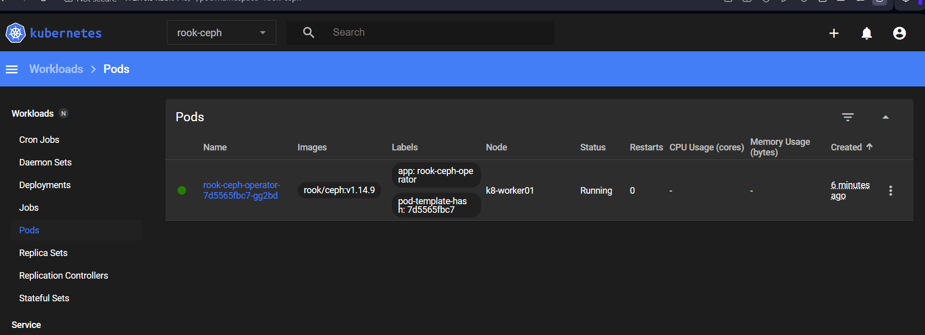
After deploy CRD will be installed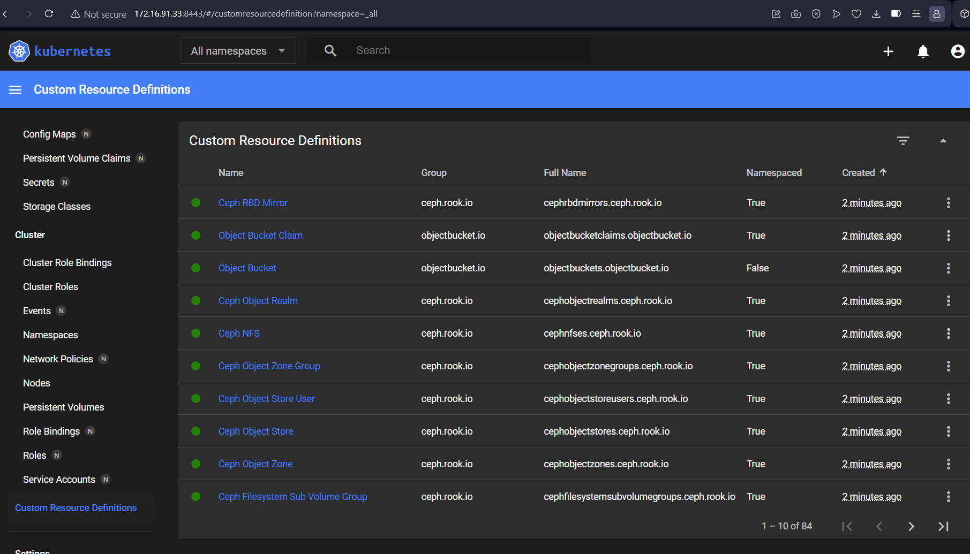
In this case I have 3 worker nodes that has unformatted disk (worker04-worker06) so this configuration edit to specific node from 04-cluster-development.yaml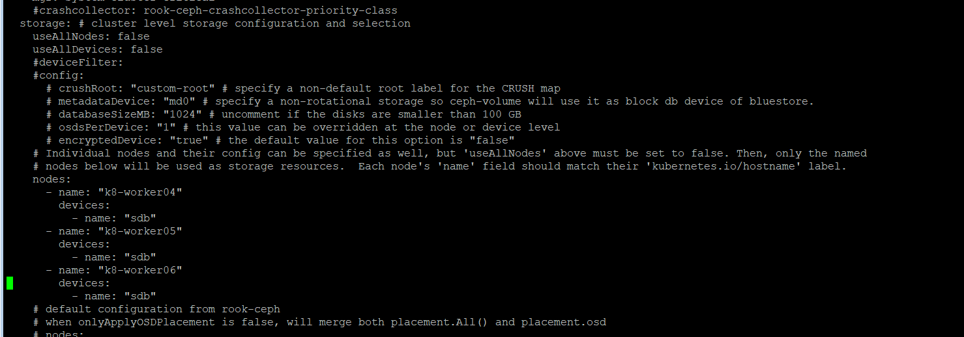
*these nodes show lsblk from each node from ansible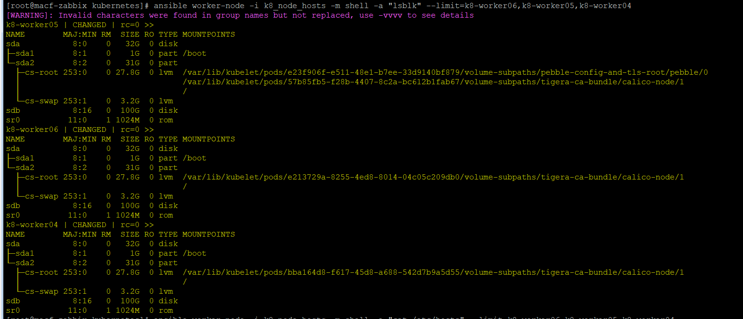
Deploy kubectl apply -f 04-cluster-development.yaml
