Create Instance for Backend Mobile Fincore Node (Pilot)
- Type Instance (ecs.g6.large)
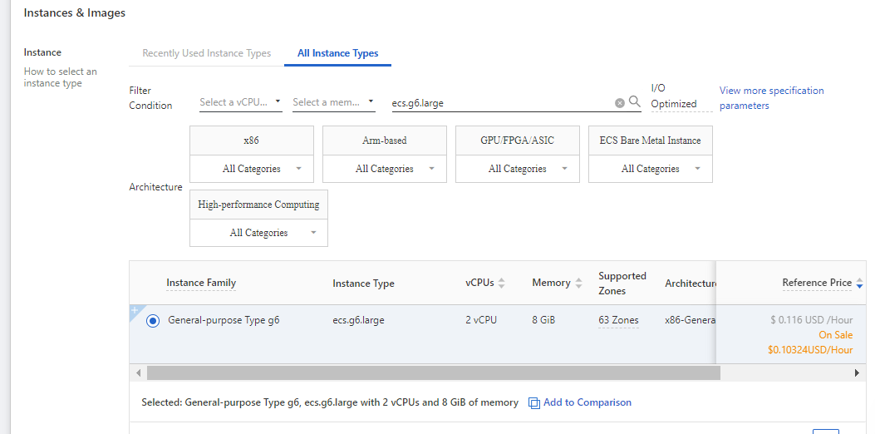
- Operating System
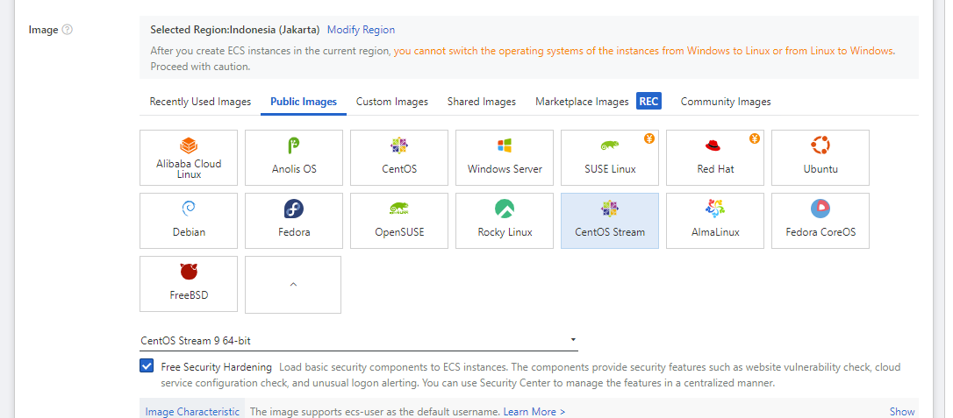
- Storage System Disk (80Gb)
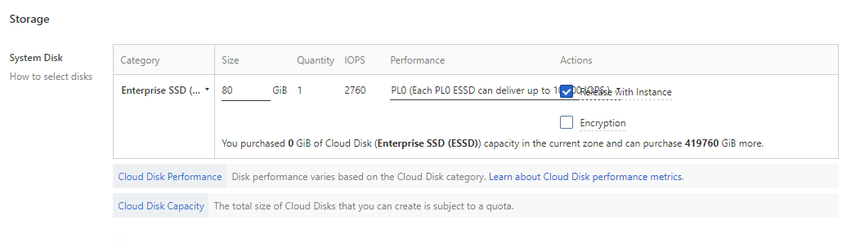
- Estimated 1 Instance
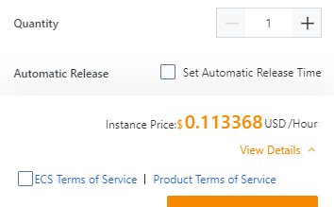
- Estimated 8 Instance
