Catatan untuk Bagian Deslon:
- Docker engine mesti menggunakan versi 20.10.23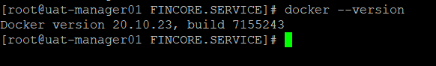
- Pastikan ada file docker-ce.repo dengan menggunakan versi dari point di atas.
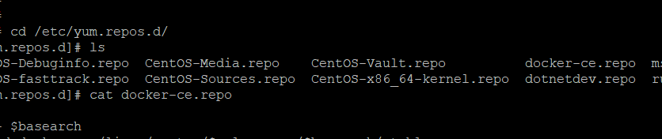
- Isi dari file docker-ce.repo
[docker-ce-stable]
name=Docker CE Stable - $basearch
baseurl=https://download.docker.com/linux/centos/$releasever/$basearch/stable
enabled=0
gpgcheck=1
gpgkey=https://download.docker.com/linux/centos/gpg

[docker-ce-stable-debuginfo]
name=Docker CE Stable - Debuginfo $basearch
baseurl=https://download.docker.com/linux/centos/$releasever/debug-$basearch/stable
enabled=0
gpgcheck=1
gpgkey=https://download.docker.com/linux/centos/gpg

[docker-ce-stable-source]
name=Docker CE Stable - Sources
baseurl=https://download.docker.com/linux/centos/$releasever/source/stable
enabled=0
gpgcheck=1
gpgkey=https://download.docker.com/linux/centos/gpg

[docker-ce-test]
name=Docker CE Test - $basearch
baseurl=https://download.docker.com/linux/centos/$releasever/$basearch/test
enabled=0
gpgcheck=1
gpgkey=https://download.docker.com/linux/centos/gpg

[docker-ce-test-debuginfo]
name=Docker CE Test - Debuginfo $basearch
baseurl=https://download.docker.com/linux/centos/$releasever/debug-$basearch/test
enabled=0
gpgcheck=1
gpgkey=https://download.docker.com/linux/centos/gpg

[docker-ce-test-source]
name=Docker CE Test - Sources
baseurl=https://download.docker.com/linux/centos/$releasever/source/test
enabled=0
gpgcheck=1
gpgkey=https://download.docker.com/linux/centos/gpg

[docker-ce-nightly]
name=Docker CE Nightly - $basearch
baseurl=https://download.docker.com/linux/centos/$releasever/$basearch/nightly
enabled=0
gpgcheck=1
gpgkey=https://download.docker.com/linux/centos/gpg

[docker-ce-nightly-debuginfo]
name=Docker CE Nightly - Debuginfo $basearch
baseurl=https://download.docker.com/linux/centos/$releasever/debug-$basearch/nightly
enabled=0
gpgcheck=1
gpgkey=https://download.docker.com/linux/centos/gpg

[docker-ce-nightly-source]
name=Docker CE Nightly - Sources
baseurl=https://download.docker.com/linux/centos/$releasever/source/nightly
enabled=0
gpgcheck=1
gpgkey=https://download.docker.com/linux/centos/gpg

- Pastikan sudah ada file daemon.json di directory /etc/docker untuk connect ke gitlab production maupun uat)
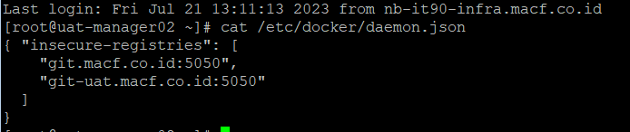
- Kondisi Docker Swarm Cluster dengan 3 Node Manager dan 4 Node Worker
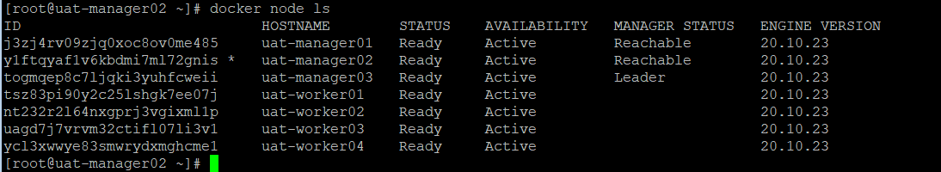

Tugas Latihan:
- Buat 2 Node Manager dan 2 Node Worker menggunakan konfigurasi seperti Catatan dihalaman sebelumnya. (spesifikasi: 2 Socket 2 Core, 8 Gb Memory, 30 GB Disk). Setting ip segment UAT, hostname sesuai urutan manager dan worker yang sudah ada, kemudian seting ntp jam sesuai active directory menggunakan chrony(ini bisa contek di server uat manager/worker yang sudah ada).
- Tambah 2 Node manager yang sudah di install, ke cluster swarm yang sudah ada menggunakan command dibawah ini:
docker swarm join --token SWMTKN-1-3vpxmeh99ovs5i411a33t14eqtxphje83givl4sfguywj5is0g-e76mw5srnfua2ry6gdl75gla9 172.16.96.44:2377
- Tambah 2 Node Worker yang sudah di install, ke cluster swarm yang sudah ada menggunakan command dibawah ini:
docker swarm join --token SWMTKN-1-3vpxmeh99ovs5i411a33t14eqtxphje83givl4sfguywj5is0g-11nacook3igx23w9g81vl59bh 172.16.96.44:2377
- Test login credential sysadmin dari gitlab uat melalui salah satu node docker yang baginda deslon buat seperti gambar di bawah ini.
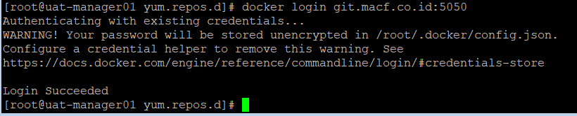
- Test pull repository dari gitlab uat/prod ke salah satu node manager. Kemudian build image dan push image ke repository gitlab uat/prod.
*note: kalo bingung chat, atau tanya aja google, baru ke gua ya lon

