Naikin Forntend fincore R4
git fetch
Git pull origin Staging-R4
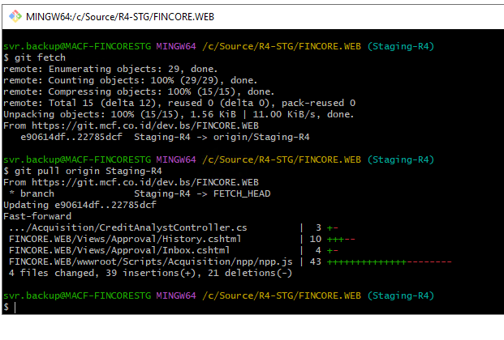
Stop Iis
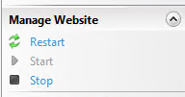
EndpointAPI.cs disesuaikan dengan PT nya (mcf atau MAF)
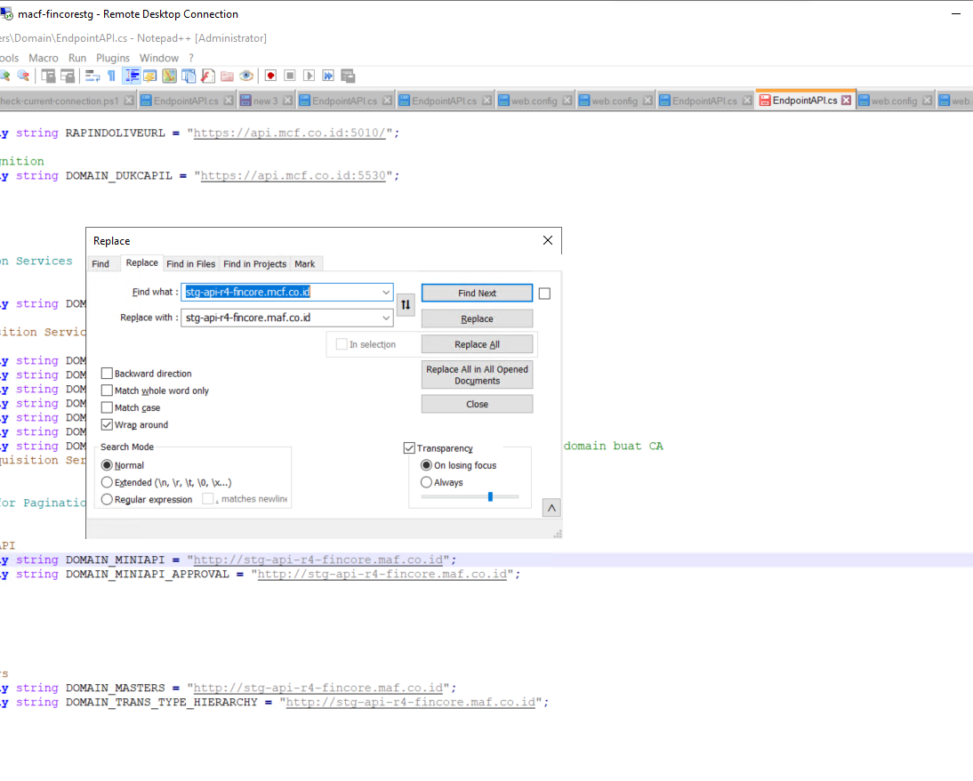
Buka CMD
tujuan Publishnya disesuaikan dengan pt nya
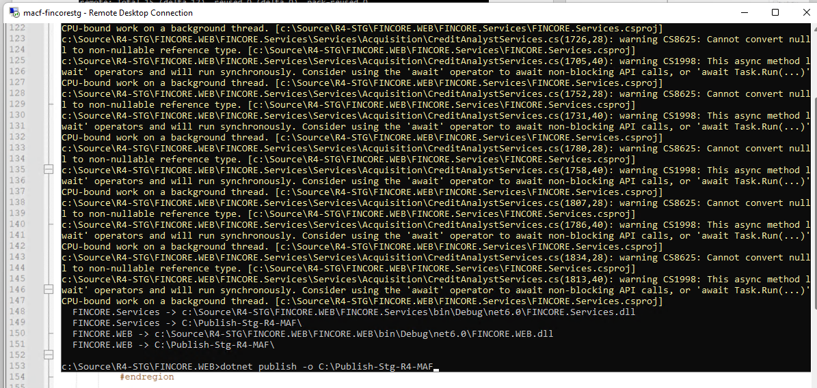
buka notepad++
tab web config , jngan di replace (pilih No )
buka port swanger
docker service update FINMCF-STG-R4_fin_credits --publish-add 82:80/tcp
docker service update FINMCF-STG-R4_fin_credits --publish-add 82:80/tcp

naikin 1 JS ,
=> ambil File NPP dari
C:/source/R4-stg/fincore.web/fincoreweb/wwwroot/scripts/acquisition/npp/npp.js
Paste Ke
C:/publish-stg-R4-MCF/wwwroot/Scripts/ acquisition/npp/npp.js
