Before
- Zldap1
  - View existing deployed certificate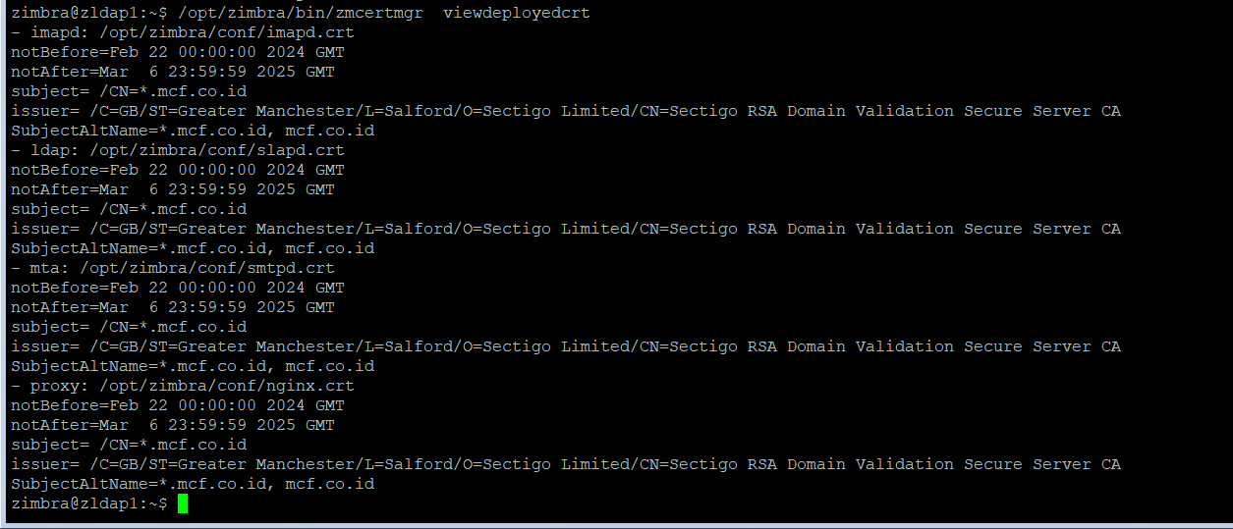
  - Verify new certificate
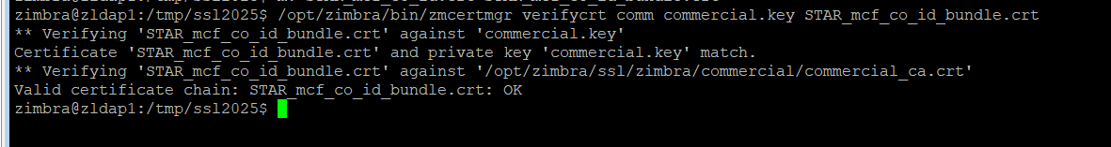
  - Backup directory ~/ssl/zimbra
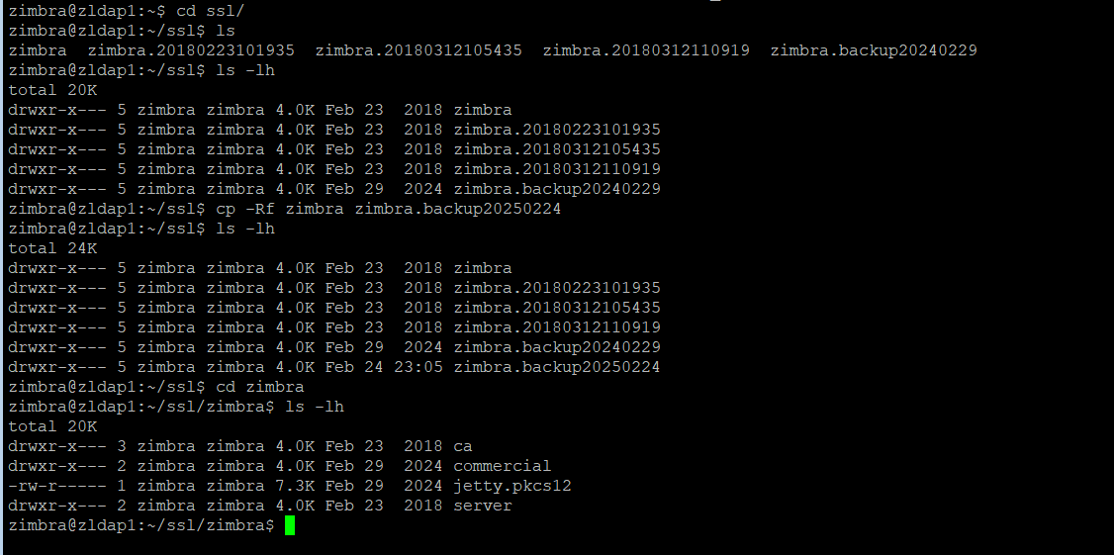
  - Copy content /tmp/ssl2025/commercial.key to ~/ssl/Zimbra/commercial/commercial.key
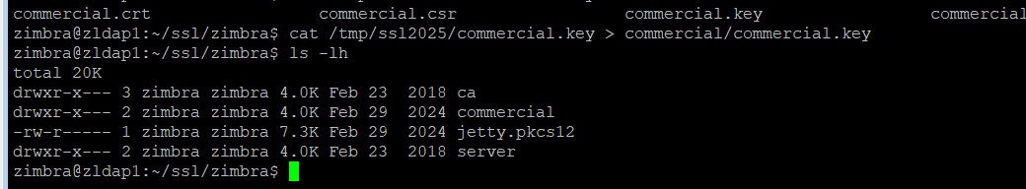
  - Verify using new commercial.key from ~/ssl/Zimbra/commercial/commercial.key
  - Deploycrt after verify OK
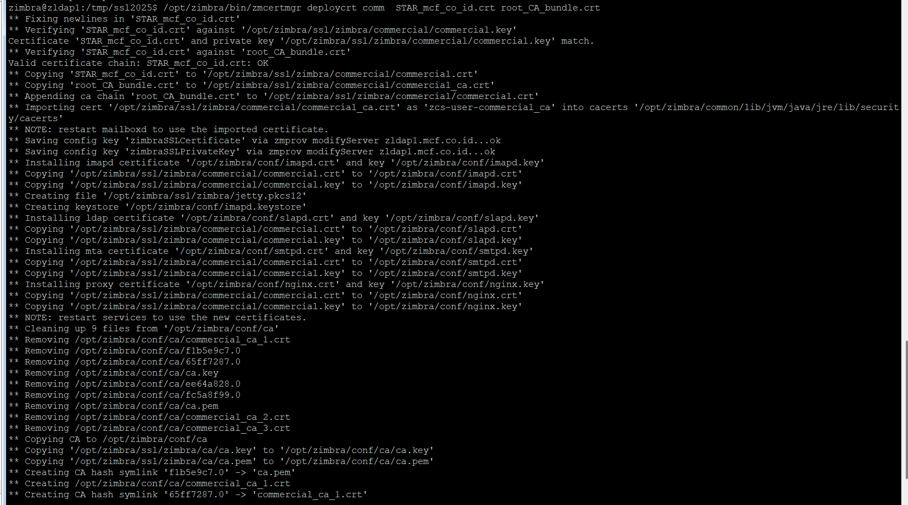
  - Check Deployed Certificate after Deployed
