Tutorial upgrade Jenkins version using war files
sumber: https://medium.com/geekculture/how-to-upgrade-jenkins-on-windows-linux-server-b7d4526abc31

- Stop Service Jenkins
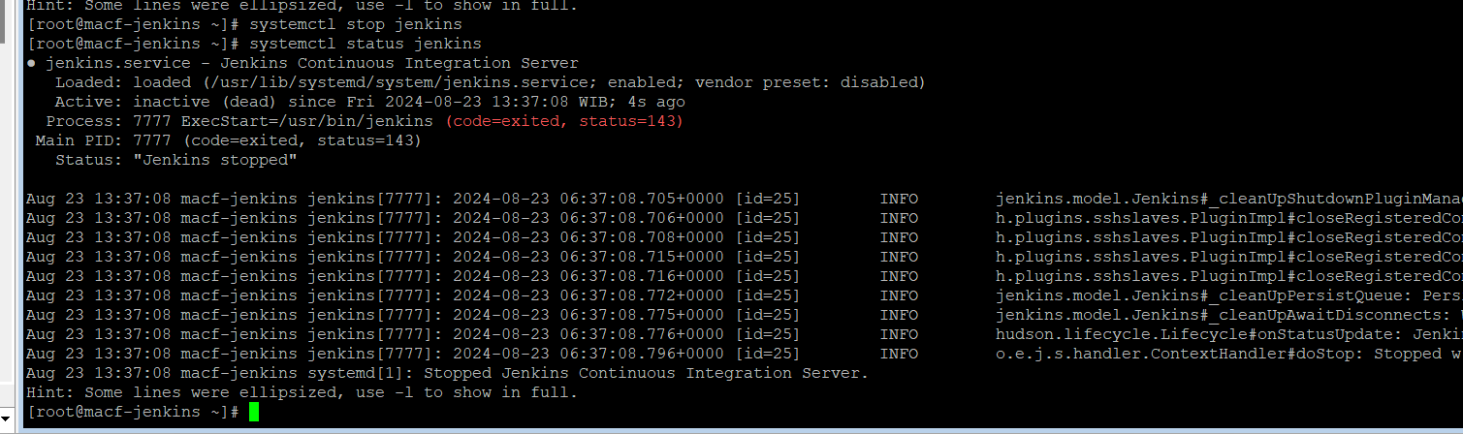
- Backup working directory /var/lib/Jenkins
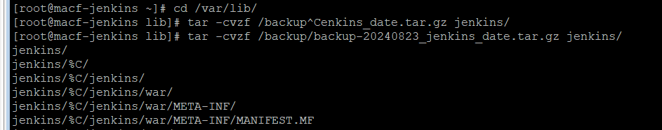
- Backup Binaries from /usr/share/java (Jenkins.war)
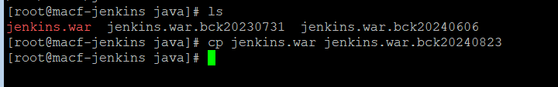
- Download latest binaries and deploy to /usr/share/java
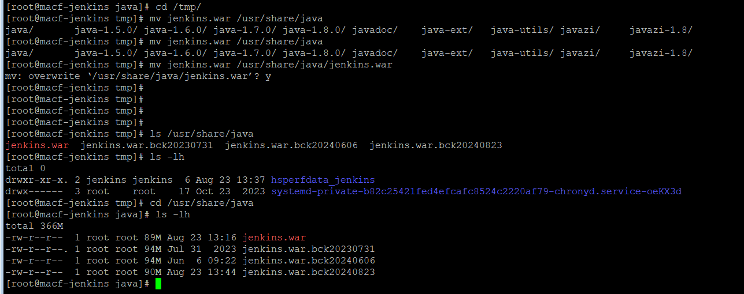
- Restart service Jenkins
