Tutorial upgrade Java version (Contoh: MACF-JENKINS)
sumber: https://docs.oracle.com/en/java/javase/17/install/installation-jdk-linux-platforms.html#GUID-CF001E7F-7E0D-49D4-A158-9CF3ED4C247C
- Check existing version
- Stop service application that using package java
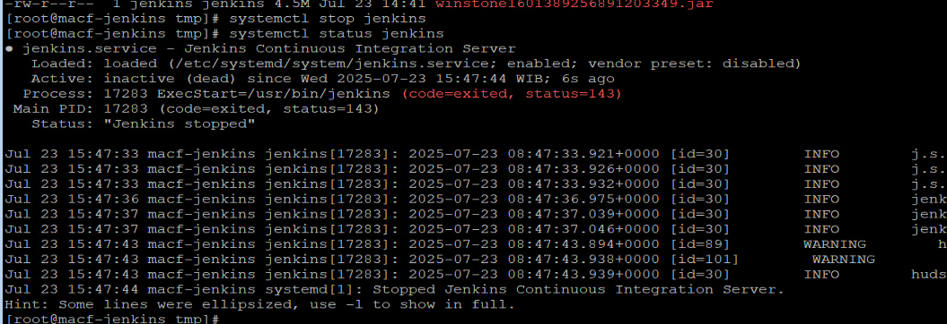
- Install RPM JDK-17 from official website java
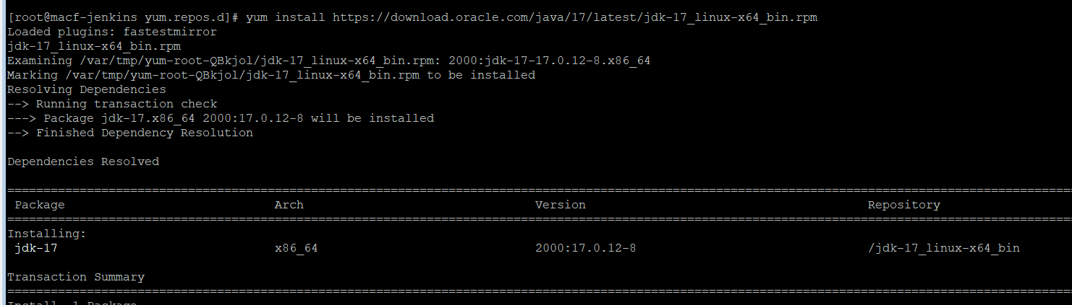
- Check after upgrade version
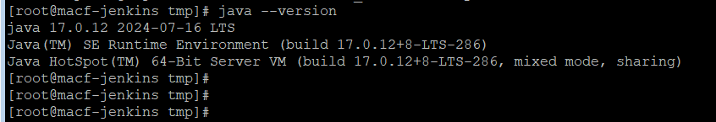
- Start service application
