Tutorial Join Domain Server Linux (Active Directory)
Sumber: https://jenciso.github.io/blog/how-to-join-centos-linux-to-an-active-directory-domain/

- Install Packages Below:
yum -y install sssd realmd oddjob oddjob-mkhomedir adcli \
samba-common samba-common-tools krb5-workstation \
openldap-clients policycoreutils-python
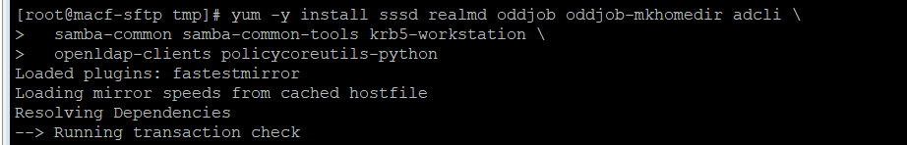

- Ensure to use your AD as domain server
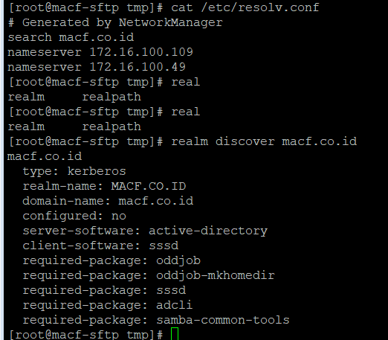
- Joining to Windows Domain
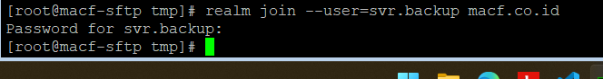
- Check CentOS 7 Machine after joined domain.
