Automation Deploy Fincore Web using Jenkins
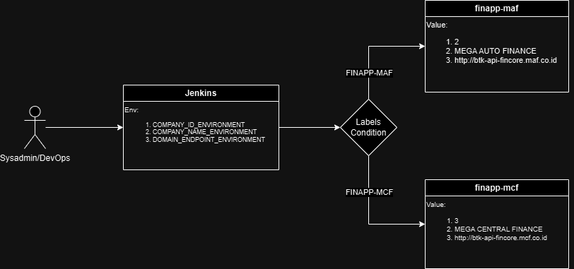

- Open project prod_automation_fincore-app
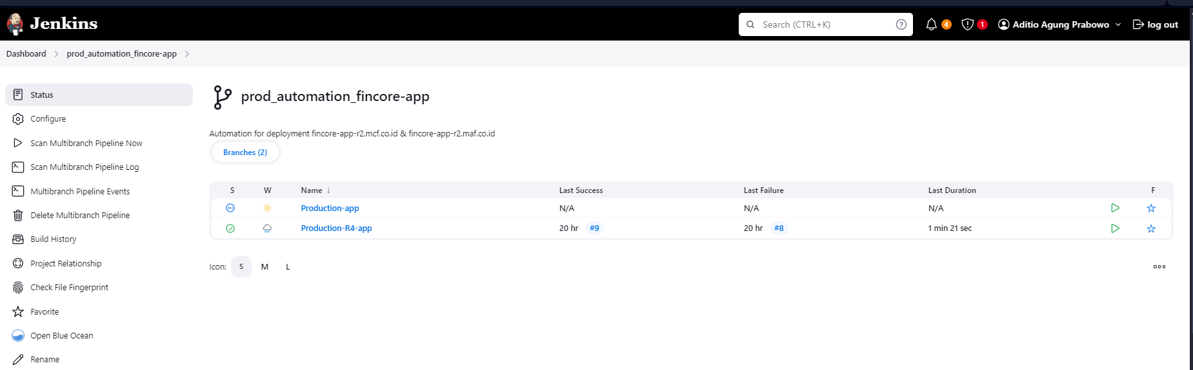
- Choose branch and set value to NODE_LABELS
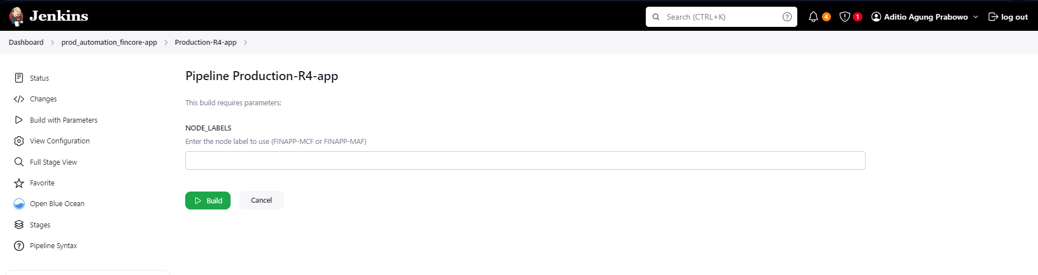
- Check progress from every steps on the pipeline overview
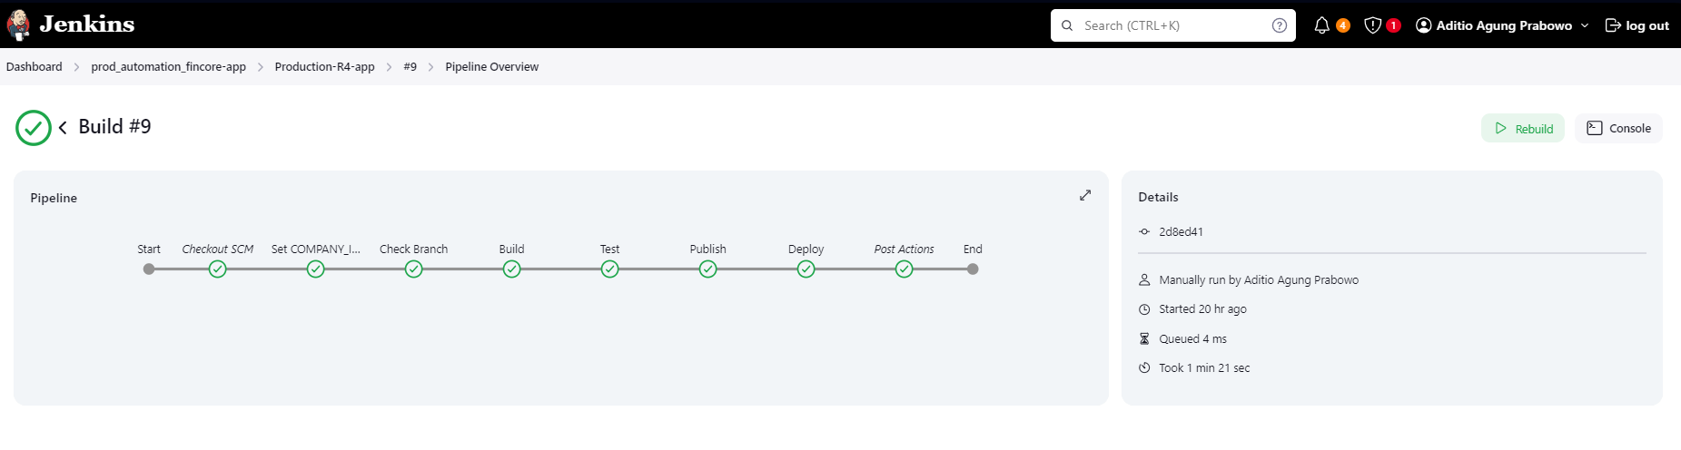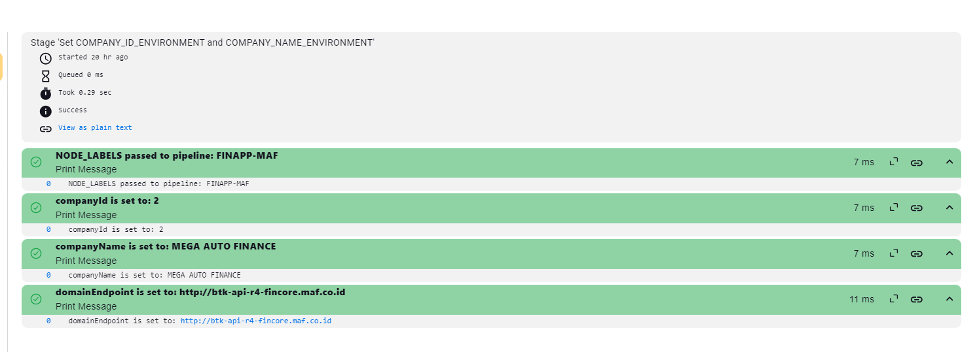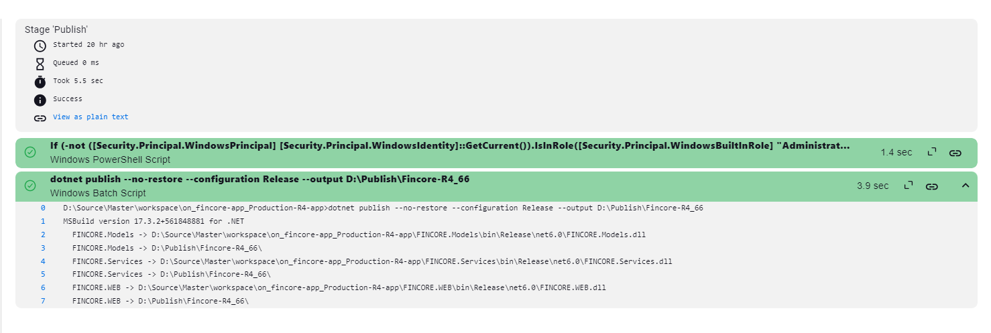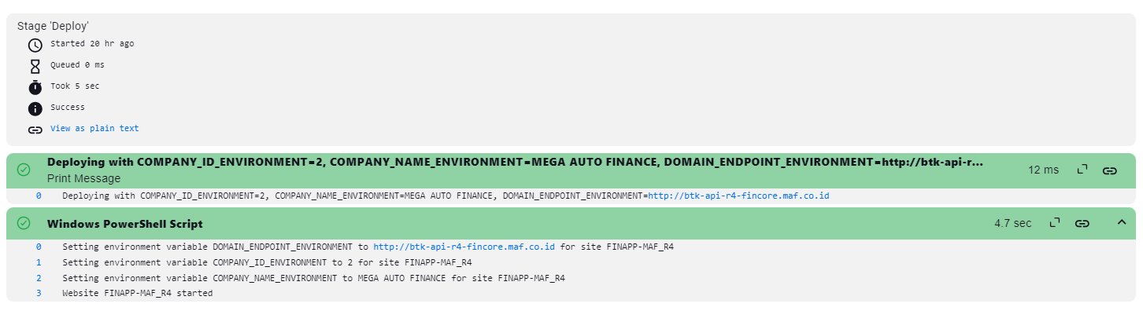
- Check environment variable on IIS site from destination Windows Server
