Tutorial Renew Certificate gitlab (git.mcf.co.id)
Before:
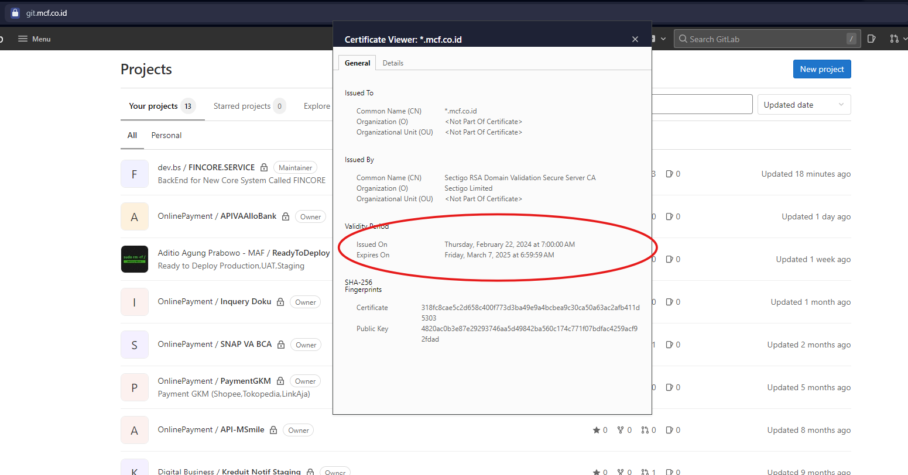
After:
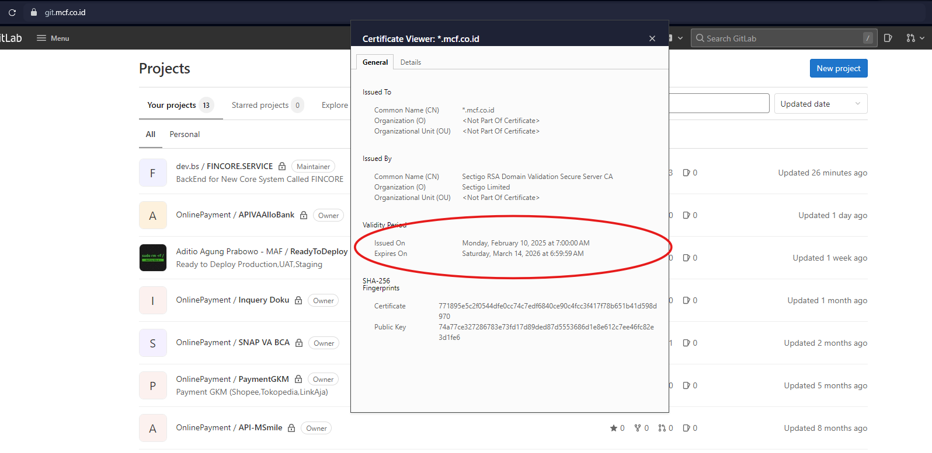

- Remote server & Jump in to directory /etc/gitlab/ssl
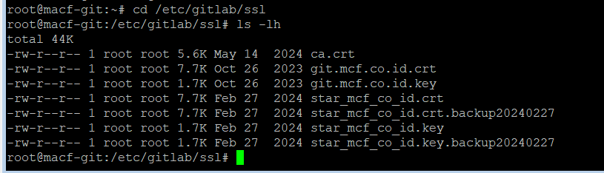
- Backup certificate existing
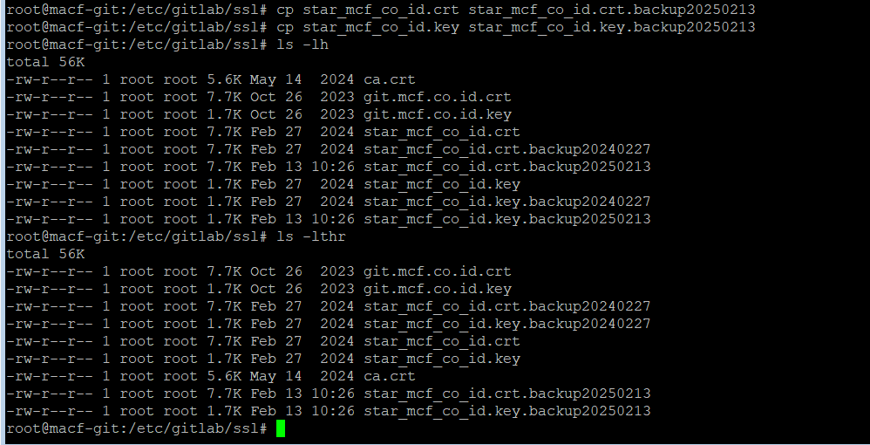
- Update isi content star_mcf_co_id.crt dan star_mcf_co_id.key menggunakan SSL terbaru
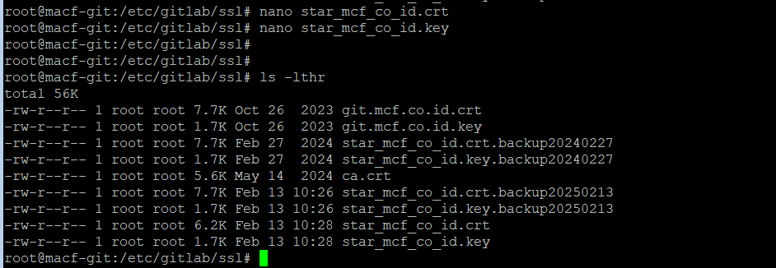
- Restart nginx from gitlab-ctl
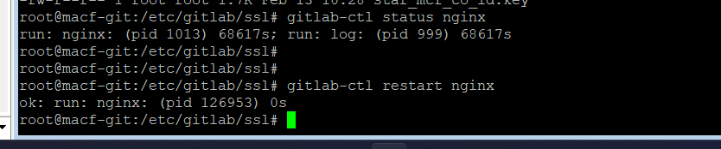
- Refresh browser dan cek valid period dari browser
