Project Manager
- Create new branch
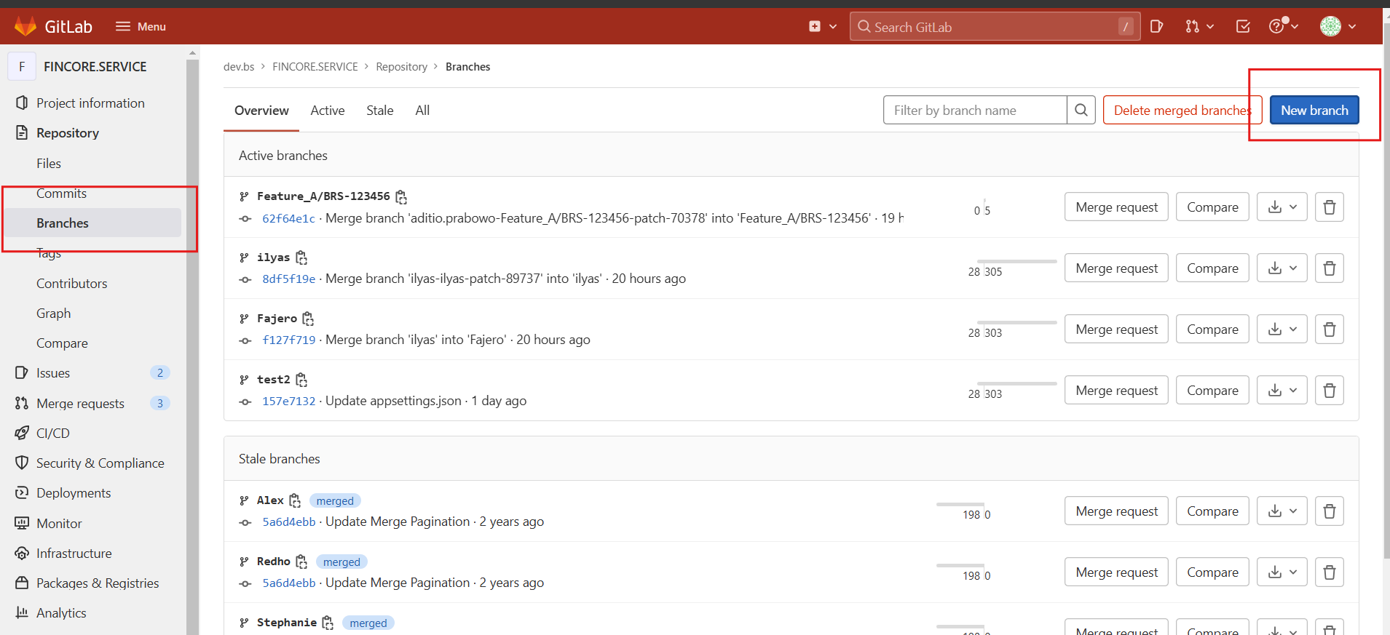
- Create new branch for new project/feature from latest branch (Staging-R2/Staging-R4)
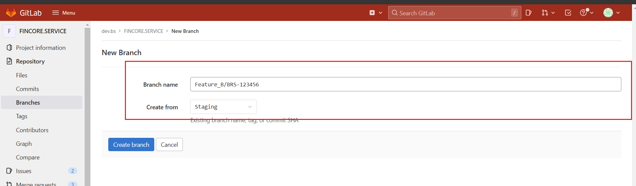
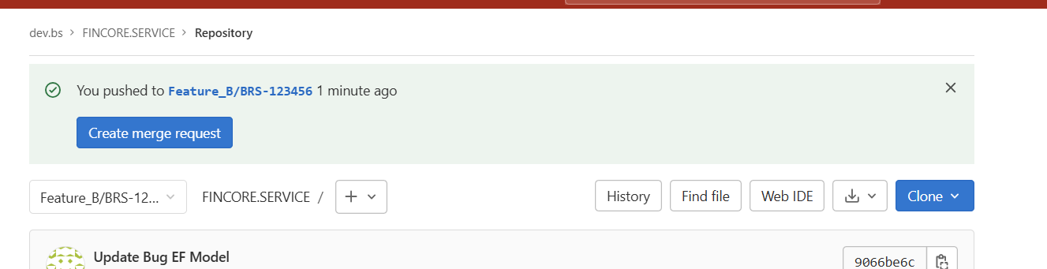

Developer
- Open Sourcetree, then clone with HTTPS from project to your local computer (don’t forget login account from gitlab)
