Migrate Domain Controller to Windows Server 2016
- Windows Server 2012 Std (existing)
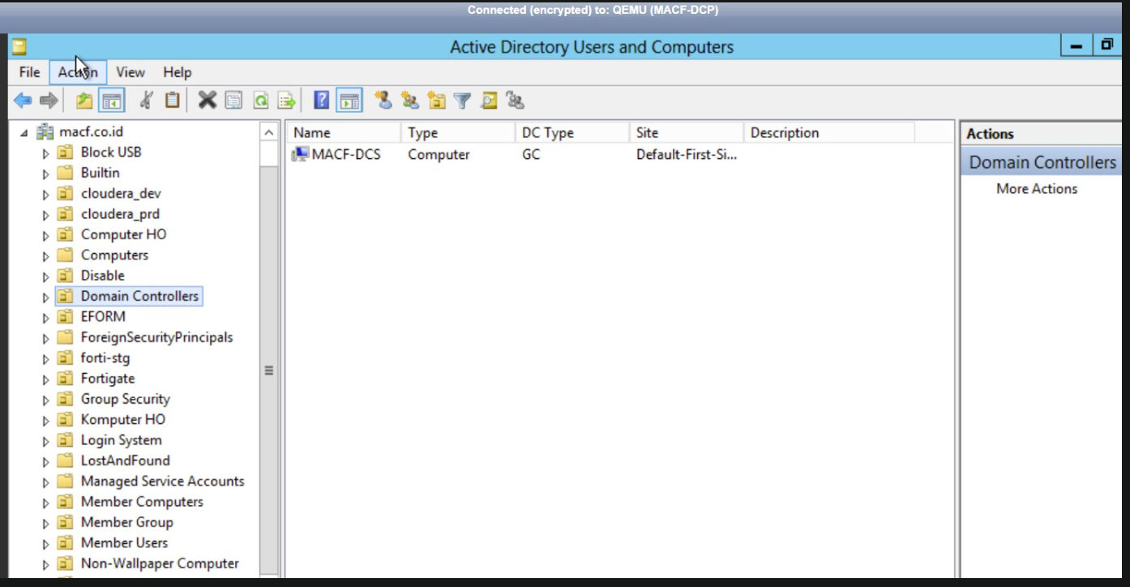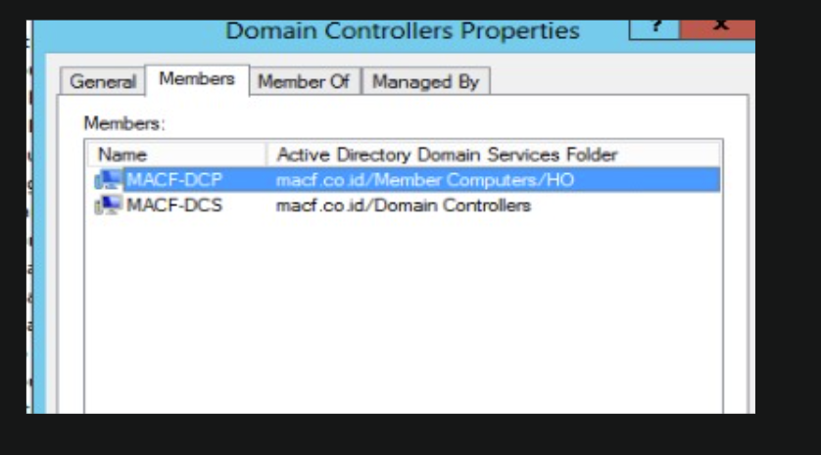
- Install Windows Server 2016 & ADDS package
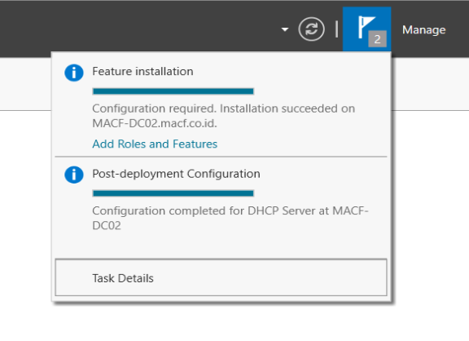
- Transfer fsmo from old server to new server
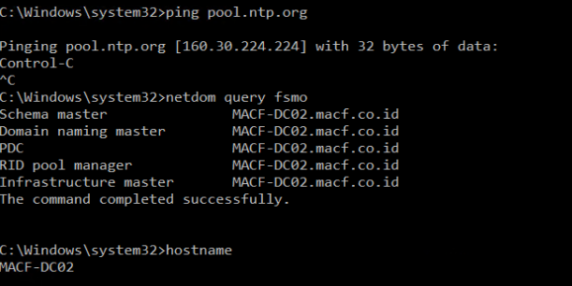
- After success migrate Domain Controller
