Create Cluster & Deploy Moofi Project
- Create Kubernetes Cluster
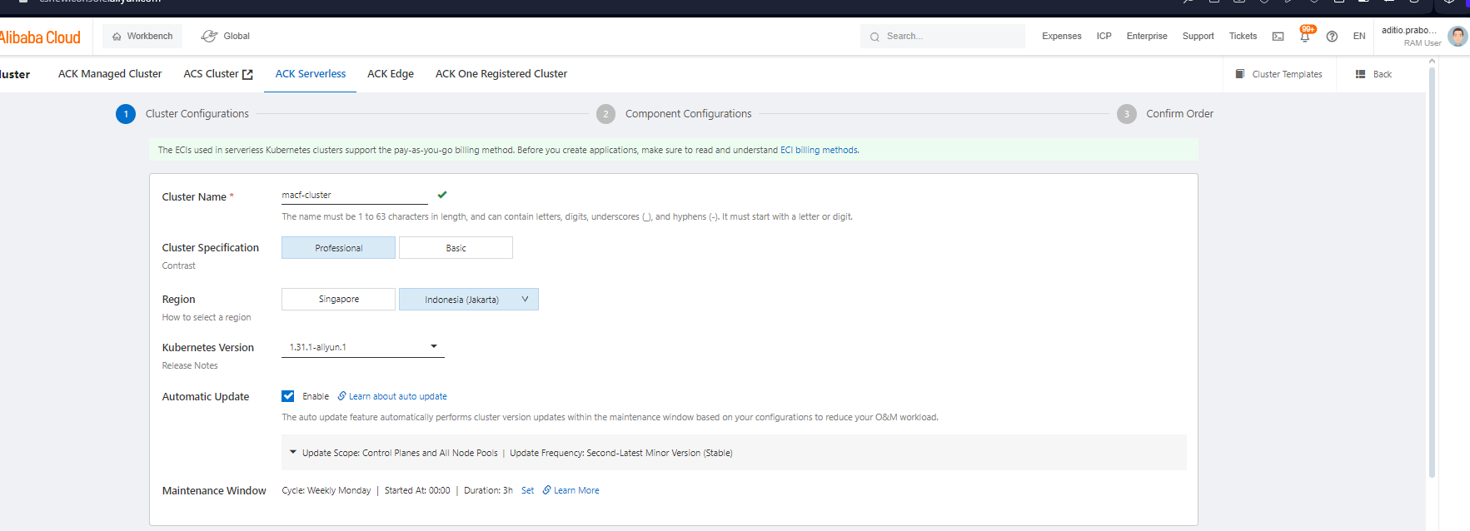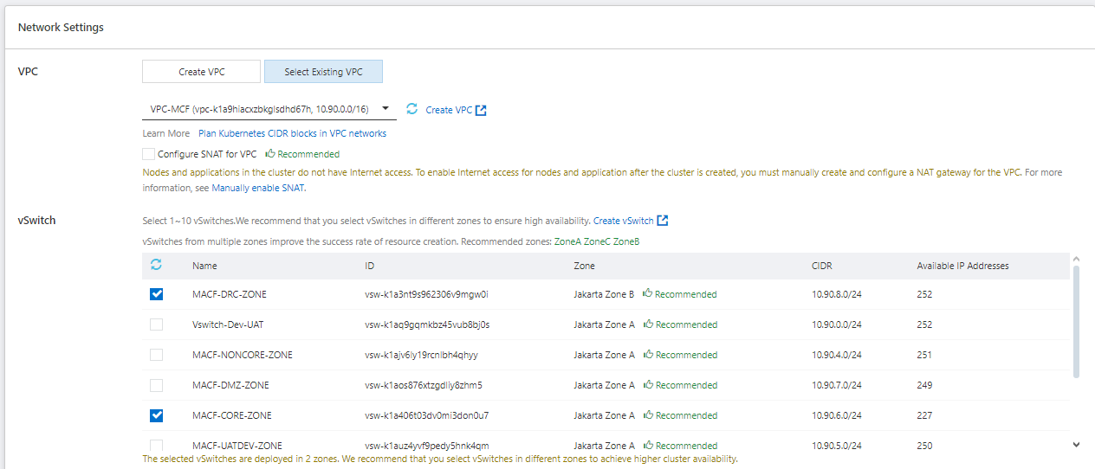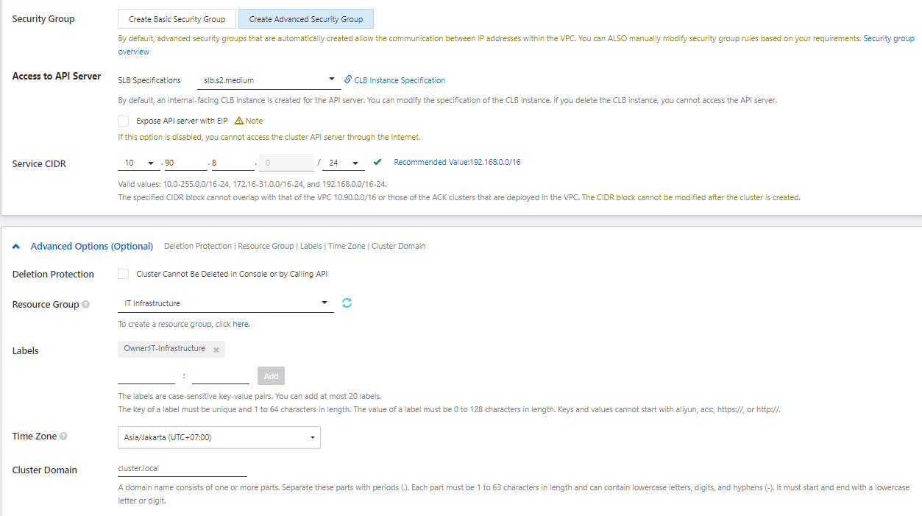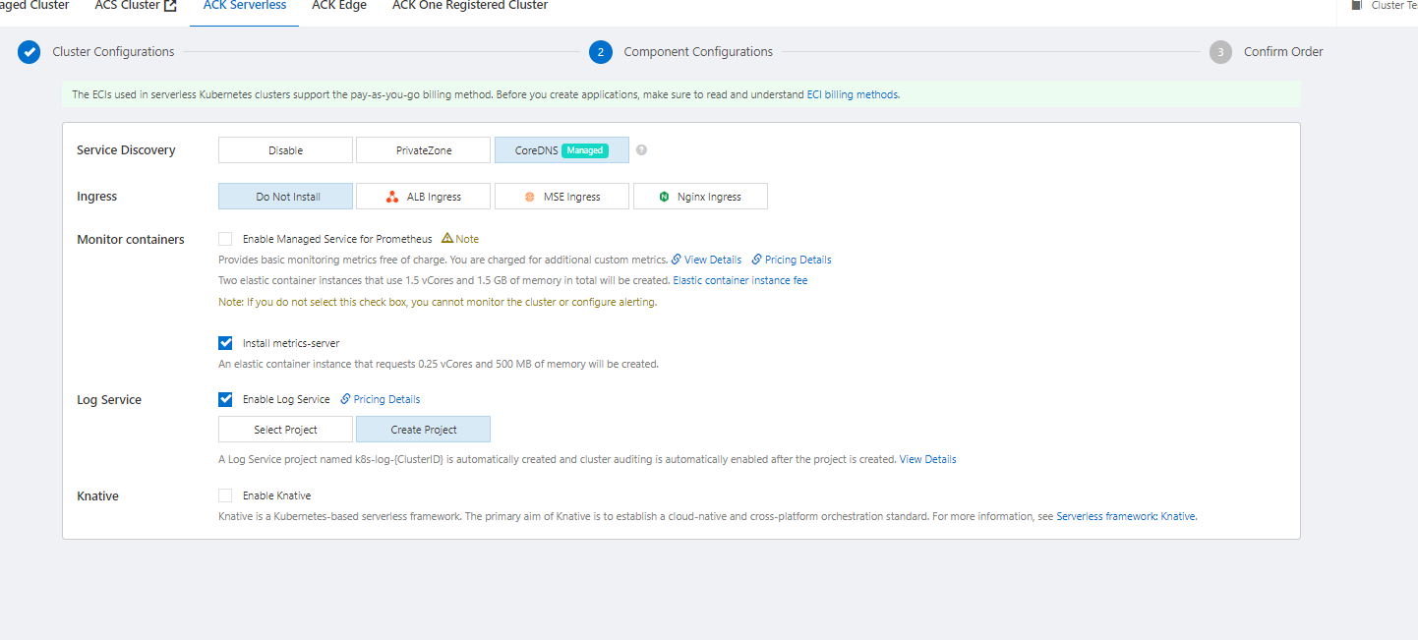
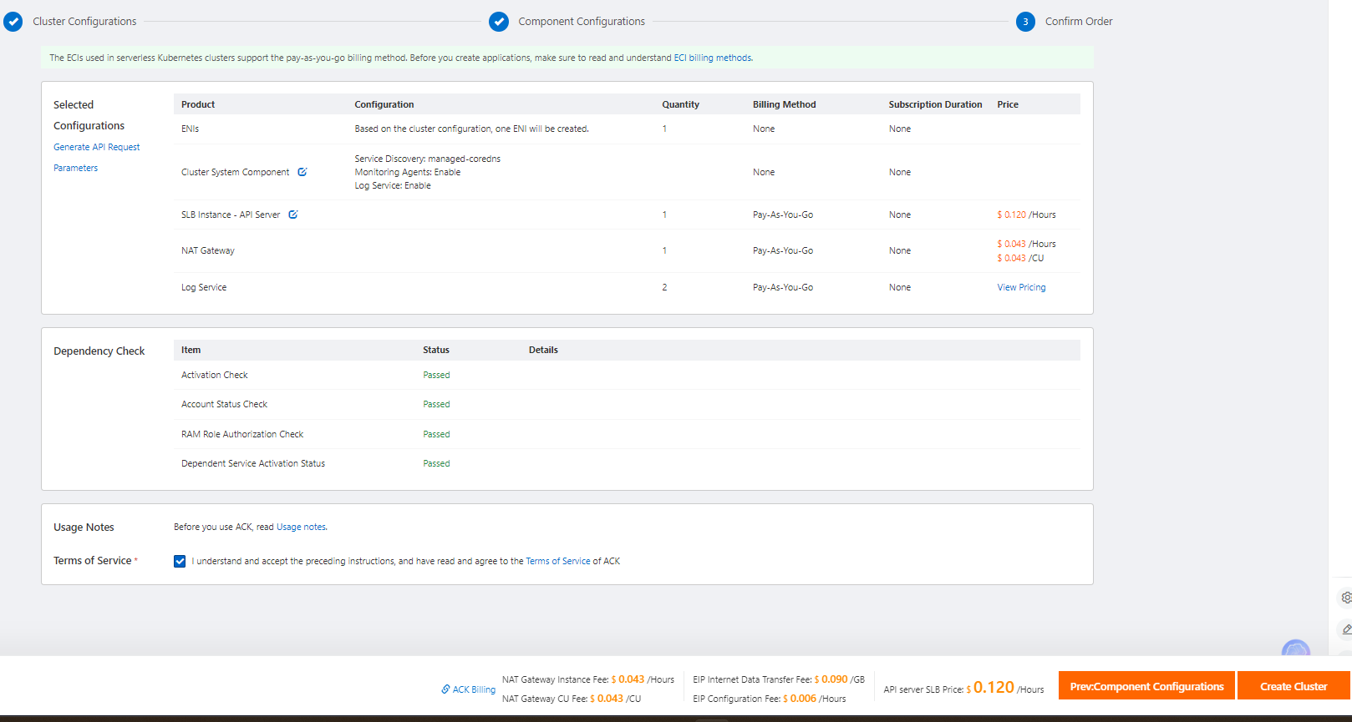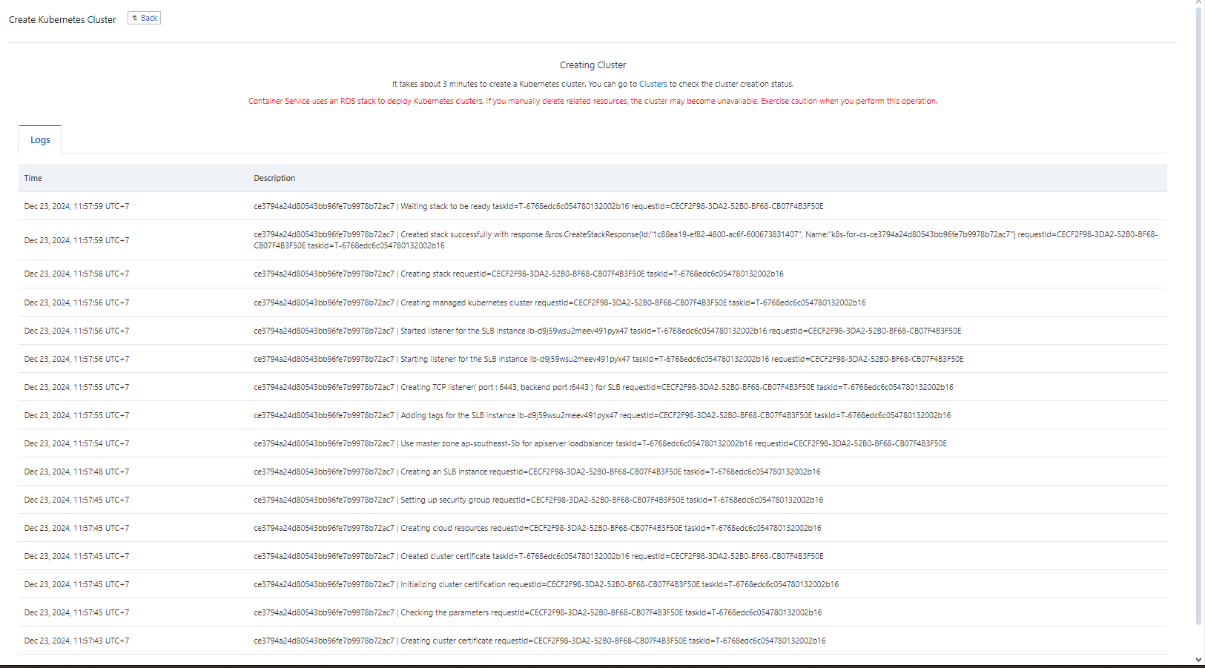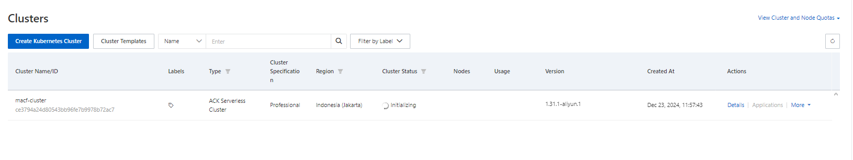
- Check Nodes after success create cluster
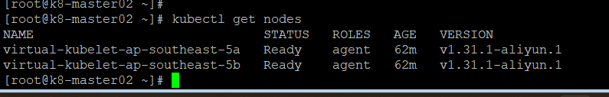
- Update enablePrivateZone to True
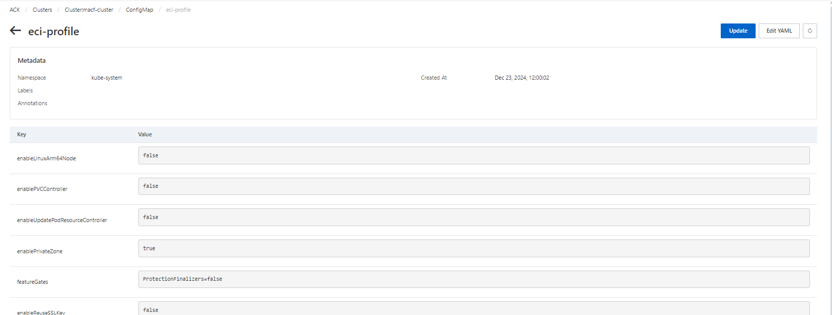
- Create Alibaba Cloud DNS Private Zone
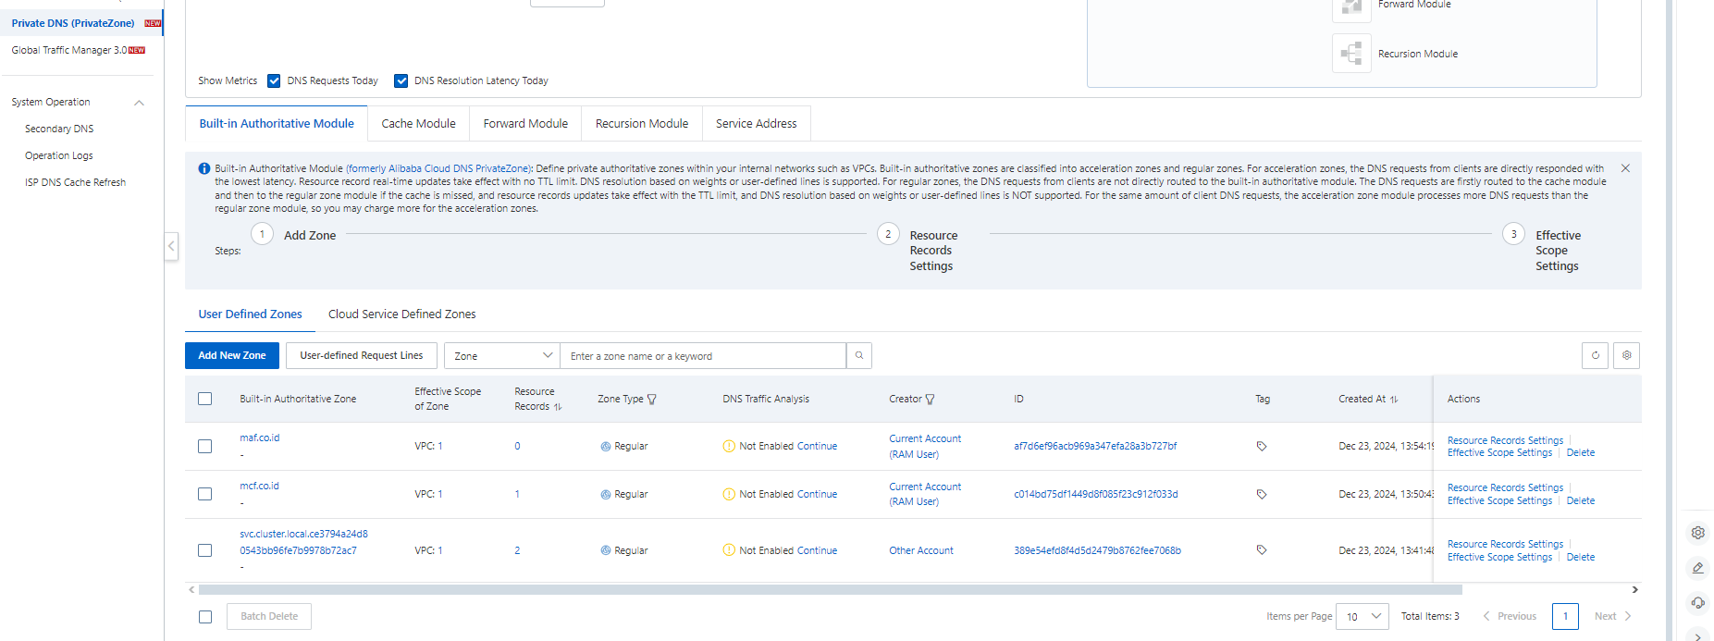
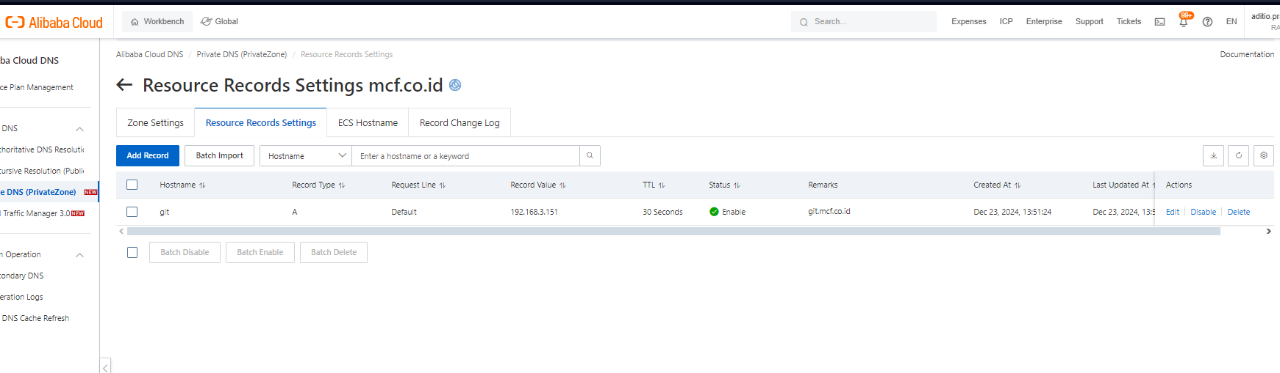
- Test Create pod using private image registry git.mcf.co.id
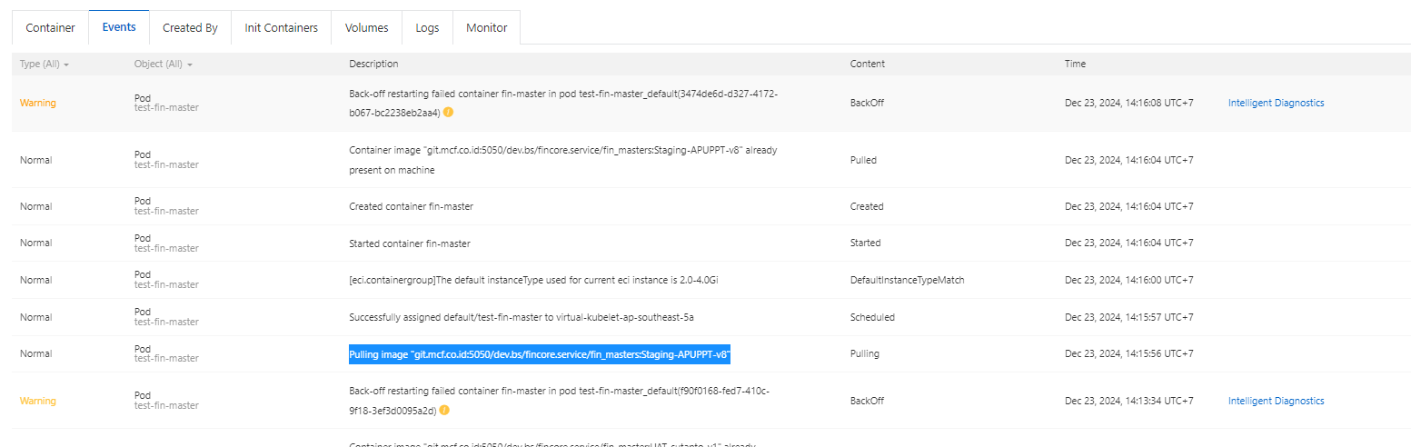
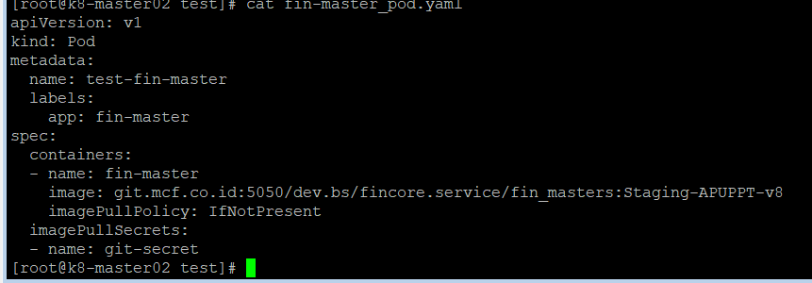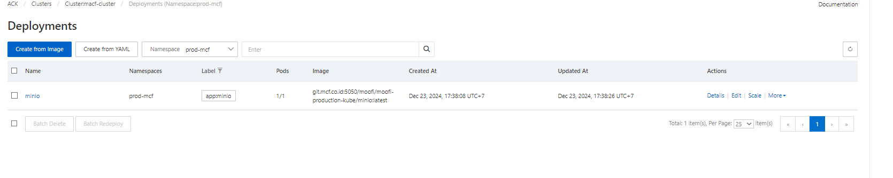
- Create General-purpose NAS (Pay-as-you-go)
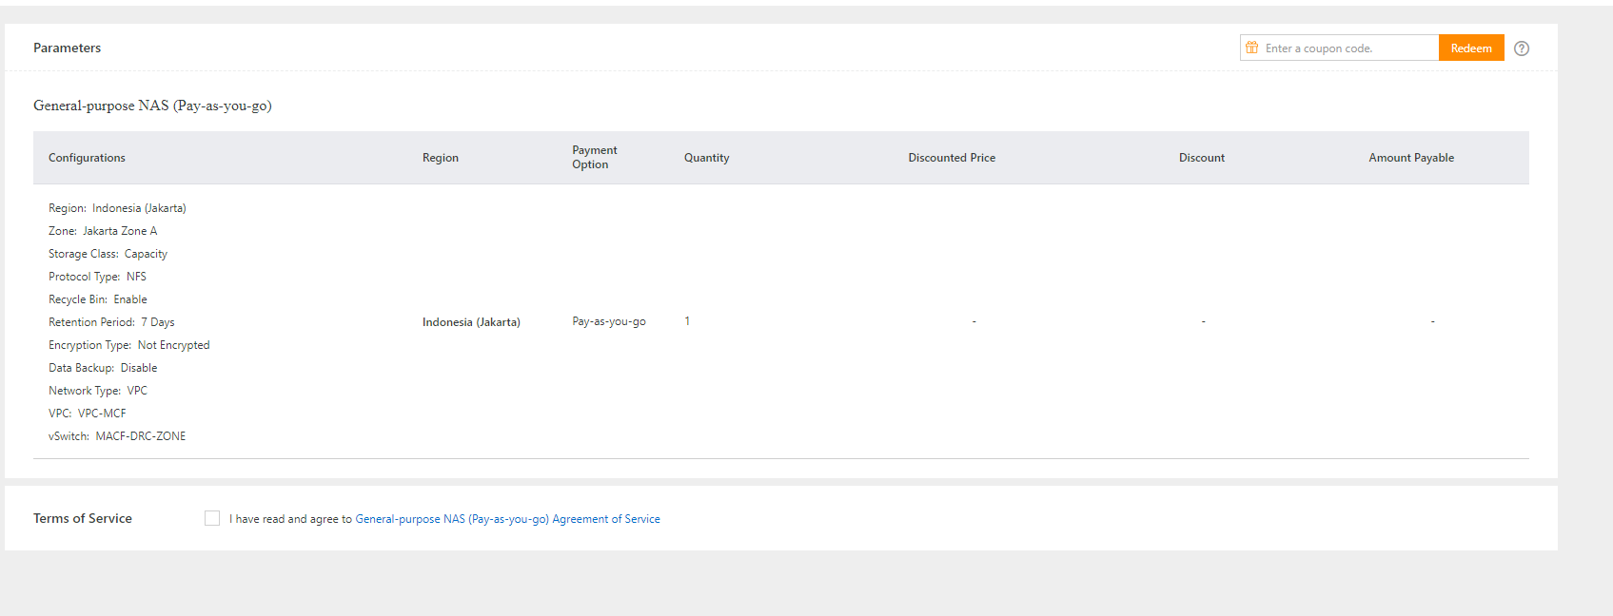
- Create Bucket-IT (OSS)
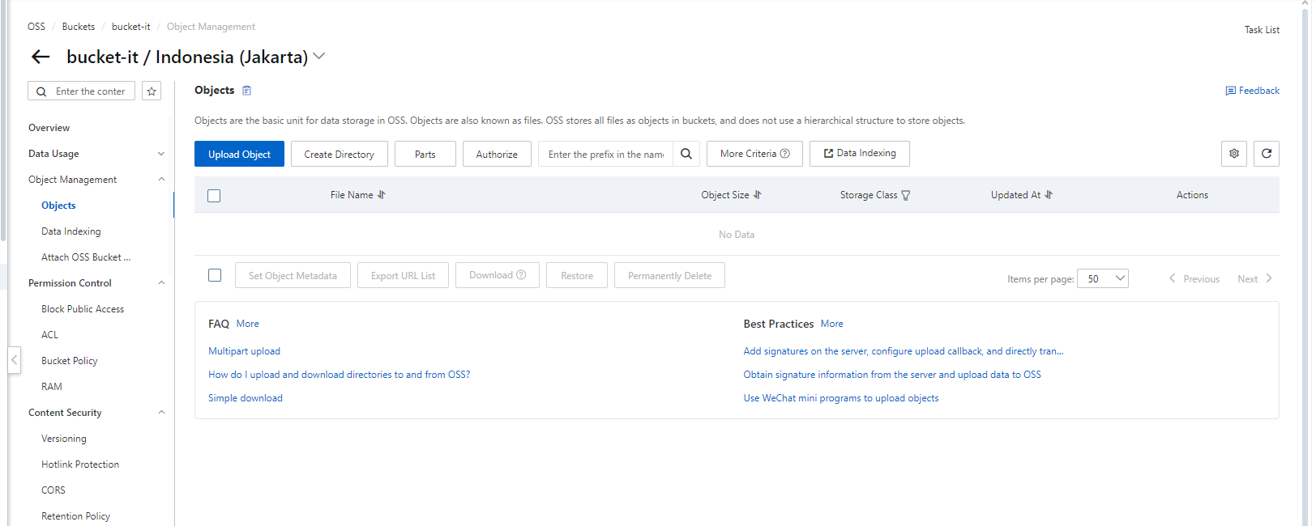
Install Istio Ingress on Alibaba Cloud Kubernetes Serverless
Link: https://www.alibabacloud.com/blog/599501
Link: https://github.com/kubernetes/dashboard
- istioctl install --set profile=demo -y
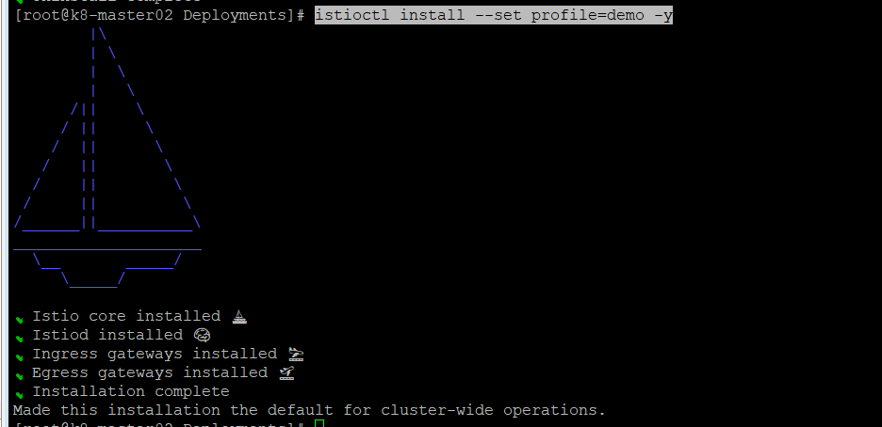
- Deploy istio gateway and virtual service
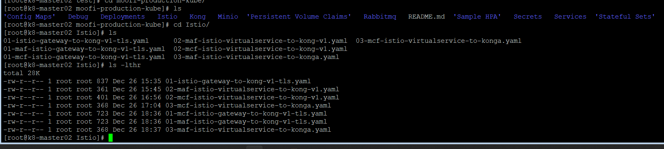
- Install Kubernetes dashboard
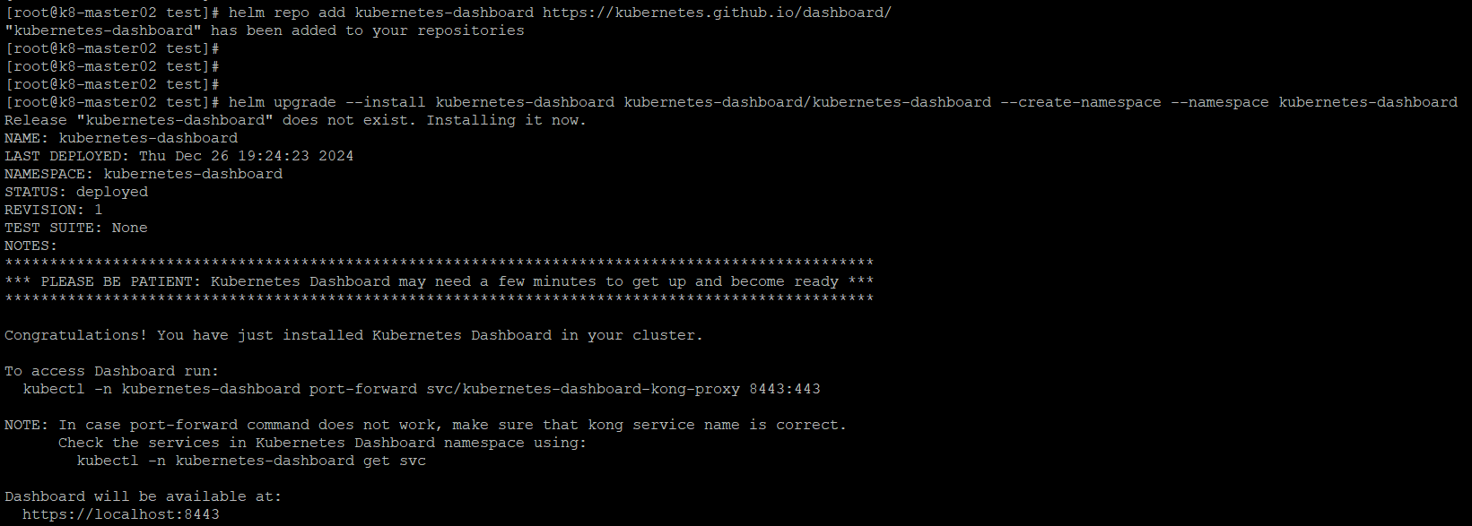
- Install Konga,Kong Database dll
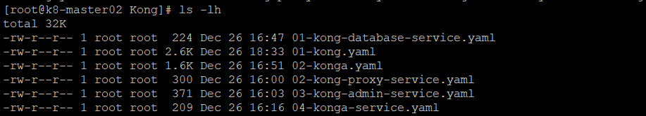
- Create CLB Intranet Kubernetes