Tutorial Upgrade Image Service Kubernetes
Contoh kasus upgrade image: fcl.result.services:6fdc237

- Remote ke node on-premise (K8-Master02) 172.16.91.32 & change directory ke /data/k8s-alibaba/test/moofi-production-kube
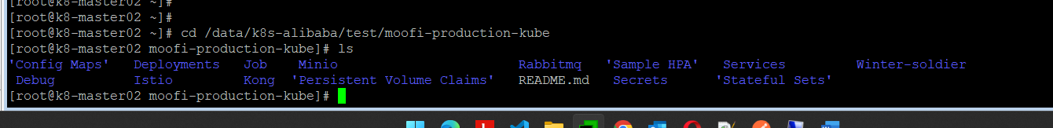
- Masuk ke folder/directory Deployments
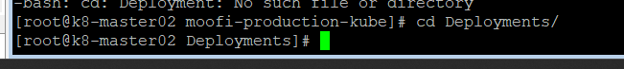
- Berhubung contoh kasus menggunakan fcl.result.services maka, edit file fcl.result.services dan ganti value image nya.
  - Before
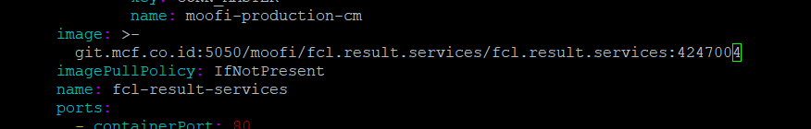
  - After
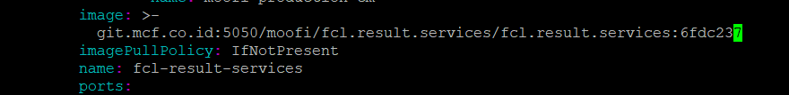
- Deploy service fcl.result.service ke namespace prod-maf dan prod-mcf dengan command spt ini:

