Extend Disk Linux from /Data
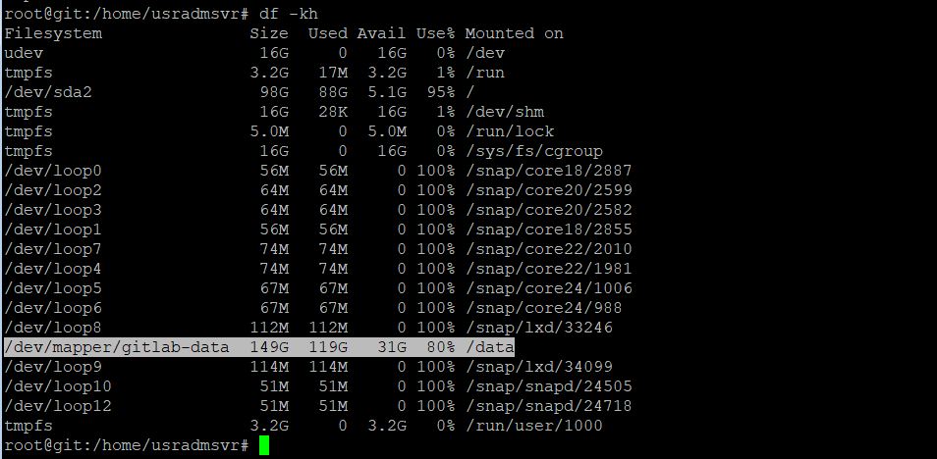

- Resize disk from 250 to 300
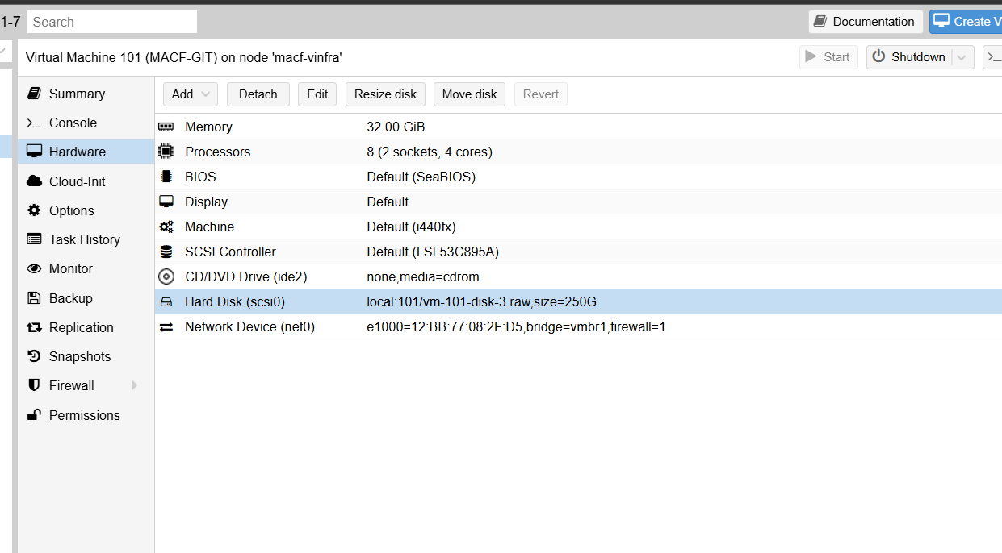
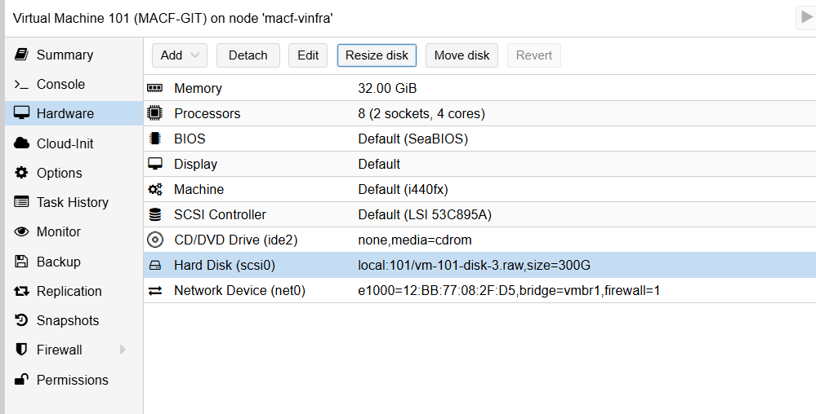
- Rescan disk and check the partition
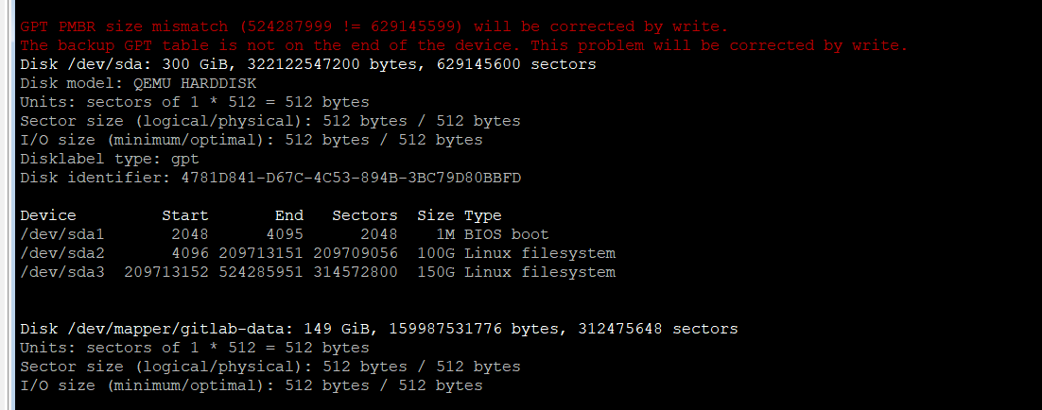
- Add new partition
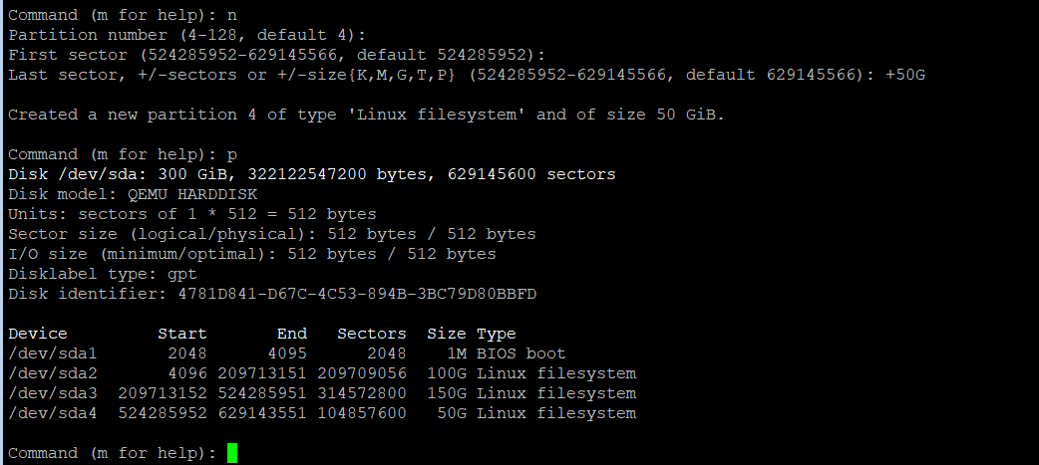
- Add Physical Volume
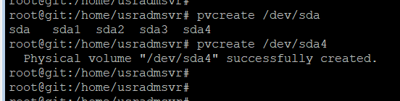
- Extend VG from new PV
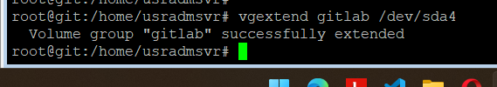
- Add 20G to LVM from VG
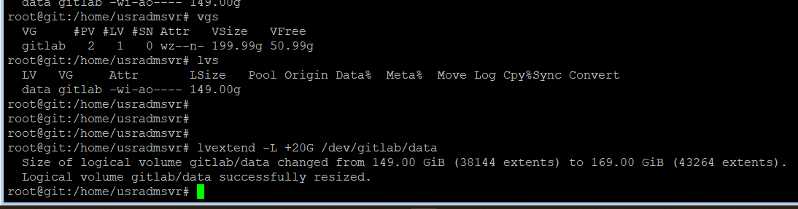
- Rescan mount point depends file system (xfs or ext4)
