Join node to cluster environment K8
*make sure all new node can access internet for pulling image calico
Before:
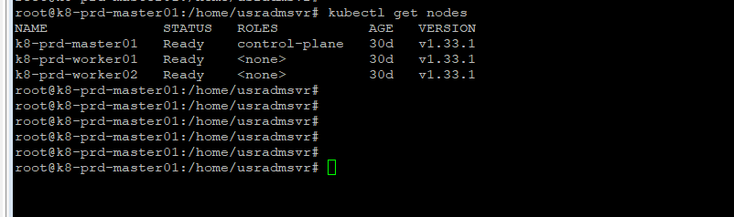

- Create token
command : kubeadm token create --print-join-command
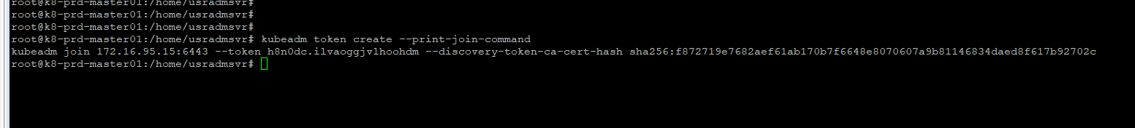
- Paste token to a new node
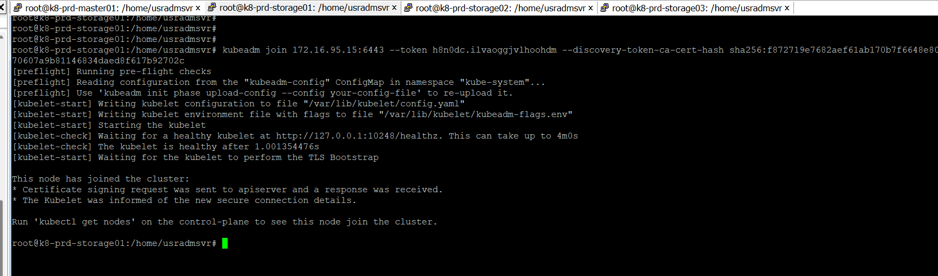
- Check nodes after step 2
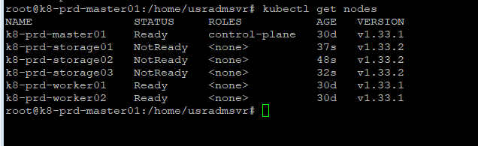
- (Optional) Label these nodes for act as storage node, so only ceph osd running on storage node.
command: kubectl label node k8-prd-storage01 role=storage-node
