Create Ceph Rook.io
Storage Architecture:
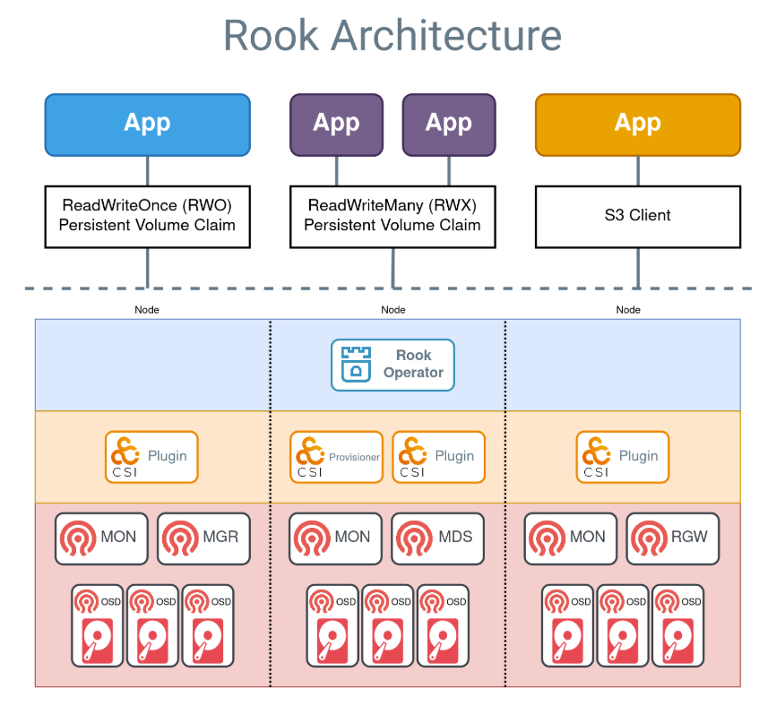
- Label node as role storage node
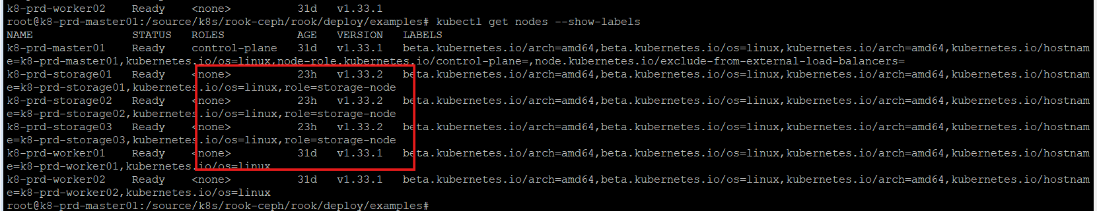
Command : kubectl label node k8-storage01 role=storage-node
- Taint node from role storage node
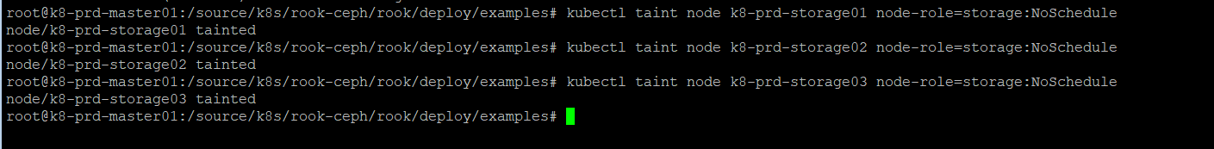
command : kubectl taint node k8-prd-storage01 node-role=storage:NoSchedule
- Clone from git official repository from rook.io https://rook.io/docs/rook/latest-release/Getting-Started/quickstart/
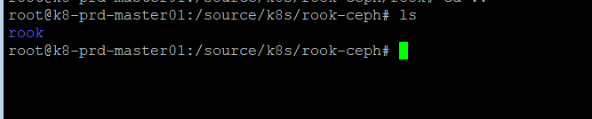
- Deploy yamls for deployment rook-ceph
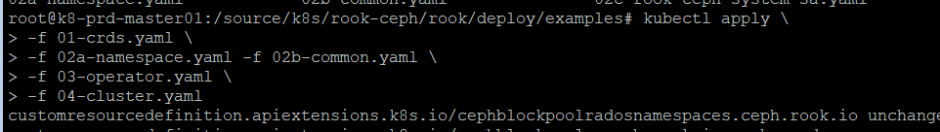
- Deploy yaml toolbox for check status and exec into the pod
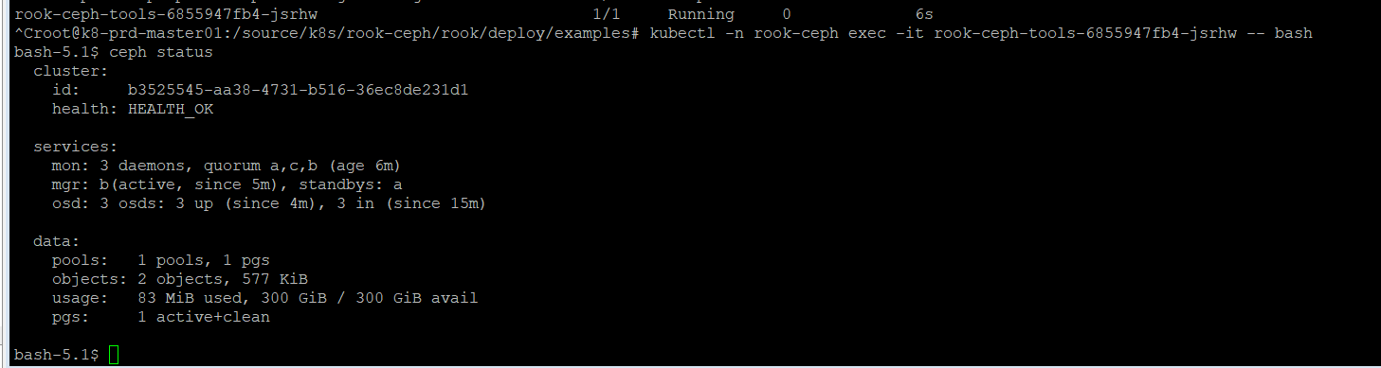
- Check osd status
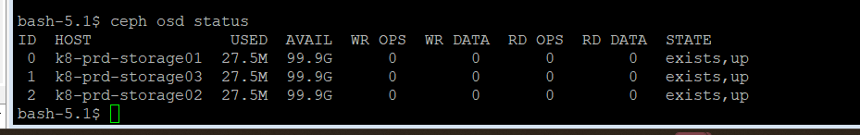
- Get secret password from rook-ceph-dashboard-password
command: kubectl -n rook-ceph get secret rook-ceph-dashboard-password -o jsonpath="{['data']['password']}" | base64 --decode && echo
Output: 4#-!?[.`"T'[>+j55`rd
- Access dashboard ceph from http-route has been created by istio ambient mode, and login as admin and password from previous step.
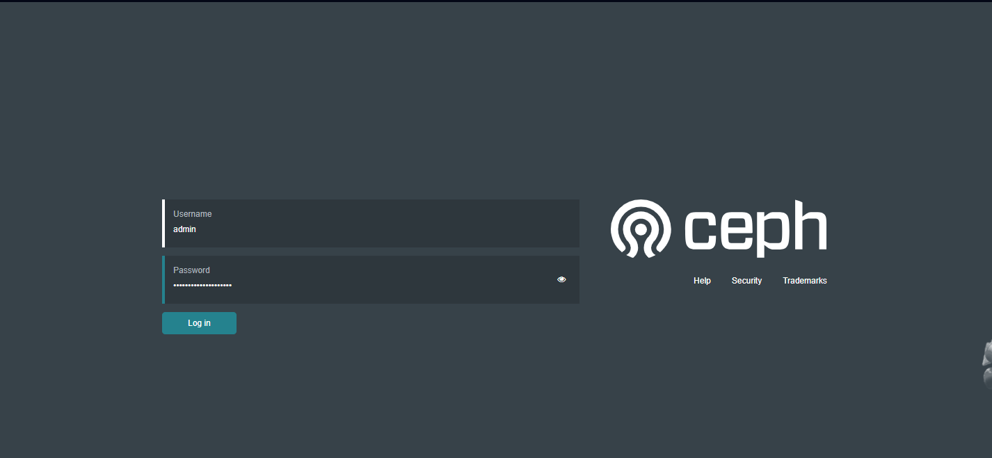
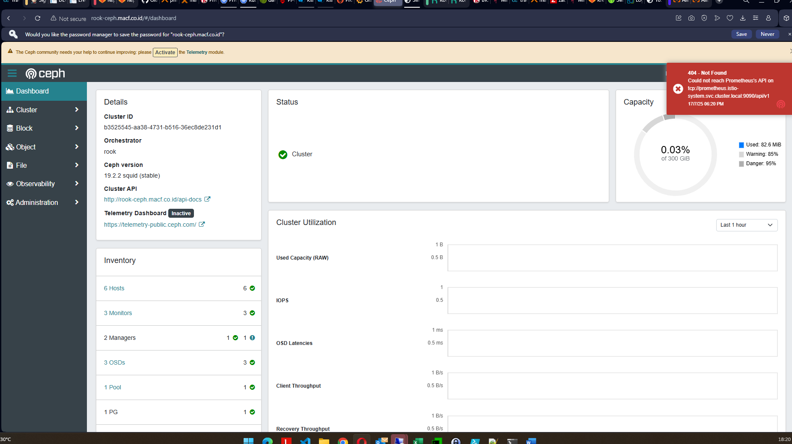
- Create storageclass.yaml for blockstorage
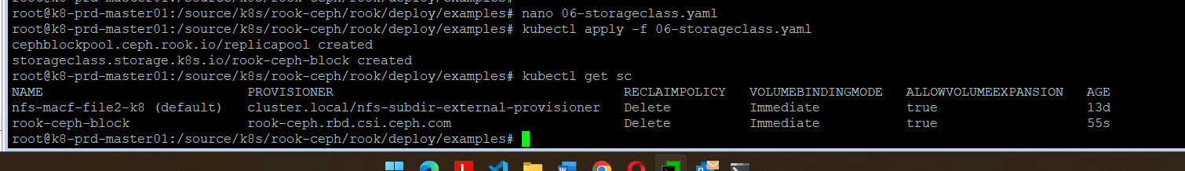
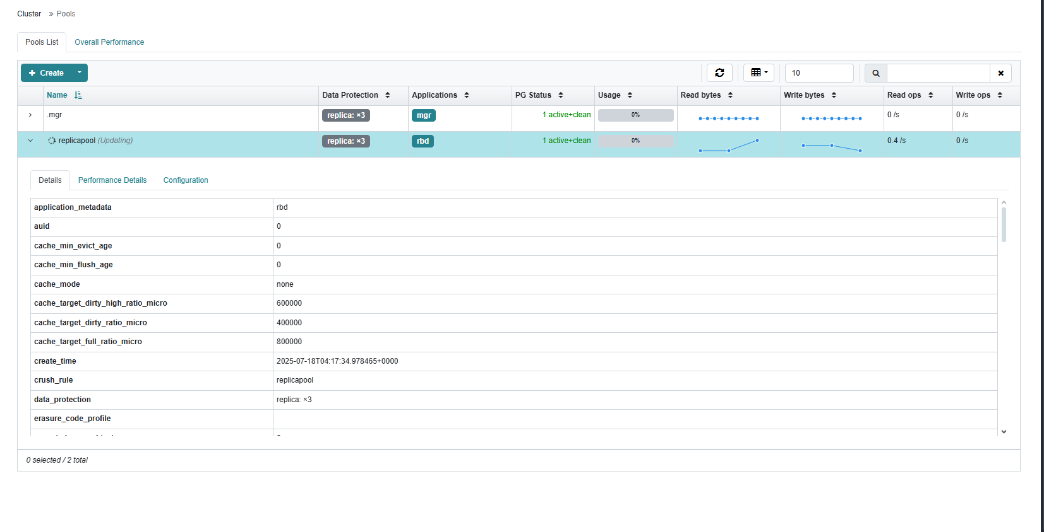
- Test create Statefulset for database postgresql
