Test Restore from Proxmox Backup Server to Proxmox VE

- From ProxmoxVE add Storage backup using type Proxmox Backup Server and fill the connection form using datastore from Proxmox Backup Server
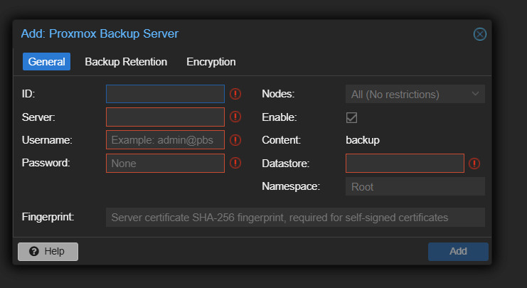
- Choose content files from Proxmox Backup Storage for restoring to ProxmoxVE
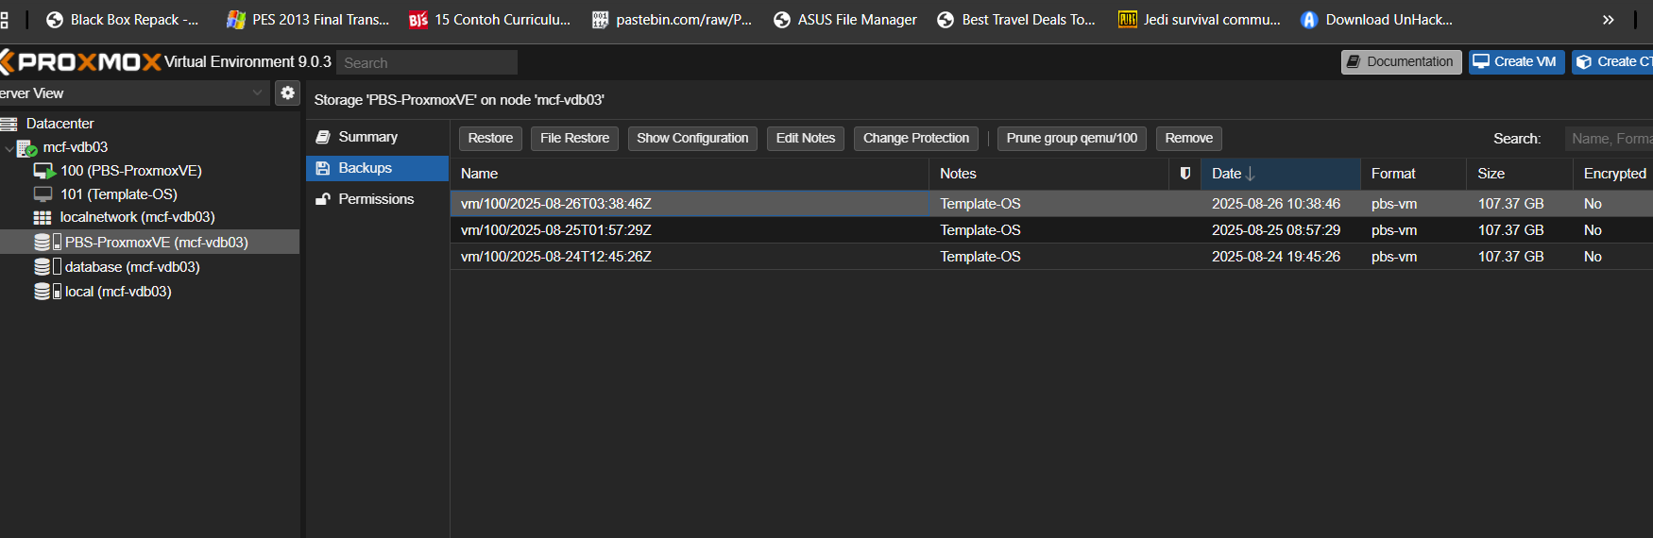
- Choose storage for targeting disk image after restoring files from Proxmox Backup Server, then you can adjust the name,memory,cpu and socket as you want.
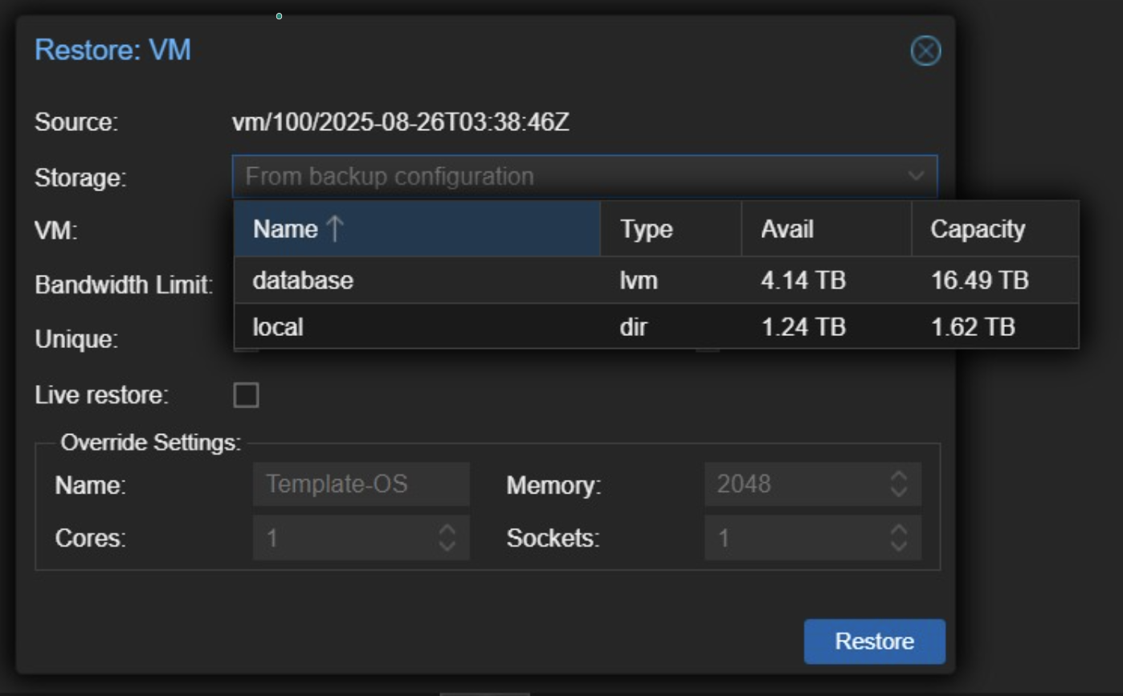
- Restore completed