Tutorial using sonarqube from local project & local laptop
This scenario will be fit in from developers review that code for checking the security before merge to main branch

- Open Sonarqube and create local project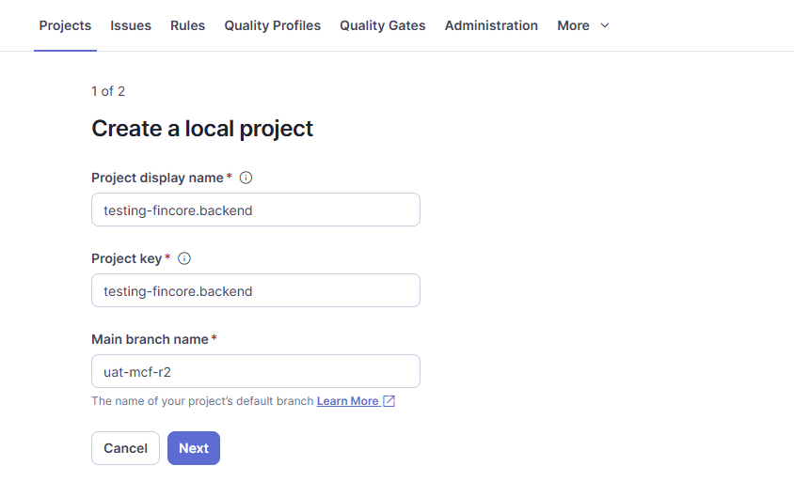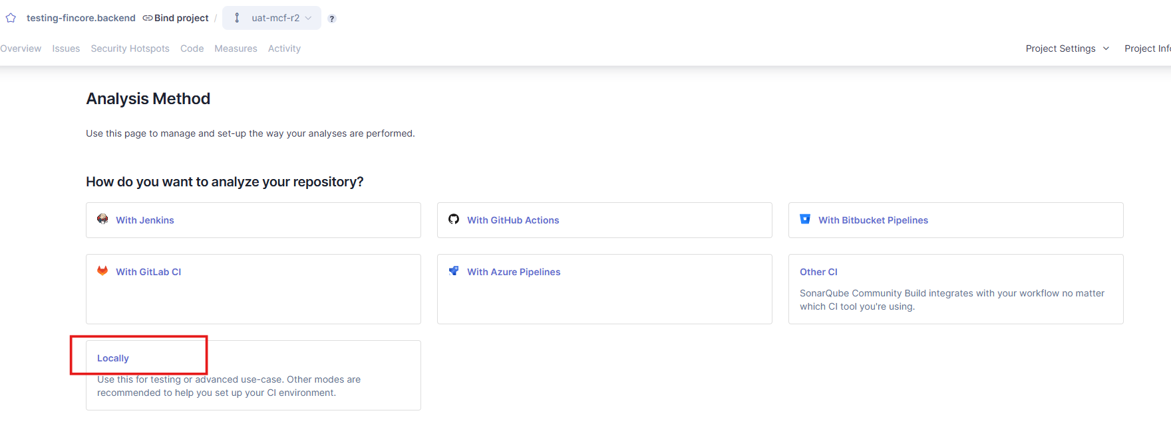

- Generate token and keep it for the next steps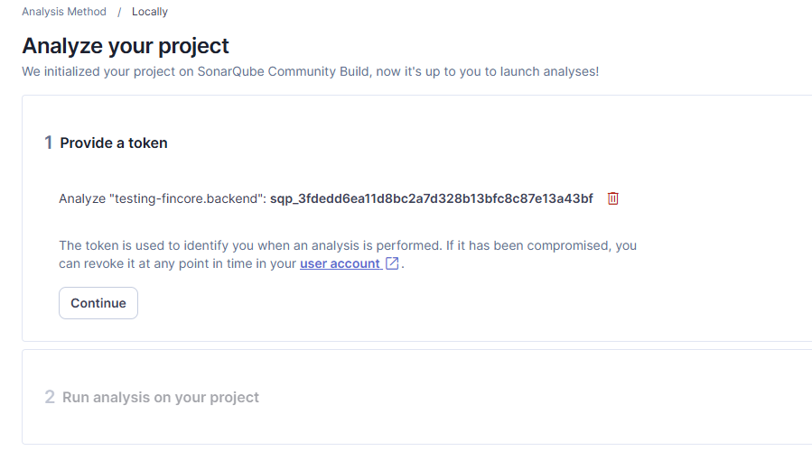
- Clone your project from your code repository 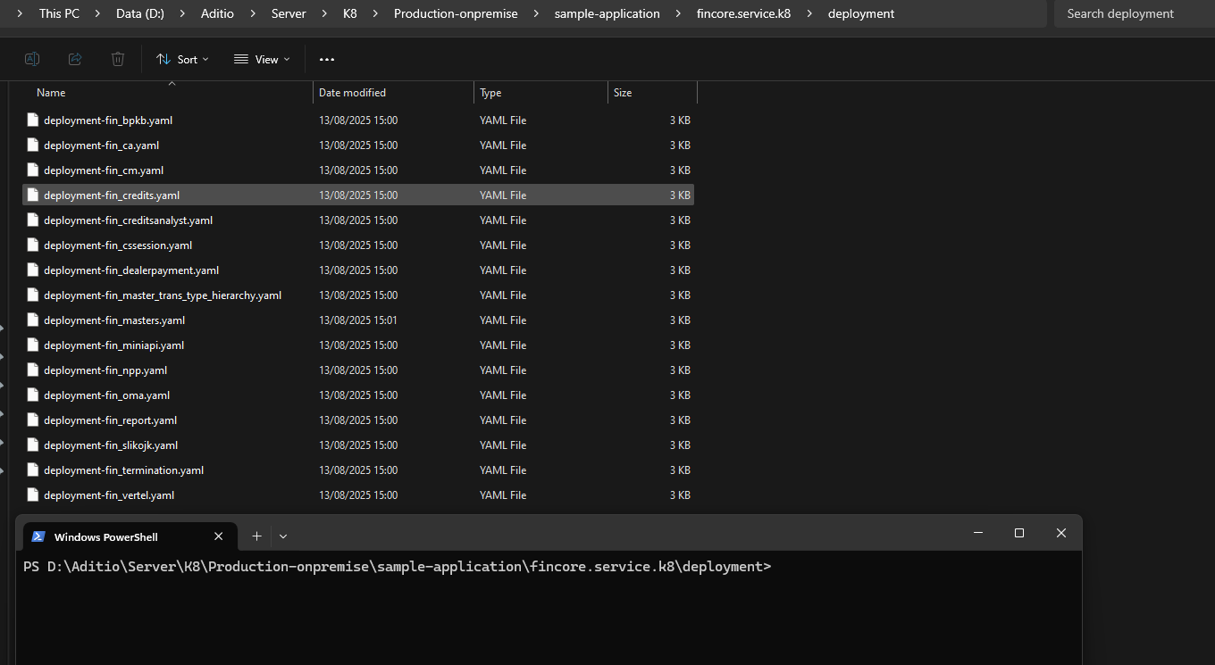
- Make sure you have a sonar-scanner, and run the sonar-scanner for scanning your project in working directory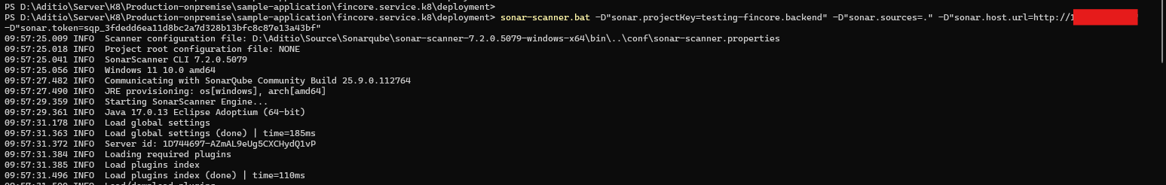
- After scanning, sonar-scanner will be sent the report analysis to sonarqube website, you can check the issues from your code and you will get the best recommended to fix your code based on that issues.