[root@uat-manager01 scout-demo-service]# docker scout quickview mafsysadmin/scout-demo:v1
✓ Image stored for indexing
✓ Indexed 79 packages
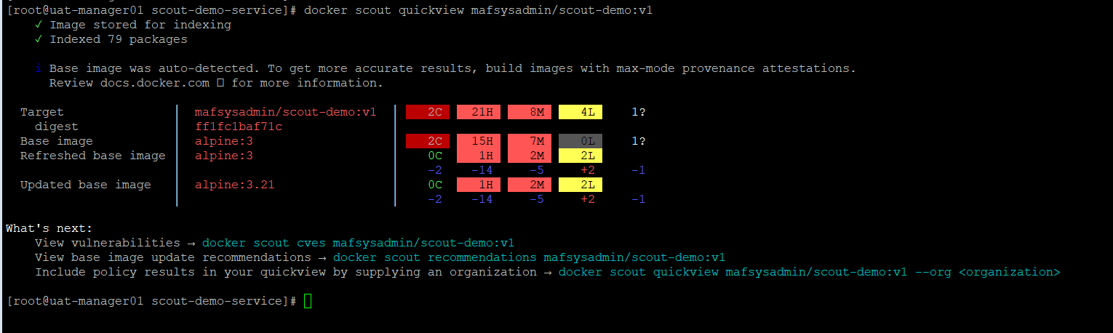
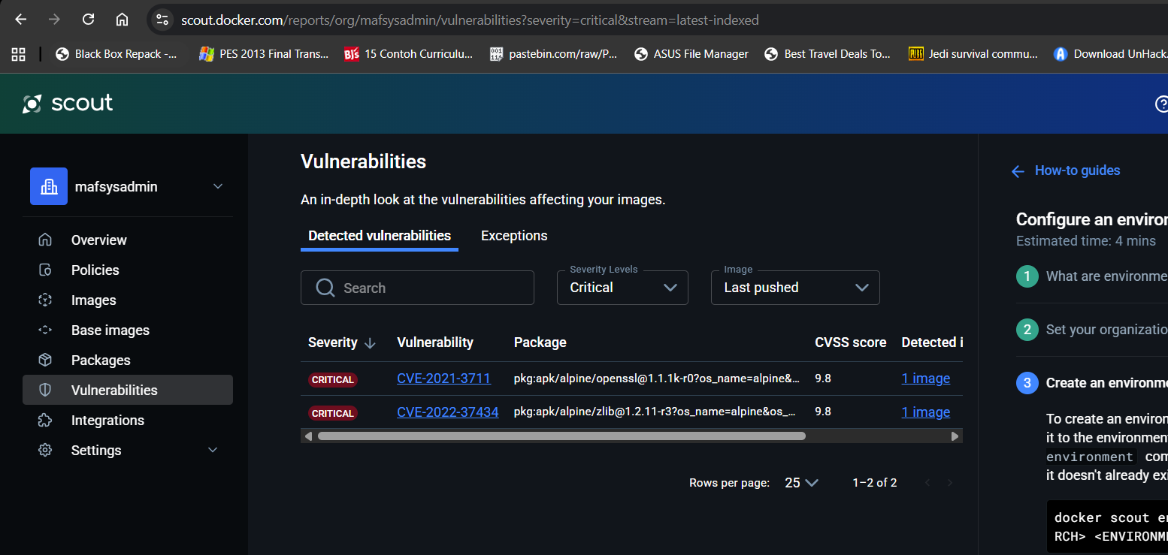

[root@uat-manager01 scout-demo-service]# docker scout cves mafsysadmin/scout-demo:v1
✓ SBOM of image already cached, 79 packages indexed
✗ Detected 11 vulnerable packages with a total of 34 vulnerabilities
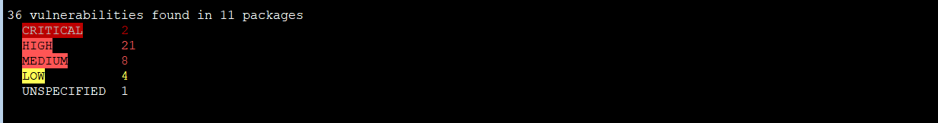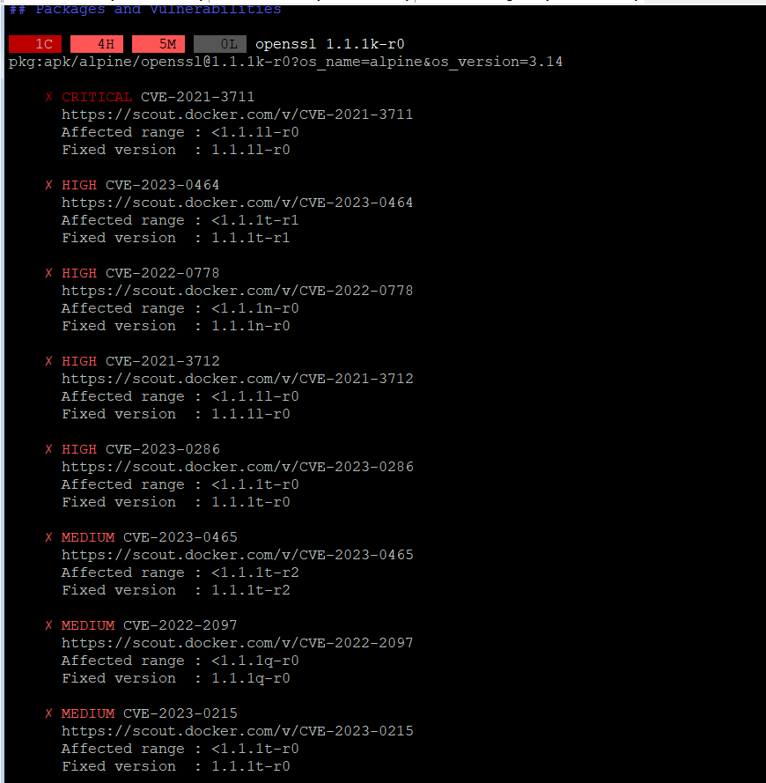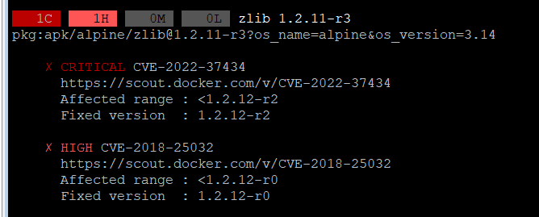

What's next:
View base image update recommendations → docker scout recommendations mafsysadmin/scout-demo:v1
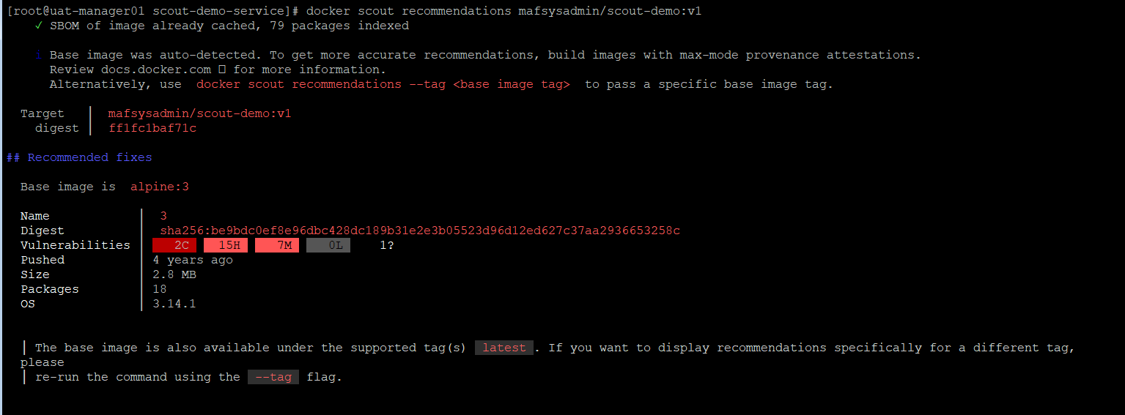
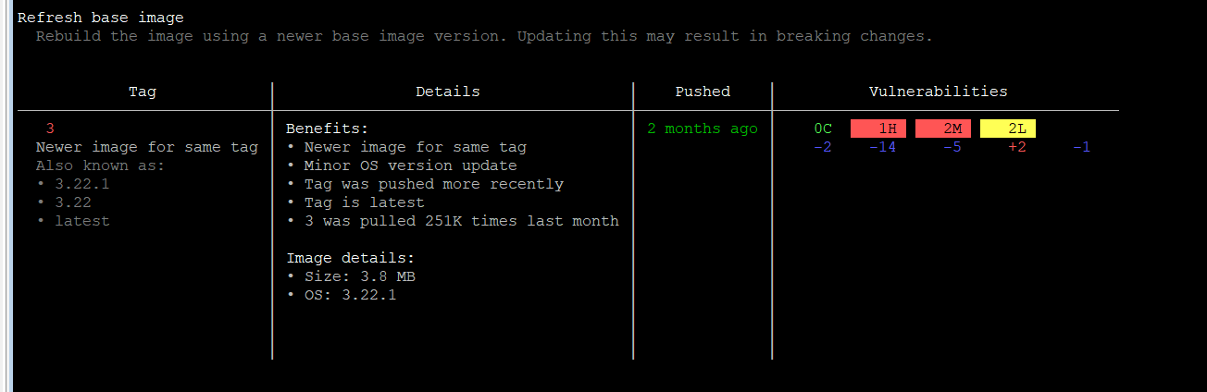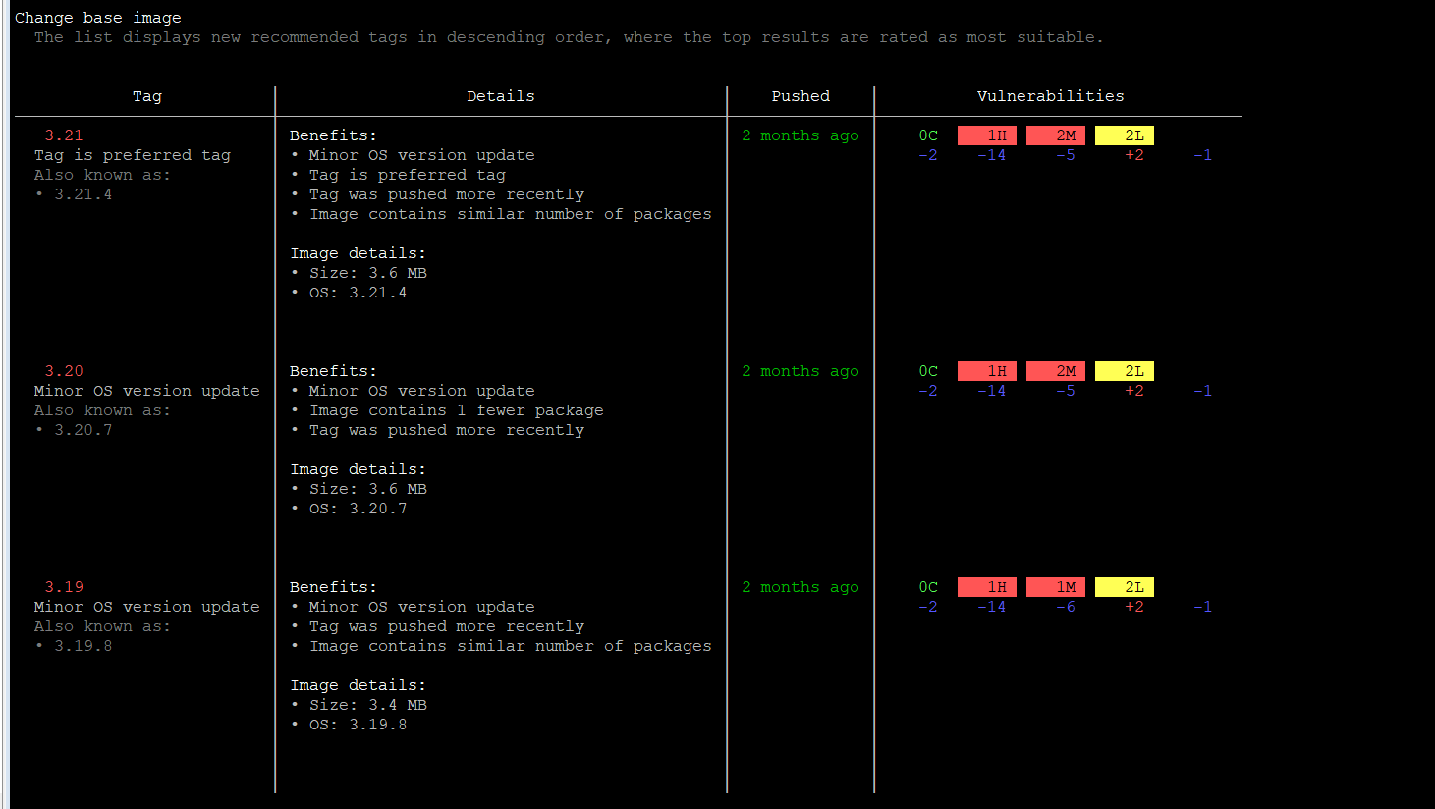

Pros:
Cons:
- Must be integrated to docker hub
- Not community
- Can be access from public

