**Problem Statement :**

(Financial tsunami) Banks lend money to each other. In tough economic times, if

a bank goes bankrupt, it may not be able to pay back the loan. A bank’s total assets

are its current balance plus its loans to other banks. The diagram in Figure 7.8

shows five banks. The banks’ current balances are 25, 125, 175, 75, and 181 mil-

lion dollars, respectively. The directed edge from node 1 to node 2 indicates that

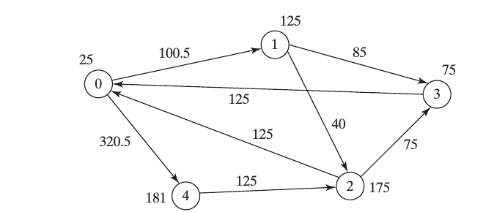

bank 1 lends 40 million dollars to bank 2.

If a bank’s total assets are under a certain limit, the bank is unsafe. The money it

borrowed cannot be returned to the lender, and the lender cannot count the loan

in its total assets. Consequently, the lender may also be unsafe, if its total assets

are under the limit. Write a program to find all the unsafe banks. Your program

reads the input as follows. It first reads two integers n and limit, where n

indicates the number of banks and limit is the minimum total assets for keeping a

bank safe. It then reads n lines that describe the information for n banks with IDs

from 0 to n-1.

The first number in the line is the bank’s balance, the second number indicates

the number of banks that borrowed money from the bank, and the rest are pairs

of two numbers. Each pair describes a borrower. The first number in the pair is

the borrower’s ID and the second is the amount borrowed. For example, the

input for the five banks in Figure 7.8 is as follows (note that the limit is 201):

5 201

25 2 1 100.5 4 320.5

125 2 2 40 3 85

175 2 0 125 3 75

75 1 0 125

181 1 2 125

The total assets of bank 3 are (75 + 125), which is under 201, so bank 3 is

unsafe. After bank 3 becomes unsafe, the total assets of bank 1 fall below

(125 + 40). Thus, bank 1 is also unsafe.

The output of the program should be:

Unsafe banks are 3 1

**ALGORITHM:**

1. Select the input file which contains one or more data set representing the bank details(lender/borrower)
2. Validate each data set.

2.1 If the file is empty “The file is empty” message is displayed.

2.2 If a particular data set contains invalid data (for e.g. alphanumeric data for loan amount) “Invalid data for <set number>” is displayed

2.3 If a particular data set is incomplete “Incomplete data for set <set number>” message is displayed.

1. If the data set passes all the above conditions then read the data set line by line and store it in a two dimensional array (lenderBorrower[][]) .
2. Row index in two dimensional array represents the lender's bank id (starting with 0) and column index represents the borrower's bank id (starting with 0) and the value represents the amount that is lend-ed to the borrower bank.
3. Each bank's current asset is stored at [bankid][bankid] in array.

Data set in the problem statement would be represented in two dimensional array as follows

0 1 2 3 4

0 320.5

1 40 85

2 125 75

3 125

4 125

1. Write a method using recursion which evaluates the above two dimensional array for all unsafe banks.
   1. Loop through the array and calculate the total asset (by adding all the non-zero values for a a particular lender bank).
   2. If the total asset < safe limit, add that bank to unsafe list and using recursion re-calculate the total asset for all the prior banks, this time excluding the amount lend-ed to the unsafe bank.
2. Display the unsafe banks if any for the current data set otherwise display “No unsafe banks found for set <set number>” message.
3. Repeat steps 2 through 7 for each data set until end of data signal, represented by character “~” is reached.

**TESTING:**

1. Program is implemented to read multiple data sets (separated by new line) from a text file.

2.If a particular data set is invalid/incomplete appropriate message is displayed and the program continues with the next data set.

3.The attached sample input file BankDetails contains three data set to test for invalid , incomplete and a valid set respectively.

