**Investment opportunities in Vizag**

**Searching the possibilities of replicating the real estate investment model of Toronto City in Vizag by comparing the neighbourhoods of both cities.**

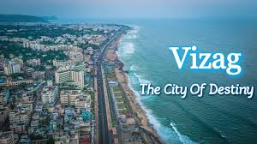

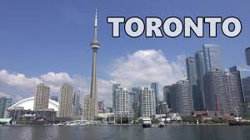

**Contents**

1. **Introduction**
2. **Data collection and preprocessing**
3. **Methodology**
4. **Results**
5. **Discussion and Conclusion**

**1.1 Description and Discussion of the Background**

***Are the neighbourhood areas in Vizag and Toronto any similar? Do they share any common characteristics?***

I have decided to explore the neighborhoods of Vizag, AP, India with the neighbourhoods of Toronto, Canada understand the investment opportunities and the city overall growth and development at par with Toronto using Clustering & Segmentation techniques, ML (Machine Learning). Data Visualizations (using seaborn and matplotlib in Python) are created to explore GDP, Per Capita Income, climatic conditions, tourism and educational institutions of both the cities. All these data points will help us understand the rate of growth in Visakhapatnam and scope of development in different sectors.

The real estate investment patterns of Toronto can be observed by analysing the data of Neighbourhood of Toronto city. Then for exploring the possibility of replicating those investment model in real estate market of Vizag, we can compare the neighbourhood data of both cities.

**1.2.Problem**

Searching the possibilities of replicating the real estate investment model of Toronto City in Vizag by comparing the neighbourhoods of both cities.

**1.3.Interest**

This project will highlight the investor opportunities with increased scope of attracting real estate investors in investing in Vizag which can help Vizag to realize its ambitious economic growth goals while preserving and enhancing livability for the benefit of local citizens.

**2. Data**

**2.1 Data Requirements**

Following datasets have been used in the project:

* Postal Codes of Visakhapatnam. Data has been scraped and cleaned from Yo!Vizag — City’s Exclusive Magazine and Portal [1] using Beautiful Soup and pandas libraries and saved in .csv format.
* Foursquare API to get the most common venues of given boroughs of Visakhapatnam and Toronto respectively.[2]
* Visakhapatnam [3] and Toronto Wikipedia Pages [4] have been scraped and cleaned for creating Word clouds.
* Zip codes of Toronto. Data has been downloaded in .csv format from <https://datasf.org/>and cleaned using pandas.

**2.2.Data Analysis:**

2 Cities will be analyzed in this project: Visakhapatnam and Toronto.

I will be using the below datasets for analyzing Visakhapatnam.

**Data 1:**Neighborhood has a total of 684 areas. Most notable areas of the city include urban areas like Dwaraka Nagar, Gajuwaka, Gopalapatnam, Jagadamba Centre, Maddilapalem, Madhurawada, Seethammadhara and semi-rural suburbs such as Simhachalam, Pendurthi, and Parwada.

Data has been scraped and cleaned from [Yo!Vizag — City’s Exclusive Magazine and Portal](https://www.yovizag.com/visakhapatnam-vizag-pin-code/)– using Beautiful Soup and pandas libraries and saved in .csv format.

