Rai, Aditi
July 9, 2026
NYU ID: ar9598
CS-GA.2433-001
Database Systems Project Part I – Modeling
Aditi Securities

Statement of Independent Effort: Aditi Rai
Total in points (100 points total):
Professor’s Comments:

1. Business Background
Aditi Securities is an investment/brokerage firm. Its day-to-day business is transactional: clients open accounts, place trades through financial professionals or online, hold portfolios of securities, and pay fees and commissions. Trades are cleared and settled through external clearinghouses, and the firm's compliance function reviews accounts and orders for suitability. Part I of the project models this transactional (relational) side of the business as an Enterprise Data Model that can serve as the single source of corporate data for the firm's Transactional Data Store.
2. Analysis of the Sample Blueprint
The sample Reference Architecture Blueprint in the project support material shows Participants (Prospect, Contract Holder, Financial Professional, Employee, Firm, Clearinghouse), Interaction mediums and views, business Processes (New Business, Death Continuance, Spousal Continuance, Remittance, Programmed Reallocation, Valuation), and Services (Get Book, Get Last Touch, Check Appoint, Get FP Detail, Contract Setup, Move Money), backed by Components and data stores. The E-R model below is the corresponding data blueprint for Aditi Securities: each blueprint participant, process, and service is supported by entities in the model. Since the sample blueprint is for an annuities business, its concepts were translated to their brokerage equivalents: Contract Holder becomes Client, Contract Setup becomes Account opening, and Move Money becomes order placement, trade execution, and settlement.
The entities are organized into value-chain areas that mirror the blueprint's separation of concerns, and are color-coded accordingly in the diagram: Client Management (Client, Account, RiskProfile), Advisory/Sales (FinancialProfessional, ClientAdvisorAssignment, Appointment), Product (Security, SecurityType, Issuer), Trading/Transactions (Order, Trade, Commission), Portfolio (Portfolio, Holding, PortfolioValuation), Firm/Compliance (Firm, Branch, ComplianceFlag), and Clearing/Settlement (Clearinghouse, Settlement). This gives 20 entities. A separate Execution entity was considered but folded into Trade, since the business rule Trade --> Order, ExecutionPrice, ExecutionDate shows that execution details depend directly on the trade; this keeps the model within the 20-entity limit without losing information.
3. Entity-Relationship Diagram
The diagram on the next page shows all entities with their primary keys (underlined), foreign keys, and relationship cardinalities (crow's foot on the many side).

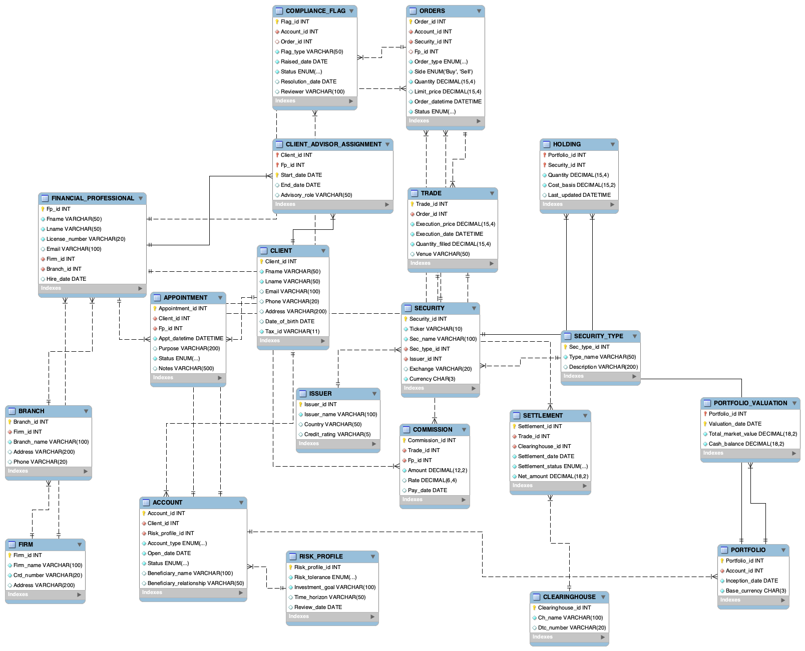
4. Entity Documentation
Client Management area:
CLIENT. A person who does business with the firm. PK Client_id; Tax_id is an alternate key. Holds name, contact, and date of birth attributes. A client owns one or more accounts.
RISK_PROFILE. The client's stated risk tolerance, investment goal, and time horizon, with a review date. PK Risk_profile_id. Each account is governed by exactly one risk profile at a time.
ACCOUNT. A brokerage account. PK Account_id; FKs Client_id and Risk_profile_id, reflecting the rule Account --> Client, RiskProfile. Also carries account type, open date, status, and beneficiary information (see amendment in Section 6).
Advisory / Sales area:
FINANCIAL_PROFESSIONAL. A licensed advisor or broker. PK Fp_id; License_number is an alternate key. FKs Firm_id and Branch_id, reflecting the rule FinancialProfessional --> Firm, Branch.
CLIENT_ADVISOR_ASSIGNMENT. Resolves the many-to-many relationship between clients and financial professionals over time. Composite PK (Client_id, Fp_id, Start_date), with End_date and Advisory_role.
APPOINTMENT. A scheduled meeting between a client and a financial professional. PK Appointment_id; FKs Client_id and Fp_id; carries date/time, purpose, status, and notes.
Product area:
ISSUER. The company or government entity that issues a security. PK Issuer_id.
SECURITY_TYPE. Lookup of product categories (stock, bond, ETF, mutual fund). PK Sec_type_id.
SECURITY. A tradable instrument. PK Security_id; (Ticker, Exchange) is an alternate key; FKs Sec_type_id and Issuer_id.
Trading / Transactions area:
ORDERS. A buy or sell instruction placed for one account and one security, reflecting the rule Order --> Account, Security, Quantity, OrderType. PK Order_id; FKs Account_id, Security_id, and an optional Fp_id (null for self-directed online orders). Named ORDERS because ORDER is a reserved word in SQL.
TRADE. An execution that fills an order, reflecting the rule Trade --> Order, ExecutionPrice, ExecutionDate. PK Trade_id; FK Order_id. One order can be filled by several partial trades.
COMMISSION. The commission earned by a financial professional on a trade. PK Commission_id; FKs Trade_id and Fp_id; (Trade_id, Fp_id) is unique.
Portfolio area:
PORTFOLIO. The collection of positions held by an account. PK Portfolio_id; FK Account_id is unique, so each account has exactly one portfolio.
HOLDING. A position in one security within a portfolio. Composite PK (Portfolio_id, Security_id) with Quantity and Cost_basis, mirroring the composite-key rule (Account,
Security) --> Quantity, CostBasis from the business rules (the account is reached through its portfolio). This mirrors the ST/SC composite-key example from lecture.
PORTFOLIO_VALUATION. A periodic snapshot of a portfolio's total market value and cash balance. Composite PK (Portfolio_id, Valuation_date).
Firm / Compliance area:
FIRM. A broker-dealer firm (Aditi Securities itself or an external distribution firm). PK Firm_id; Crd_number is an alternate key.
BRANCH. An office of a firm. PK Branch_id; FK Firm_id.
COMPLIANCE_FLAG. A compliance item such as a suitability review or AML alert, raised on an account and optionally tied to a specific order. PK Flag_id; FKs Account_id and optional Order_id.
Clearing / Settlement area:
CLEARINGHOUSE. An external clearing organization (e.g., DTCC). PK Clearinghouse_id.
SETTLEMENT. The settlement of one trade through one clearinghouse. PK Settlement_id; FK Trade_id is unique (each trade settles once); FK Clearinghouse_id; carries settlement date, status, and net amount.
5. Business Rules, Functional Dependencies, and Normalization
The main business rules were collected as functional dependencies and drove the choice of keys:
Order_id --> Account_id, Security_id, Quantity, Order_type (a given order references one account and one security). Trade_id --> Order_id, Execution_price, Execution_date. Account_id --> Client_id, Risk_profile_id (each account belongs to one client with one risk profile at a time). Fp_id --> Firm_id, Branch_id. (Portfolio_id, Security_id) --> Quantity, Cost_basis for HOLDING. (Portfolio_id, Valuation_date) --> Total_market_value, Cash_balance for PORTFOLIO_VALUATION.
Every relation is in third normal form: all non-key attributes are fully functionally dependent on the whole key (no partial dependencies on the composite keys of HOLDING, PORTFOLIO_VALUATION, or CLIENT_ADVISOR_ASSIGNMENT), and there are no transitive dependencies because facts that would create them are moved to their own entities. For example, firm and branch details are not stored on FINANCIAL_PROFESSIONAL (Fp_id --> Firm_id --> Firm_name would be transitive), issuer and type details are not stored on SECURITY, and risk information is not stored on CLIENT or ACCOUNT beyond the Risk_profile_id foreign key.
6. Verification Against the Blueprint Cases
Each case described in the support material was checked against the model, translated to its Aditi Securities equivalent:
New Business / Contract Setup: opening a client relationship creates a CLIENT row, a RISK_PROFILE row, an ACCOUNT row, and its PORTFOLIO row. Supported.
Move Money / Remittance: money movement is captured by ORDERS (the instruction), TRADE (the execution), and SETTLEMENT (the cash movement with Net_amount through a CLEARINGHOUSE); cash on hand is tracked in PORTFOLIO_VALUATION.Cash_balance. Supported.
Programmed Reallocation: a reallocation is a set of sell and buy ORDERS against the same account, which update HOLDING rows through their TRADEs. Supported.
Valuation: the periodic valuation process writes PORTFOLIO_VALUATION snapshots per portfolio. Supported.
Death Continuance / Spousal Continuance: this case was not supported by the initial design, so the model was amended by adding Beneficiary_name and Beneficiary_relationship to ACCOUNT, and Status (Active/Frozen/Closed) so an account can be frozen during continuance processing and transferred to the beneficiary. Supported after amendment.
Get Book (an FP's book of business): join CLIENT_ADVISOR_ASSIGNMENT to CLIENT and ACCOUNT for a given Fp_id. Supported.
Get Last Touch: the most recent APPOINTMENT row for a client gives the last contact. Supported.
Check Appoint / licensing: FINANCIAL_PROFESSIONAL.License_number together with the FIRM and BRANCH relationships lets the firm verify that an FP is licensed and appointed before an order is accepted. Supported.
Get FP Detail: FINANCIAL_PROFESSIONAL with its FIRM and BRANCH. Supported.
Commissions: COMMISSION links each TRADE to the FP paid on it. Supported.
Suitability: RISK_PROFILE captures the client's stated tolerance and COMPLIANCE_FLAG records suitability reviews on an account or a specific order. Supported.
7. Assumptions
Each account belongs to exactly one client (joint ownership would add an associative entity, left out to stay within the entity limit). Each account has exactly one portfolio and one current risk profile. An order may be self-directed, so its FP reference is optional. One order may be filled by multiple partial trades, but each trade settles exactly once through one clearinghouse. Aditi Securities is stored as a FIRM row so external distribution firms can be represented the same way.
8. Files in the Archive
This report, the E-R model and the full-resolution diagram.

