Rai, Aditi
July 23, 2026
NYU ID: ar9598
CS-GA.2433-001
Database Systems Project Part II – Logical Schema Optimization and Unstructured Data Collection
Aditi Securities

Statement of Independent Effort: Aditi Rai
Total in points (100 points total):
Professor’s Comments:

1. Introduction
Part I of the project produced a documented entity-relationship model for Aditi Securities, an investment/brokerage firm, covering clients, accounts, advisors, securities, orders, trades, portfolios, compliance, and settlement. Part II extends that work by collecting unstructured data relevant to the firm's business, organizing it into a small data lake, optimizing the logical database schema so that structured and unstructured data are inter-related in a single hybrid model, describing the reference architecture that supports this hybrid data, and using a cloud platform to store the lake.
The business goal of the lake is forecasting risk on the securities that clients hold. Where the sample study in the course material forecasts chronic diseases from health-related factors, Aditi Securities forecasts security and portfolio risk from market factors: price behavior, news sentiment, and risk factors disclosed by issuers in their SEC filings.
2. Data Lake and Datasets Collected
Three real datasets were collected, one structured and two unstructured, all keyed by ticker symbol so they can be related to the SECURITY table from Part I:
Daily price history (structured, CSV) from Yahoo Finance for three securities held by clients — AAPL, MSFT, and JPM — covering April 17 through July 15, 2026, with open, high, low, close, adjusted close, and volume.
Market news headlines (unstructured, JSON) from Yahoo Finance for AAPL, collected July 22, 2026: fourteen headlines with publisher, age, and related tickers. Headlines such as "'Magnificent 7' stocks erase $797 billion in market value" carry sentiment that is not available in any structured feed.
SEC EDGAR filing text (unstructured, TXT): the Risk Factors section (Item 1A) of Apple's Form 10-K for fiscal 2025, which discloses macroeconomic, tariff, supply-chain, and competition risks in narrative form.
The lake is organized into two zones. The raw zone (datalake/raw/prices, /news, /filings) holds datasets exactly as collected; the curated zone (datalake/curated) holds data derived from the raw zone that is clean enough to load into the relational schema — here, security_signals.csv, which contains per-ticker signals such as news sentiment, risk-factor mentions, and three-month price return. A README.txt documents the layout.
Insights from the lake feed the EDA from Part I as follows: each raw document is cataloged as a row in the new LAKE_DOCUMENT table with a foreign key to SECURITY; signals extracted from those documents become rows in the new SECURITY_SIGNAL table. Because signals are keyed by Security_id, they join directly to HOLDING (which clients hold the security), to RISK_PROFILE through ACCOUNT (whether the holding still suits the client), and to COMPLIANCE_FLAG (a negative sentiment or new risk factor on a widely held security can automatically raise a suitability review). This is how unstructured content becomes decisions in the structured, operational side of the business without generating the insights themselves in this part of the project.
3. Logical Schema Generation and Optimization
The logical schema was generated from the Part I conceptual model in MySQL Workbench, with MySQL as the target database system (Database > Forward Engineer on the Part I model produces the DDL; the Part I script aditi_securities.sql is that logical schema). The optimization steps and their reasoning are:
Step 1 — Normalization. The Part I schema is in third normal form: every non-key attribute is fully functionally dependent on its whole key (no partial dependencies on the composite keys of HOLDING, PORTFOLIO_VALUATION, or CLIENT_ADVISOR_ASSIGNMENT), and there are no transitive dependencies, because facts such as firm/branch details, issuer details, and risk information live in their own tables and are referenced by foreign key. No further decomposition was required.
Step 2 — Extension for hybrid data. Two tables were added (part2_schema_extension.sql). LAKE_DOCUMENT catalogs every object in the lake — source, type, format, storage URI, and collection date — with an optional foreign key to SECURITY; the unique Storage_uri prevents duplicate registration, and holding only metadata in the RDBMS while content stays in the lake keeps the lake from becoming a data swamp. SECURITY_SIGNAL stores the insights derived from those documents as one row per security, document, date, and signal type, with foreign keys to both SECURITY and LAKE_DOCUMENT so that every signal is traceable to the exact document it came from (data lineage). Both new tables are themselves in 3NF.
Step 3 — Physical considerations. Signals are numeric (DECIMAL) rather than free text so they can be indexed and aggregated; the unique constraint on (Security_id, Document_id, Signal_date, Signal_type) makes signal loads idempotent, so re-running ETL does not duplicate rows.
4. Reference Architecture
The end-to-end architecture that lets Aditi Securities leverage hybrid data is shown below. External sources (Yahoo Finance, SEC EDGAR) are ingested into the raw zone of a cloud data lake; ETL cleanses and derives signals into the curated zone; curated signals are loaded into the MySQL database, where the Part I schema acts as the Transactional Data Store and the two link tables tie lake content to the operational entities. Reporting and analytics — suitability reviews, portfolio risk — read from the combined structured and hybrid tables. Governance (metadata management via LAKE_DOCUMENT, data quality checks in ETL, retention standards for aging raw files, and access control) spans all layers, consistent with the DIKW governance goals in the project background.
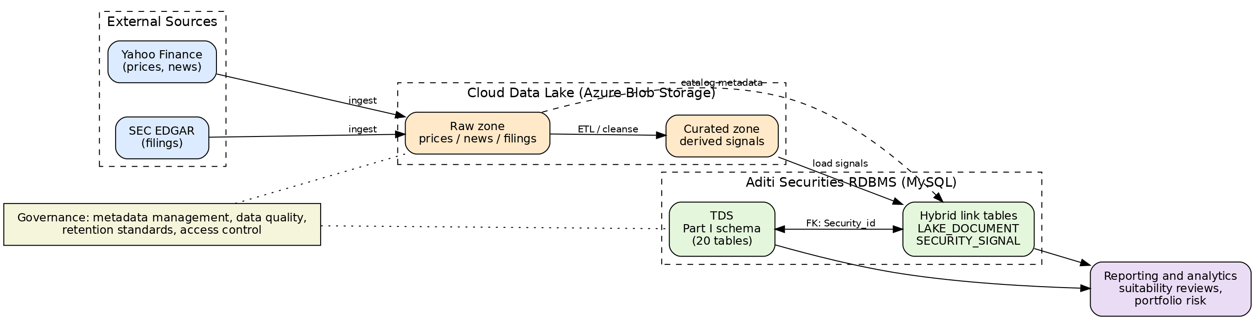
5. Cloud Storage
The data lake is stored in Microsoft Azure Blob Storage. A storage account was created with a container named aditi-datalake, and the datalake folder (raw and curated zones) was uploaded preserving the folder structure, so the Storage_uri values in LAKE_DOCUMENT resolve to blob paths. Azure Blob Storage was chosen because it is object storage priced for exactly this workload: cheap for rarely rewritten raw files, supports folder-like prefixes matching the zone layout, and integrates with Azure analytics services if the firm later builds machine-learning models on the lake. The screenshot below shows the container with the uploaded lake.
[Insert your Azure portal screenshot here after uploading the datalake folder — see the steps in the submission notes.]
6. Files in the Archive
This report; the data lake (datalake folder with raw and curated zones and README); the logical schema from Part I (aditi_securities.sql) and its Part II extension (part2_schema_extension.sql); and the reference architecture diagram (part2_reference_architecture.png).

