Rai, Aditi
August 5, 2026
NYU ID: ar9598
CS-GA.2433-001
Database Systems Project Part III – Logical Schema Optimization and Machine Learning Model Creation
Aditi Securities

Statement of Independent Effort: Aditi Rai
Total in points (100 points total):
Professor’s Comments:

1. Introduction
Part I of the project produced the Aditi Securities entity-relationship model (20 entities covering clients, accounts, advisors, securities, orders, trades, portfolios, compliance, and settlement). Part II extended the logical schema with a hybrid data lake (LAKE_DOCUMENT, SECURITY_SIGNAL) built from real Yahoo Finance price/news data and an SEC EDGAR filing, stored in Azure Blob Storage, to forecast security and portfolio risk from market factors.
Part III optimizes that logical schema into a physical database design, documents the business use cases for a quote-and-onboarding workflow, and trains a real machine learning model on the Part II data lake to forecast next-day security price movement — a concrete instance of the risk-forecasting use case the project has targeted since Part II.
2. EDA Physical Database Design
The physical design (full script in part3_physical_design.sql) applies four standard techniques to the Part I/II logical schema, each chosen to match how the firm actually queries the data:
Indexing. Secondary indexes were added on the foreign keys and columns behind the firm's highest-frequency lookups: ORDERS(Account_id) and ORDERS(Security_id, Order_datetime) for trading-desk and client-service queries; TRADE(Execution_date) for end-of-day settlement reconciliation; HOLDING(Security_id) so a new SECURITY_SIGNAL can be traced back to every affected portfolio; CLIENT_ADVISOR_ASSIGNMENT(Fp_id) and APPOINTMENT(Fp_id, Appt_datetime) for the "Get Book" and "Get Last Touch" use cases documented in the Part I report; COMPLIANCE_FLAG(Account_id, Status) for the compliance dashboard; and SECURITY_SIGNAL(Signal_type, Signal_date) for cross-security signal digests.
Partitioning. ORDERS, SECURITY_SIGNAL, and PORTFOLIO_VALUATION grow without bound (new rows every trading day or ETL run) while nearly every query on them filters by a recent date range, so all three are range-partitioned by year on their date column. This lets MySQL prune whole partitions instead of scanning the full table, and lets older partitions be archived independently. MySQL requires every unique key on a partitioned table to include the partitioning column, so the primary keys of ORDERS and SECURITY_SIGNAL were widened to (Order_id, Order_datetime) and (Signal_id, Signal_date); the AUTO_INCREMENT surrogate key still guarantees practical uniqueness. PORTFOLIO_VALUATION already keys on (Portfolio_id, Valuation_date), so it partitions without any key change.
Clustering. InnoDB clusters each table's data pages on its primary key, so the clustering decision is really the choice of primary key. Every high-insert table (ORDERS, TRADE, SECURITY_SIGNAL, APPOINTMENT) intentionally uses an AUTO_INCREMENT surrogate key rather than a natural key such as Ssn or Ticker, so new rows are always appended at the end of the clustered index instead of triggering random-page inserts and page splits. Read-heavy lookup tables (SECURITY, ISSUER, SECURITY_TYPE) keep the same pattern; their alternate keys (Ticker/Exchange, License_number, Crd_number) are already enforced as secondary indexes via the UNIQUE constraints from Part I/II.
Selective materialization. The advisory/compliance workflow repeatedly needs "for every holding, what is the most recent risk signal on that security," a join across HOLDING, SECURITY_SIGNAL, and SECURITY that gets expensive once SECURITY_SIGNAL has years of partitioned history. PORTFOLIO_RISK_SUMMARY materializes that join (one row per portfolio/security with the latest sentiment, 3-month return, and open risk-mention count) and is refreshed by the same nightly ETL job that loads new signals, using an idempotent INSERT ... ON DUPLICATE KEY UPDATE.
Deployment: the target is a mainstream relational database system, MySQL, matching Parts I and II. The full pipeline is deployed live to Azure: the Part II data lake lives in Azure Blob Storage (storage account aditisecuritieslake26, containers raw/ and curated/), and the Part I/II schema plus the physical design script in this section were executed via Azure Cloud Shell against a provisioned Azure Database for MySQL Flexible Server (aditi-securities-mysql.mysql.database.azure.com, MySQL 8.0.21, Burstable B1ms). All 20 base tables, the 8 secondary indexes above, the three range-partitioned tables (ORDERS, SECURITY_SIGNAL, PORTFOLIO_VALUATION, each with p_2025_and_before / p_2026 / p_2027 / p_future partitions), and the materialized PORTFOLIO_RISK_SUMMARY table are confirmed live on the server.
Running the script against a live server surfaced a real physical-design constraint that isn't visible from the DDL alone: InnoDB refuses a foreign key constraint on a partitioned table, and this applies both to a partitioned table's own FKs and to FKs that other tables hold pointing into it. ORDERS' three original FKs (to ACCOUNT, SECURITY, and FINANCIAL_PROFESSIONAL) needed to be dropped before partitioning, and so did two FKs from other tables that were easy to miss on paper — TRADE.Order_id and COMPLIANCE_FLAG.Order_id both reference ORDERS(Order_id). All five constraints were named explicitly and dropped immediately before their respective PARTITION BY statements; referential integrity for those relationships is now enforced at the application/ETL layer instead, which is standard practice for high-volume partitioned fact tables in production systems that need partition pruning more than they need a database-enforced foreign key.
3. Business Use Cases: Quote and Onboarding Workflow
The workflow-based application lets a prospect obtain an investment plan (the brokerage equivalent of an insurance quote) and open an account. The use case diagram below documents the actors (Prospect/Client, Financial Professional, Compliance Officer, and the automated system) and their use cases, modeled in UML use-case notation with <<include>> relationships showing sub-steps that are always performed as part of a larger use case.
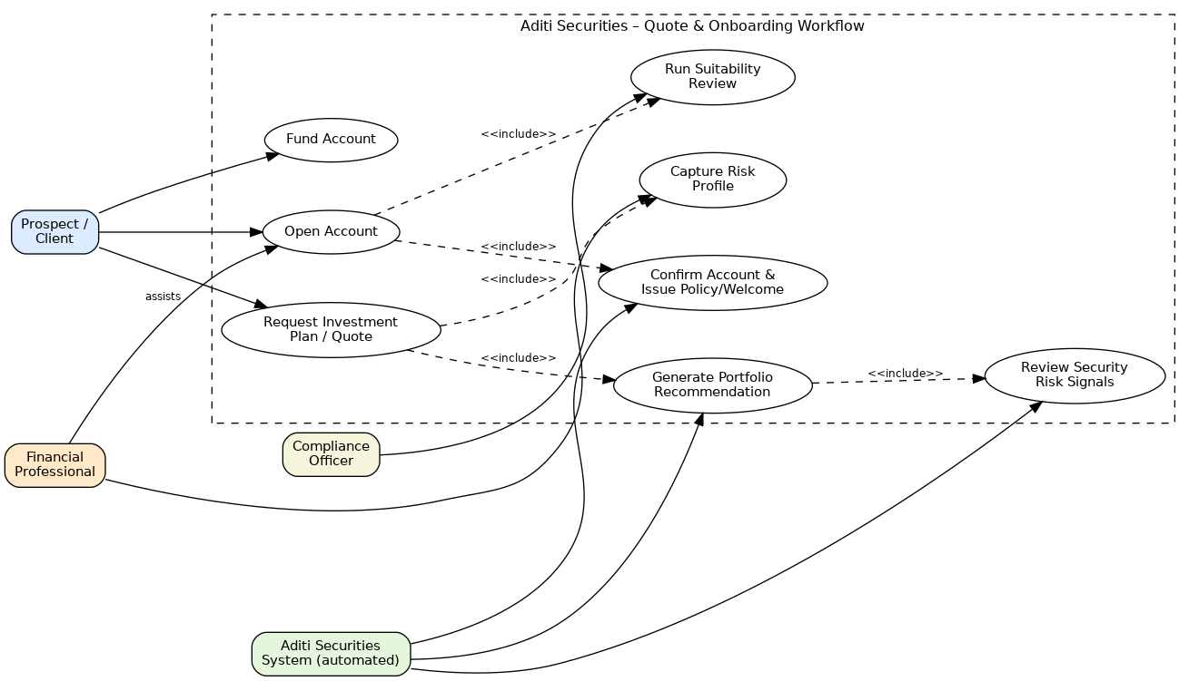
Request Investment Plan / Quote — the prospect describes their goals; this includes Capture Risk Profile (creates a RISK_PROFILE row) and Generate Portfolio Recommendation, which itself includes Review Security Risk Signals (reads PORTFOLIO_RISK_SUMMARY / SECURITY_SIGNAL so the recommendation avoids securities with deteriorating signals).
Open Account — creates the ACCOUNT and PORTFOLIO rows; includes Run Suitability Review (a COMPLIANCE_FLAG check by the Compliance Officer) and Confirm Account & Issue Policy/Welcome.
Fund Account — the client's first deposit, recorded as the account's opening PORTFOLIO_VALUATION.Cash_balance snapshot.
This workflow is documented at the process level only; per the assignment, no database program is implemented for it in this part of the project.
4. Machine Learning Model Creation
4.1 Refined Use Case and Big Data Evaluation Approach
The Part II use case — forecasting security and portfolio risk from price behavior, news sentiment, and filing risk factors — is refined here into a concrete, testable prediction task: given a security's recent price action, will it move up or down the next trading day? This is evaluated using the standard short/medium/long-term lens for Big Data ideas: short term, it gives advisors a same-day talking point when reviewing a holding; medium term, accumulating daily predictions and their accuracy builds a track record that can be back-tested against actual suitability outcomes; long term, once enough signal history accumulates in SECURITY_SIGNAL, the same pipeline can be extended to combine price-based features with news sentiment and filing risk mentions for a materially stronger model.
4.2 Model Selection and Training
Two supervised classifiers were trained and compared on real data pulled directly from the Part II data lake (datalake/raw/prices/*.csv for AAPL, MSFT, and JPM): logistic regression and a depth-limited decision tree, chosen because both are fast to train, easy to explain to a non-technical compliance reviewer, and well suited to a binary outcome (price up vs. down).
Feature engineering (train_ml_model.py): for each ticker's daily series, 1- and 2-day lagged returns, 5- and 10-day moving averages, price position relative to those moving averages, 5-day rolling volatility, and day-over-day volume change. The target is whether the next trading day's return is positive.
Data: 183 raw daily price rows across the 3 tickers reduce to 156 usable rows after the rolling-window features' warm-up period is dropped; split 75/25 into train/test with stratification (117 train / 39 test rows).
Results: logistic regression reached 56.4% test accuracy versus a 51.3% majority-class baseline; the decision tree matched the baseline at 51.3%. Logistic regression's largest standardized coefficients were Price_vs_MA5 (-0.384) and Lag2_return (0.384), meaning a price that has run up faster than its 5-day average tends to mean-revert the next day, while a positive return two days ago is followed by continued upward drift. Logistic regression was selected as the deployed model and saved to security_movement_model.pkl.
These accuracies are modest and expected: daily equity moves are close to a random walk, and 156 rows from three tickers over one quarter is a small sample. The result still demonstrates a complete, working pipeline — real data in, engineered features, a trained and saved model, and a plausible economic interpretation of its coefficients — that improves as more price history and more tickers accumulate in the lake (Section 4.3).
4.3 Growing the Big Data Platform
The lake was designed in Part II to grow without restructuring: additional tickers only add rows to the existing raw/prices schema, additional news cycles only add rows to raw/news, and each new filing season adds another raw/filings document. As history accumulates, the same feature pipeline in train_ml_model.py can retrain on a much larger sample, and the News_sentiment and Risk_mention_* signals already captured in SECURITY_SIGNAL (currently sparse, one date per ticker) can be joined onto the daily price features once they are collected daily rather than ad hoc, materially improving the model without any schema change. Model outputs (predicted next-day direction, per security) are written back into PORTFOLIO_RISK_SUMMARY (Section 2), so the ML layer feeds the same EDA that Part I designed and Part II extended, rather than living in a silo.
4.4 Updated Reference Architecture
The Part II reference architecture is extended with an Analytics/ML layer that reads engineered features from the curated zone, trains and scores the model, and writes risk scores into the new PORTFOLIO_RISK_SUMMARY table so predictions reach the same reporting layer as the structured data. Governance now also covers model monitoring, alongside the metadata management, data quality, and retention standards already in place from Part II.
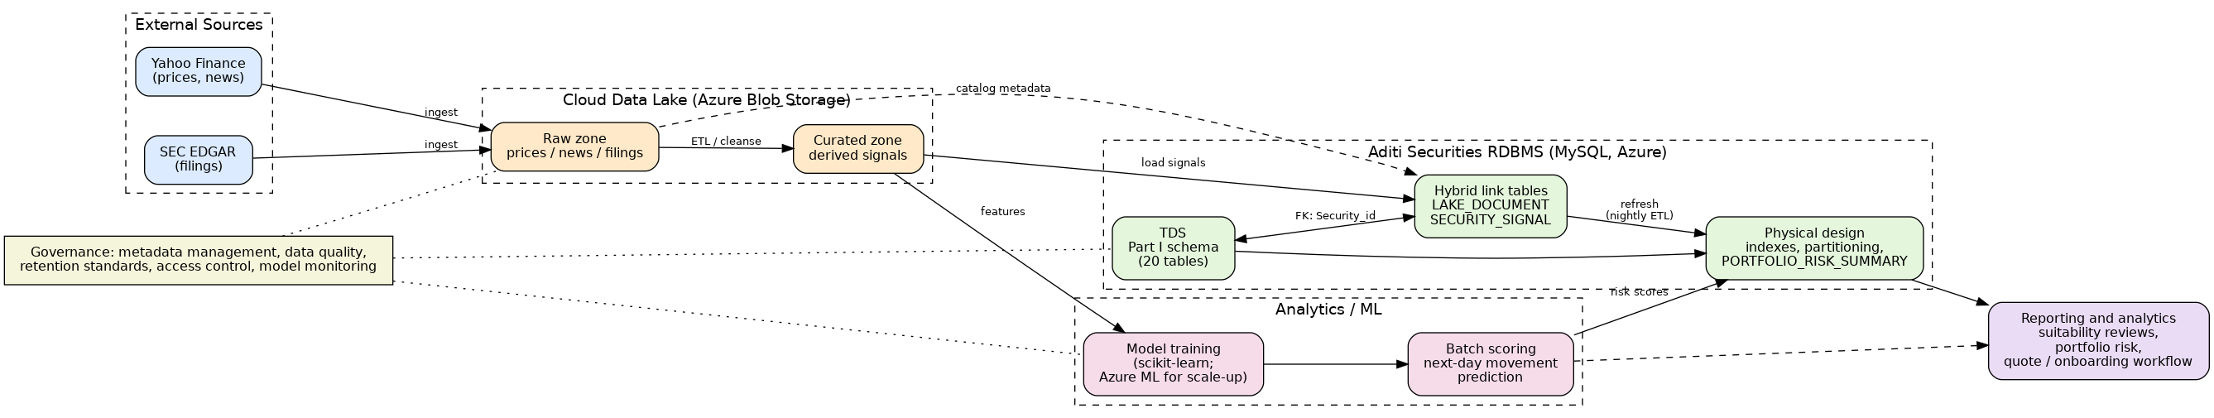
4.5 Leveraging Azure Big Data Analytics
Model training and scoring run today as a scheduled Python job (train_ml_model.py) against the curated zone, which is genuinely deployed in Azure Blob Storage (Part II); results are written into the Aditi Securities MySQL database from Section 2, local or cloud depending on which instance the job is pointed at. For scale-up, Azure Machine Learning is the natural next step for managed training/scoring pipelines and model versioning, and Azure Synapse Analytics or Stream Analytics would support near-real-time scoring as intraday price and news events are ingested, rather than the current daily batch — an extension consistent with the "semi real-time big data analytics" goal described in Section 1 of the assignment.
5. Files in the Archive
This report; the physical design script (part3_physical_design.sql); the use-case diagram (usecase_diagram.png) and updated reference architecture diagram (part3_reference_architecture.png, source arch3.dot); the ML training script (train_ml_model.py), its run log (ml_model_output.txt), and the saved trained model (security_movement_model.pkl); and the Part I/II files carried forward (aditi_securities.sql, part2_schema_extension.sql, the datalake folder).

