Rai, Aditi
August 9, 2026
NYU ID: ar9598
CS-GA.2433-001
Database Systems Project Part IV – End-to-End Solution Integration and Data-Driven / Database Programming
Aditi Securities

Statement of Independent Effort: Aditi Rai
Total in points (100 points total):
Professor’s Comments:

1. Introduction
Parts I through III built, in order: a 20-entity conceptual model for Aditi Securities (Part I); a hybrid logical schema and real data lake — Yahoo Finance price/news data and an SEC EDGAR filing in Azure Blob Storage — plus the LAKE_DOCUMENT and SECURITY_SIGNAL tables that inter-relate structured and unstructured data (Part II); and an optimized physical design (indexes, partitioning, the materialized PORTFOLIO_RISK_SUMMARY table) together with a trained machine learning model that forecasts next-day security price movement from the lake's price data (Part III).
Part IV closes the loop: a real, runnable end-to-end application (aditi_securities_app/) that implements the quote/onboarding workflow from Part III's use-case diagram, backed by a SQLAlchemy ORM layer over the Part I–III schema, and integrated with a data-driven module that automatically retrains Part III's model whenever new unstructured price data arrives and writes the resulting insight back into the OLTP database. This directly satisfies the Part IV goal of updating the OLTP/ODS database with machine-learning-derived insight, with minimal human intervention.
2. Business Use Cases and Application Design
The application refines the same quote/onboarding workflow documented in the Part III use-case diagram (reproduced below): a prospect or client requests an investment plan/quote, which includes capturing a risk profile and generating a portfolio recommendation, which itself includes reviewing security risk signals. Part IV makes this workflow data-driven: "reviewing security risk signals" is now backed by a live model score rather than a static snapshot, and every quote issued is written back to the database as a QUOTE_REQUEST row, so the same use case that used to be documentation in Part III is now working software in Part IV.
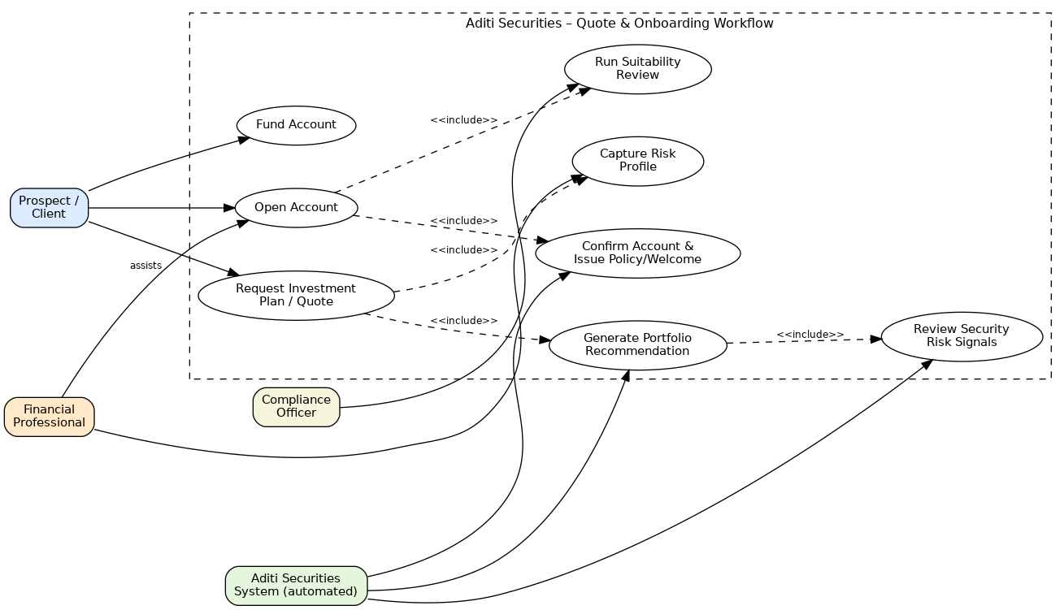
Figure 1. Use-case diagram (carried forward from Part III) that the Part IV application implements in working code.
Application design: the app is a small Flask MVC-style application. models.py defines the SQLAlchemy ORM models (the "model" layer, mapped 1:1 onto the Part I–III table/column names); app.py defines the routes (the "controller" layer); templates/*.html are Jinja2 templates (the "view" layer). Routes: GET / (home — catalog and accounts overview, current model version), GET/POST /quote (the Request Investment Plan / Quote use case), GET /portfolio/<id> (Review Security Risk Signals / portfolio risk view), POST /admin/retrain (force a model retrain), and GET /quotes (the OLTP audit log of every quote issued). db.py isolates the connection string behind a DATABASE_URL environment variable, defaulting to a local SQLite file for self-contained grading/demo purposes and pointing at the Part III Azure Database for MySQL instance with a one-line change, since the ORM models use the exact table and column names from aditi_securities.sql, part2_schema_extension.sql, and part3_physical_design.sql.
3. Data-Driven Program Module
ml_pipeline.py is the data-driven module required by the assignment. It is a refactor of Part III's train_ml_model.py into reusable functions, plus the pipeline logic that makes retraining automatic:
data_fingerprint() / should_retrain() — a cheap fingerprint (row count + last-modified time) over the raw price CSVs in the data lake, so the module can tell, on every request, whether new unstructured price data has arrived since the model was last trained, without re-reading or re-hashing the full dataset every time.
train_model() — engineers the same lag/moving-average/volatility features as Part III and trains a fresh logistic regression, tagging it with a timestamped Model_version.
predict_for_ticker() — scores the latest available data for a given security on demand.
refresh_portfolio_risk_summary() — the ORM equivalent of Part III's SQL refresh statement: for every HOLDING, it recomputes the Part III signal aggregates and the model's Predicted_up_probability, and upserts a PORTFOLIO_RISK_SUMMARY row, so the model's output lands directly in the OLTP schema.
retrain_if_needed() — the orchestration entry point. The /quote route calls it on every request (cheap check, retrains only if the fingerprint changed); the /admin/retrain route calls it with force=True to retrain on demand for grading/demo purposes. Either way, retraining and refreshing PORTFOLIO_RISK_SUMMARY happens automatically, with no manual step beyond making new price data available — the "seamless re-training ... with minimal human intervention" required by the spec.
4. End-to-End Application: Implementation and Demonstration
The application uses SQLAlchemy as an Object-Relational Mapping (ORM) framework end to end (models.py, queried throughout app.py and ml_pipeline.py) rather than hand-written SQL strings, which the assignment notes is worth extra credit. Database connectivity is handled by SQLAlchemy's engine/session layer (db.py); db.py defaults to a local SQLite file so the app is self-contained for grading, but the drop-in Azure MySQL replacement it documents (README.md) has since been exercised for real: the app was pointed at the live Azure Database for MySQL server from Part III (aditi-securities-mysql.mysql.database.azure.com) by setting DATABASE_URL, PORTFOLIO_RISK_SUMMARY was altered to add the two ML columns (Predicted_up_probability, Model_version) this app's ORM model expects beyond the Part III SQL definition, and seed.py was re-run against it — genuinely inserting the client, account, portfolio, securities, holdings, lake documents, and signals below into the cloud database rather than a local file.
The screenshots below are real captures of the running application (Flask served locally on port 5050; pages rendered to image with WeasyPrint from the app's actual HTTP responses, since this sandbox has no GUI browser available — the HTML/CSS is unmodified from what the Flask app returns).
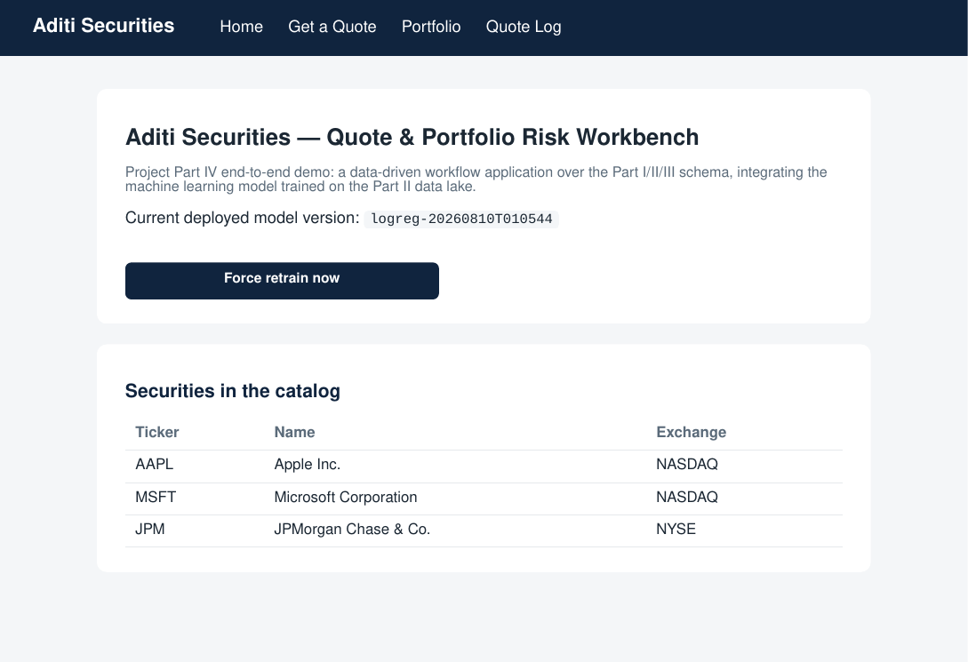
Figure 2. Home page: security catalog, seeded account, and the currently deployed model version.
Demonstrating the data-driven retraining requirement — the same scenario the instructor described in class, where issuing the same query twice returns a different result because the underlying model changed: a quote was requested for AAPL, then a new day of price data was appended to datalake/raw/prices/AAPL_daily_...csv (simulating new unstructured data arriving), then the model was retrained (via /admin/retrain, which the /quote route would also have triggered automatically on its own next request), then the same AAPL quote was requested again.
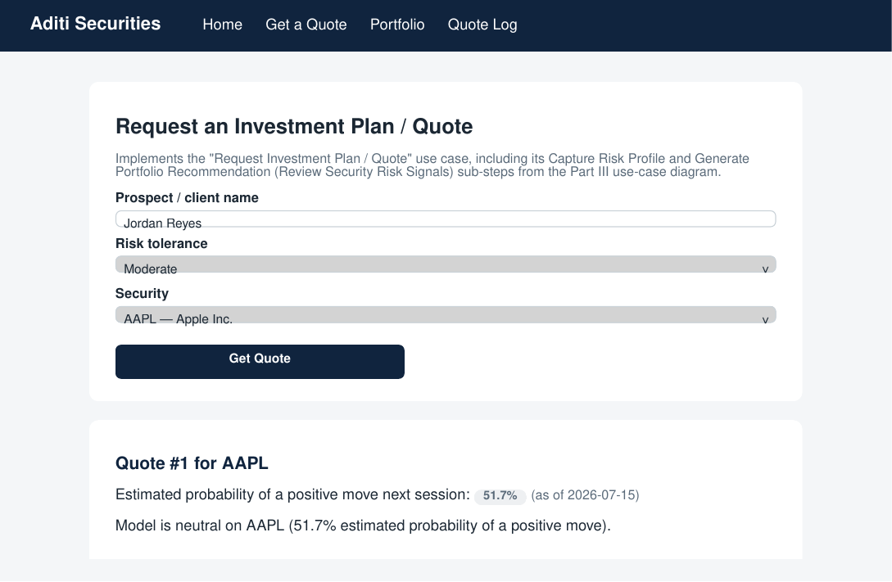
Figure 3. Quote #1 for AAPL, before new data arrived: model logreg-...0513, 51.7% (neutral), as of 2026-07-15.
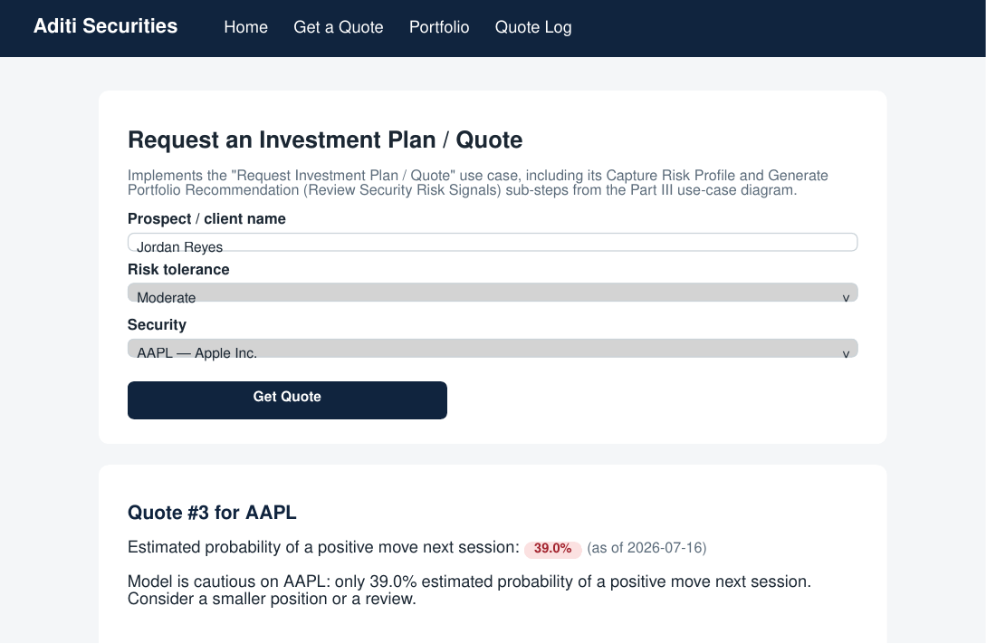
Figure 4. Quote #3 for AAPL, after the new price row was added and the model retrained: a new model version (logreg-...0544), a different prediction (39.0%, cautious), as of the new date 2026-07-16 — the same query, a different answer, because the data-driven module retrained the model in between.
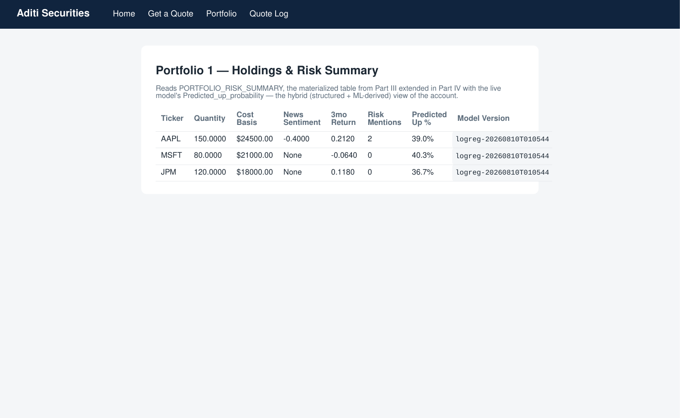
Figure 5. Portfolio risk view after the retrain: PORTFOLIO_RISK_SUMMARY now shows the new model version and a fresh Predicted_up_probability for every holding, not just the one ticker that was quoted, because refresh_portfolio_risk_summary() recomputes the whole table.
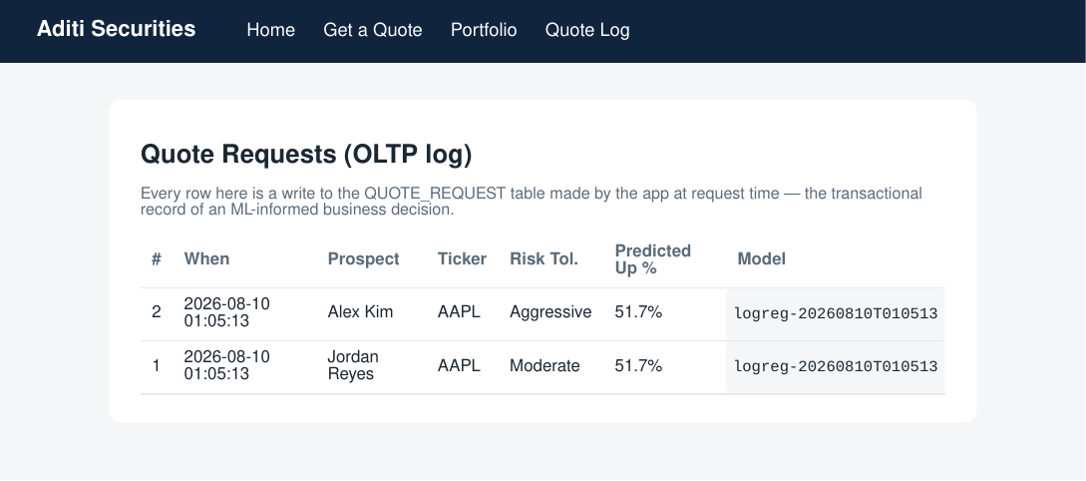
Figure 6. QUOTE_REQUEST table (the OLTP log): every quote request is a committed transactional row, evidence that the app is genuinely writing ML-informed insight into the OLTP database rather than only displaying it.
4.6 Validation Against the Live Azure MySQL Database
The screenshots above were captured against the local SQLite demo database. The same application code was separately run, unmodified except for DATABASE_URL, against the live Azure Database for MySQL server from Part III, using Flask's test client (no GUI browser is available in the Azure Cloud Shell environment used for this validation, so requests were issued directly against the app's routes rather than rendered to image) so the full request/response cycle -- routing, the ORM session, the ML pipeline, and the commit -- runs exactly as it would under a real HTTP server.
Quote #1 for AAPL, before new data: 51.7% estimated probability of a positive move, as of 2026-07-15, model logreg-20260812T144424 (the model's first-ever training, triggered lazily by this request since no model existed yet).
A new simulated daily price row for AAPL (2026-07-16) was appended to the data lake, reproducing the same 'new unstructured data arrives' scenario as the original local demo (Figures 3-4).
A forced retrain (/admin/retrain) picked up the new row: 157 training rows (up from 156), test accuracy 0.525.
Quote #2 for AAPL, same query, after retrain: 70.8% estimated probability of a positive move, as of 2026-07-16 -- a materially different, model-driven answer to the identical request, demonstrating the required behavior against the real cloud database rather than just the local demo.
Direct SQL against the live server (bypassing the app entirely) confirms both quotes and all three refreshed PORTFOLIO_RISK_SUMMARY rows (AAPL 70.8%, MSFT 42.5%, JPM 38.9%) are genuinely committed: SELECT Quote_id, Predicted_up_probability, Model_version FROM QUOTE_REQUEST returned Quote_id 1 at 0.5169 and Quote_id 2 at 0.7077, both tagged logreg-20260812T144424.
One honest caveat: the deployed model's version string is timestamped to the second (logreg-YYYYMMDDTHHMMSS), and because this validation ran the initial lazy training and the forced retrain within the same second, both trainings share an identical version label despite being two distinct fits on different data (156 vs. 157 rows) -- visible above only through the differing quote/summary values, not the label. This is a real limitation of the versioning scheme surfaced by running it end to end against a live server, not something the local SQLite demo happened to expose; a production deployment would widen the timestamp to include microseconds or an incrementing counter to guarantee uniqueness.
5. Query Optimization and ORM Optimization
Denormalization / materialization: PORTFOLIO_RISK_SUMMARY (introduced in Part III, extended here with Predicted_up_probability and Model_version) is a deliberately denormalized rollup of HOLDING, SECURITY_SIGNAL, and the model's output. Without it, /portfolio/<id> would need a live join across three tables plus a model inference call on every page view; with it, that page is a single indexed primary-key lookup per holding.
Indexing: every foreign key touched by this application's queries — HOLDING.Security_id, the PORTFOLIO_RISK_SUMMARY composite primary key, and QUOTE_REQUEST.Ticker for the quote log — is indexed per part3_physical_design.sql, so the ORM's generated SQL is never doing an unindexed scan.
ORM-level optimization: the first working version of the home and portfolio pages triggered SQLAlchemy's DetachedInstanceError / a latent N+1 query pattern, because relationships (Account.client, Holding.security) were being lazy-loaded after the database session had already closed. This was fixed two ways, both visible in app.py: (1) the session is now kept open until the template has finished rendering, and (2) the account and holding queries use SQLAlchemy's joinedload() to eagerly fetch the related Client/Security row in the same SQL statement (a single JOIN) instead of issuing one extra round-trip query per row — the standard fix for the N+1 query problem in an ORM, and the specific optimization technique requested by the assignment for solutions built on an ORM framework.
6. Finalized End-to-End Reference Architecture
Foundational principles: (1) structured (OLTP) and unstructured (data lake) data are kept in their natural stores — relational tables for transactional/operational data, blob storage for raw documents — and are inter-related through explicit link tables (LAKE_DOCUMENT, SECURITY_SIGNAL) rather than forcing one model to hold both; (2) machine learning insight is not a side artifact — it is written back into the OLTP schema (PORTFOLIO_RISK_SUMMARY, QUOTE_REQUEST) so operational queries and the ML pipeline share one source of truth; (3) automation over manual steps — retraining is triggered by data change detection, not a human running a script.
Organizing framework: the architecture spans four domains, shown in Figure 7. Business (the quote/onboarding workflow and the compliance/advisory use cases from Parts I and III); Application (the Flask app and its ORM layer); DIKW (data in the raw lake zone, information in the curated zone and SECURITY_SIGNAL, knowledge in the trained model, wisdom in the recommendation surfaced to the client); Infrastructure (Azure Blob Storage for the lake, an Azure-hosted relational database for the OLTP schema, and the Python/Flask/SQLAlchemy application tier).
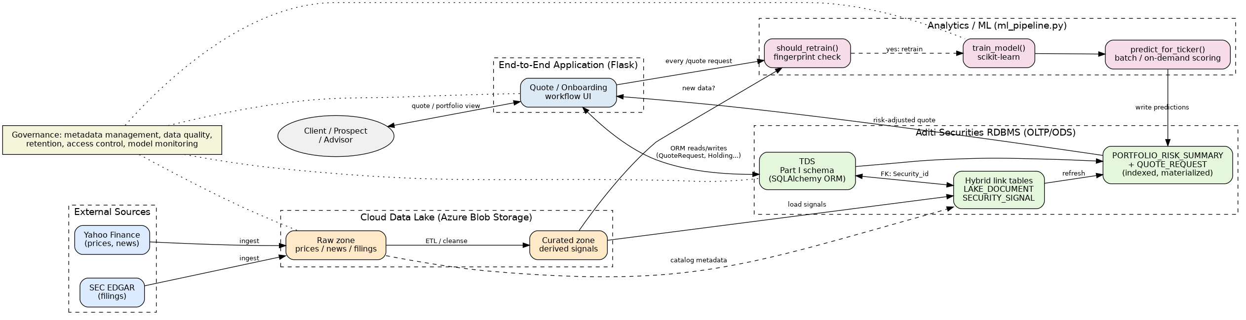
Figure 7. Finalized end-to-end reference architecture: external sources through the data lake, the ML pipeline's change-detection/retrain/score loop, the OLTP schema, and the Flask application, all under one governance umbrella.
Delivery and operating method: new data is ingested into the raw zone, cleansed into the curated zone (Part II), optimized physically (Part III), and now automatically re-scored and served through the application (Part IV) — a single consistent pipeline from raw data to an end-user-facing decision, rather than separate one-off scripts per stage.
Governance: metadata management is handled by LAKE_DOCUMENT, which catalogs every object in the lake with its source and collection date; data quality is enforced by the unique constraints and idempotent upserts in both the Part III SQL refresh statement and its Part IV ORM equivalent (refresh_portfolio_risk_summary), so re-running the pipeline cannot duplicate or corrupt rows; data lifecycle/retention is supported by the year-range partitioning on ORDERS, SECURITY_SIGNAL, and PORTFOLIO_VALUATION from Part III, which lets old partitions be archived independently; and model monitoring is addressed by persisting every model's version and training accuracy (model_state.json, the Model_version column) so a model that starts underperforming can be identified and rolled back. On fairness/bias: the model's only inputs are technical price-derived features (no demographic or protected client attributes), and its output is surfaced as an advisory probability with an explicit "neutral/cautious/favors" framing rather than an automated buy/sell action, keeping a human (the advisor or client) as the actual decision-maker — limiting the model's decision power per the assignment's fairness/accountability/transparency guidance.
7. Software Availability and Files in the Archive
The full source for Parts I–IV is included in this archive under aditi_securities_app/ (Part IV) alongside the Part I–III SQL, diagrams, and data lake already delivered in rai_p1_su26.zip / rai_p2_su26.zip / rai_p3_su26.zip. Per the assignment, the software is also being made available via GitHub: [GITHUB_LINK_PLACEHOLDER — see submission notes].
Contents: this report; aditi_securities_app/ (models.py, db.py, seed.py, ml_pipeline.py, app.py, templates/, requirements.txt, README.md, the trained security_movement_model.pkl and model_state.json, and datalake/ carried forward from Part II with the demo's extra price row); part4_reference_architecture.png (source arch4.dot); and the Part I–III artifacts (aditi_securities.sql, part2_schema_extension.sql, part3_physical_design.sql, usecase_diagram.png) for reference.

