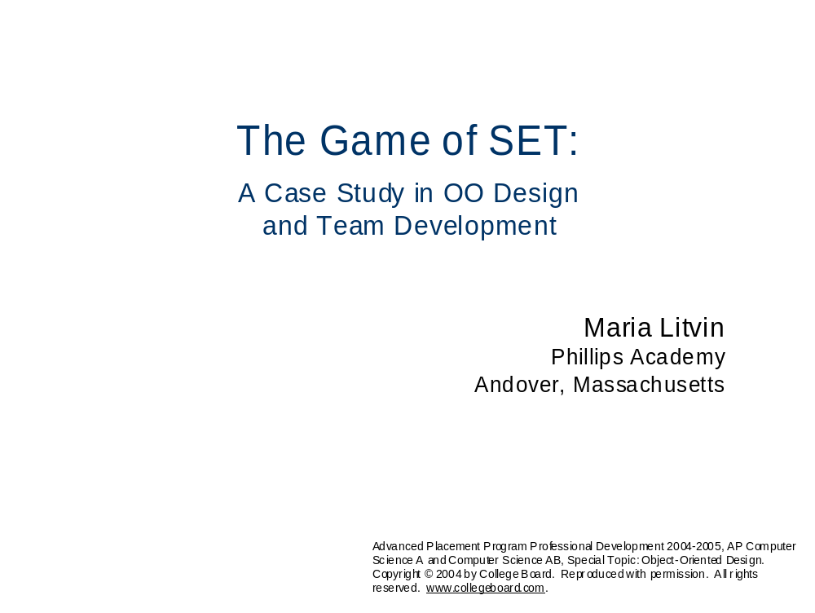

I thank Marsha Jean Falco, president of SET Enterprises, Inc. (and the inventor of the SET game) for the permission to use SET in this project.

I am very grateful to Gary Litvin for his help with the design and implementation of the GUI code.

Slide 3

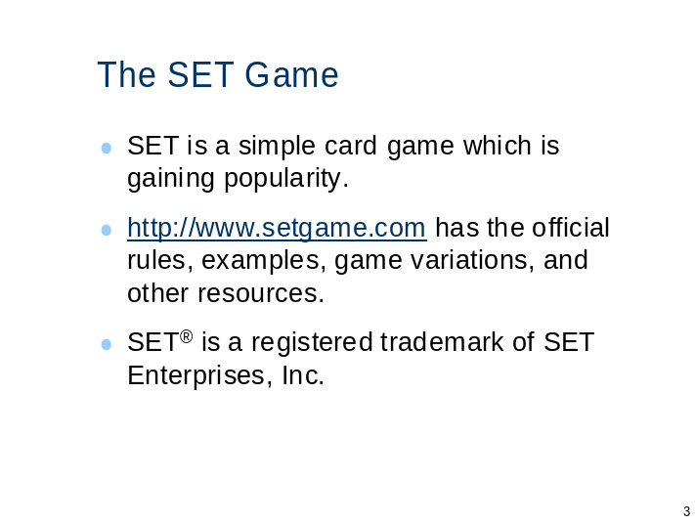

Slide 4

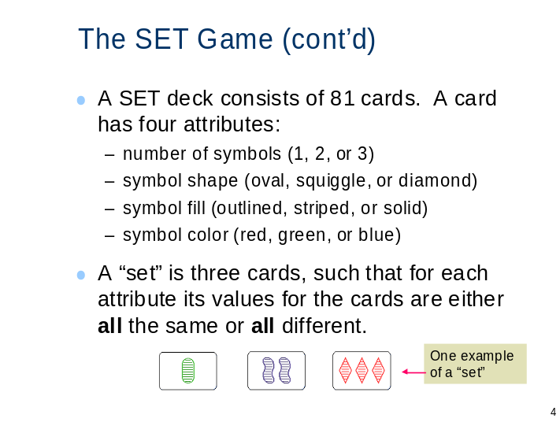

Slide 5

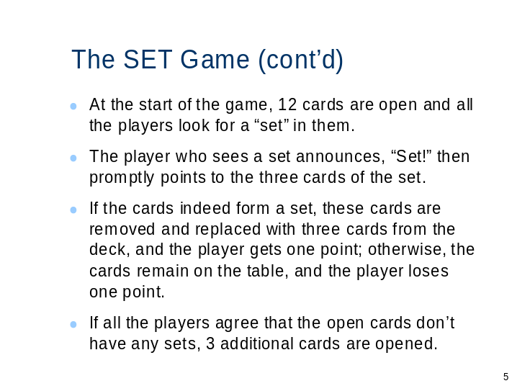

Slide 6

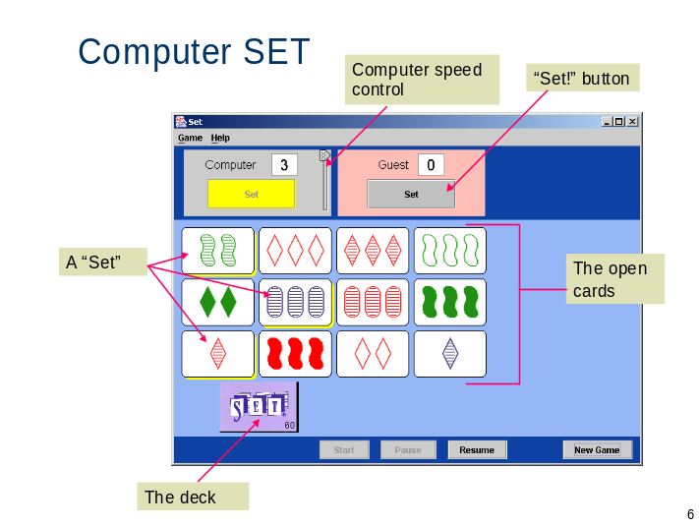

Slide 7

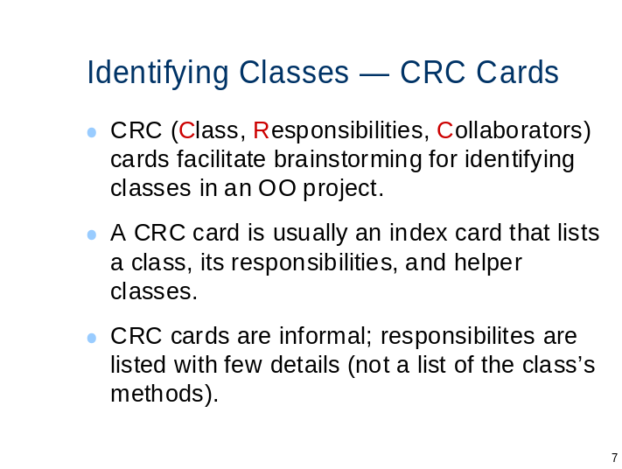

Slide 8

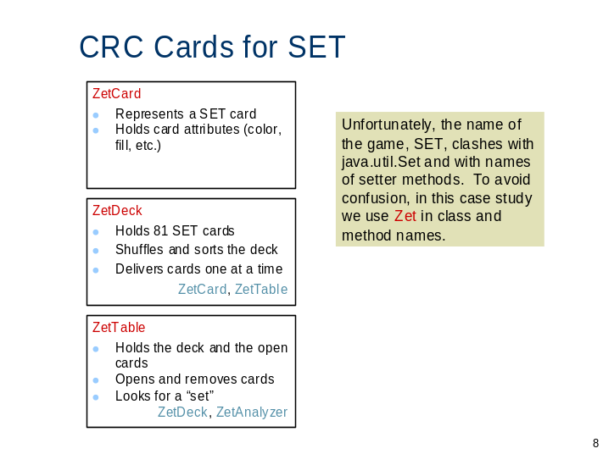

Slide 9

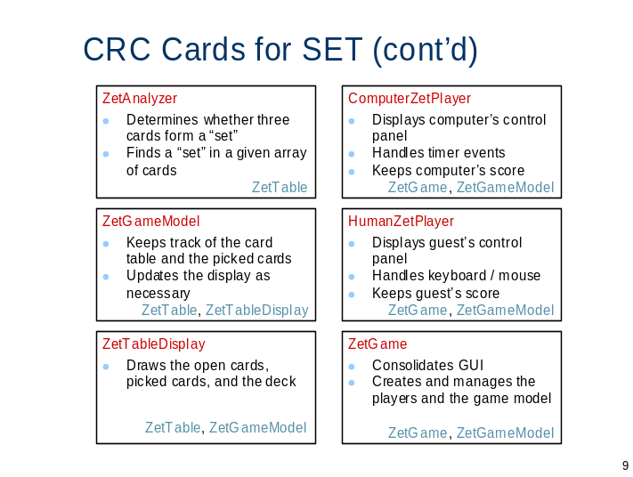

Slide 10

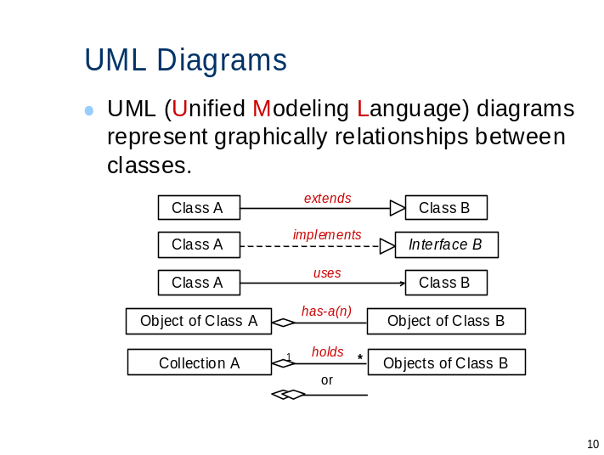

Slide 11

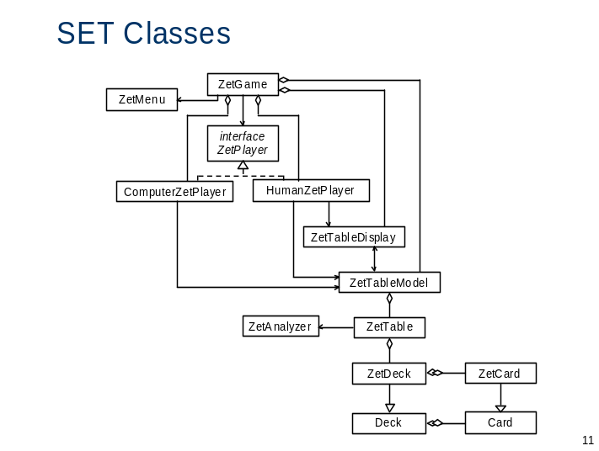

Slide 12

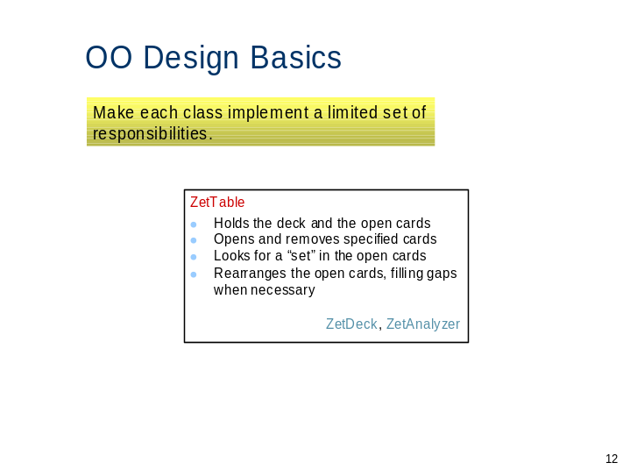

Slide 13

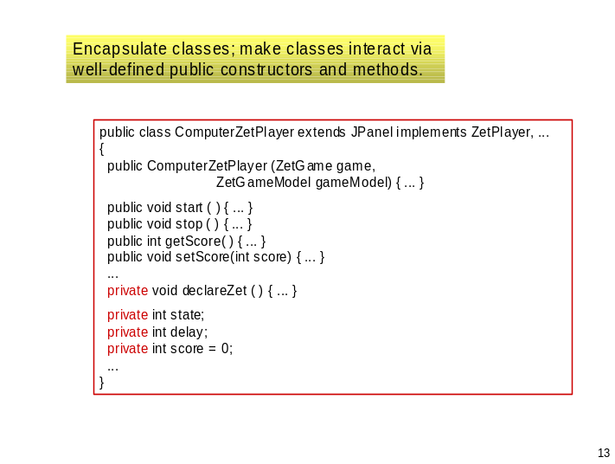

Slide 14

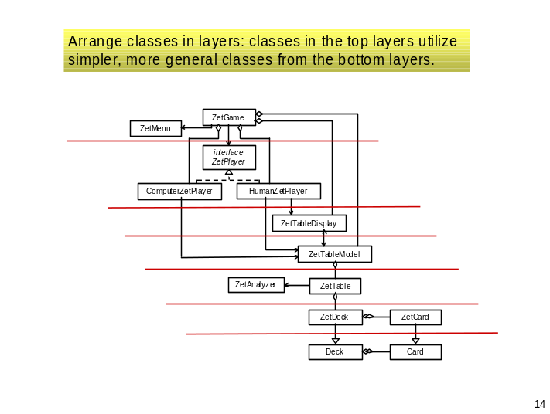

Slide 15

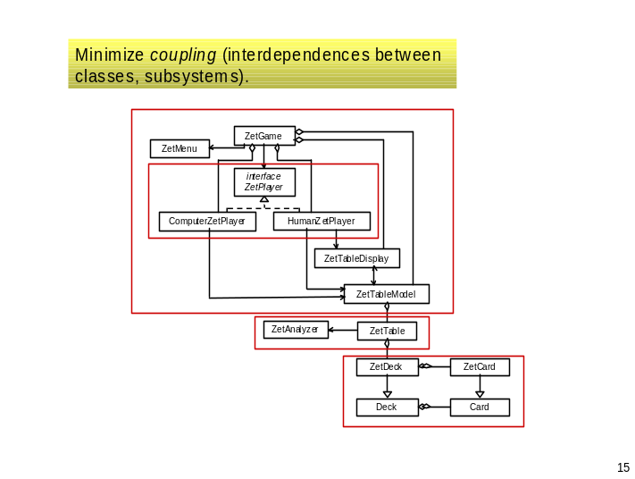

Slide 16

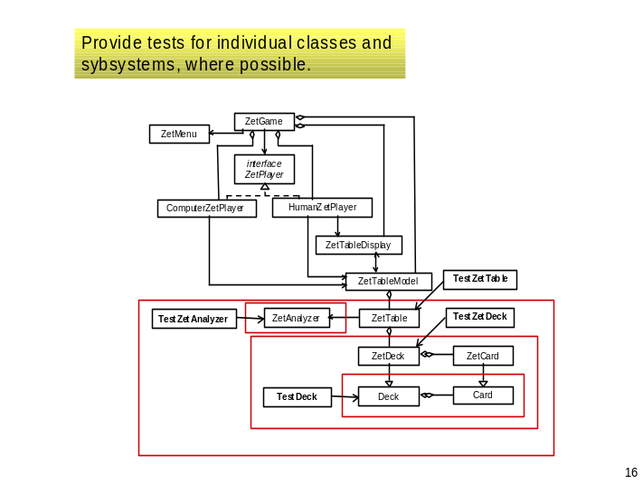

Slide 17

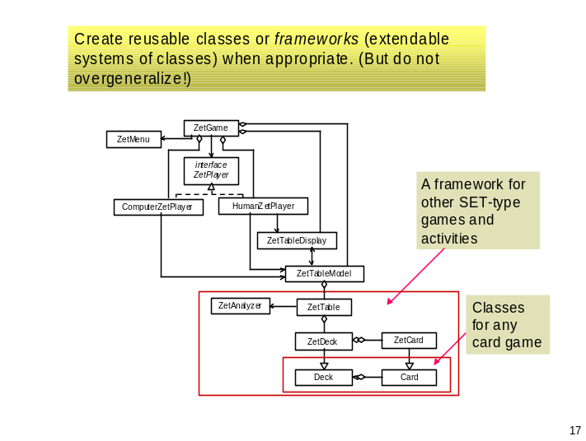

Slide 18

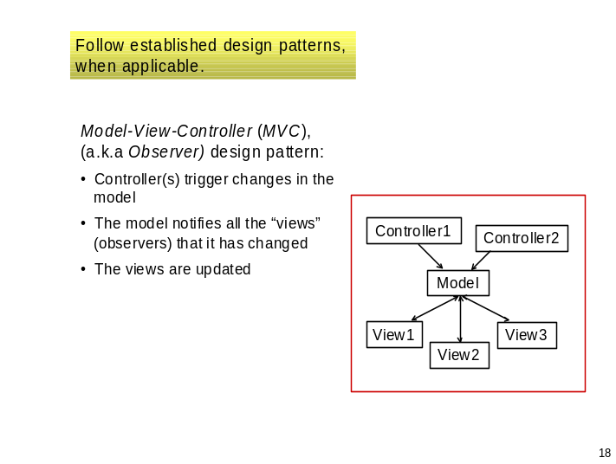

Slide 19

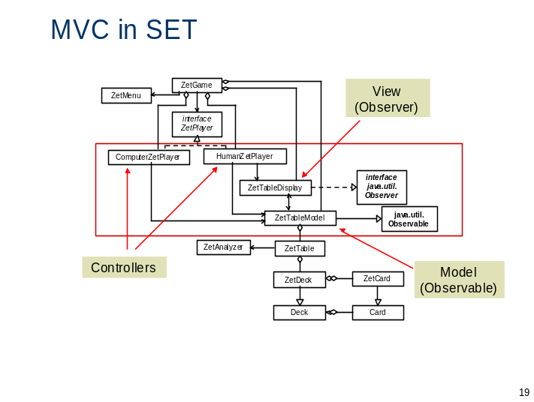

Slide 20

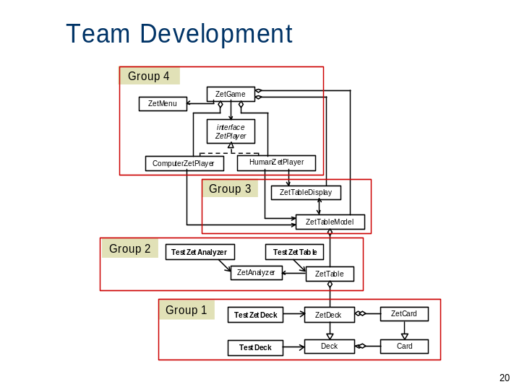

Slide 21

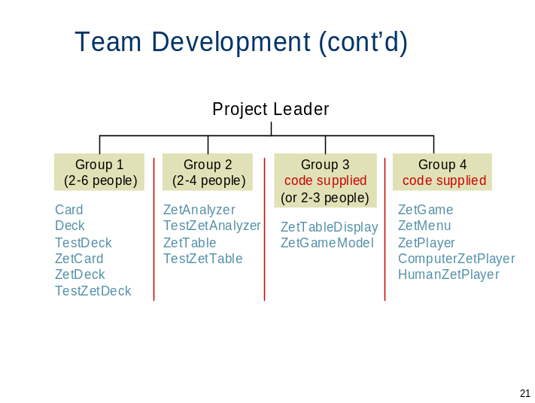

Slide 22

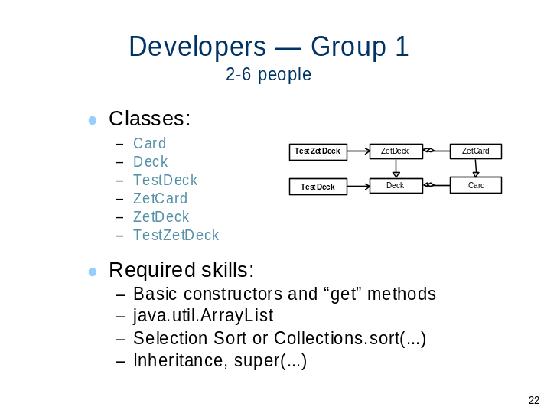

Slide 23

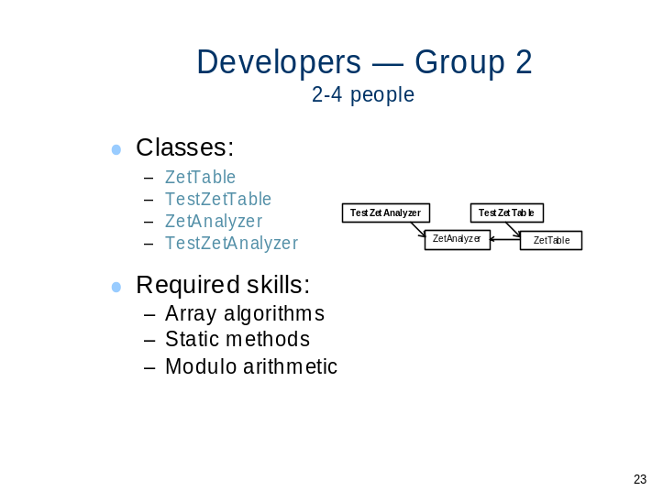

Slide 24

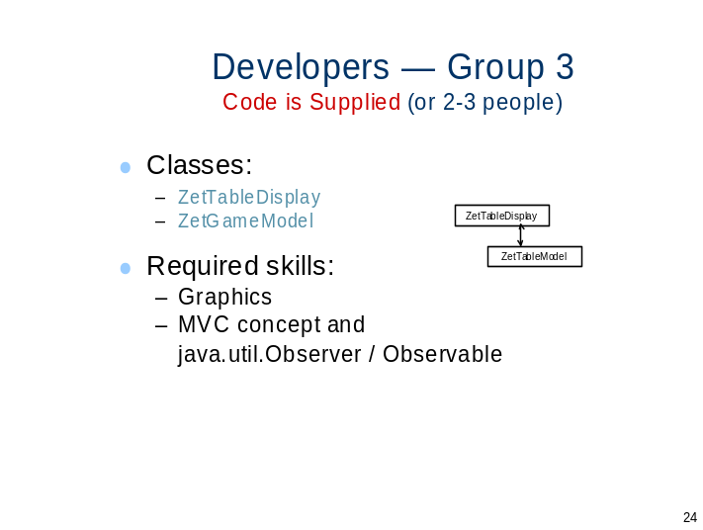

Slide 25

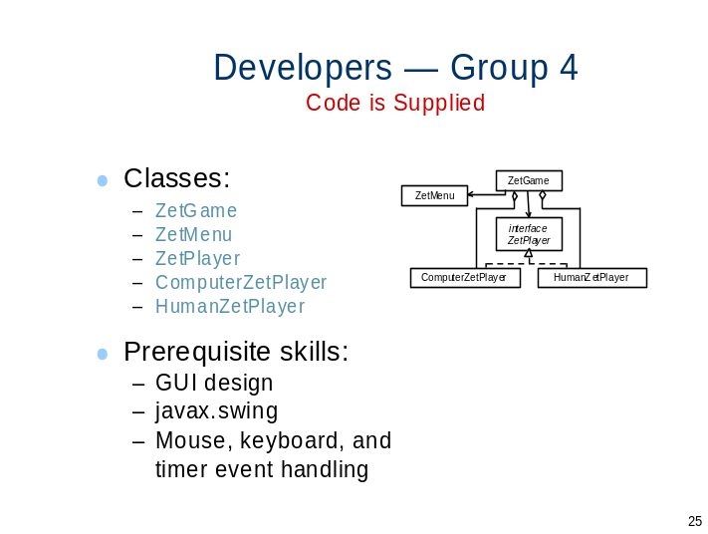

Slide 26

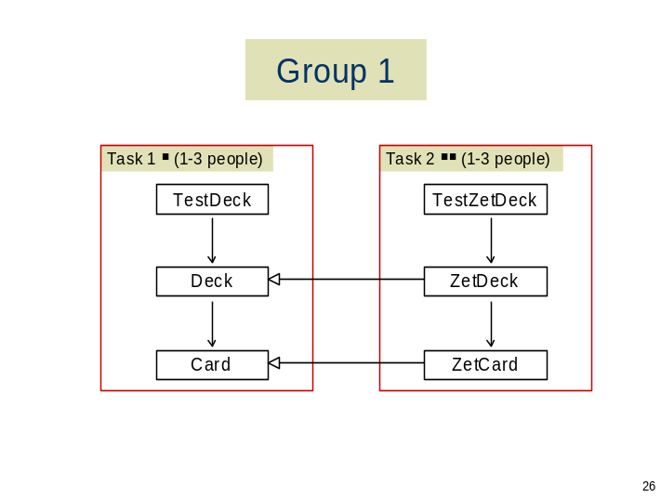

Slide 27

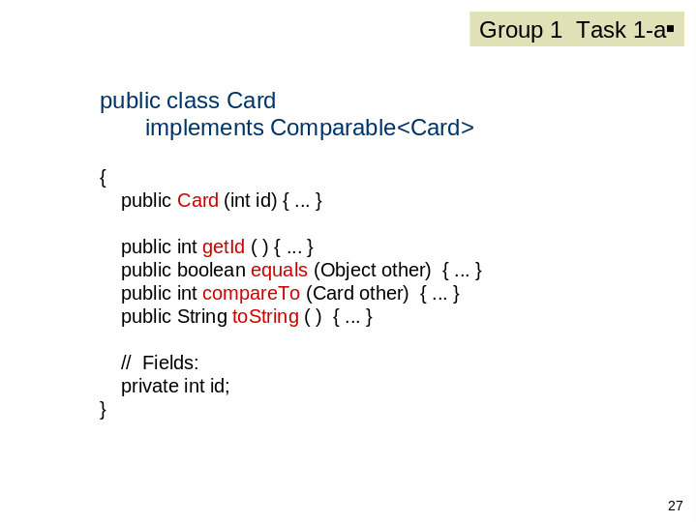

Slide 28

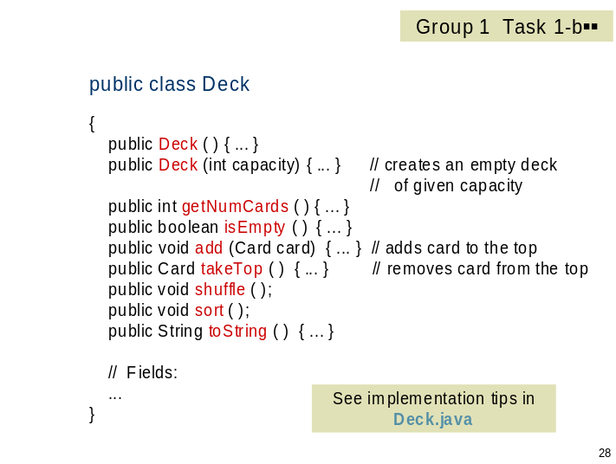
Slide 29

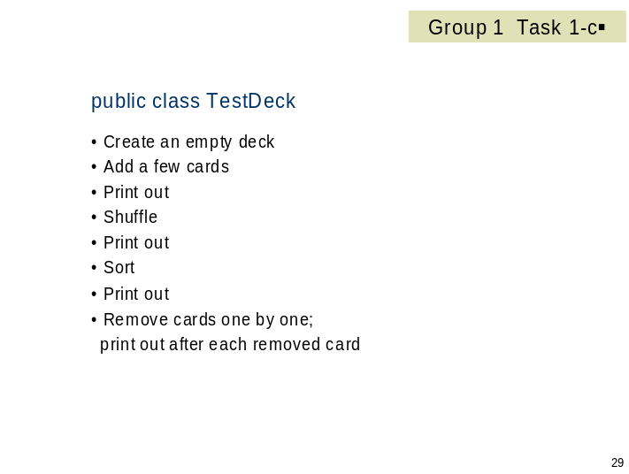

Slide 30

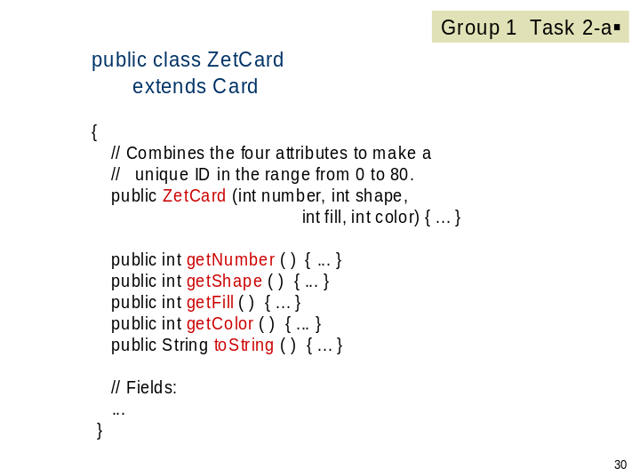

Slide 31

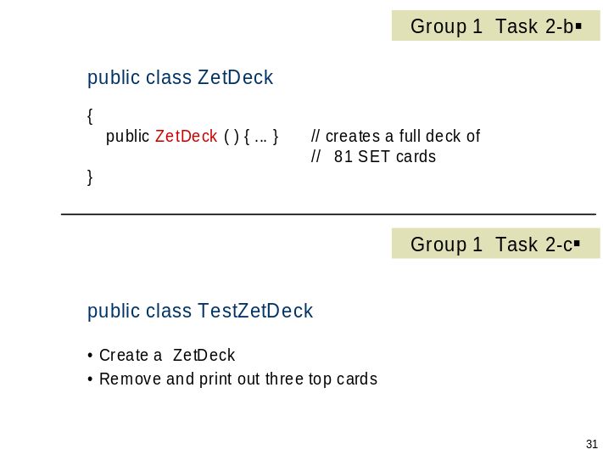

Slide 32

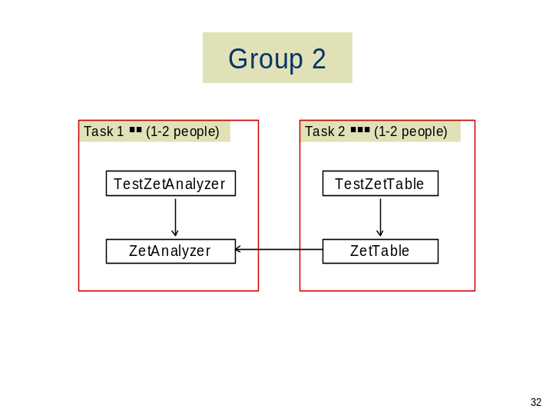

Slide 33

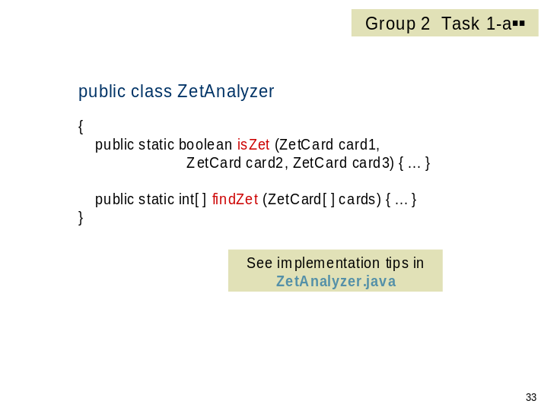

Slide 34

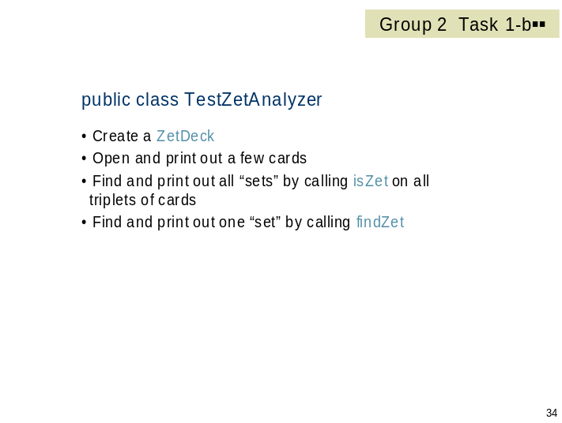

Slide 35

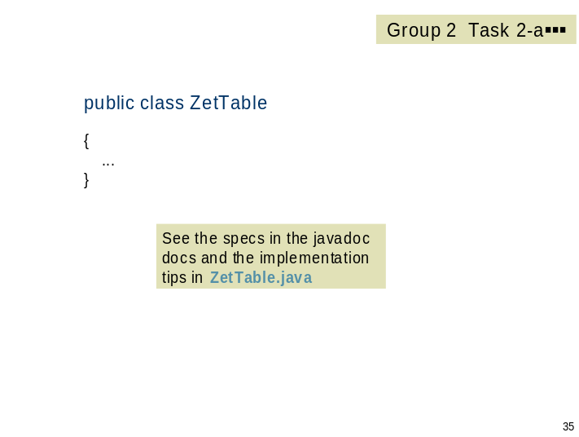

Slide 36

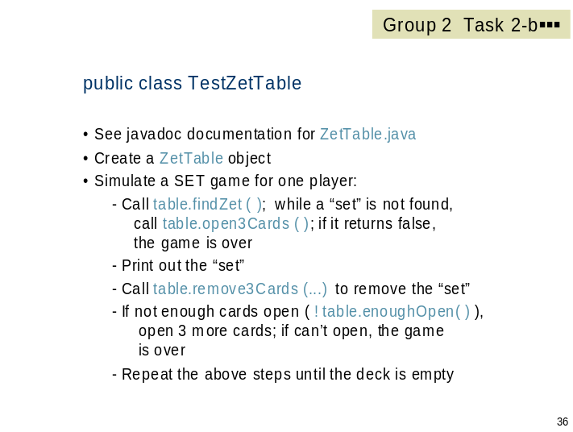

Slide 37

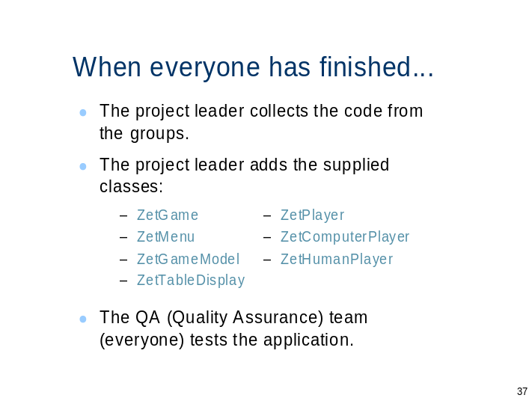

Slide 38

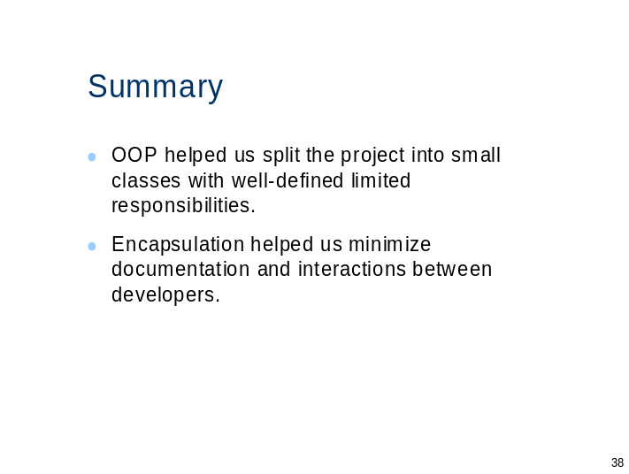

Slide 39

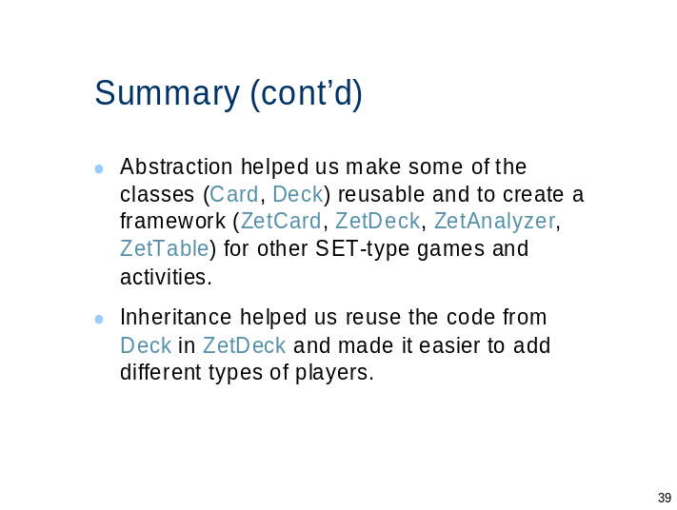

Slide 40

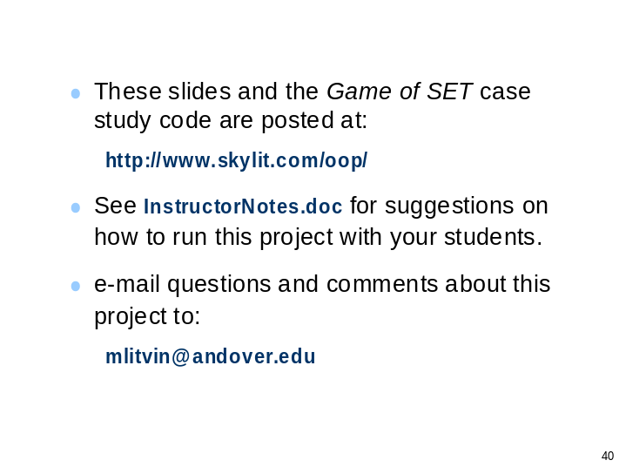

The Game of SET:
A Case Study in OO Design
and Team Development

Notes for the Instructor

Objective: This exercise gives students a taste of how object-oriented design and programming might work in the “real world.” The emphasis is on project design and on working as a team, not on writing Java code.

Time requirement: 2-3 hours to include the preliminary discussion of OO design principles, this project’s design, coding, and discussion of the lessons learned.

Team composition: 4-10 people. If necessary, several independent teams can work in parallel.

Prerequisites: The members of the team may have varying levels of technical proficiency. All participants must have some understanding of classes, objects, constructors and methods. At least one participant (Group 1 Task 1-b) should be familiar with java.util.ArrayList or be able to figure out how to use its add and get, and remove methods. The same person must be familiar with Selection Sort and a similar shuffling algorithm, or use the Collections.sort and Collections.shuffle library methods. Group 2 Task 1-a expects basic familiarity with modulo 3 arithmetic, although the programmer can get around it with more verbose code. Group 2 Task 2-a requires a fast coder who can write several methods quickly and is familiar or can figure out a partitioning algorithm for an array (similar to one used in Quicksort).

In order to facilitate the appropriate allocation of tasks among team members, the difficulty of each task is labeled with , , or  . “Shell” Java files with method headers and development tips are provided for the more difficult tasks. The difficulty of the tasks can be controlled by the instructor who can provide some code from the solution.

The project can accommodate more experienced programmers, familiar with graphics and MVC, by delegating the Group 3 tasks to students instead of using the provided code.

Project administration: At first, all students participate together in the initial discussion of OO design principles and the project design. After that, a team is formed for implementing the code. The instructor appoints one Project Leader and two Group Leaders, and splits the rest of the students between Group 1 and Group 2. The Project Leader and the Group Leaders must be enthusiastic, have strong organizational skills, and be fluent in using an IDE and putting projects together. The Group Leaders can also participate as developers on some tasks. If necessary the instructor can act as the Project Leader.

Team work: The two groups work independently of each other: write code, and test it independently when possible. In this project, Group 2 has to use for testing the classes developed by Group 1. Leaders of Group 1 and Group 2 test the finished code before passing it to the project leader. The members of a group work independently on their tasks. However, the group leaders must monitor their group’s progress and, if necessary, mobilize those who completed their tasks to help other group members. This project is about team work, not competition.

Before the project: Review the main OO design principles, discuss the project design and its decomposition into independent tasks and demonstrate the Set Game application.

Slide handouts: The project leader should get copies of slides 20-36. The Group 1 leader gets copies of slides 26-31 and the Group 2 leader gets copies of slides 32-36. All participants should get a copy of slide 20 or have it displayed for the whole class.

Docs handouts: All students get javadoc-generated documentation for the classes the team will be working on. It is available in the docs folder and accessible through docs\index.html.

Code handouts: The project leader gets the following files:

ZetGame.java
ZetMenu.java
ZetPlayer.java
ComputerZetPlayer.java
HumanZetPlayer.java
ZetTableDisplay.java
ZetGameModel.java
deck.jpg

The Group 1 leader gets the tips and documentation file for Task 1-b, Group1\Deck.java.

The Group 2 leader gets the tips and documentation files for Tasks 1-a and 2-a: Group2\ZetAnalyzer.java and Group2\ZetTable.java, respectively.

During the project: Monitor the progress of each group, provide assistance when necessary. Developers who have finished their task can help others in their group. Insist that each task developer tests his or her code independently and each group tests the code before having it integrated into the final project.

After the project: Test the program thoroughly. Make each group and its members present each task and the code written for it. Review how the key OOP concepts are used in this project.

Feedback: We will appreciate any comments and suggestions for improving this project. Please e-mail mlitvin@andover.edu.

