Name: Aditi Rajak
PRN: 24070521113
SEC: B2

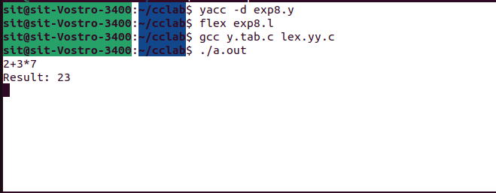

Name: Aditi Rajak
PRN: 24070521113
SEC: B2
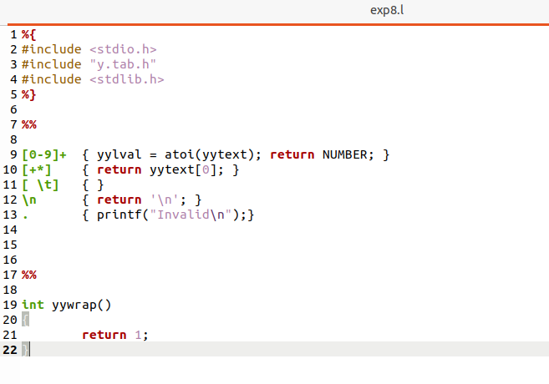

Name: Aditi Rajak
PRN: 24070521113
SEC: B2
