**10th July – Azure Storyboard for ExpenseTrackingSystem**

**Part 1: Azure Story Board**

**1)Work items:**  
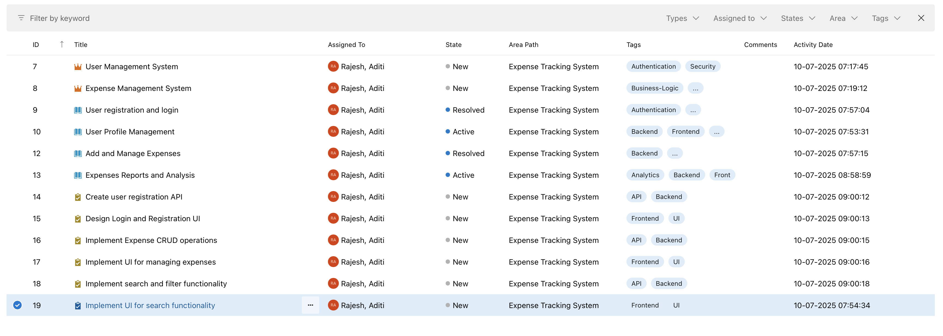

**2)Epic:**

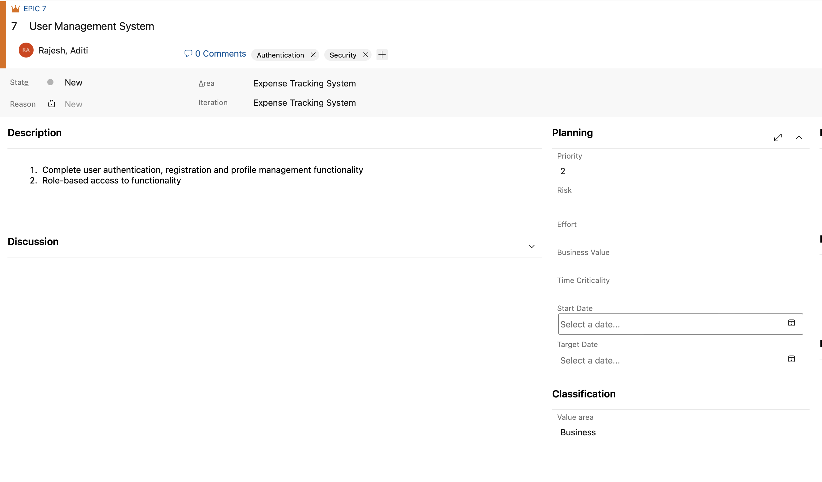

**3)User story:**

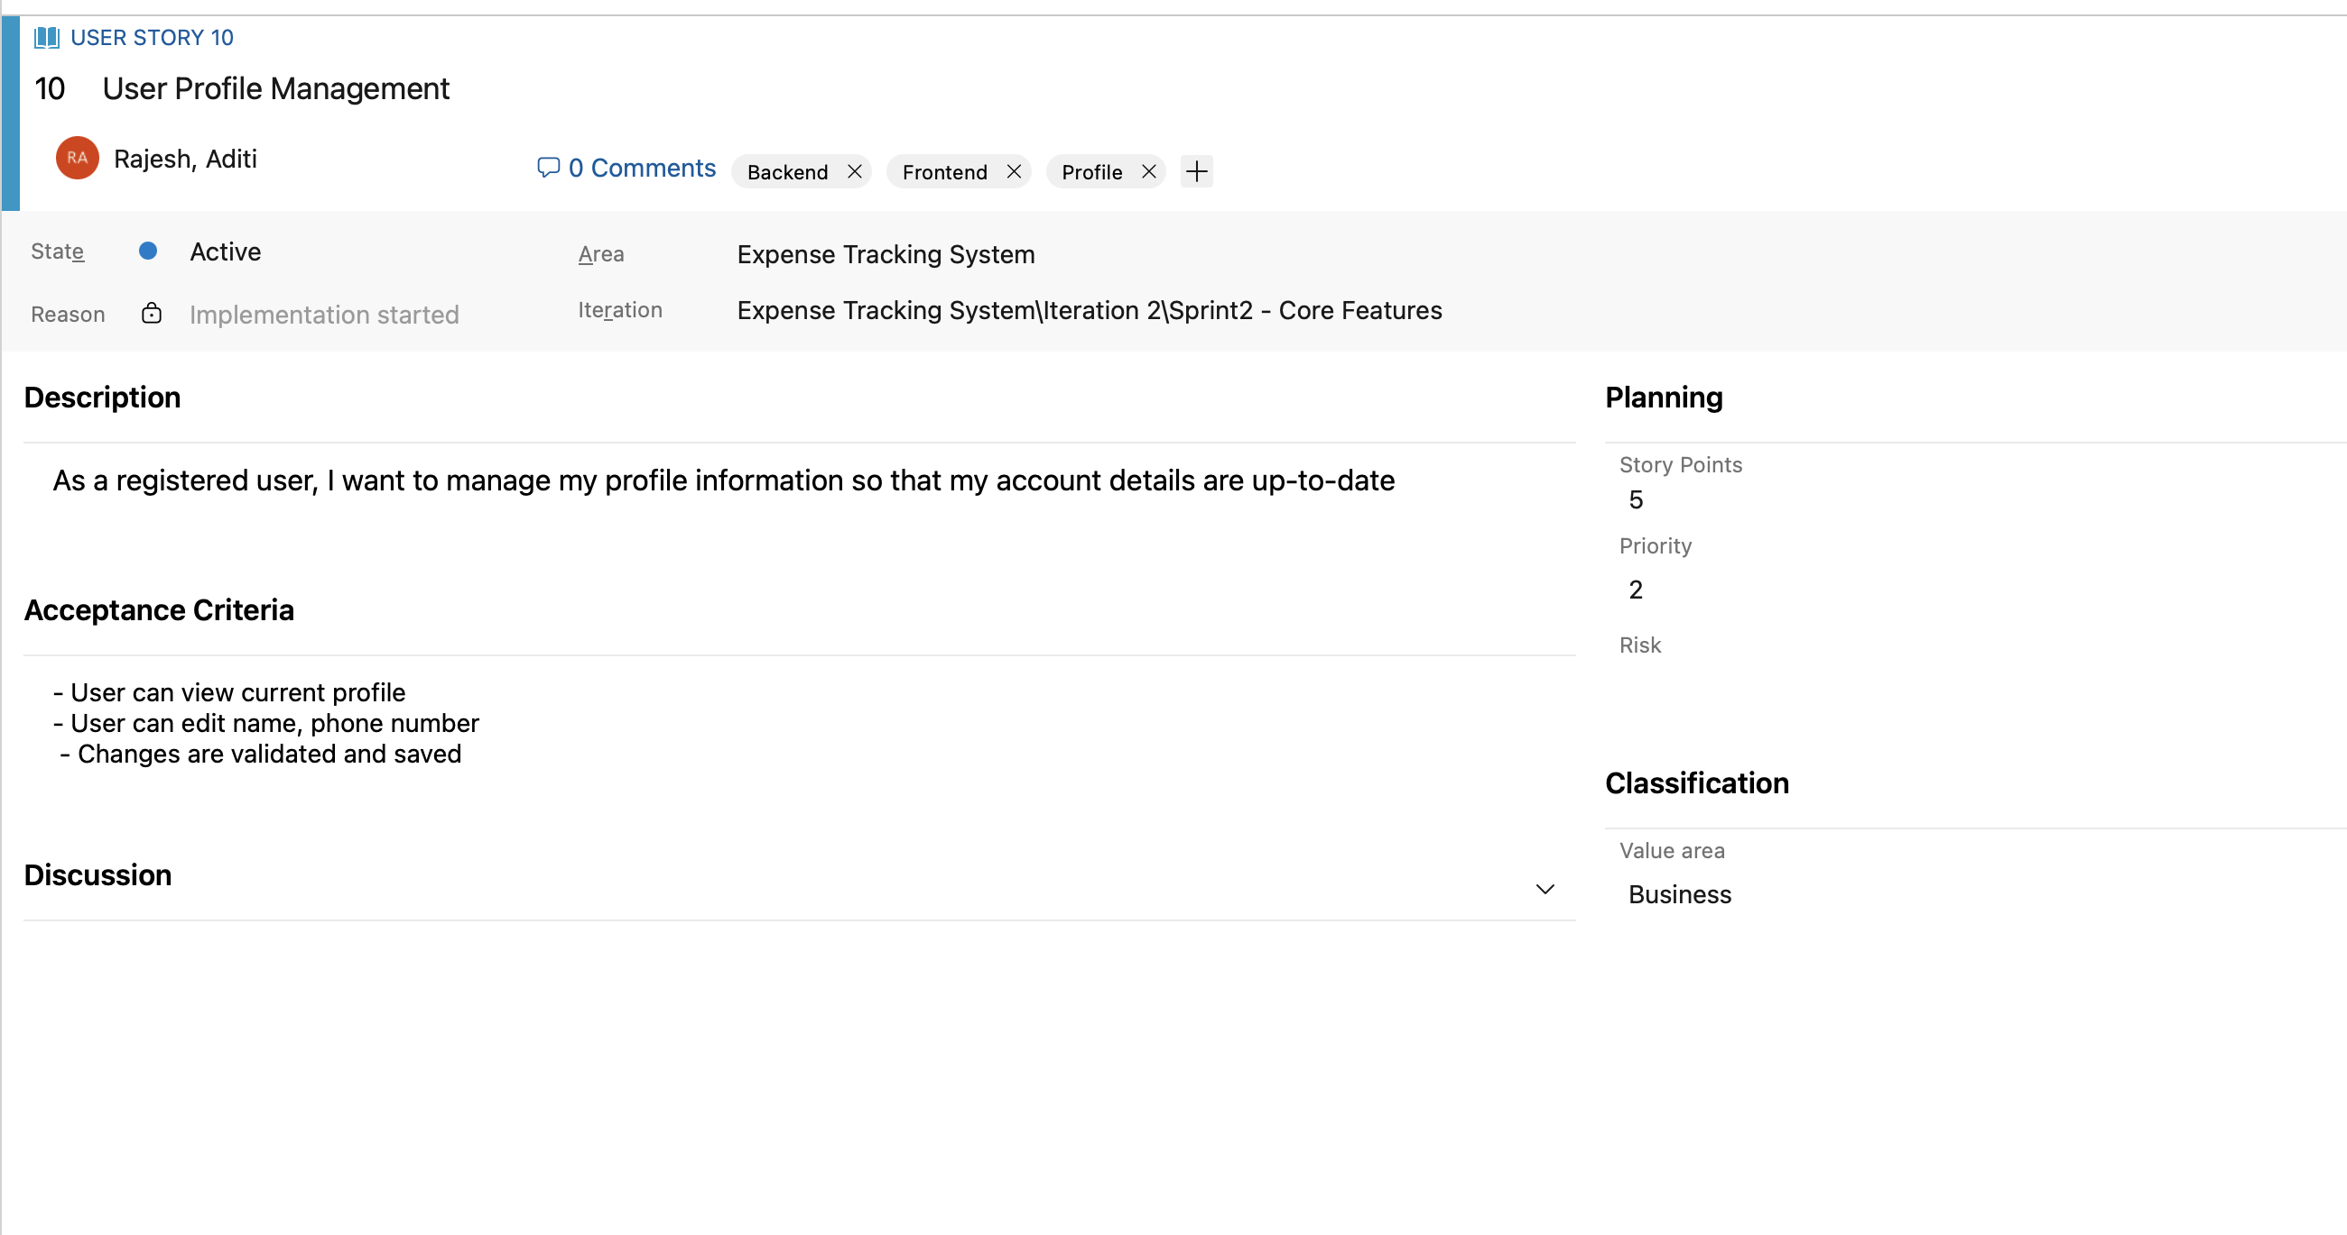

**4)Task:**

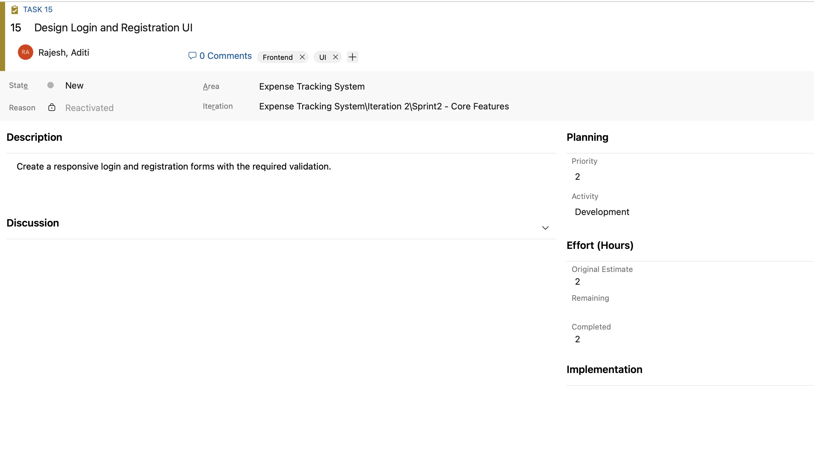

**5)Sprints:**

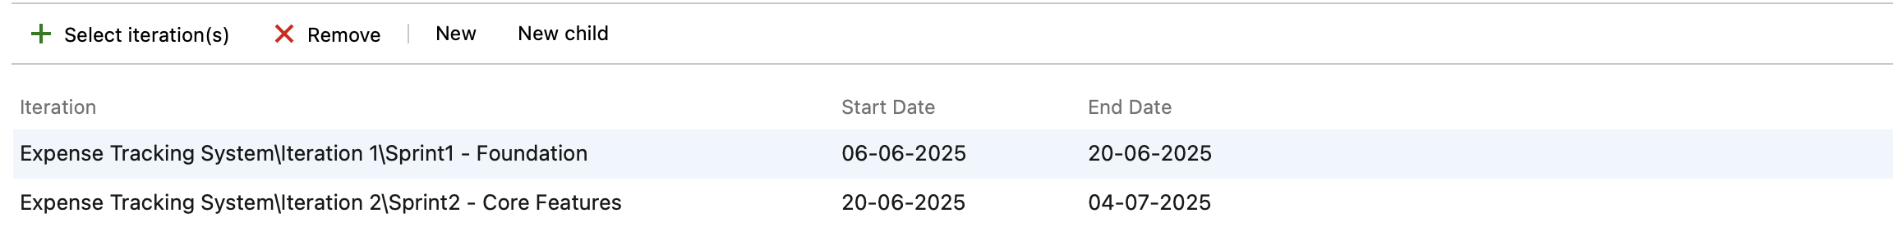

**6)Sprint 1:**

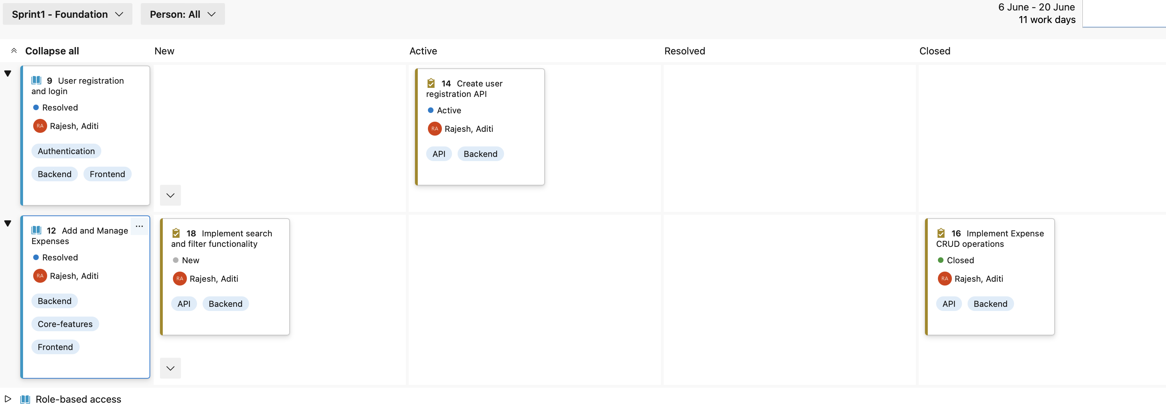

**7)Sprint 2:**

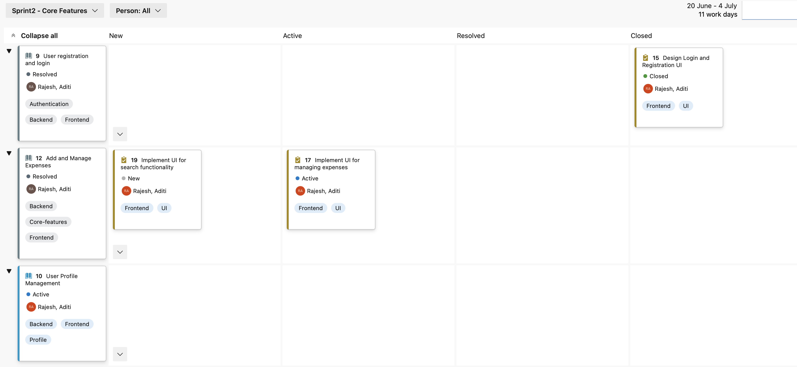

**8)Kaban board:**

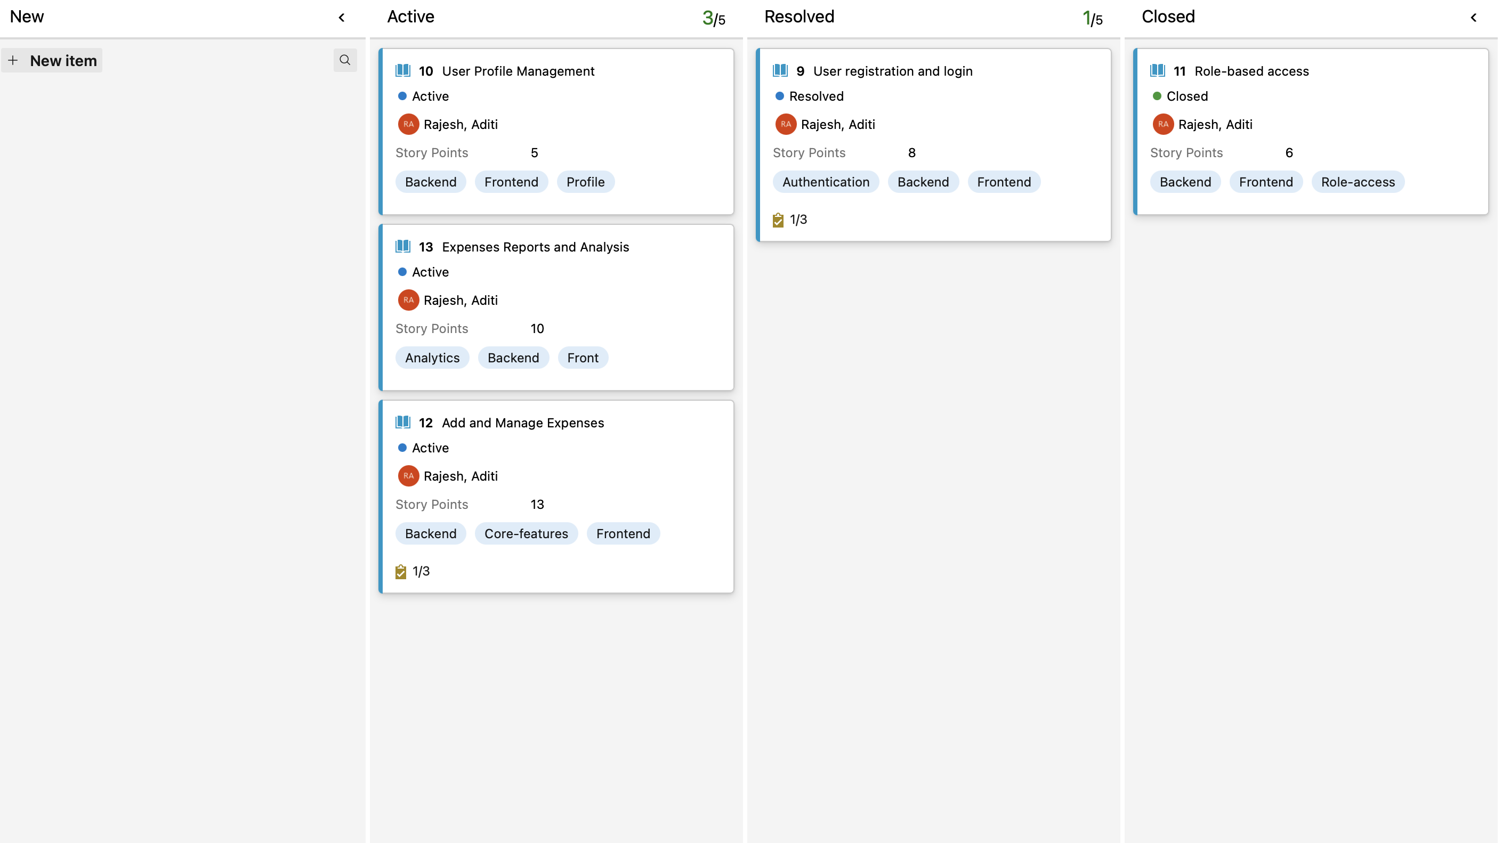

**Part 2: Class Diagram**  
  
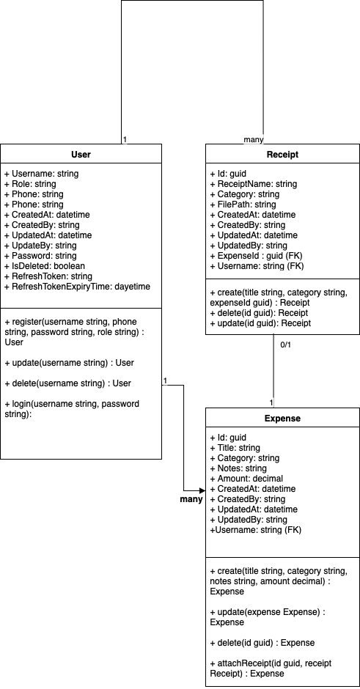

**Part 3: Sequence Diagram**: User Login

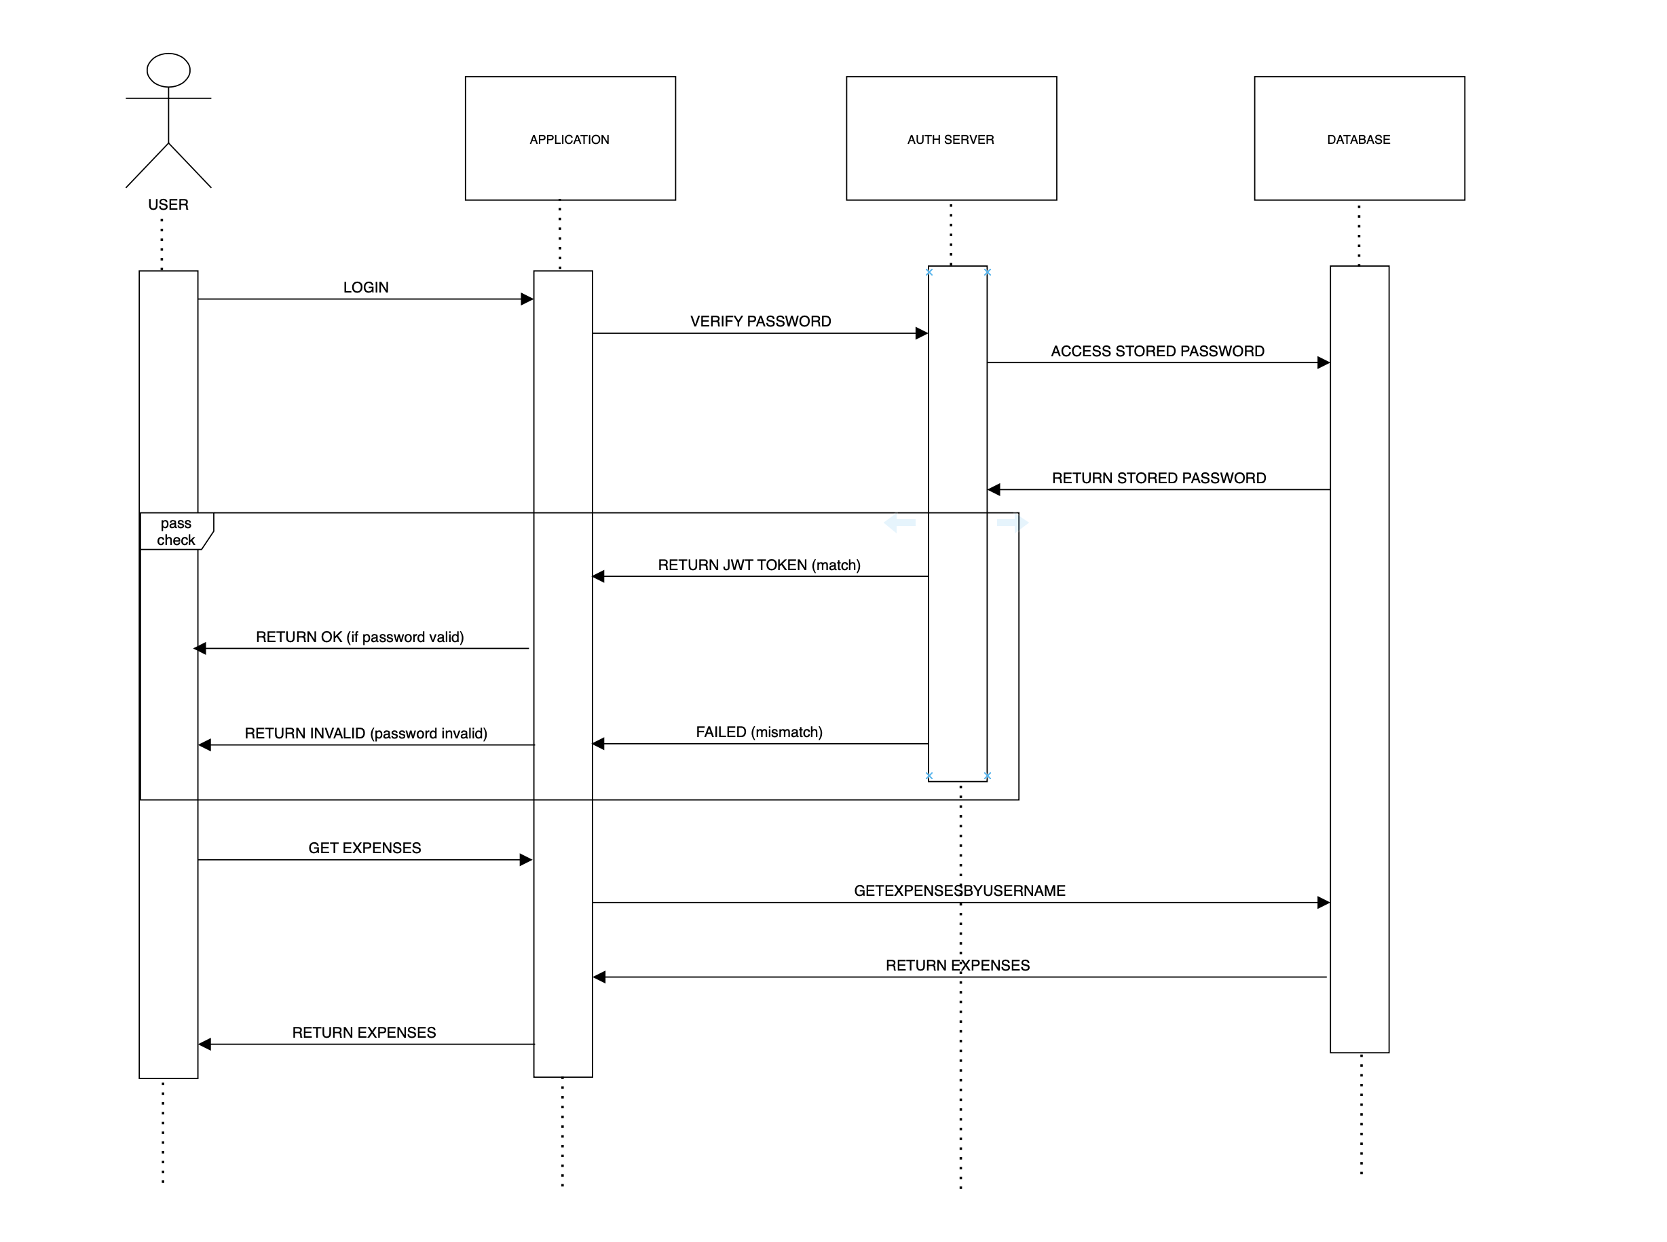

Sequence Explanation:

1. User tries to access the application via username and password
2. The application accesses the auth server for password validation
3. Auth server retrieves stored password from database, decrypts and checks if password match.
4. If password matches, user gets JWT session token to use the application. Otherwise, login request denied.
5. User after successfully logged in, gets expenses from application.
6. Application retrieves user expenses from the database and displays it to the user.