**Assignment: Deploy a .NET API on Azure Virtual Machine Using Docker**   
Solution:  
  
1. Create a virtual machine on azure:  
**a) deployed VM**

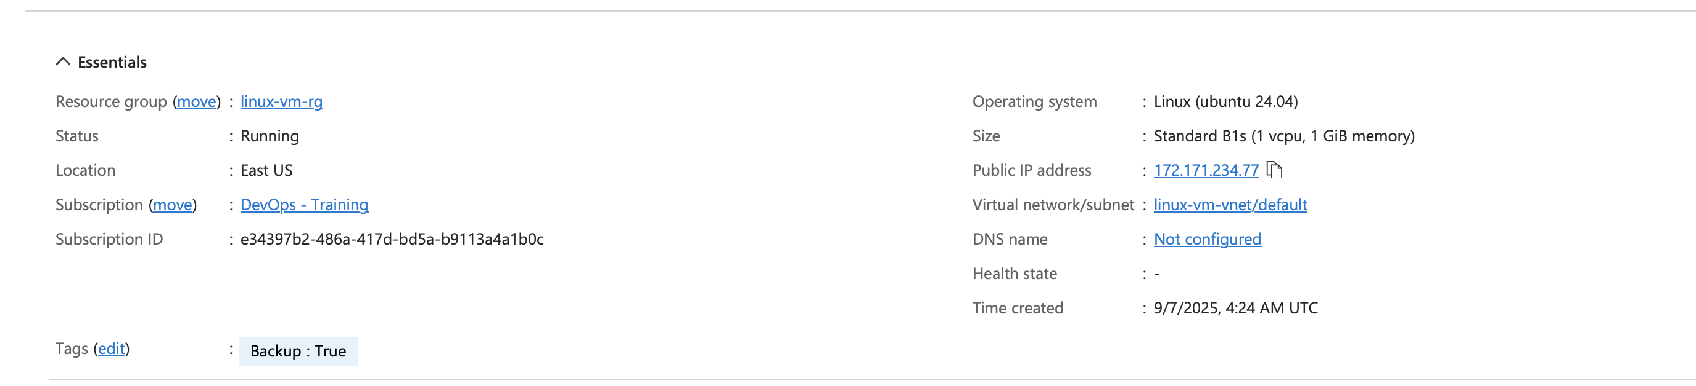

**b) changing permissions for the .pem file**  




**c) connecting local machine with the virtual machine via ssh**

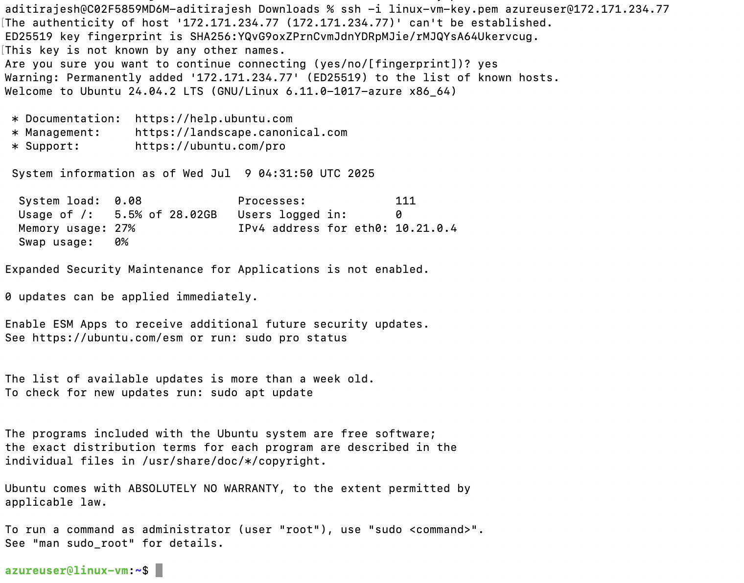

2. Install docker

**a) update packages in the linux machine**





**b) install docker container**

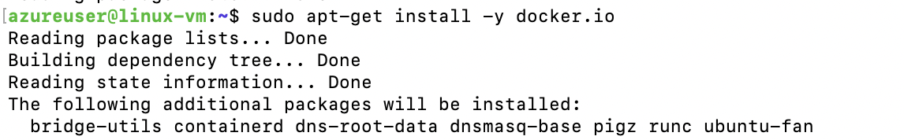

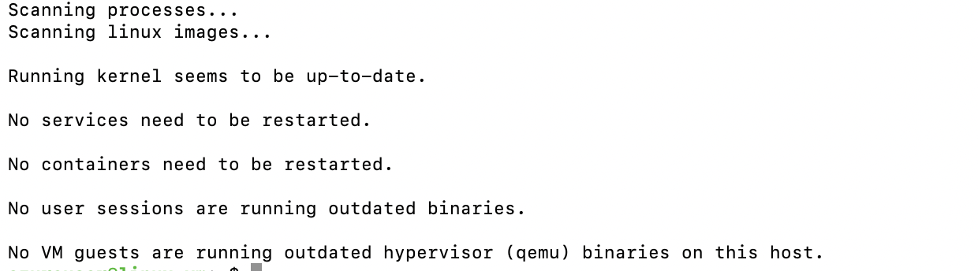

(only including starting and ending snippets, the actual download result is longer)

**c) start docker**

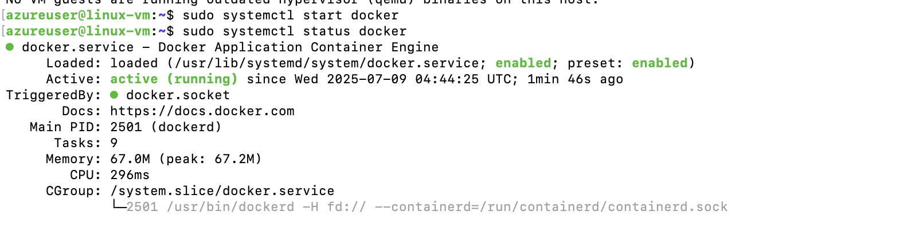

**d)enable docker on boot**

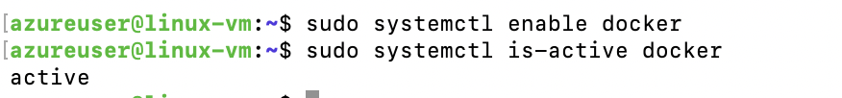

**e) check docker version**



3) Build local WebApi app

**a) api app:**

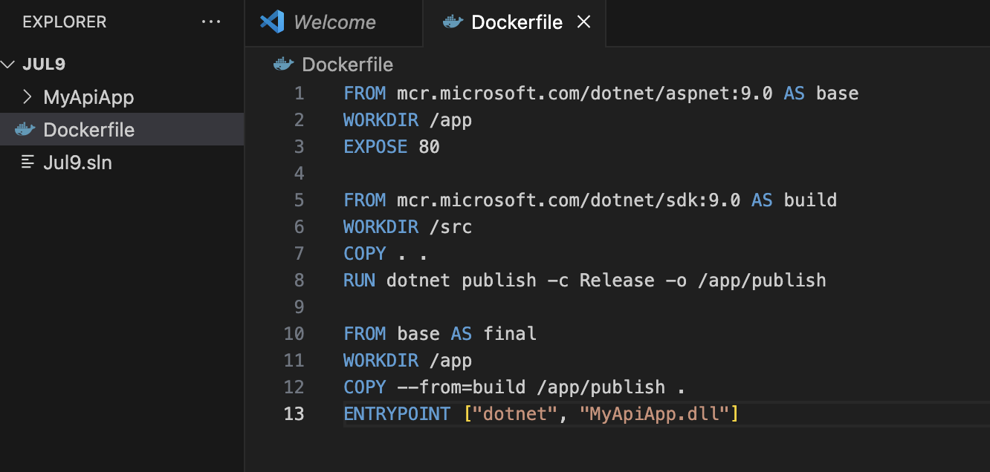

**b) build docker image locally**

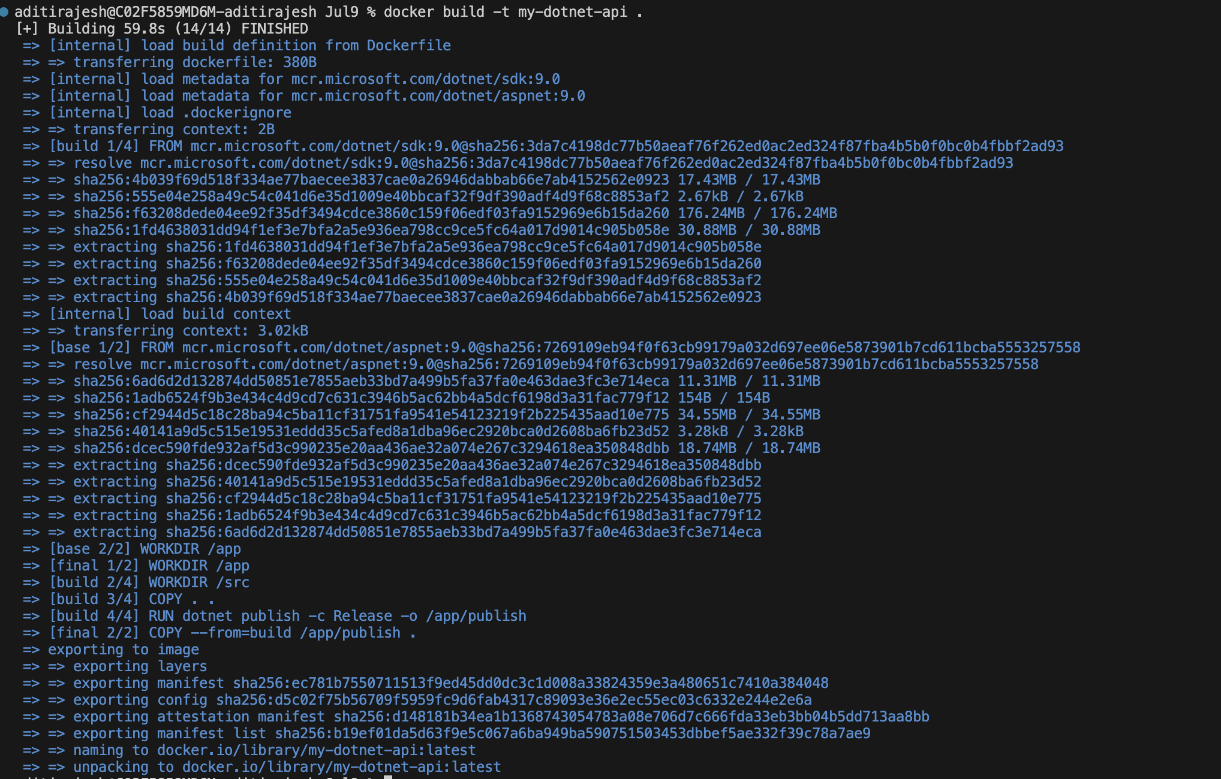

**c) push the image onto docker hub**

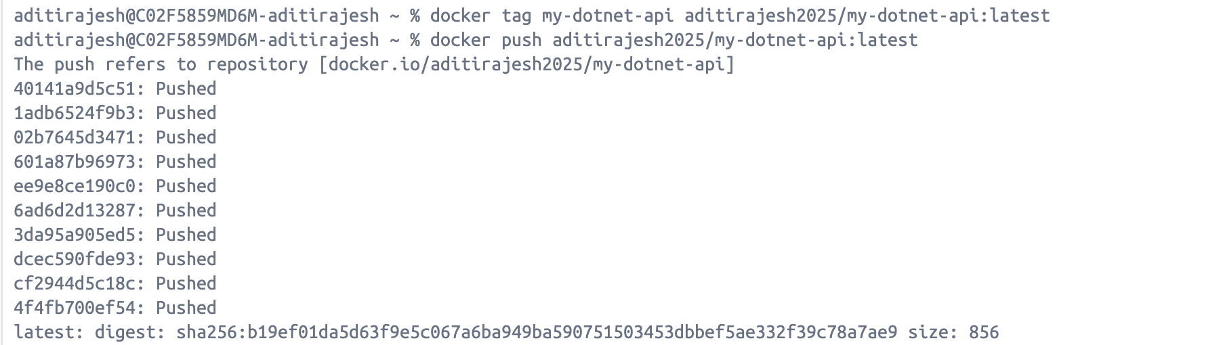

4)Run and pull the API on Azure VM

**a) pull docker image in SSH session**

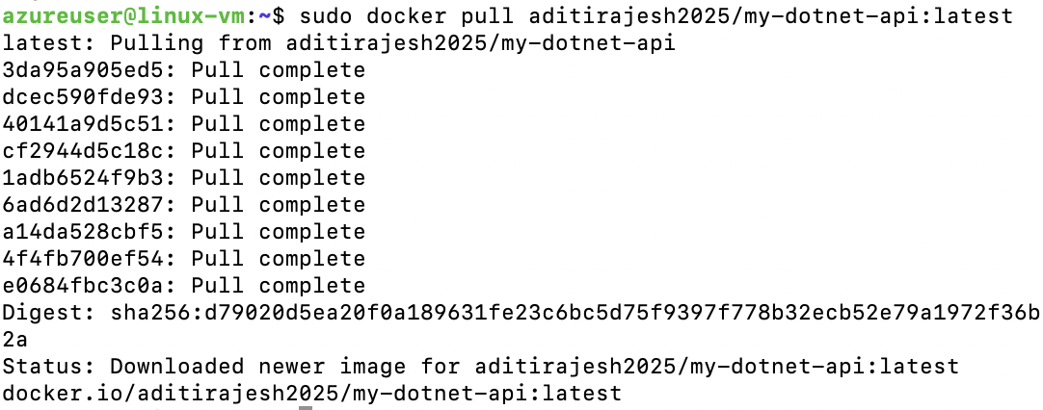

**b)running the container**



**c)verify the container is running**

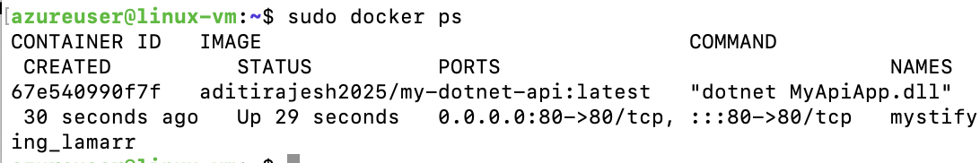

5) Testing the API

**a) default response:**

