Multiagent system
Submitted by Aditi R Deshpande

Process
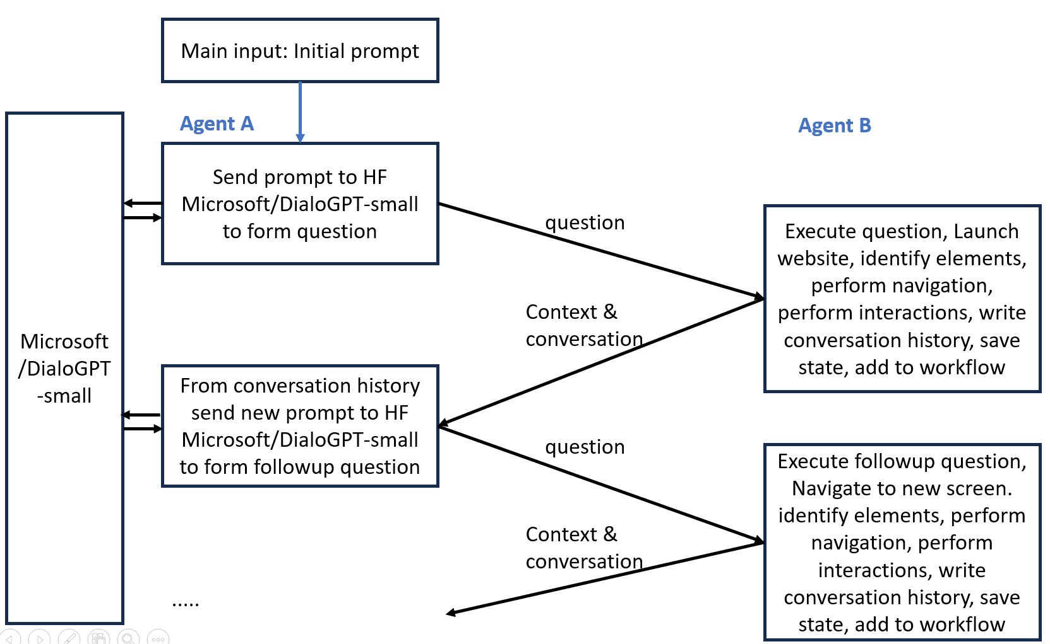

Code
The submitted code is main_app.txt. Rename it to main_app.py
- Main_app.py – Python program for the multiagent system created to run on Python version 3.11.3
- Requirements.txt – libraries required to run the main_app.py
- hf_key.txt – API key required by Agent A

Steps:

Prerequisites
- Create an API token in Huggingface (https://huggingface.co/settings/tokens) with READ permission.
- Copy the token in a text file called hf_key.txt and place the file in the folder containing main_app.py
- Install the required libraries using
pip install -r requirements.txt

Run the program
- “python main_app.py” from the command prompt

Logic:
Agent A: This agent uses Microsoft/DialoGPT-small model to frame the questions to ask Agent B based on the initial goal and the conversation history.
Agent B: It launches the website and identifies all the elements in the page. Based on the question asked by Agent A it explores and identifies the element to use/click to navigate further. It takes a screenshot at each step.
Agent A: Based on the previous question and exploration results it comes up with followup questions in realtime to ask Agent B.
This process is repeated 6 times.
Note:
- If a page requires you to log in, the application waits for you to complete the sign-in manually (Continue with Google).
- If there is a modal window requiring user input, user must respond manually before the program proceeds.

- Input options:
Choose an option:
1. Run AI-powered test (Wikipedia)
2. Interactive mode with AI question generation
3. Quit
Enter choice (1, 2, or 3): 1

- Results: Workflow and Screen shots

Second example: python main_app.py
- Input options:
Choose an option:
1. Run AI-powered test (Wikipedia)
2. Interactive mode with AI question generation
3. Quit
Enter choice (1, 2, or 3): 2

📋 EXAMPLE TASKS:
1. Search articles in Wikipedia
URL: https://en.wikipedia.org/wiki/Main_Page
2. Create project in Linear
URL: https://linear.app
3. Filter database in Notion
URL: https://www.notion.so
4. Create task in Asana
URL: https://app.asana.com
5. Search products on Amazon
URL: https://www.amazon.com
6. Find repositories on GitHub
URL: https://github.com

🎯 ENTER YOUR OWN TASK (or 'quit' to exit):
What do you want to learn? Create project in Linear
Enter the application URL: https://linear.app

- Results: Workflow and Screen shots

