-- If this number is lower than expected, a node has disconnected.
SHOW GLOBAL STATUS LIKE 'wsrep_cluster_size';

-- 2. Check Node State: This tells you the health of the CURRENT node.
-- The value should be 'Synced' (or 4).
-- If it says 'Donor' or 'Joined', it's in the process of syncing.
SHOW GLOBAL STATUS LIKE 'wsrep_local_state_comment';

-- 3. Check Cluster Status: This confirms the cluster is stable.
-- The value should be 'Primary'.
-- If it says 'non-Primary' or 'split-brain', you have a major network issue.
SHOW GLOBAL STATUS LIKE 'wsrep_cluster_status';

-- 4. Check if Node is Ready: This confirms the node is online and ready for queries.
-- The value should be 'ON'.
SHOW GLOBAL STATUS LIKE 'wsrep_ready';

-- 5. Check for Network Issues: These numbers should be 0.
-- If they are high, it means the network is unstable and the cluster
-- is having trouble communicating.
SHOW GLOBAL STATUS LIKE 'wsrep_local_send_queue_avg';
SHOW GLOBAL STATUS LIKE 'wsrep_flow_control_paused';

-- 6. Check for Node Disconnects:
-- A high number here means nodes are frequently dropping from the cluster.
SHOW GLOBAL STATUS LIKE 'wsrep_cluster_state_uuid';
-- (If this UUID is different across nodes, they are not in sync)

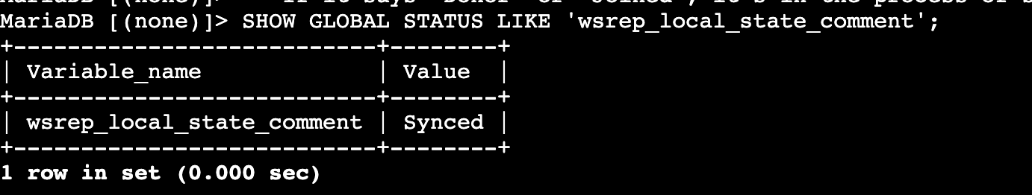

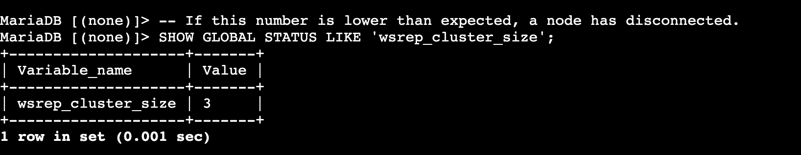

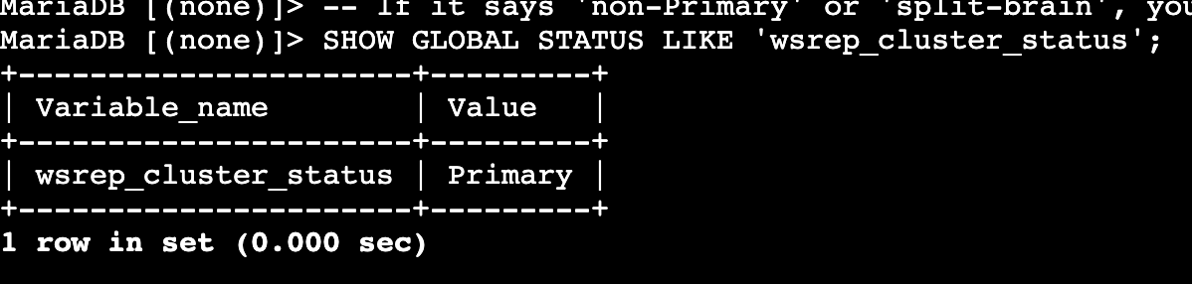
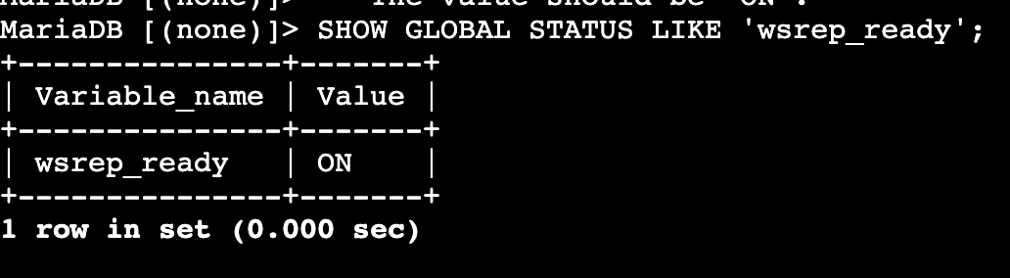

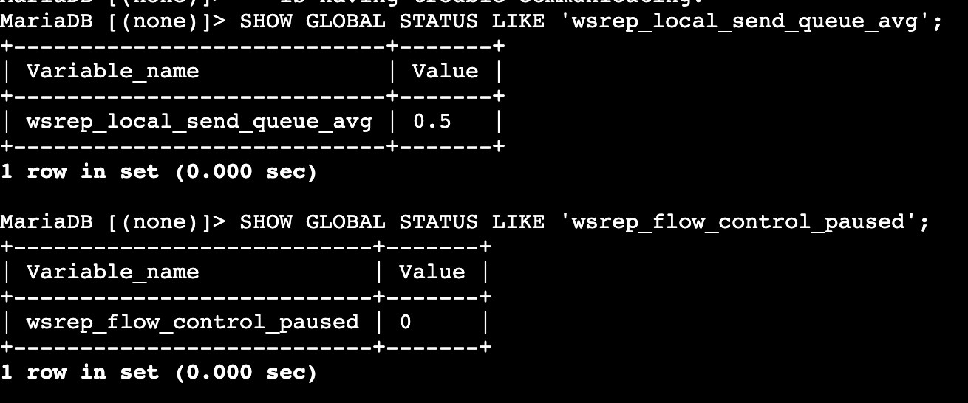
Command | Description | What it Checks | Expected Outcome
SHOW GLOBAL STATUS LIKE 'wsrep_cluster_size'; | The most important check. | The number of nodes currently connected, synced, and active in the cluster. | 3 (or the total number of nodes you have). A lower number means a node has failed or disconnected.
SHOW GLOBAL STATUS LIKE 'wsrep_local_state_comment'; | Checks the health of the current node you are connected to. | The operational state of the specific node you are querying. | Synced. If it says Joining or Donor, the node is in the process of syncing with the cluster.
SHOW GLOBAL STATUS LIKE 'wsrep_cluster_status'; | Checks the health of the entire cluster. | Whether the cluster has a majority and is in a healthy, operational state. | Primary. If this says non-Primary or split-brain, it means the cluster nodes cannot communicate properly and have formed separate, conflicting groups.
SHOW GLOBAL STATUS LIKE 'wsrep_ready'; | Confirms if this specific node is online and accepting queries. | Whether the node is ready to accept read and write traffic. | ON. If this is OFF, the node is still initializing or has an issue.
SHOW GLOBAL STATUS LIKE 'wsrep_local_send_queue_avg'; | A key network health indicator. | The average number of data packets waiting to be sent to other nodes. | 0 or a very low number (e.g., < 0.1). A high or rising number indicates a network bottleneck or a slow node that can't keep up.
SHOW GLOBAL STATUS LIKE 'wsrep_flow_control_paused'; | A performance metric. | How often (as a ratio) the cluster has had to pause writes because one node is too slow to apply them. | 0 or a very low number. If this number is high, it means your fastest nodes are constantly being throttled by your slowest node, which hurts write performance.
SHOW GLOBAL STATUS LIKE 'wsrep_cluster_state_uuid'; | A data consistency check. | A unique ID representing the cluster's current dataset. | The exact same long string (UUID) on all nodes. If this value is different on any node, that node is not in sync with the others.

