Multilingual experience and multimodal brain MRI
NEBULA101 (OpenNeuro ds005613) — analysis report
[YOUR NAME] | [COURSE / PROGRAM] | [DATE]
[ADVISOR or instructor if required]

Abstract
This report describes a multimodal neuroimaging analysis of language diversity and balanced language exposure in healthy young adults from the public NEBULA101 dataset. Self-report measures included the number of languages spoken (nlang) and Shannon entropy of daily language exposure. Resting-state functional MRI was preprocessed with SPM12/25 (segmentation, coregistration, normalisation to MNI, smoothing) and summarised with seed-based functional connectivity (Nilearn) including motion regression. Diffusion MRI was preprocessed with FSL (eddy, tensor fit) and analysed with tract-based spatial statistics (TBSS) and permutation inference (randomise, TFCE). In n=51 participants with complete T1-weighted, resting fMRI, and DWI data, neither nlang nor entropy showed significant associations with the pre-specified functional connectivity summaries after Bonferroni adjustment across three outcomes, nor with fractional anisotropy on the white-matter skeleton at family-wise error p < 0.05. Sex and head motion covariates accounted for appreciable variance in connectivity. Results constrain the magnitude of linear questionnaire–brain associations in this subsample and are discussed with respect to power, construct overlap, and design limitations.

1. Introduction
A large fraction of the world's population uses more than one language in daily life. Cognitive neuroscience has long asked whether multilingual experience is associated with differences in brain structure and function. Findings are mixed: some studies report altered white-matter microstructure or functional connectivity in multilinguals, while others find small or inconsistent effects. One source of heterogeneity is how “multilingualism” is operationalised. Counting languages captures diversity of repertoires; entropy of self-reported exposure captures how evenly languages are used. These constructs are related but not identical, and both can be derived from the Language Experience and Proficiency Questionnaire (LEAP-Q) bundled with NEBULA101.
The present project uses OpenNeuro dataset ds005613 (NEBULA101), which provides multimodal MRI and rich language-history data for 101 adults. For feasibility, a subset of n=51 participants was analysed with all three modalities locally available, stratified to preserve variation in nlang.

2. Research questions and hypotheses
The primary research question was whether nlang and entropy make independent contributions to (a) resting-state functional connectivity among a priori language-related seeds in MNI space and (b) voxelwise fractional anisotropy on the TBSS skeleton, after adjusting for age, education, sex, and (for fMRI) mean head motion.
Two directional hypotheses were evaluated at the group level. The structural hypothesis was that higher nlang and/or higher entropy would be associated with higher fractional anisotropy along language-related white-matter trajectories on the TBSS skeleton. The functional hypothesis was that the same predictors would be associated with altered resting-state coupling within the seeded language circuit (direction left open, because both increased segregation and “efficiency”-like decreases have been discussed in the literature).

3. Methods

3.1 Participants and design
The analysis cohort comprised n=51 participants listed in subset_50_participants.txt, drawn from the 101-subject NEBULA101 release. Demographics and z-scored predictors for second-level models come from shared_design_matrix.csv. Pearson correlation between nlang and entropy in this cohort was approximately r = 0.43, so unique (partial) effects should be interpreted as modestly constrained by shared variance.
Figure. Distribution of nlang and of exposure entropy in the n=51 cohort (generated for this report).
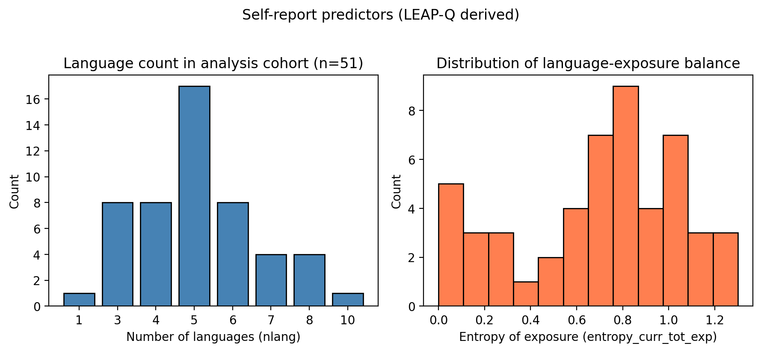
Figure. Scatter of nlang versus entropy; predictors are correlated and partial effects should be interpreted accordingly.
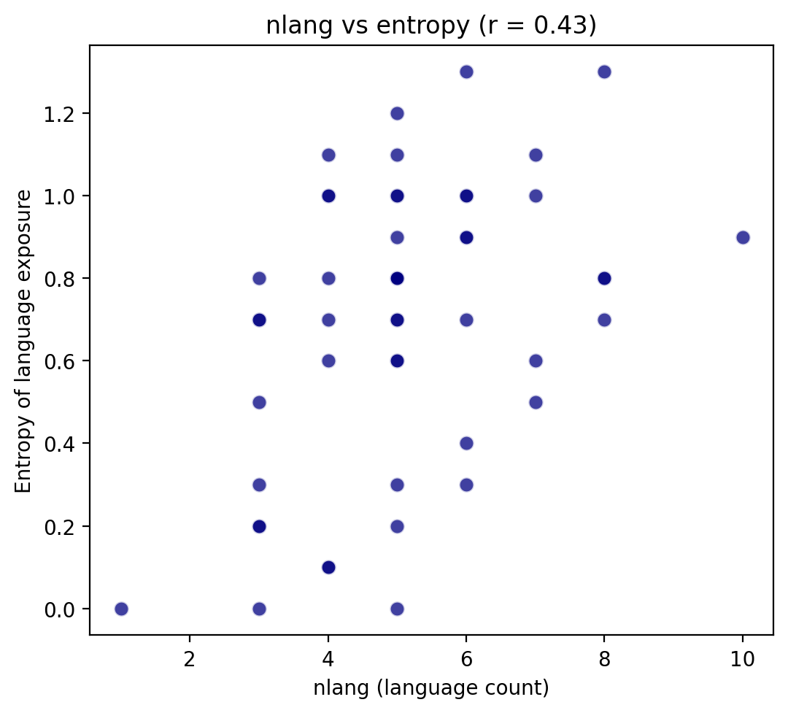

3.2 Imaging data
MRI was acquired on a Siemens MAGNETOM Prisma 3 T (Campus Biotech Geneva). Resting fMRI used a multiband EPI sequence (TR = 2 s, whole-brain coverage). High-resolution T1-weighted anatomical images were used for segmentation and MNI warps. Diffusion data were multi-shell (including b ≈ 0, 700, 1000, 2800 s/mm²) with many gradient directions.

3.3 Resting fMRI preprocessing
Six-degree-of-freedom motion parameters were estimated with SPM realign (estimate). Each participant's T1 was segmented with the unified segmentation routine; the resulting forward deformation field was used to normalise the coregistered BOLD time series to MNI space (3 mm isotropic) and images were smoothed (6 mm FWHM). Smoothed warped BOLD (sw*.nii) was the input to connectivity analyses. Full logs are in normalize_bold_log.txt.

3.4 Functional connectivity and second-level model
Six spherical seeds (8 mm radius) in MNI space were defined in fc_with_motion.py (IFG_L, STG_L, AngG_L, SMA_L, IFG_R, STG_R). Time series were band-pass filtered (0.01–0.1 Hz), detrended, and z-scored; the six SPM motion parameters were regressed from each seed. Subject-level Fisher-z connectivity matrices were saved as npy files. Three outcomes entered group OLS models in Python (statsmodels): mean Fisher-z across all 15 unique edges, left IFG–STG z, and right IFG–STG z. Predictors of interest were nlang_z and entropy_z; covariates were age_z, edu_z, sex_binary, and mean_FD_z (mean framewise displacement, Power et al., z-scored). Simple Bonferroni adjustment across the three outcomes was applied for the two predictors of interest.
Figure. Group-mean Fisher-z resting-state connectivity (six seeds, MNI-normalised BOLD, motion-regressed; generated for this report).
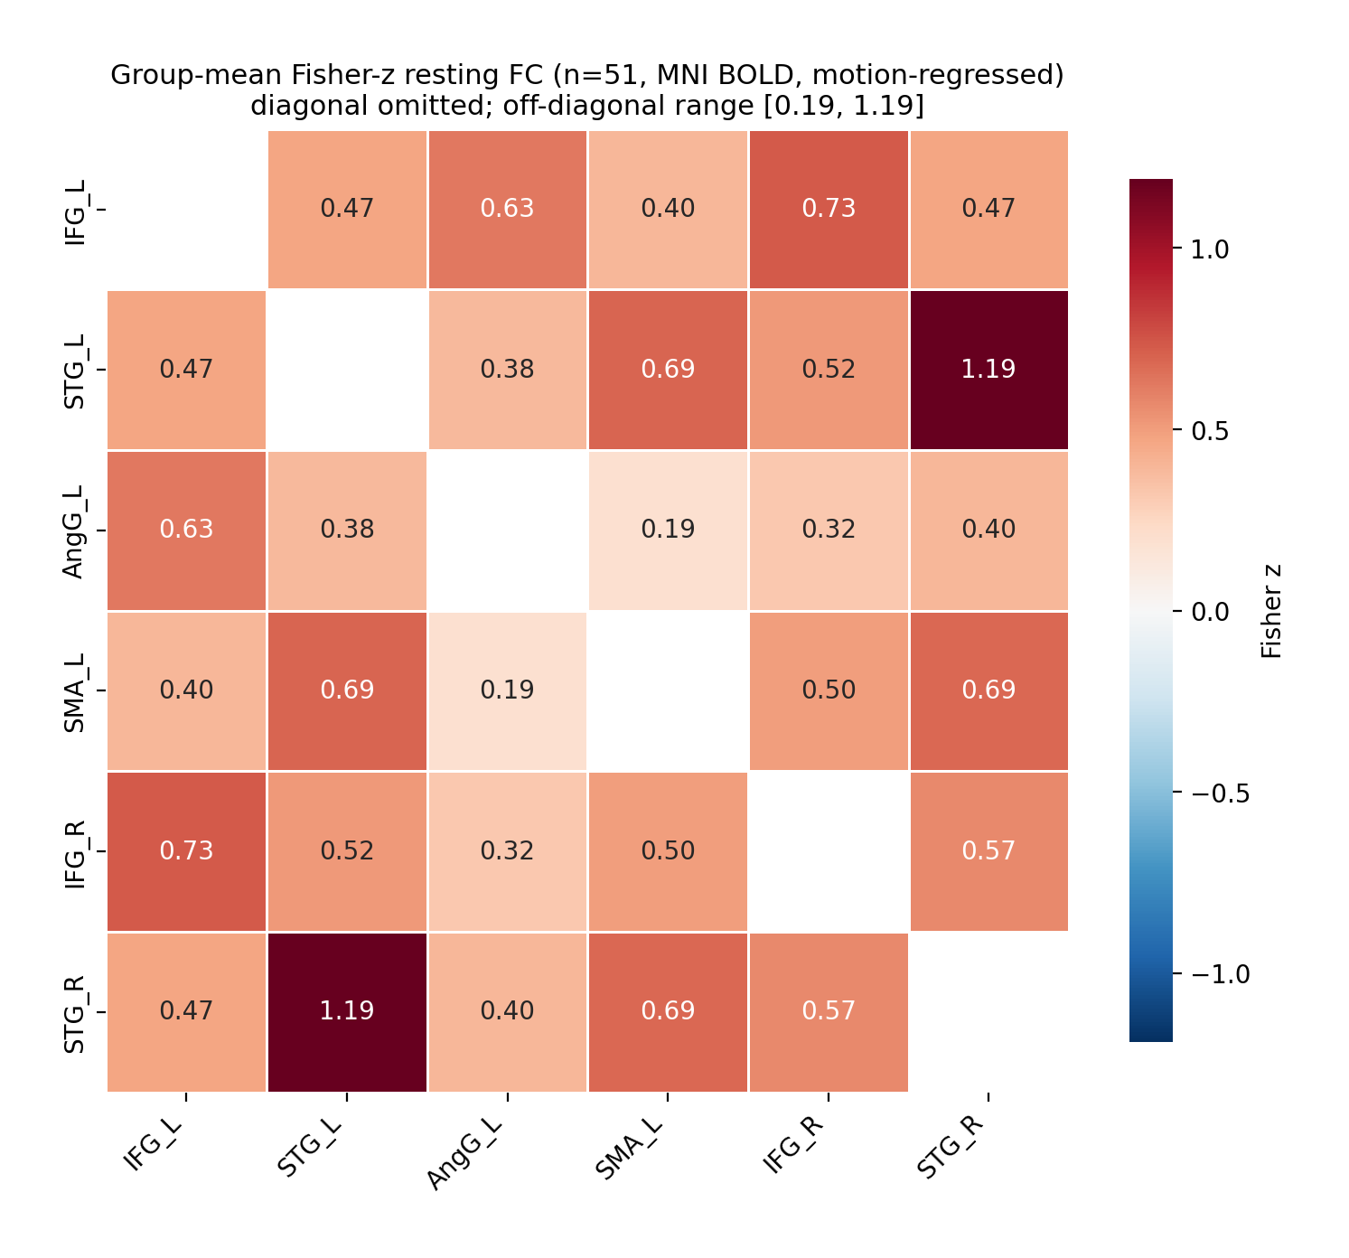
Figure. Distribution of mean framewise displacement across participants (Power et al. metric).
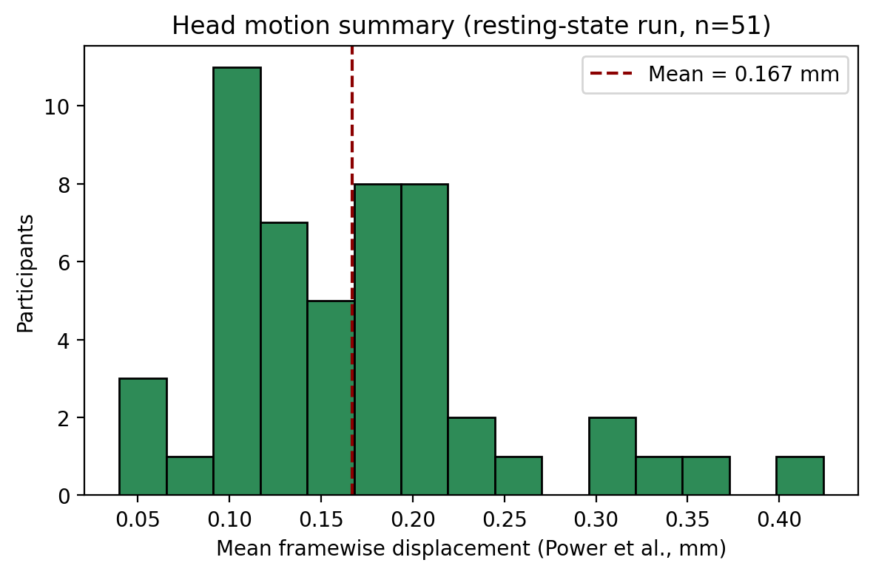
Figure. Descriptive relationship between mean network Fisher-z and nlang (covariates are not partialled out in the plot).
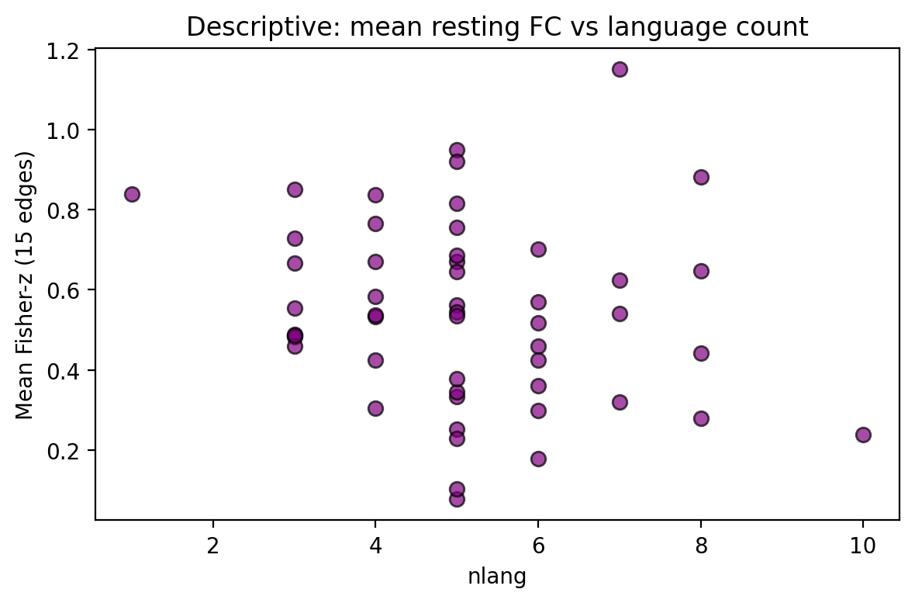

3.5 Diffusion MRI and TBSS
Per subject, eddy-corrected data and dtifit produced FA maps in derivatives/dwi_processed/. TBSS registered all FA images, built a mean FA skeleton, and projected each subject onto the skeleton (all_FA_skeletonised.nii.gz). Group inference used FSL randomise with 5000 permutations, TFCE, and the same five demographic regressors as in the design matrix (without mean FD). Contrasts tested positive and negative relationships of FA with nlang and with entropy.

4. Results

4.1 Functional connectivity
Across the three pre-specified outcomes, neither nlang_z nor entropy_z reached significance after Bonferroni correction across outcomes. Standardised coefficients were small. Sex (male vs female) showed lower mean connectivity and lower IFG–STG Fisher-z on both hemispheres at uncorrected p < 0.05. Mean FD was positively associated with right IFG–STG coupling (p = 0.023), consistent with motion-related variance in that edge. Tabulated coefficients are in derivatives/nilearn_fc_motion/fc_glm_motion_results.csv.

4.2 White-matter microstructure (TBSS)
Voxelwise permutation testing on the skeleton found no voxels with TFCE corrected p-maps exceeding the conventional FWE threshold (corrp > 0.95) for any of the four contrasts. Raw t-map ranges and maximum corrp values are summarised in derivatives/tbss_inspection_report.txt. Thus the pre-registered structural hypothesis was not supported at the chosen threshold in this sample and model.

4.3 Supplemental figures from the project tree
Additional panels were saved earlier in the derivatives folder; they are embedded below when the file path still exists on disk. Missing files are skipped with a short inline note so you can regenerate or restore them.
Figure. Pre-made: predictors / design summary.
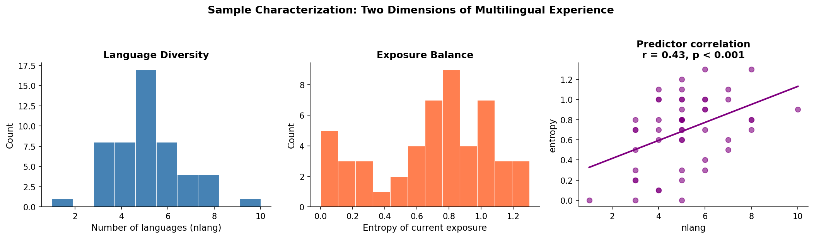

Figure. Pre-made: methods pipeline schematic.
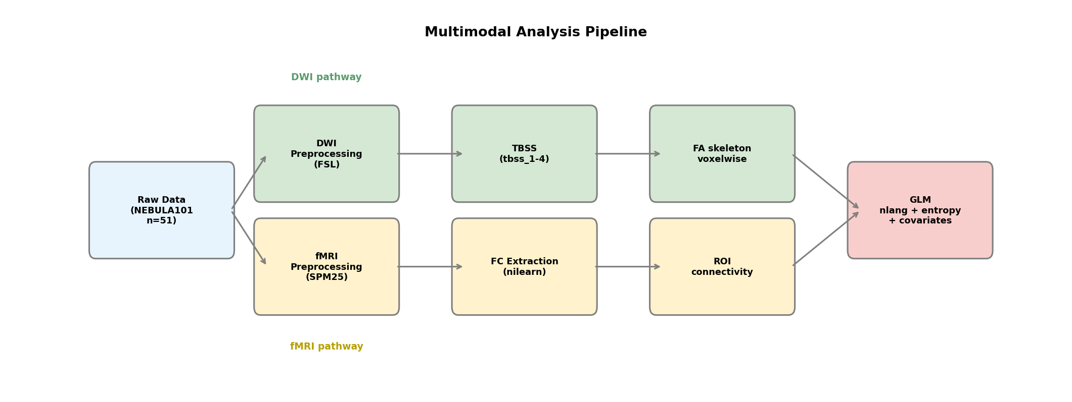

Figure. Pre-made: TBSS / skeleton overview.
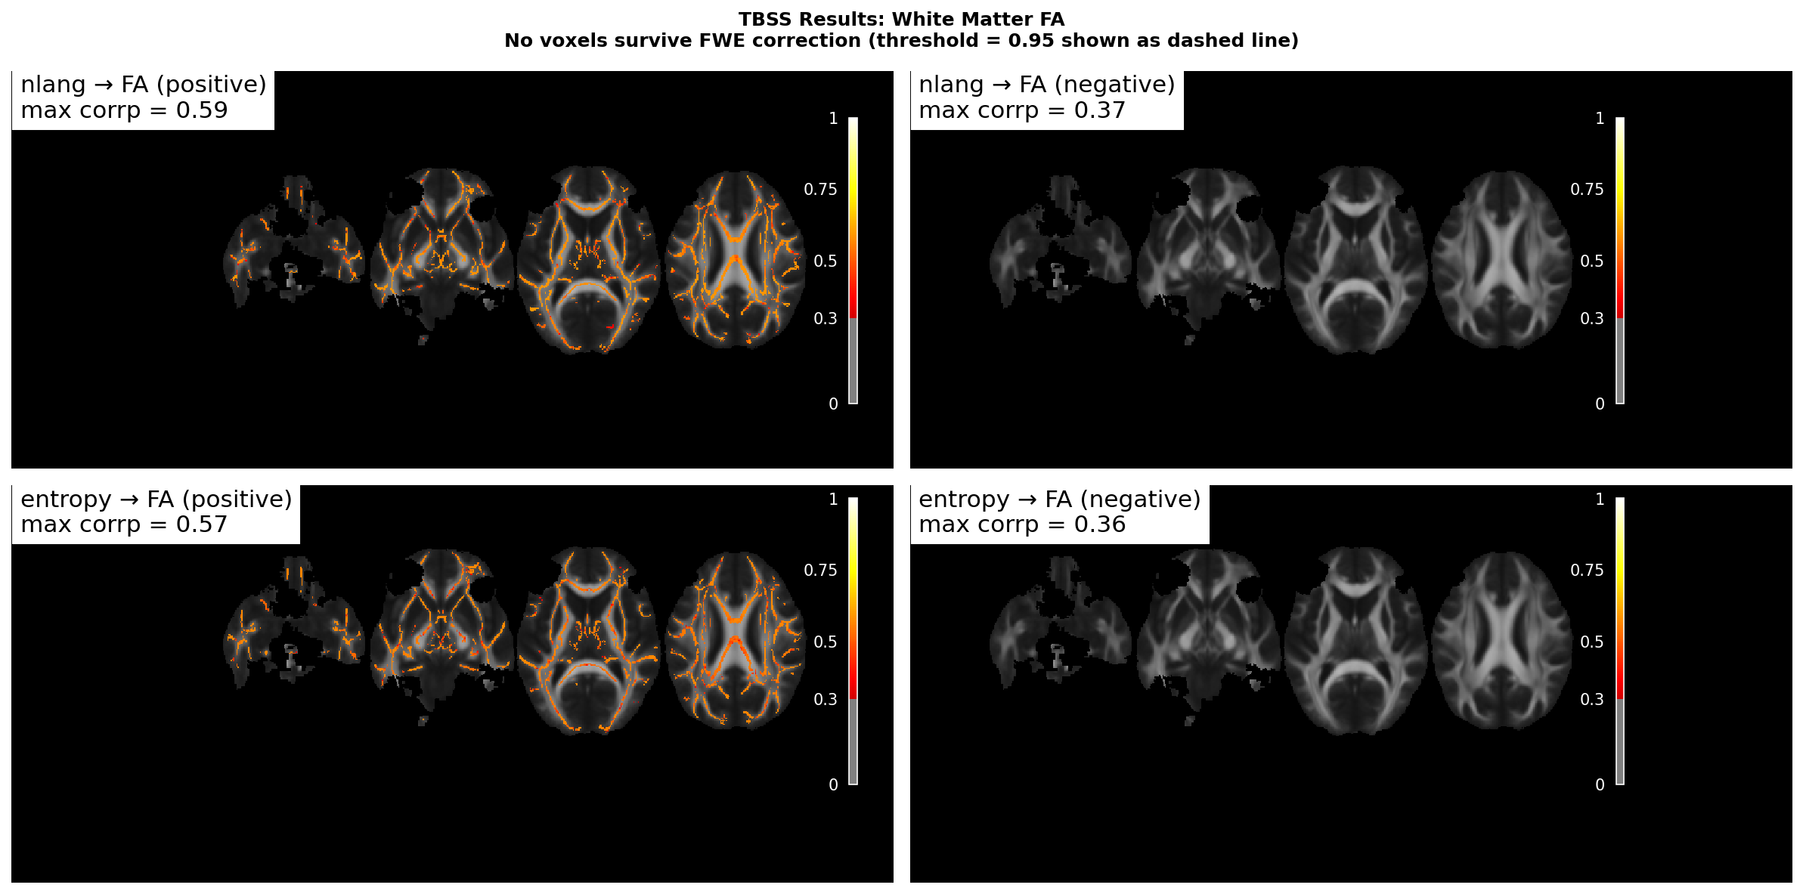

Figure. Pre-made: FC results summary.
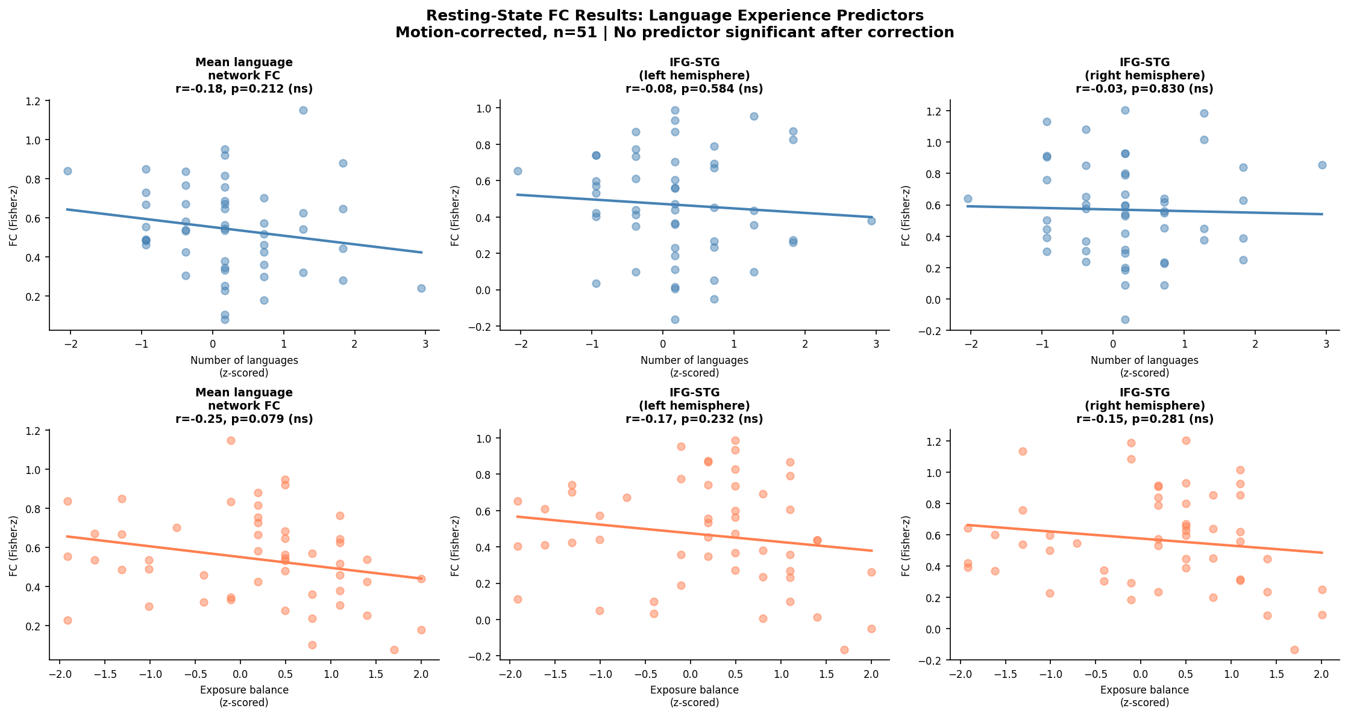

Figure. Pre-made: results table figure.
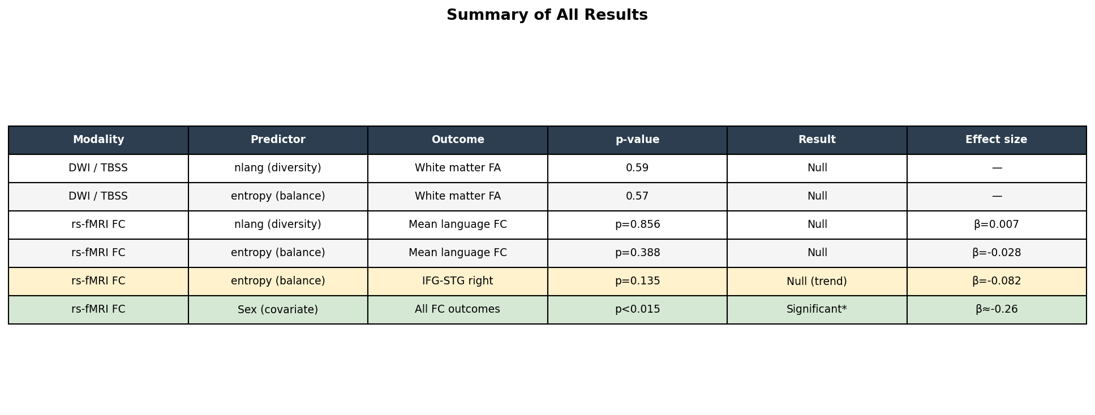

Figure. Pre-made: group FC matrix (legacy pipeline).
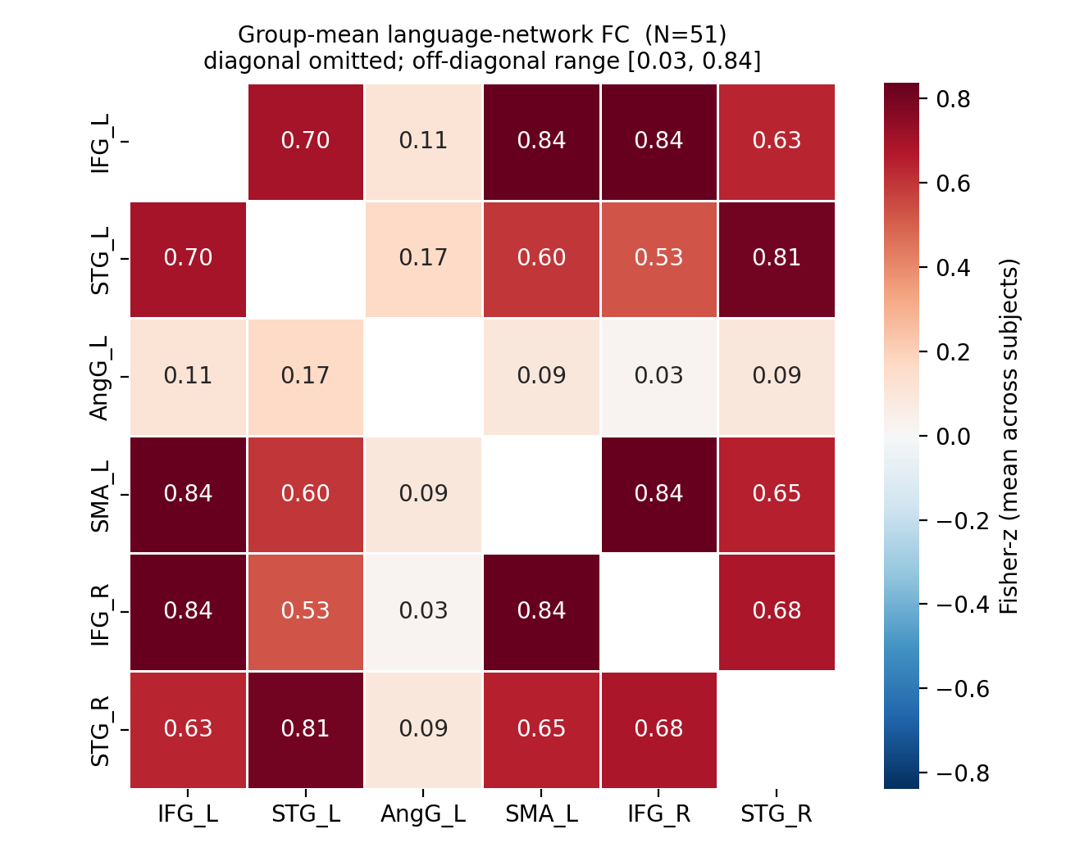

Figure. Pre-made: glass-brain connectome.
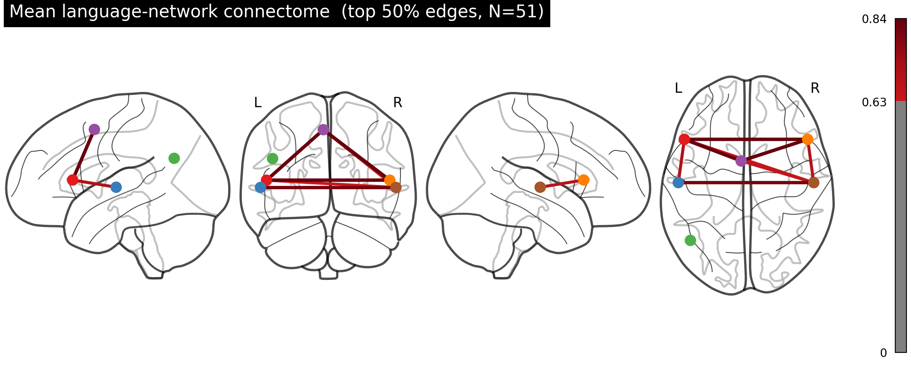

Figure. TBSS slicesdir QC montage (all subjects FA).
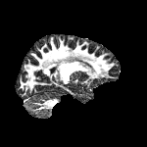

Figure. Example single-subject FA panel.
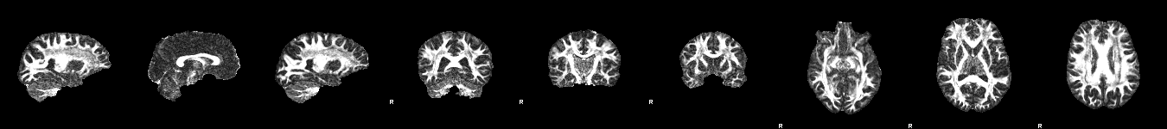

5. Discussion
Null group findings for nlang and entropy under strict correction do not imply that multilingual experience is irrelevant to the brain; they indicate that linear effects of these questionnaire scores on these particular summaries were not detectable in n=51. Possible factors include limited power, correlated predictors, restriction of range in an educated multilingual sample, summary measures (FA only; seed-based FC only), and the absence of task-based localisers for subject-specific ROIs. Sex and motion effects on FC highlight the importance of nuisance modelling in resting-state work.

6. Conclusion
This multimodal workflow—from SPM normalisation through Nilearn FC and TBSS with randomise—yields an auditable analysis path with open data. The main inferential results for the primary hypotheses were null under the stated thresholds; secondary associations involving sex and motion warrant cautious interpretation. Future work could add NODDI or fixel models, task-defined ROIs (e.g. Alice localiser), or multiverse specifications.

References (selected)
Ashburner, J., & Friston, K. J. (2005). Unified segmentation. NeuroImage, 26, 839–851.
Marian, V., Blumenfeld, H. K., & Kaushanskaya, M. (2007). LEAP-Q. JSLHR, 50(4), 940–967.
Power, J. D., et al. (2012). Motion and FC. NeuroImage, 59, 2142–2154.
Smith, S. M., et al. (2006). TBSS. NeuroImage, 31, 1487–1505.
Smith, S. M., & Nichols, T. E. (2009). TFCE. NeuroImage, 44, 83–98.
NEBULA101: OpenNeuro ds005613 dataset documentation.

Appendix: Key paths
PNG files generated for this Word document live under:
report_assets\generated\fig_group_mean_fc_matrix.png
report_assets\generated\fig_cohort_predictors.png
report_assets\generated\fig_mean_fd_distribution.png
report_assets\generated\fig_nlang_entropy_scatter.png
report_assets\generated\fig_mean_fc_vs_nlang.png
[PLACEHOLDER: Institutional approval or data-use statement if required for your course or journal.]

