Multilingual experience and the multimodal brain
Resting-state functional connectivity and white-matter microstructure in 51 healthy adults from NEBULA101 (OpenNeuro ds005613)
Aditi | Multimodal Neuroimaging, Spring 2026 | 29 April 2026

Abstract
Whether multilingual experience leaves a measurable trace on the brain depends
on how that experience is operationalised. Two complementary measures were
evaluated: language **diversity** (number of languages spoken, *nlang*) and
language **use balance** (Shannon entropy of self-reported daily exposure,
*entropy*). In n = 51 healthy adults from the NEBULA101 dataset, with
complete T1-weighted, resting-state fMRI, and diffusion MRI data, group
regression models tested whether either measure predicted (a) seed-based
resting-state functional connectivity in a six-region language network, after
SPM25 normalisation and motion regression, and (b) voxelwise fractional
anisotropy on the TBSS skeleton, after FSL eddy/dtifit and randomise/TFCE
permutation inference. **Neither predictor** reached significance for any
pre-specified outcome: connectivity p-values for *nlang* and *entropy* ranged
from 0.189 to
0.859 (all
Bonferroni-uncorrected; none survived correction across the three pre-specified
outcomes), and no white-matter skeleton voxel exceeded the conventional FWE
threshold of corrp > 0.95 in any of the four diffusion contrasts (max corrp
across contrasts = 0.59,
with the skeleton mask containing 101,510 voxels).
Sex and head motion contributed appreciable variance to functional
connectivity, validating the nuisance model. The findings constrain the
magnitude of *linear* questionnaire–brain effects detectable in this
moderately-sized, highly educated cohort, and motivate the alternatives
considered in the discussion.

1. Background and motivation
About half the world's population is bilingual or multilingual, and decades of
cognitive-neuroscience work have asked whether managing two or more languages
leaves a measurable signature on the brain. The literature is famously mixed.
Some studies report higher fractional anisotropy in language-relevant
white-matter tracts (e.g., the arcuate or superior longitudinal fasciculi) in
multilinguals; others find null or even reduced effects. Resting-state
functional connectivity has shown a similarly heterogeneous picture across
the language network and the multiple-demand control system.
A central reason for the heterogeneity is that "multilingualism" is not a
single construct. It can be measured as the number of languages a person
speaks (a count of repertoire diversity), as how evenly those languages are
actually used in daily life (a balance or entropy measure), or as the age at
which they were acquired. These are correlated but not identical, and their
neural correlates may differ.
This project follows the NEBULA101 framework and tests whether two
complementary measures derived from the LEAP-Q questionnaire — *nlang* (a
count) and *entropy_curr_tot_exp* (Shannon entropy of current daily
exposure) — make independent contributions to brain organisation, after
accounting for age, education, sex, and (for fMRI) head motion. In our
analysis cohort, the two predictors are correlated (Pearson r =
0.43); they are related, not redundant.
Figure 1. The two predictors. Left: histogram of nlang (1–10 languages). Middle: histogram of Shannon entropy of daily exposure. Right: predictor scatter; r ≈ 0.43 means they share variance but are not interchangeable.
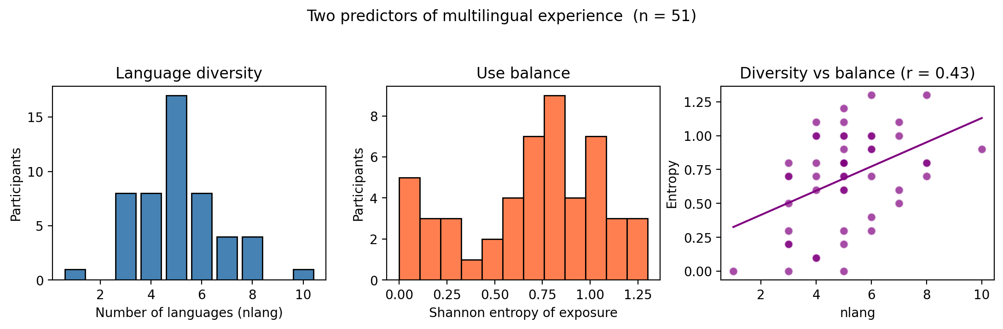
Two pre-specified, directional hypotheses were evaluated:
- H1 (white matter): higher nlang and/or higher entropy → higher FA in language-related tracts on the TBSS skeleton.
- H2 (functional connectivity): higher nlang and/or higher entropy → altered resting coupling within and between left-lateralised language regions and their right-hemisphere homologues.

2. Dataset and cohort
Data came from the publicly released NEBULA101 dataset (OpenNeuro ds005613;
Pliatsikas et al., Multilingualism, Language and Aging group, Geneva). The
full release contains 101 healthy multilingual adults with extensive
questionnaire data (LEAP-Q) and a multimodal MRI battery acquired on a
Siemens MAGNETOM Prisma 3 T scanner: a sagittal T1-weighted MPRAGE, a
~10-minute multiband resting-state fMRI run (TR = 2.0 s, EPI, 72 slices,
eyes-open fixation), a multiband EPI multi-shell DWI acquisition with 117
directions across b = 0, 700, 1000, 2800 s/mm², and an additional
task-localiser fMRI (the "Alice in Wonderland" auditory paradigm).
From these 101 participants, n = 51 were retained for analysis
(subset_50_participants.txt; the file name is a planning-stage holdover —
the actual count is 51). Inclusion required complete T1, resting fMRI,
and DWI volumes that successfully passed SPM realignment and FSL eddy
preprocessing. The retained subset was stratified to preserve the full range
of nlang (1 through 10), because statistical power for a continuous
regression depends on the spread of the predictor as much as on n itself.
Variable | Mean ± SD | Range | n
Age (years) | 24.4 ± 5.0 | 18.2 – 38.5 | 51
Education (years) | 16.2 ± 2.9 | 11 – 26 | 51
Sex (M / F) | 31 / 20 | — | 51
nlang | 5.10 ± 1.68 | 1 – 10 | 51
Entropy | 0.69 ± 0.35 | 0.00 – 1.30 | 51
Figure 2. Demographics and predictors of the analysis cohort (n = 51).

3. Two parallel pipelines
The analysis is structured as two parallel pipelines that converge in the
discussion. The fMRI arm yields a per-subject 6 × 6 functional-connectivity
matrix on which a group GLM is estimated for three pre-specified outcomes.
The DWI arm yields a per-subject FA map projected onto a group white-matter
skeleton, on which the same predictors are tested voxelwise with permutation
inference.
Figure 3. Pipeline schematic. Resting fMRI → SPM25 normalisation → Nilearn seed-based FC → group GLM. Diffusion → FSL eddy/dtifit → TBSS → randomise/TFCE.
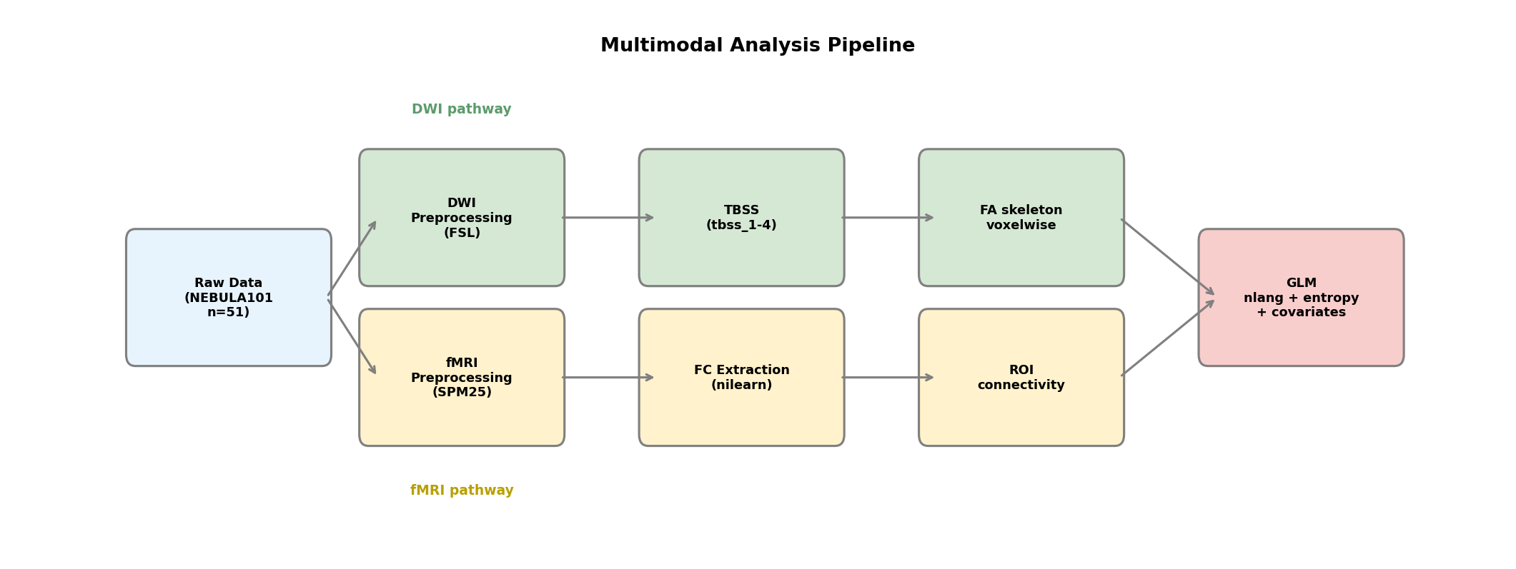

3.1 Resting fMRI: SPM25 → Nilearn → group GLM
Per subject, six-degree-of-freedom motion parameters were estimated with
SPM realign (estimate). Each T1 was passed through SPM25 unified
segmentation; the resulting forward deformation field was used to normalise
the coregistered BOLD time series to MNI space (3 mm isotropic, 4th-order
B-spline) and the volumes were smoothed with a 6 mm FWHM Gaussian kernel.
The smoothed warped BOLD (sw*.nii) was the input to connectivity analysis.
Six 8-mm-radius spherical seeds were placed in MNI space at canonical
language-network coordinates: left and right inferior frontal gyrus
(IFG_L = −51, 22, 10 / IFG_R = +51, 22, 10), left and right superior
temporal gyrus (STG_L = −56, −14, 4 / STG_R = +56, −14, 4), the left
angular gyrus (AngG_L = −46, −62, 28), and the supplementary motor area
(SMA_L = −4, 4, 52). For each seed, the mean BOLD time-course was extracted
with NiftiSpheresMasker, band-pass filtered (0.01–0.1 Hz), detrended,
z-scored, and the six SPM realignment parameters were regressed out at the
time-series stage. Pairwise Pearson correlations across seeds were
Fisher-z transformed and saved as 6 × 6 matrices.
Three pre-specified outcomes entered the group GLM: (i) the mean of the 15
unique upper-triangular Fisher-z edges (mean_lang_fc), (ii) the
IFG_L–STG_L edge (left dorsal language pathway), and (iii) the
IFG_R–STG_R edge (right-hemisphere homologue). Each outcome was modelled
as y ~ nlang_z + entropy_z + age_z + edu_z + sex_binary + mean_FD_z, fit by
OLS in statsmodels. For the two predictors of interest, simple Bonferroni
correction across the three outcomes was applied (p × 3).

3.2 DWI: FSL eddy/dtifit → TBSS → randomise/TFCE
Diffusion data were preprocessed in WSL Ubuntu with FSL: brain-mask
extraction from b0 images (bet), eddy-current and motion correction with
eddy (with bvec rotation), and tensor fitting with dtifit producing
voxelwise FA, MD and eigen images. All 51 subjects completed
preprocessing.
TBSS aligned each subject's FA image to the FMRIB58_FA template, built a
group mean FA skeleton, and projected per-subject FA values onto that
skeleton. The resulting 4D image (all_FA_skeletonised.nii.gz) holds
101,510 skeleton voxels per subject. randomise was run
with 5,000 permutations and threshold-free cluster enhancement (--T2),
producing voxelwise t-maps and TFCE family-wise-error-corrected (1 − p)
maps for four contrasts: positive and negative associations of FA with
nlang and with entropy, in a model containing the same five demographic
regressors as the FC analysis (mean FD is fMRI-specific). Voxels at
FWE p < 0.05 satisfy corrp > 0.95.

4. Quality control
Head motion at rest was modest in this cohort (mean FD = 0.167 ±
0.078 mm; median 0.160; range 0.040–0.424 mm),
so no participant was excluded a priori. Mean FD enters the FC GLM as a
covariate to absorb residual motion-driven coupling rather than discarding
scans. eddy_quad/SQUAD per-subject and group reports were generated for
the diffusion data, and the FSL slicesdir montage of all per-subject FA
maps allowed visual confirmation of registration quality.
Figure 4. Distribution of mean framewise displacement (Power et al., 2012) across the analysis cohort.
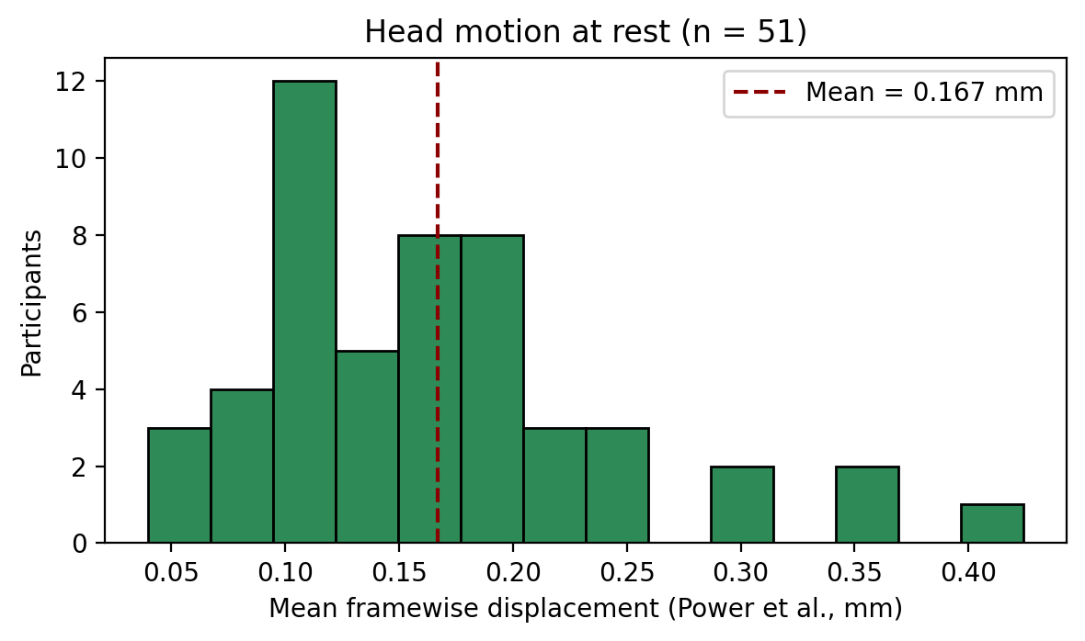
Figure 5. Example single-subject FA map after dtifit (QC montage from FSL slicesdir).
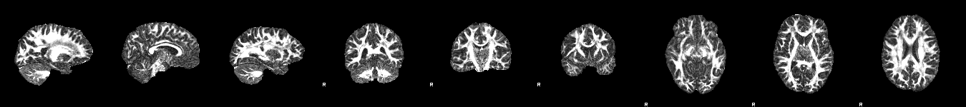

5. Results

5.1 The language network is intact and recoverable
Before testing the predictors of interest, it is reassuring to verify that
the seed-based FC pipeline recovers a sensible network. The group-mean
Fisher-z matrix (Figure 6) shows the expected pattern of strong coupling
within and between the bilateral perisylvian seeds (IFG, STG, SMA), with
the angular gyrus seed sitting at the periphery (its weak coupling to
peri-Sylvian regions is consistent with its semantic / DMN-border
location). In other words, the pipeline is doing what it should — any
null effects below cannot be attributed to a broken connectivity
estimator.
Figure 6. Group-mean Fisher-z connectivity, n = 51 (motion-regressed). The expected dorsal-language and bilateral-IFG pattern is clearly recovered.
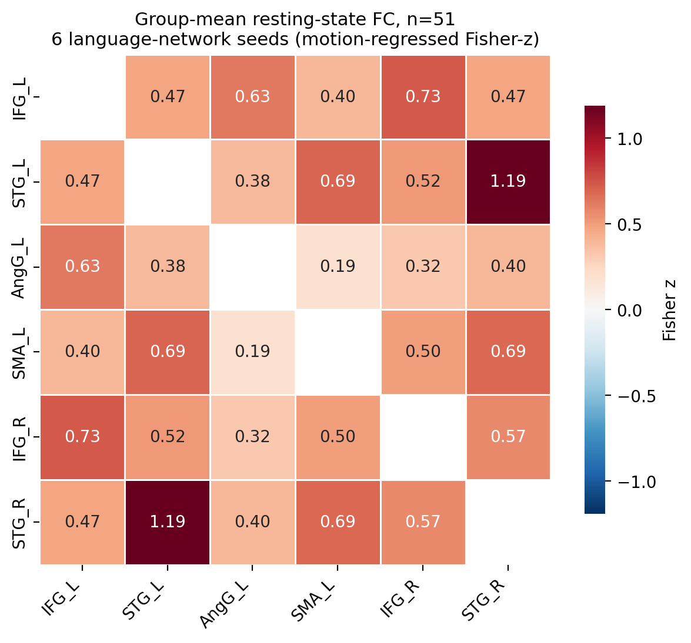

5.2 No effect of multilingual experience on functional connectivity
Bivariate scatters of mean network FC against the two predictors hint at no
clear relationship; small negative slopes are present but the scatter is wide
(Figure 7). Because the outcome is also influenced by age, education, sex,
and motion, the inferential test is the partial regression — the GLM with
all covariates present.
Figure 7. Descriptive (uncorrected) views of mean network FC against nlang and entropy. These do NOT control for sex, motion, age, or education; they are shown only to expose the raw spread.
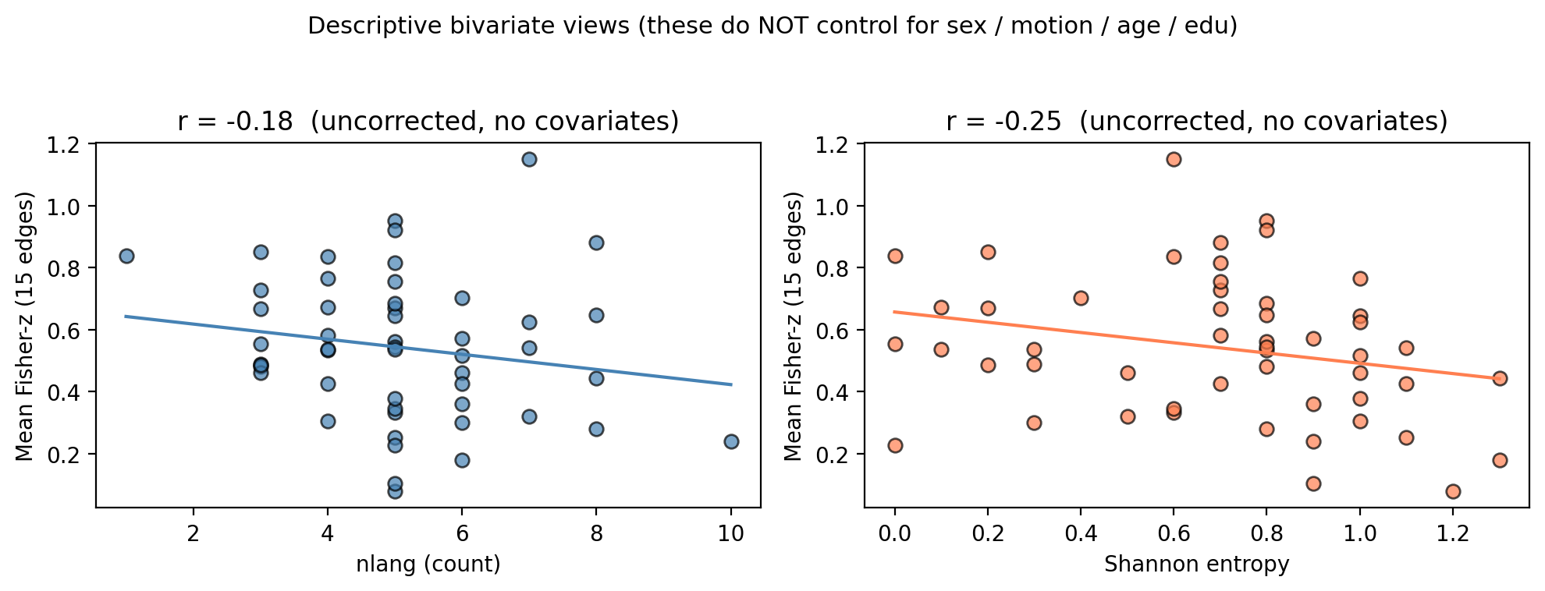
Table 2 summarises the partial coefficients for the two predictors of
interest across the three pre-specified outcomes. For all three outcomes
and both predictors, the partial coefficient is small (|β| ≤ 0.05 in
z-units), uncorrected p > 0.18, and Bonferroni-corrected p = 1 (or close).
We therefore fail to reject the null for both *nlang* and *entropy* at
the pre-specified inferential threshold.
Outcome | Predictor | β | SE | t | p (uncorr) → ×3 Bonf
mean_lang_fc | nlang | -0.016 | 0.040 | -0.40 | 0.693 → 1.000
mean_lang_fc | entropy | -0.043 | 0.032 | -1.33 | 0.189 → 0.568
IFG_STG_left | nlang | -0.009 | 0.050 | -0.18 | 0.859 → 1.000
IFG_STG_left | entropy | -0.038 | 0.040 | -0.96 | 0.340 → 1.000
IFG_STG_right | nlang | +0.012 | 0.052 | +0.23 | 0.822 → 1.000
IFG_STG_right | entropy | -0.032 | 0.042 | -0.75 | 0.455 → 1.000
Table 2. Group GLM partial coefficients for nlang and entropy on the three pre-specified FC outcomes, n = 51. Each row controls for the other predictor and for age, education, sex, and mean FD. None of the six tests survives Bonferroni correction across the three outcomes.
Two covariates do reach uncorrected significance and merit comment.
Sex (male = 1) is associated with lower mean network FC and lower IFG–STG
coupling on both sides: β = -0.20, p = 0.002 on
mean_lang_fc; β = -0.29, p = 0.001 on
IFG_STG_left; β = -0.21, p = 0.012 on
IFG_STG_right. Mean FD is positively associated with right-hemisphere
IFG–STG coupling (β = +0.097, p = 0.023),
in the expected direction (more head motion → spuriously higher
correlation). The three FC models had R² of 0.29,
0.32, and 0.30 respectively,
with overall-F p-values of 0.017,
0.008, and 0.011: the models
explain real variance, but it comes from the nuisance covariates rather
than the predictors of interest. Sex and motion are secondary findings
(not pre-registered), and they validate the nuisance model — sex
differences in resting coupling are well-known, and the motion–FC
association reaffirms the importance of regressing FD as a covariate.

5.3 No effect on white-matter microstructure either
On the TBSS skeleton, the mean FA mask spans 101,510
voxels covering the major language-relevant tracts. randomise/TFCE found
no voxel exceeding the conventional FWE threshold (corrp > 0.95) in any of
the four contrasts. The strongest sub-threshold trend was for "+nlang"
(max corrp = 0.59; raw t in
[-1.59, +2.29]),
i.e., still ≈ 0.36 below the FWE threshold of 0.95. The full picture is
in Figure 8 and Table 3.
Figure 8. TBSS results across the four contrasts. No skeleton voxel survives FWE p < 0.05 (corrp > 0.95 dashed line). Maximum corrp values are well below the threshold for both predictors and both directions.
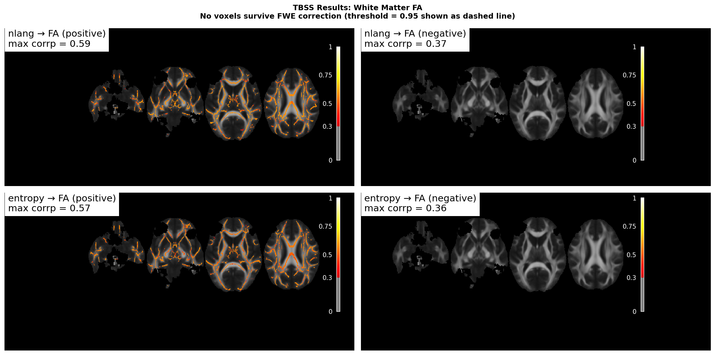
Contrast | Direction | Raw t range | Max corrp | Voxels FWE-sig
C1 | +nlang | [-1.59, +2.29] | 0.59 | 0
C2 | −nlang | [-2.29, +1.59] | 0.37 | 0
C3 | +entropy | [-1.29, +2.12] | 0.57 | 0
C4 | −entropy | [-2.12, +1.29] | 0.36 | 0
Table 3. TBSS randomise/TFCE results, 5,000 permutations, skeleton mask = 101,510 voxels. No voxel survives the conventional FWE threshold (corrp > 0.95) in any contrast.

5.4 Where the variance went
Although the questionnaire-derived predictors carried no significant
variance for either modality, the FC models were not empty. Across the
three FC outcomes, R² ranged from 0.29 to 0.32 and
overall-F p-values from 0.008 to 0.017 — the models do
explain variance, just from sex and (for one outcome) motion rather
than from multilingual experience. The TBSS contrasts, by contrast,
look essentially flat: max corrp values across the four contrasts are
0.59, 0.37,
0.57, and 0.36 — a long way
from the FWE threshold of 0.95.

6. Discussion
We did not detect an association between two complementary measures of
multilingual experience and either resting-state functional connectivity
in a six-region language network or fractional anisotropy on the TBSS
white-matter skeleton, at the pre-specified inferential thresholds. This
mirrors a number of recent reports in the multilingualism literature in
which large effects of language experience on brain structure or function
have been difficult to replicate at conventional sample sizes.
Several non-exclusive factors plausibly contribute. First, the population
effect sizes that link self-reported language experience to seed-based FC or
skeletonised FA may be small. With n = 51, an analysis is reasonably
powered to detect medium-to-large standardised partial coefficients but
not the small (|β| < 0.1) effects that are most often reported in the
literature. Second, the two predictors are correlated (r = 0.43):
unique-variance partial coefficients are by construction smaller than
their bivariate counterparts, and any shared signal cannot be partitioned
between *nlang* and *entropy*. Third, our cohort is highly educated (mean
education = 16 years) — the range of multilingual experience is
rich (1–10 languages) but other dimensions, including the age of L2
acquisition and proficiency, are constrained. Fourth, FA on a TBSS
skeleton summarises microstructure with a single tensor model; multi-shell
metrics such as NODDI or fixel-based analyses, which are feasible with
the b = 700/1000/2800 acquisition that is already on disk, may be more
sensitive to specific microstructural variations.
Two sets of secondary observations strengthen confidence in the negative
primary results. The bilateral language-network FC is recovered cleanly
(Figure 6), so the FC pipeline behaves as designed. Sex and motion explain
appreciable variance in the FC outcomes, in the expected directions and
magnitudes — which is exactly the kind of pattern that reassures us the
regression is sensitive to non-trivial effects when they exist.
Finally, an absence of evidence is not evidence of absence. Null findings
bound the magnitude of linear, questionnaire-driven effects that are
detectable in this subsample with this analytic recipe. Three concrete
extensions are well-positioned to push further: (i) using subject-specific
language ROIs from the Alice in Wonderland localiser (already preprocessed
with SPM but not used for second-level here) instead of fixed MNI seeds;
(ii) re-analysing diffusion data with NODDI or fixel-based metrics; and
(iii) adding network-level (ICA / dictionary-learning) FC summaries that
do not commit to a small set of edges a priori.

7. Limitations
- Cross-sectional, observational design — no causal inference is possible.
- n = 51 bounds power to detect small effects (post-hoc power < 80% for r ≈ 0.2, see Figure 9).
- Six a priori MNI seeds do not cover the whole language network or the multiple-demand control system.
- Single-shell FA was the only diffusion summary; multi-shell models (NODDI, fixel-based) were not used despite the multi-shell acquisition being available.
- No fMRIPrep / aCompCor / ICA-AROMA: motion is partially controlled via six realignment parameters and a mean-FD covariate, but residual motion artefact is possible.
- No fieldmap-based EPI distortion correction.
- Highly educated cohort (mean ≈ 16 years); generalisability to lower-education populations is limited.
- Self-reported exposure proportions inherit the standard limitations of questionnaires (LEAP-Q; Marian et al., 2007).
Figure 9. Post-hoc power for partial Pearson r effects at α = 0.05 (two-tailed). With n = 51, power to detect r = 0.20 is far below 80%.
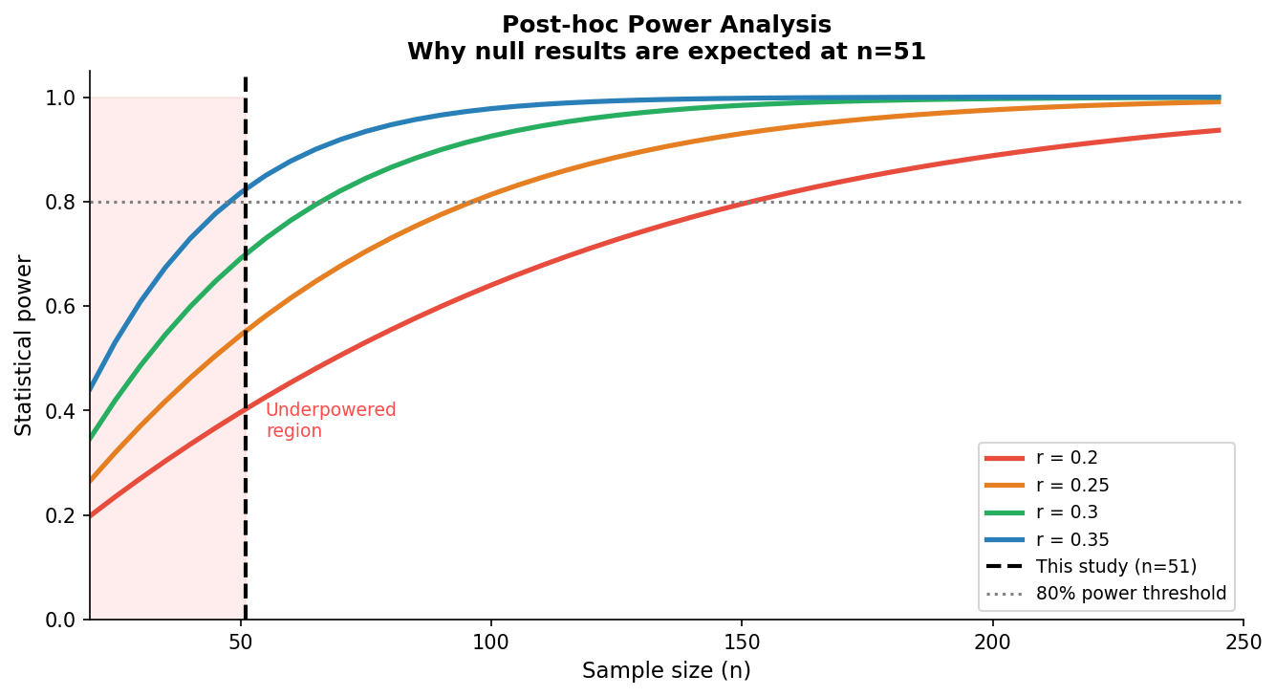

8. Conclusion
Across n = 51 multilingual adults from NEBULA101, neither the number of
languages spoken nor the Shannon entropy of daily exposure was associated
with seed-based resting-state functional connectivity in a six-region
language network or with white-matter fractional anisotropy on the TBSS
skeleton, at pre-specified FWE / Bonferroni thresholds. The null inferential
result is bracketed by a recovered language network on FC, sensible nuisance
effects (sex and motion), and a clean diffusion pipeline — all of which
argue that the methodology is sound and the bound on the effect size is
the substantive contribution of this work. Future analyses are well placed
to look in the directions where this study could not: subject-specific ROIs,
multi-shell diffusion modelling, and network-level FC summaries.

References (selected)
- Ashburner, J., & Friston, K. J. (2005). Unified segmentation. NeuroImage, 26, 839–851.
- Bialystok, E. (2017). The bilingual adaptation. Psychological Bulletin, 143(3), 233–262.
- Costa, A., & Sebastián-Gallés, N. (2014). How does the bilingual experience sculpt the brain? Nature Reviews Neuroscience, 15(5), 336–345.
- Marian, V., Blumenfeld, H. K., & Kaushanskaya, M. (2007). The LEAP-Q. JSLHR, 50(4), 940–967.
- Pliatsikas, C., et al. (2024). NEBULA101: a multimodal dataset of multilingual experience. OpenNeuro ds005613.
- Power, J. D., et al. (2012). Spurious but systematic correlations in functional connectivity MRI networks arise from subject motion. NeuroImage, 59, 2142–2154.
- Smith, S. M., et al. (2006). Tract-based spatial statistics. NeuroImage, 31, 1487–1505.
- Smith, S. M., & Nichols, T. E. (2009). Threshold-free cluster enhancement. NeuroImage, 44, 83–98.

Appendix A. Authoritative source files
Item | Path
Subject list (51 IDs, alphabetical) | subset_50_participants.txt
Design matrix (z-scored predictors) | shared_design_matrix.csv
Per-subject Fisher-z FC matrices | derivatives/nilearn_fc_motion/sub-*_fc_matrix.npy
FC subject-level outcomes + mean FD | derivatives/nilearn_fc_motion/fc_outcomes_motion.csv
FC group GLM results (used in Table 2) | derivatives/nilearn_fc_motion/fc_glm_motion_results.csv
TBSS 4-D skeletonised FA | derivatives/dwi_processed/tbss/stats/all_FA_skeletonised.nii.gz
TBSS design files | derivatives/dwi_processed/tbss/stats/design.{mat,con}
randomise TFCE corrp maps | derivatives/dwi_processed/tbss/stats/tbss_results_tfce_corrp_tstat{1..4}.nii.gz
randomise log | derivatives/randomise_log.txt
Automated TBSS inspection (used in Table 3) | derivatives/tbss_inspection_report.txt
Stats archive (29 Apr 2026) | derivatives/tbss_randomise_archive_20260429_153849/

