[AWS Whitepapers & Guides (amazon.com)](https://aws.amazon.com/whitepapers/?whitepapers-main.sort-by=item.additionalFields.sortDate&whitepapers-main.sort-order=desc&awsf.whitepapers-content-type=*all&awsf.whitepapers-global-methodology=*all&awsf.whitepapers-tech-category=*all&awsf.whitepapers-industries=*all&awsf.whitepapers-business-category=*all)

[How I Passed the AWS Certified Developer Associate Exam (freecodecamp.org)](https://www.freecodecamp.org/news/how-i-passed-the-aws-certified-developer-associate-exam/)

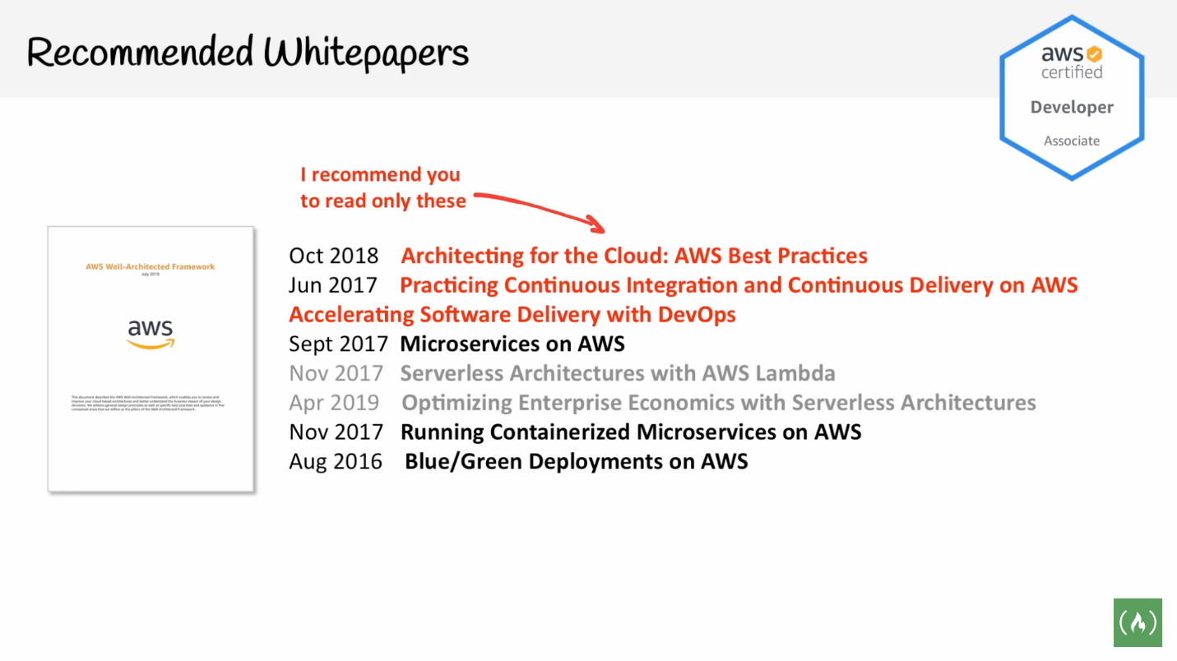

In my case, I read the following ones:

* Practicing Continuous Integration and Continuous Delivery on AWS: Accelerating Software Delivery with DevOps
* Microservices on AWS
* Architecting for the Cloud: AWS Best Practices