**La Cocina Brings Back The Street Food Scavenger Hunt!**

*In anticipation of the second annual San Francisco Street Food Festival,   
La Cocina has partnered with The Go Game to create a no-holds-barred Street Food Scavenger Hunt celebrating local vendors and restaurants.*

(San Francisco – June 3, 2010) Writing a rap song for crème brulée, hunting down frogs legs from a truck, choreographing the best chicken dance—these are only a few of what San Francisco’s most diehard foodies did in the name of competition at last year’s Street Food Scavenger Hunt.

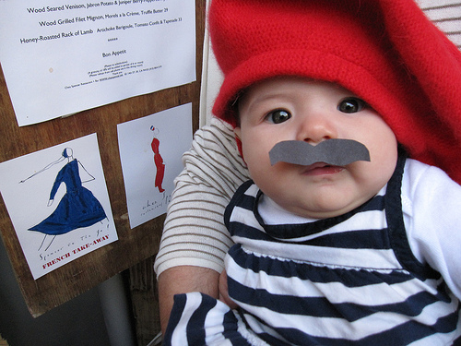

This year the Hunt returns, with more challenges, bigger prizes, and more opportunities to participate. Teams of up to 5 players can sign up at www.sfstreetfoodfest.com between now and July 31. The game begins August 1 and culminates with bonus missions and an awards ceremony on the day of the Street Food Festival, August 21.

Starting August 1 and on each subsequent Sunday, missions for the week will be released on the game’s website. Missions can take the form of trivia, location-based challenges, creative photos and videos or some combination of the three. Teams play at their own pace. This year, prizes will be given not only for high scores but also for creativity and speed. Teams will have plenty of opportunities to interact with other players and score votes and points using social media outlets such as Facebook and Twitter.

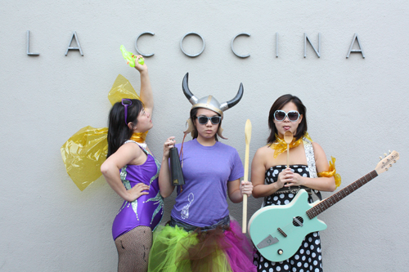This year’s prizes include gifts from Street Food Festival sponsors such as Kitchen Aid, Whole Foods, Crumpler, William-Sonoma, and more.

The second annual Street Food Festival will be held on August 21 from 11 a.m. until 7 p.m. between 24th and 26th streets, from Shotwell to Treat streets, including Garfield Park.

ABOUT LA COCINA:

<Text from other Press Releases>

MEDIA CONTACT

<Text from other Press Releases>